Service调取接口

import fetch from '../config/fetch';  
import {cookieUtil} from'../assets/js/common';  
var token = cookieUtil.get('login_token') || '';  
  
class GoodsListService {  
 getGoodsList(params) {  
 if(token){params.**login_token** = token;}  
 return fetch('goods/queryGoods', params,'POST');  
 }  
}  
export default new GoodsListService();

config

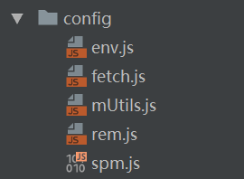

页面调用

import goodsListService from '../../service/goodsListService';

goodsListService.getGoodsList(params).then().catch()