**5.1 CPU architecture**

**Name ___________ class_____________**

1. What are the features of Von Neumann Architecture

____________________________________________________________________________________________________________________________________________________________________________________________________________________________________________________________________________________

1. The function of CU

______________________________________________________________________________________________________________________________________________________________________________________________________________

1. The function of ALU

______________________________________________________________________________________________________________________________________________________________________________________________________________

1. A processor has just one general-purpose register. Give the name of this register.

_____________________________________________________________________

1. State the role of each of the following special purpose registers used in a typical processor.
2. PC

_________________________________________________________________________________________________________________________________________

1. MAR

_________________________________________________________________________________________________________________________________________

1. MDR

_________________________________________________________________________________________________________________________________________

1. CIR

_________________________________________________________________________________________________________________________________________

1. IX

_________________________________________________________________________________________________________________________________________

1. SR

_________________________________________________________________________________________________________________________________________

1. What does 3MHz mean

_________________________________________________________________________________________________________________________________________

1. The processor uses buses in the FE cycle. The diagram shows three buses and two descriptions. Draw one line from each bus to its appropriate description.

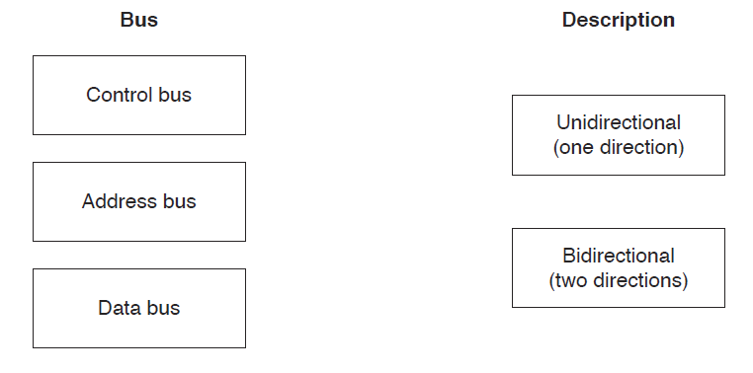

1. (a) The diagram shows the components and buses found inside a typical Personal Computer (PC).

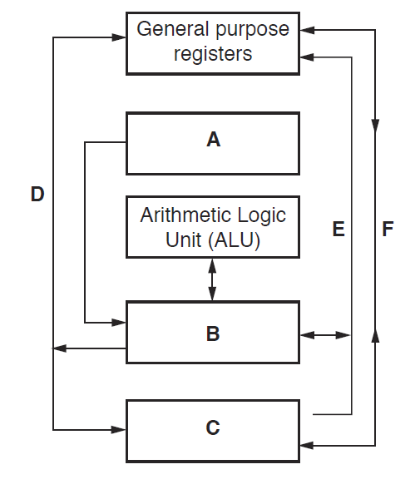

Some components and buses only have labels A to F to identify them.

For each label, choose the appropriate title from the following list. The title for label D is

already given.

• Control bus

• System clock

• Data bus

• Control unit

• Main memory

• Secondary storage

A ...........................................................................................................................................

B ...........................................................................................................................................

C ...........................................................................................................................................

D Address bus

E ...........................................................................................................................................

F ...........................................................................................................................................

(b) Clock speed is a factor that affects the performance of a PC. Explain this statement.