**5.2 system bus**

**Name ___________ class_____________**

1. Name three ways to increase Processor performance

____________________________________________________________________

____________________________________________________________________

____________________________________________________________________

2. Match the following components to the numbers on the diagram: Processor, Data bus, Control Bus, Main memory, Keyboard, Secondary storage, Address bus, Clock, Monitor, VDU (Visual Display Unit) controller, disk controller, keyboard controller

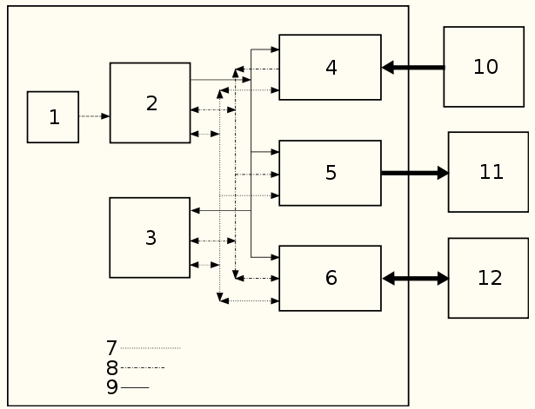

1. For the following diagram where applicable add single or multi directional connections between devices and buses

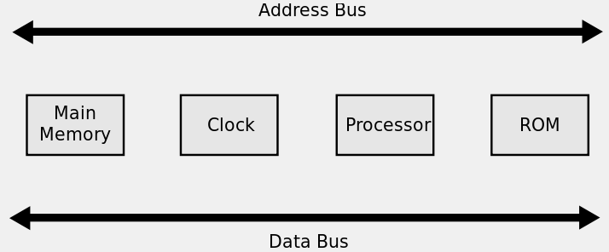

1. **(a)** Explain how the width of the data bus and system clock speed affect the performance of a computer system.

Width of the data bus

___________________________________________________________________

___________________________________________________________________

___________________________________________________________________

___________________________________________________________________

Clock speed

___________________________________________________________________

___________________________________________________________________

___________________________________________________________________

___________________________________________________________________

**(b)** Most computers use Universal Serial Bus (USB) ports to allow the attachment of devices.

Describe **two** benefits of using USB ports.

1_____________________________________________________________________________________________________________________________________

2_____________________________________________________________________________________________________________________________________