Software Design
Specification

Data Viewer
Revision 0.1

Table of Contents
1. Overview 1
1.1 Introduction 1
1.2 Function Description 1
1.3 Terminology and Abbreviation 3
2. Software Architecture 4
2.1 Architecture Diagram 4
2.2 Moduels List 5
3. Software Design 6
3.1 Raw Data Parsing 6
3.2 Data Expression 7
3.3 GUI Layout 8
3.4 Utilities 8
3.5 Required Python Modules 8
4. Data Storage 8
4.1 Introduction 8
4.2 Data Storage Design 8
5. User Manual 9
5.1 Preparation 9
5.2 Start Dataviewer 9
5.3 Select Data Profile 9
5.4 Create/Open Session 9
5.5 Load Data from Raw Data Files 9
5.6 Load Data from Data Storage 9
6. Appendix 9
6.1 Raw Data Format 9
6.2 Protoccols 9
6.3 Xlsx Template 9
6.4 BIN Data Storage Format 9
7. References 10

Revision History
Version | Name | Reason For Changes | Date
0.1 |  | Initial Revision

Approved By
Approvals should be obtained for project manager, and all developers working on the project.

Name | Signature | Department | Date

Overview

Introduction
Dataviewer is a GUI-based tool written in python language, to process, analyze and view the BMS raw data; this document includes detail description on the tool, including function requirements, architecture, design and use guide etc.

The target audience of the document are user or deveoper of Dataviewer.

Function Description
Dataviewer has a GUI main windows, with data viewframe, menubar and control/tool frame.

User can load raw data files (text-based) via file dailogframe, or load raw data from data storaage (bin-based); the data are parsed and displayed in the data viewframe.

The data viewframe is tableform with data items at top raw and the value column in chronological order.
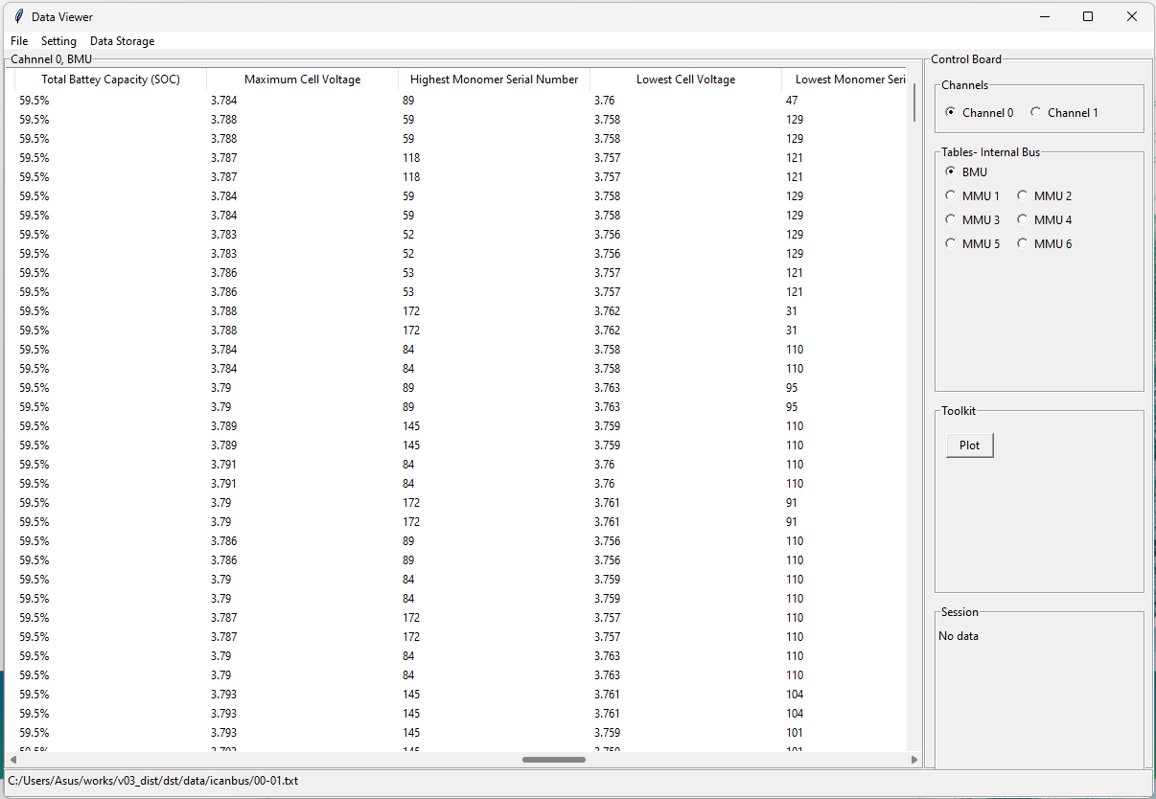
User can view more data by operating the two scrollbars.

There are multiple table forms, user can select which one of them is displayed in the viewframe, via the control frame at left, for example, select channel, BMU or MMU.

User also can open plot tool by clicking the “Plot” button in the toolkit frame at lifet side.

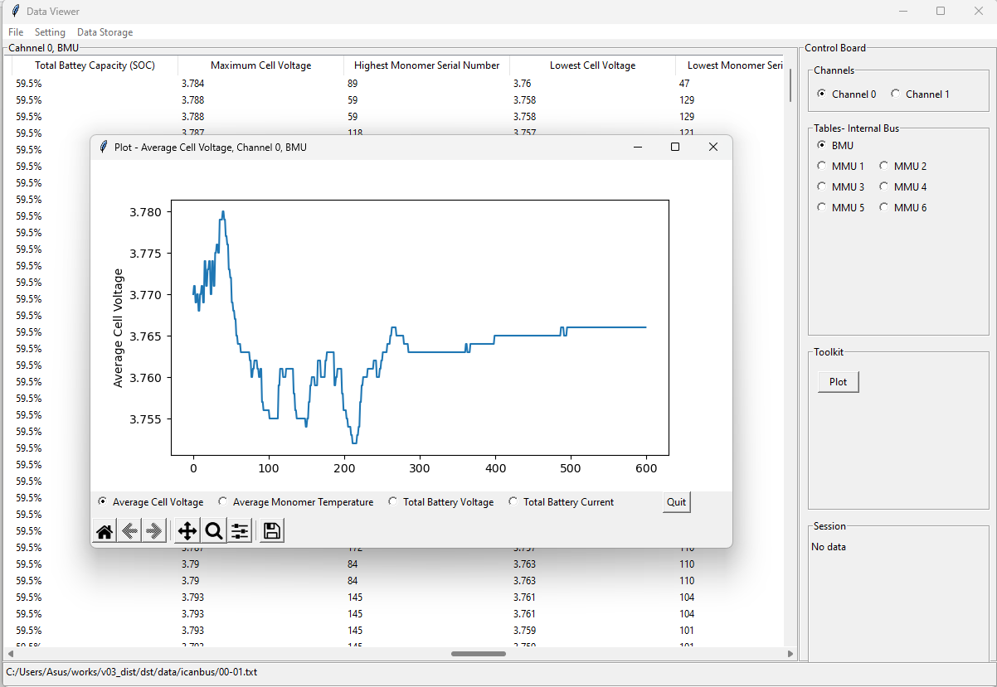

Terminology and Abbreviation

Term. & Abbr. | Definition
raw data
dataset

Software Architecture

Architecture Diagram
The dataviewer has layered architecture as below:

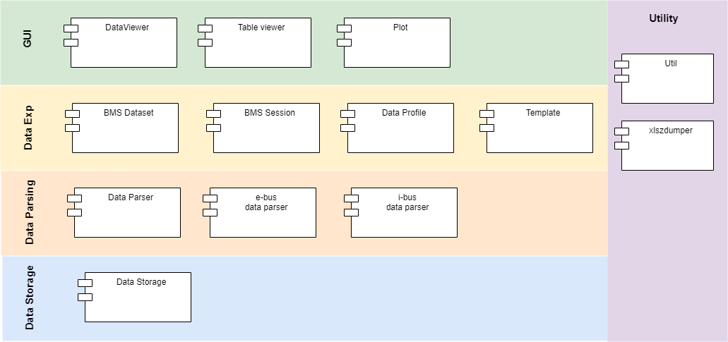

GUI layer includes all GUI related modules, i.e DataViewer which is main frame of GUI layout, Table viewer which implents data viewframe and plot which holds the plot related tool etc.

Data Expression layer holds dataset which is objects of BMS data orgnized in run-time memory.

Data Parsering layer reads raw data file and translate the raw data into the dataset.

Data Storage layer is an API layer to the bin-based data storage file.

There are common-used functions or modules in utility.

Moduels List
In this project, one module is a python file, such like Dataviewer.py, bmsdataset.py dataparser.py etc.

Module | Description
DataViewer
tableviewer
plot
bmssession
bmsdataset
dataprofile
template
dataparser
ebusdataparser
ibusdataparser
util
xlsxdumper
datastorage

Software Design
This charpter describes detail design of moduels

Raw Data Parsing
BMS applys CAN protocol to transfer data; in text-based raw data file, each CAN frame data occupys one text line as below,

0003, 0, 88, 18F20502, C2, 0E, C2, 0E, C3, 0E, C5, 0E
0007, 1, 88, 18FB2AA0, A0, D0, 07, 00, 00, 00, 00, 00
0011, 0, 88, 18F30004, 9E, 02, 9E, 02, 9E, 02, 9E, 02
0008, 1, 88, 18F20003, BD, 0E, BD, 0E, C0, 0E, BD, 0E
0003, 1, 88, 18F10200, D8, 08, EF, 7D, 00, 00, 43, 00
0006, 1, 88, 18F20305, B1, 0E, B3, 0E, B2, 0E, B2, 0E
0014, 0, 88, 18F20600, C3, 0E, C4, 0E, C4, 0E, C7, 0E
0003, 0, 88, 18F004A0, C8, 0E, 59, B0, 0E, 2F, BA, 0E

The meaning of the specific data:

row 1: interval between frames, unit is 0.1ms
row 2: channel number
row 3: frame info
row 4: frame ID, defined in the BMS communication protocol
row 5 and after: 8-byte frame data

The raw data of each frame is parsed according to the certain protocol, into bin based data disctioanry which is called dataset, including data element name-value pairs, for example “0003,0,88,18F20502,C2,0E,C2,0E,C3,0E,C5,0E” is parsed into data dicttionary object like:

{ 'intval': 3, # interval
'chn': 0, # channel
'finfo': 136, # frame info, 0x88
'fid': 418514178, # frame ID, 0x18F20502
'fname': 'MMU Cell Voltage Data 5', # frame name, see protocol document
‘remark’: # data element name-value paires
[ [ 'Cell Voltage 21', 3.778 ], [ 'Cell Voltage 22', 3.778 ],
[ 'Cell Voltage 23', 3.779 ], [ 'Cell Voltage 24', 3.781 ] ] }

all frame are translated in the above object and to be further processed in Data Expression, see Data Expression. The module dataparser is API to data parsing layer, ebusparser handles external bus protocl specific data frames, and ibuparser handles internal bus protocol specific data frame. For more detail, see protocol documents.

Data parsing layer can be expanned to handle more protocols.

Data Expression
Parsed BMS data in the data parsing layer are converted in dataset at data expression layer, and values of same type of frame are chronologically combined in one value list.

Dataset is the object of BMS data in run-time memory, a mixed form of name-valuelist pairs dictionary; it is organized according to the data frame formats defined in certain protocol, the following example is dataset of “BMU System Status”, frame ID 0x18F000A0:

"BMU System Status":
{
"rtime":[<value list>], # relative time, unit 0.1ms
"System Running Status":[<value-list>],
"System Running Mode":[<value-list>],
"Error Code":[<value-list>],
"Failure Level":[<value-list>],
"Input Control Status":{
"Contactor 1 Detection":[<value-list>],
"Contactor 2 Detection":[<value-list>],
"Contactor 3 Detection":[<value-list>],
"Contactor 4 Detection":[<value-list>],
"MMU Power State":[<value-list>],
"High Level Detection, pre-stay":[<value-list>],
"Low Level Detection Charge Motor Signal":[<value-list>],
"D14 Low Level Detection, pre-stay":[<value-list>],
"Hardware mutual":[<value-list>],
"VMS KEY Status":[<value-list>],
"CHG KEY Status":[<value-list>],
"CC2 Shape State":[<value-list>] },
"Output Control Status":{
"Contactor 1 Enable":[<value-list>],
"Contactor 2 Enable":[<value-list>],
"Contactor 3 Enable":[<value-list>],
"Contactor 4 Enable":[<value-list>],
"Contactor 5 Enable":[<value-list>],
"Contactor 6 Enable":[<value-list>],
"Contactor 7 Enable":[<value-list>],
"MMU Power Enable":[<value-list>],
"Low Side Drive Move 1 Enable":[<value-list>],
"Low Side Drive Move 2 Enable":[<value-list>],
"BMU PWR Lock Make can":[<value-list>],
"VCC Make can":[<value-list>],
"Sensor PWR ENABLE":[<value-list>],
"GPRS PWR ENABLE":[<value-list>] }
}

In the module template, there defines dataset format of all types of frame.
Compelete dataset including both channels, BMU and MMUS , shall be like:

dataset = [ {<channel 0>}, {<channek 1>}]
channel = {‘bmu’:{}, ‘mmus’:{}} # for internal bus, or {‘mbmu’:{}, ‘sbmus’:{}} for external bus
bmu = {“BMU System Status”:{<bmu system status frame>}, “BMU System Message 1”:{<bmu system message 1>}, .... } # for more detail, see temaplate.py and protocol documents

mmus = [<mmu list>] # one project may include multiple MMUs
mmu = {"MMU System Status":{<"MMU System Status">}, "MMU Information 1":{<"MMU Information 1">}, ... } # for more detail, see temaplate.py and protocol documents

The module bmsdataset is many entery to data expression layer, it implements APIs for the GUI layer to access dataset. It provide the following methods:

insert:
insert parsed BMS data to the dataset

getTitles :
get list of data element titles, i.e ["System Running Status", "System Running Mode", ...], see template.py

getValueByTitle:
get value list by the title

The module template defines dataset format for all types of frames, and the module dataprofile include project specific info, such like CAN bus channel and protocol info etc,

The module bmssession implements a mechanism to organize dataset from multiple text-based raw files. It allows user to load multiple raw data files by one session, so that ease the operations, see user guide.

GUI Layout

Utilities

Required Python Modules

Data Storage

Introduction

Data Storage Design

User Manual

Preparation

Start Dataviewer

Select Data Profile

Create/Open Session

Load Data from Raw Data Files

Load Data from Data Storage

Appendix

Raw Data Format

Protoccols

Xlsx Template

BIN Data Storage Format

References

