1. 接口调用流程

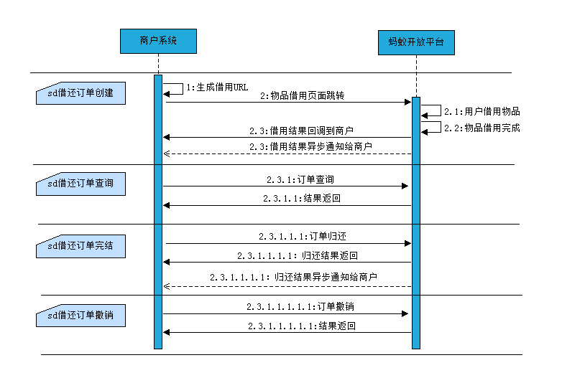

**4.1信用借还订单创建**zhima.merchant.order.rent.create

申请借用并完成相关支付方式签约的接口。

页面接口，跳转至芝麻借用页面。用户完成后，页面回调至商户指定页面并返回结果。

如果商家设置了通知地址，会将订单创建结果异步通知商户。

**4.2信用借还订单查询**zhima.merchant.order.rent.query

订单创建后，用户可根据商户外部订单号查询订单状态。

**4.3信用借还订单完结**zhima.merchant.order.rent.complete

用户归还物品后，调用该接口，完成订单的核销，并扣取相应的租金费用；

用户逾期未归还物品，调用该接口，扣取物品赔偿金

如果商家设置了通知地址，会将订单完结结果异步通知商户。

**4.4信用借还订单撤销**zhima.merchant.order.rent.cancel（可选）

订单创建后，用户可根据订单号撤销订单。

1. SDK快速接入
2. **信用借还订单创建接口zhima.merchant.order.rent.create**

|  |
| --- |
| AlipayClient alipayClient = new DefaultAlipayClient("https://openapi.alipay.com/gateway.do","app_id","your  private_key","json","GBK","alipay_public_key"); //your private_key:商户私钥；alipay_public_key:蚂蚁公钥  ZhimaMerchantOrderRentCreateRequest request = new ZhimaMerchantOrderRentCreateRequest();  request.setBizContent("{" +  " \"invoke_type\":\"WINDOWS\"," + //访问蚂蚁的对接模式：windows-支付宝服务窗  " \"invoke_return_url\":\"https://www.bing.com\"," + //回调到商户的url地址  " \"invoke_state\":\"{\\\"xxx\\\":\\\"xxx\\\"}\"," + //商户发起借用服务时，需要在借用结束后返回给商户的参数  " \"out_order_no\":\"2016100100000xxxx\"," + //外部订单号  " \"product_code\":\"w1010100000000002858\"," + //信用借还的产品码，固定不变  " \"goods_name\":\"充电宝\"," + //物品名称  " \"rent_info\":\"2小时内免费，超过2小时 2元/小时\"," + //租金信息描述  " \"rent_unit\":\"DAY_YUAN\"," + //租金单位  " \"rent_amount\":\"100.00\"," + //租金  " \"deposit_amount\":\"200.00\"," + //押金，同时也是物品价值，用户需根据该字段金额进行赔偿  " \"deposit_state\":\"Y\"," + //是否允许不准入的用户支持支付押金借用：Y支持，N不支持  " \"borrow_cycle\":\"2\"," + //借用周期，必须是正整数  " \"borrow_cycle_unit\":\"HOUR\"," + //借用周期单位  " \"borrow_shop_name\":\"肯德基文三路门店\"" + //物品借用门店  " \"rent_settle_type\":\"alipay\"" + //租金的结算方式  " }");  ZhimaMerchantOrderRentCreateResponse response = client.pageExecute(request, "GET"); //这里一定要用GET模式  String url = response.getBody();//从body中获取url  System.out.println("generateRentUrl url:" + url); |

1. **信用借还订单查询zhima.merchant.order.rent.query**

|  |
| --- |
| AlipayClient alipayClient = new DefaultAlipayClient("https://openapi.alipay.com/gateway.do","app_id","your  private_key","json","GBK","alipay_public_key"); //your private_key:商户私钥；alipay_public_key:蚂蚁公钥  ZhimaMerchantOrderRentQueryRequest request = new ZhimaMerchantOrderRentQueryRequest();  request.setBizContent("{" +  " \"out_order_no\":\"2016100100000xxxx\"," + //外部订单号  " \"product_code\":\"w1010100000000002858\"" + //信用借还的产品码，固定不变  " }");  ZhimaMerchantOrderRentQueryResponse response = alipayClient.execute(request);  if(response.isSuccess()){  System.out.println("调用成功");  } else {  System.out.println("调用失败");  } |

1. **信用借还订单完结zhima.merchant.order.rent.complete**

|  |
| --- |
| AlipayClient alipayClient = new DefaultAlipayClient("https://openapi.alipay.com/gateway.do","app_id","your  private_key","json","GBK","alipay_public_key"); //your private_key:商户私钥；alipay_public_key:蚂蚁公钥  ZhimaMerchantOrderRentCompleteRequest request = new ZhimaMerchantOrderRentCompleteRequest();  request.setBizContent("{" +  " \"order_no\":\"100000\"," + //信用借还订单号  " \"product_code\":\"w1010100000000002858\"," + //信用借还的产品码，固定不变  " \"restore_time\":\"2016-10-01 12:00:00\"," + //物品归还时间  " \"pay_amount_type\":\"RENT\"," + //金额类型：RENT(租金)，DAMAGE(赔偿金)  " \"pay_amount\":\"100.00\"," + //支付金额  " \"restore_shop_name\":\"肯德基文三路门店\"" + //物品归还门店名称  " }");  ZhimaMerchantOrderRentCompleteResponse response = alipayClient.execute(request);  if(response.isSuccess()){  System.out.println("调用成功");  } else {  System.out.println("调用失败");  } |

1. **信用借还订单撤销zhima.merchant.order.rent.cancel（可选）**

|  |
| --- |
| AlipayClient alipayClient = new DefaultAlipayClient("https://openapi.alipay.com/gateway.do","app_id","your  private_key","json","GBK","alipay_public_key"); //your private_key:商户私钥；alipay_public_key:蚂蚁公钥  ZhimaMerchantOrderRentCancelRequest request = new ZhimaMerchantOrderRentCancelRequest();  request.setBizContent("{" +  " \"order_no\":\"100000\"," + //信用借还订单号  " \"product_code\":\"w1010100000000002858\"" + //信用借还的产品码，固定不变  " }");  ZhimaMerchantOrderRentCancelResponse response = alipayClient.execute(request);  if(response.isSuccess()){  System.out.println("调用成功");  } else {  System.out.println("调用失败");  } |