1. The following two tables contain data relating to stock holdings and stock prices respectively:

StockHoldings StockPrice

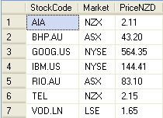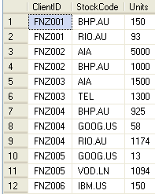

How would you manipulate this data in order to return the total value (Units \* Price) of the client holdings in each stock (you can use SQL, Excel functions or any other means to answer this)?