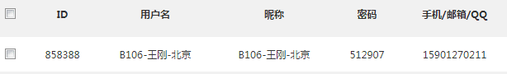

C:\Users\Administrator\Documents\Tencent Files\5765809\Image\C2C\NGO65Q6QL9IJ5Q5JX(@H)[S.png