CloudFormation

Kubernetes

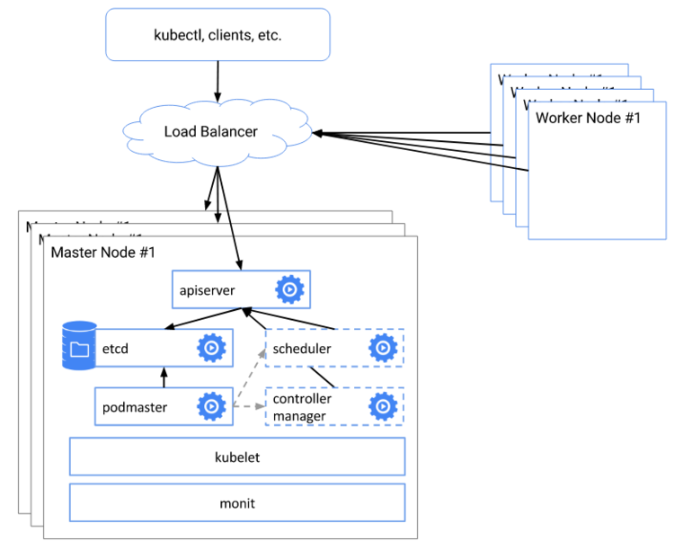

Helm

