An explainable rule-knowledge-graph-LLM agent for exposome-eye risk stratification: strong benchmarks, operable reports, limited rule transportability
Running title: Transportability of exposome rules for eye disease

Guoqing Wang¹,², Xianglong Yi¹,²,*
Affiliations
1. Department of Ophthalmology, The First Affiliated Hospital of Xinjiang Medical University, Urumqi, Xinjiang, China
2. Xinjiang Medical University, Urumqi, Xinjiang, China
*Corresponding author
Xianglong Yi, M.D., Ph.D., Department of Ophthalmology, The First Affiliated Hospital of Xinjiang Medical University, No.137 Liyushan South Road, Urumqi, Xinjiang 830054, China. Email: yixianglong1010@163.com. ORCID: 0000-0002-8222-7836.
ORCID: Guoqing Wang 0009-0002-6154-6990; Xianglong Yi 0000-0002-8222-7836.
Manuscript type: Original research
Main text: 6,495 words (Introduction–Discussion); abstract 371 words
Tables: 4; Figures: 6 main + 2 supplementary
Keywords: exposome; eye disease; transportability; measurement; ageing cohorts; clinical decision support
Funding: none. Competing interests: none.
Data: publicly available cohort and survey data; no human-subjects involvement
Prepared: 2026-10-28

Abstract
Background. Multi-layer agents that combine deterministic rules, knowledge-graph retrieval and a language model are inspectable, but whether they outperform general models, and whether their rules hold elsewhere, are rarely tested together.
Methods. Huiyan combines 21 rules, a LightRAG knowledge graph of 1,060 evidence chunks and an LLM arbiter that returns a source-linked trace. We evaluated system-level classification against three baselines (internal NHANES, which also informed rule development; external KNHANES), rule-level direction under a pre-registered three-state standard (CHARLS; eight ageing cohorts, 285,878 participants), and concordance across four literature indexes. We additionally audited which evaluation pairs the post-confirmatory rule revision had touched and repeated the external comparison on the untouched subset.
Results. The internal matrix contained no replicated pair that the rule revision had not touched (0 of 6), so it yields no out-of-sample estimate and is reported only as a development description (agent F1 0.571 versus rule layer 0.522). Externally, on 301 KNHANES pairs the agent scored 0.375 against 0.360 for its own deterministic rule layer and 0.176, 0.173 and 0.120 for LightRAG, a pure LLM and naive RAG. On the 296 pairs untouched by the revision the ordering held but the level collapsed: 0.211, 0.200, 0.122, 0.089 and 0.086. The agent's advantage is precision, not recall: it flags 30 of 301 pairs, 9 of them correctly, and its recall on replicated pairs is 0.500 with a 16.7% flag rate on contradicted and 7.2% on uninformative pairs. Rule track: only 6 of 21 rules were testable in the cohorts; of 18 rule x cohort pairs, 8 replicated, 8 were uninformative and 2 contradicted; two met the pre-registered criterion, but both prediction intervals spanned unity. Literature concordance was 0.889 (PubMed), 0.916 (Web of Science), 0.922 (Europe PMC) and 0.800 (CNKI), with 16/17 cross-index agreement.
Conclusions. The agent outperformed LLM and RAG baselines, and narrowly its own rule layer, on external data, but only a fifth of its external F1 survives when the pairs that informed development are removed. Its rules were largely untestable elsewhere (15 of 21), and none was robustly transportable where testable; the constraint was measurement, not sample size. Agent validation should report system-level and rule-level results separately, disclose which pairs informed development, and state which exposures were measured.

Introduction
Visual loss in later life is predominantly chronic rather than acute. Global estimates of vision impairment remain methodologically contested [1], and the leading contributors in ageing populations are cataract, glaucoma, age-related macular degeneration and diabetic retinopathy [2-4]. Each has been the subject of prevalence projection. Glaucoma, late AMD and diabetic retinopathy can cause irreversible loss once advanced, whereas cataract is surgically treatable but access-dependent; the potential value of exposome risk stratification lies in identifying people whose modifiable exposures place them at risk before vision is lost.
That framing, that risk is carried by a set of modifiable exposures rather than by a single factor, is the exposome concept [5]. In ophthalmology the relevant exposome spans metabolic state, nutrition, lifestyle and environment: hyperglycaemia, smoking, alcohol, adiposity and particulate or ultraviolet exposure have each been linked to one or more major eye diseases, with smoking and cataract among the better documented associations [6]. The literature is nevertheless uneven. Associations are reported for different outcomes, at different exposure thresholds, in populations with different age structures and different instruments, and a rule distilled from one body of evidence is not automatically valid elsewhere.
Clinical decision support is a natural vehicle for turning such rules into action, and rule-based systems have the advantage of being inspectable: every conclusion can be traced to a named rule and a cited source. The difficulty is that the evidence base for the rules is itself heterogeneous. In prediction modelling the general expectation is that performance falls on external data and should be reported rather than assumed, but transportability is usually evaluated as a single aggregate drop in performance. That tells us that a model degraded; it does not tell us which of its components failed. For a rule-based agent the component is the rule, and an aggregate F1 cannot distinguish an agent that is right for the right reason from one that is right despite rules that no longer hold. Literature-based validation has a related problem: when the validation search reuses the literature from which the rules were built, concordance is partly circular.
We therefore built Huiyan, an explainable agent that combines a deterministic rule engine, a LightRAG knowledge graph over the evidence base and a language-model arbiter that grades risk and returns a source-linked trace (Figure 1). The agent is deliberately rule-first. The language model cannot add rules or invent evidence; it can only grade the signals that the rule engine and the retrieval layer surface, and it abstains when the evidence is absent. This design keeps every output inspectable, but it also means that the agent inherits the validity of its 21 literature-derived rules. We evaluated five targets: system classification against three baselines, a working interface and rule/source traceability, cross-cohort transportability, rule direction under a pre-registered three-state standard, and independent concordance across four literature indexes. Validation used four independence-defined tiers: a 134-pair literature-only development set, internal validation in NHANES, external validation in KNHANES and CHARLS, and eight population-based ageing cohorts on three continents; a fifth layer tested rule direction against PubMed, Web of Science, Europe PMC and CNKI.
This design yields three contributions: a system-level account of performance against three baselines under five seeds and two backend generations; a rule-level transportability classification for every testable rule, reported under both precision denominators because the gap between them would otherwise misstate behaviour; and an explicit statement of what the evidence base cannot support, since 15 of the 21 rules were untestable for concrete data reasons. The paper proceeds from architecture and validation design, through system and rule-level results, to the measurement constraint that explains why a strong agent can still carry rules that do not travel.

Methods

Study design and reporting
This was a retrospective, multi-cohort evaluation of a fixed rule-based decision-support agent for ocular risk in older adults. Cohort analyses follow STROBE [7]; the TRIPOD+AI [8] and DECIDE-AI [9] statements govern estimated prediction models and prospective deployment and were assessed as not applicable to fixed rules. No participant was contacted and all analyses used de-identified public data.
The development, internal and external-survey tiers were fixed before the internal confirmatory analyses, and the eight-cohort and literature-index layers were pre-registered on 2026-10-15 before any model in those layers was fitted. The four tiers are defined by independence from the development material: a 134-pair literature-only development set used only to construct the rule base; internal validation in NHANES, where the pair-level gold and development-era baselines were built (independence axis: data source); external validation in KNHANES [10] and CHARLS [11], which differ by country, sampling and examination design (axis: site); and eight population-based ageing cohorts on three continents (axis: population). A fifth, literature-index layer assessed rule direction against PubMed, Web of Science, Europe PMC and CNKI; it is independent of the cohort databases and of any single index, though not of the source literature.
The agent's five validation targets were system classification, a working interface and evidence traceability, cross-cohort transportability, rule direction under a pre-registered three-state standard, and independent literature concordance. A pre-registered blinded expert panel was planned as a sixth target and was not conducted (Limitations). The eight-cohort layer was pre-registered before any cohort-layer model was fitted, including its testable rule set, per-cohort BMI cut-point, covariate set and transportability criterion (analysis plan section 19).

Data sources and validation datasets

Development set
The 134-pair development set was assembled from the published literature and used only to construct the 21 rules and the evidence base. It contributes no independent performance estimate; every result reported below is out-of-sample with respect to it.

NHANES: internal validation
NHANES contributed 180 pair-level tests across its exposure-outcome combinations; 159 were testable and 21 were underpowered. For rule-level precision under survey-design variance, 16 rule-relevant pairs were testable. The independence axis is the data source: the pair-level gold and the development-era baselines were built in this database, so this layer is internal by construction, not a test of site transfer.

KNHANES: external validation
KNHANES [10] contributed 352 pair-level tests; 301 were testable, 50 were underpowered, and one pair could not be estimated (numerical overflow in the survey model, logged as fit_fail). Fifteen rule-relevant pairs were testable for precision. The independence axis is site: the survey differs from NHANES in country, sampling frame and examination design.

CHARLS: external validation
CHARLS 2011 [11] contributed 14 exposure-outcome pairs; all 14 were testable, and 4 rule-relevant pairs were available for precision. The independence axis is site. Because only four rule-relevant pairs were available, CHARLS is reported as a direction check and no precision conclusion is drawn from it alone.

Eight ageing cohorts: external validation
Eight population-based cohorts were analysed from raw provider files: SHARE [12], HRS [13], ELSA [14], KLoSA [15], LASI [16], MHAS [17], CLHLS and CRELES; CLHLS and CRELES are cited to their data deposits [18-20]. The layer contains 598,386 unique person-wave records from 285,878 participants. SHARE distributes five imputation replicates as stacked rows; replicate 1 was used for descriptive and power calculations and the five were combined by Rubin's rules for model estimates. MHAS contributes no confirmatory rule × cohort cell because its measured exposures and ocular outcomes do not co-occur with sufficient non-missing data; Supplementary Table S6 records its cells as infeasible rather than omitting the cohort. Third-party harmonised releases (Gateway, easySHARE, RAND HRS) were excluded by design, because another team's operationalisation would make the transportability question circular; provider-official derived modules (SHARE's gv_* variables and imputed BMI, MHAS constructed files) were used as documented in the analysis plan. The independence axis is population: the cohorts are separate surveys with no cross-cohort linkage, and none contributed to rule construction. Every variable was operationalised from the cohort's own codebook under blocking availability, gate and plausibility checks; the full quality-control log is Supplementary Note S1.

Literature-index layer
The literature layer queried PubMed, Web of Science (100 papers, 2 rules), Europe PMC (521 papers across 21 queries, 17 informative) and CNKI (7 rules, 5 informative). It is independent of the four cohort databases and of any single index, but it cannot remove the shared source literature from which the rules were derived.

Rule engine
The system encodes 21 deterministic rules linking an exposome exposure (metabolic, nutritional, lifestyle or environmental) to an ocular outcome, each with a declared direction from the published literature (Table 2). Every rule carries an evidence level (A, B or C); r01 (uric acid and cataract) is a negative control because the underlying literature is contradictory. Rule-relevant pairs are the (exposure flag, outcome item) pairs a rule asserts something about; all other pairs are exploratory. Every flag has a codebook-derived operationalisation (for example intraocular pressure > 21 mmHg, cup-to-disc ratio ≥ 0.7), recorded in the machine-readable rules.yaml and variable_map.yaml shipped with the code. The rule engine is deterministic: given the same flags it returns the same matched rules, and it can return no rule rather than invent one.

LightRAG knowledge graph
The evidence layer combines a LightRAG index [21] over 1,060 evidence chunks with an evidence store. Retrieval uses hybrid entity-and-relation search; the arbiter receives the top five evidence chunks within a 6,000-character context. Embeddings use doubao-embedding-vision-251215 at 2,048 dimensions. The retrieved subgraph is returned with the report, tracing each rule through its intermediate entities to the source chunk.

LLM arbiter
The arbiter was a local Qwen3.8-27B model served by llama-server in the primary generation and GLM-5.3-flash in the fairness generation, with temperature 0. It was bounded to the rule signals and retrieved evidence, could not add rules or override the rule layer, and the agent abstained when no rule fired and no evidence was retrieved. Provider-level nondeterminism was probed at temperature 0: 24 of 24 repeats were stable on the logged DeepSeek probe, and an earlier 1-in-12 flip was provider-side and predated the local Qwen arbiter; the deterministic rule layer is therefore the reproducible component.

Validation phases and baselines
The validation targets were evaluated across the four tiers and the literature layer, each where the data supported it. System classification compared the full system with three baselines: retrieval-only LightRAG, a plain language model, and naive retrieval. Each baseline was run under five seeds with the language-model component held fixed, so that differences reflect architecture rather than model choice. Paired comparisons used exact accuracy McNemar tests, computed per seed. Two baseline generations are reported side by side and never pooled: an 80-pair generation with local Qwen3.8-27B baselines and a 159-pair generation with GLM-5.3-flash baselines. The full system's performance was also evaluated on the independent KNHANES 301-pair matrix under the same three-state gold.

Statistical analysis
A rule-relevant pair was replicated when its Benjamini-Hochberg-Yekutieli q < 0.05 and its estimate lay in the rule's declared direction, contradicted when q < 0.05 and it lay in the opposite direction, and uninformative otherwise [22]. Two precision denominators are reported and never interchanged: declared-domain precision omits uninformative pairs; conservative precision counts every tested rule-relevant pair and treats an uninformative result as a failure to replicate. Exact binomial intervals use Clopper-Pearson [23]. The pre-registered precision pass lines were 0.70 (internal) and 0.80 (external); the point estimates meet them, but the Clopper-Pearson lower bounds reported below do not exclude values below the line. Random-effects pooling with prediction intervals, E-values, leave-one-cohort-out analysis, meta-regression, cohort-level power and the measurement-modality audit are post hoc. A secondary post hoc binary collapse (gold positive = replicated; predicted positive = flag) is also reported with sensitivity, specificity, PPV and Cohen's κ per generation (Supplementary Table S7); four-level exact accuracy is not computable (no gold risk tier exists; the grade derives from rule severity), and the arbiter context is bounded at 6,000 characters.
Each rule-relevant pair was estimated by within-cohort logistic regression with age and sex as covariates, wave fixed effects where more than one wave contributed, and variance clustered by participant. SHARE's five imputations were fitted separately and combined by Rubin's rules [24]. Multiplicity was controlled over two pre-registered families (confirmatory rule-relevant pairs and exploratory all tested pairs). Power was computed per pair: the minimum detectable odds ratio at 80% power was derived from observed marginal counts, and the design effect from the survey-to-model confidence-interval width ratio rather than a conventional value. The age positive control (sex was included as a covariate, not as a control) was specified as a falsification test and pooled with the same random-effects estimator used for the rules. A synthetic effect-injection regression (post hoc) injected a known OR of 2 into the cohort frames: detection was 100% with zero false positives. Construct validation used NHANES 2005–2008 (n = 14,440), which measured the same participants by self-report and by objective near-vision testing, with the same age + sex + wave model. E-values follow VanderWeele and Ding [25], with each odds ratio converted to a risk ratio using the unexposed risk before use; corrected values are reported throughout.
For the eight-cohort layer, between-cohort heterogeneity was summarised by REML τ², Cochran's Q, I² and 95% prediction intervals [26]. The pre-registered transportability criterion required replication with q < 0.05 in at least two cohorts. A heterogeneity-aware criterion (prediction interval excluding the null and I² below 75%) and a regional subgroup comparison were added after the primary results were known and are reported as post hoc.

Construct substitutions and protocol deviations
The rule base names specific constructs; the cohort layer tests whichever construct the data can support. Five AMD rules (r05, r06, r09, r11, r17) were tested against any AMD because no cohort separates late from early AMD. r02–r04 were specified against self-reported physician-diagnosed diabetes because no cohort has usable fasting glucose or HbA1c; self-reported diabetes prevalence across the four cohorts testing r02 ranges from 1.36% (CLHLS) to 19.14% (CRELES), so the proxy is not on one scale across cohorts.
Survey design variance was specified but not implemented: the cohort frames contain no weight, strata or PSU variable (SHARE's country field is empty in all 1,693,515 rows), so every confidence interval, q-value and three-state label rests on unweighted cluster-robust variance. The rule set was modified after the first confirmatory run: the 20-rule v1.1 set became the 21-rule v1.2 set (exposure cross-coverage of r02/r03/r04 altered; r22 added) and the confirmatory analysis was re-run. The pre-registration records this as test-set fitting; the resulting recall of 1.000 is constructed, not earned. No pre-run version-control snapshot exists; the timeline is documented in Supplementary Methods.
Analyses used Python 3.10 (pandas, statsmodels, SciPy) and R 4.6.1 (survey).
Supplementary tables and figures are provided as Multimedia Appendix 1.

Ethics
This is a secondary analysis of de-identified public data with no participant contact; the full statement is in the Declarations.

Results
All rule-level inference uses the pre-registered three-state standard: a rule-relevant pair is replicated when its Benjamini-Hochberg-Yekutieli q < 0.05 and its odds ratio points in the declared direction, contradicted when q < 0.05 and it points the other way, and uninformative otherwise. Declared-domain precision is directional concordance among significant pairs, replicated / (replicated + contradicted); conservative precision counts every tested pair and treats an uninformative result as a failure (Figure 3). Because the reference standard has three states, uninformative pairs are neither positives nor negatives: sensitivity and specificity are not uniquely defined without a binary collapse that the three-state standard rejects, and κ is not applicable because the reference standard is a data-derived estimate, not an annotator label. System-level F1 treats replicated as the positive class and everything else as non-positive, so it is a conservative binary summary in which part of the full system's advantage reflects flagging behaviour rather than accuracy.

System architecture
Huiyan combines a deterministic rule engine (21 rules), a LightRAG knowledge graph (1,060 evidence chunks) and an LLM arbiter that returns a report with the rule, the KG path and the source chunk (Figure 1). The classification benchmark below is produced by the deployable full agent (rule layer, negative-control gate, evidence confirmation, LLM arbiter); the rule layer alone is reported as an ablation.

Validation overview
The validation returned these core results: the full agent beat the three LLM/RAG baselines on F1 wherever it was run end to end, and also beat its own deterministic rule layer externally by a narrow margin (KNHANES 0.375 versus 0.360; baselines 0.176, 0.173 and 0.120); the internal NHANES matrix contained no replicated pair untouched by the post-confirmatory rule revision, so it contributes no out-of-sample estimate; on the 296 KNHANES pairs untouched by that revision every method fell sharply and the agent kept the lead (0.211 versus 0.200, 0.122, 0.089 and 0.086); a worked case resolved every output to a rule, KG path and source chunk (Supplementary Figures S1-S2); in the cohort layer 6 of 21 rules were testable, with 8 of 18 rule × cohort pairs replicated, 8 uninformative and 2 contradicted; rule direction by tier was NHANES 6/0/10, KNHANES 5/0/10, CHARLS 0/0/4, eight cohorts 8/2/8 (replicated/contradicted/ uninformative); and index-level precision was 0.889 (PubMed), 0.916 (Web of Science), 0.922 (Europe PMC) and 0.800 (CNKI). Table 3 collects both levels for every dataset; system-level F1 exists only where the three baselines were run.

Internal validation in NHANES
The 134-pair development set contributed no independent estimate (Table 1 and Supplementary Table S3); every estimate below is out-of-sample with respect to it. At the pair level, 159 of 180 NHANES pairs were testable and 21 underpowered; 16 rule-relevant pairs were testable under survey-design variance: 6 replicated, none contradicted, 10 uninformative — declared-domain precision 1.00 (95% CI 0.541–1.00), conservative precision 0.375, rule testability 0.889 (16 of 18; pre-registered coverage of the full testable matrix 0.131). The point estimate meets the pre-registered 0.70 precision line, but the Clopper-Pearson lower bound does not exclude values below it. Sensitivity analyses (Supplementary Table S2) show replication outside the highest evidence tier: the single level-A pair did not replicate (0 of 1), levels A and B give 4 of 13 (0.308), and the 16-pair headline set gives 6 replicated (0.375). Continuous modelling (Figure 4) reproduces the pattern: cotinine per SD is unrelated to cataract (0.92, q = 0.31) or late AMD (1.08, q = 0.53) in NHANES, BMI-cataract is significant per SD in KNHANES (1.077, 1.034–1.122, q = 0.0014) and null in NHANES (1.030, q = 0.71); direction agreed in 19/24 NHANES and 9/10 KNHANES pairs.
At the system level the internal NHANES matrix is reported as a development description, not as performance. The 134-pair development set contributed no independent estimate, and the 80-pair matrix was itself used in development: the rule set was revised after the first confirmatory run (r02–r04 exposure coverage altered, r22 added; Methods records this as test-set fitting). The audit is decisive: of the 159-pair matrix's 6 replicated pairs, all 6 are covered by a rule that the revision touched, leaving zero contamination-free positives. The matrix therefore supports no out-of-sample estimate; its recall of 1.000 measures the revision. For completeness the numbers are: deployable full agent F1 = 0.571 (P 0.400 / R 1.000) on the 80 pairs (Qwen3.8-27B baselines, R11-corrected gold), ahead of LightRAG 0.392 ± 0.007, pure LLM 0.335 ± 0.010 and naive RAG 0.080 ± 0.110 over five seeds (Figure 2); under the earlier gold the pre-revision v1.1 set scored 0.111 (P 0.091 / R 0.143). Accuracy McNemar was significant against LightRAG (p = 0.0064–0.0117) and pure LLM (p = 0.0004–0.0013) but not naive RAG (p = 0.42–1.00). The ablation localises the gain: bare rule layer 0.522, +negative-control gate 0.545, +evidence confirmation and arbiter 0.571. The full agent extended the ordering to the 159-pair GLM-5.3-flash generation: F1 = 0.522 (P 0.353 / R 1.000) versus rule layer 0.480 and baselines 0.186, 0.178 and 0.069, with accuracy McNemar significant against all three (per-seed p < 10⁻⁶). A stronger commercial LLM as a standalone judge produced more, not fewer, false positives (precision 0.10). Under a secondary binary collapse (gold positive = replicated; predicted positive = flag), the full agent reached sensitivity 1.00, specificity 0.878, PPV 0.400 and κ 0.520, every one of which inherits the constructed recall (Supplementary Table S7); naive RAG's near-null flagging (sensitivity 0–0.17, κ ≈ 0) explains its accuracy-McNemar null. The full agent flags 17 of 80 pairs against 4–31 for the baselines, and most predicted-positive pairs are uninformative rather than contradicted, so precision stays low (0.07–0.35).

External validation in KNHANES and CHARLS
Of 352 KNHANES pair-level tests, 301 were testable, 50 underpowered and one non-estimable (numerical overflow in the survey model); all 14 CHARLS 2011 pairs were testable. Rule-level precision: 15 KNHANES pairs testable — 5 replicated, none contradicted, 10 uninformative — declared-domain precision 1.00 (0.478–1.00), conservative precision 0.333, rule testability 0.882; CHARLS had 4 testable pairs, all uninformative (declared precision undefined, conservative 0.000), so no conclusion is drawn from it alone.
On KNHANES the full agent was run end to end on all 301 testable pairs, which makes this the only agent-level external estimate, and it is also the only one that can be split into pairs the rule revision touched and pairs it did not. On all 301 pairs the agent reached F1 = 0.375 (P 0.300 / R 0.500), against its own deterministic rule layer at 0.360 (P 0.281 / R 0.500) and the three baselines at 0.176 (LightRAG), 0.173 (pure LLM) and 0.120 (naive RAG). Accuracy McNemar was significant against all three baselines before and after Benjamini-Hochberg correction over the 15 tests per matrix (q < 0.001 in every case), but that test is dominated by the 277 uninformative pairs, on which abstention earns credit; F1 is the declared metric and accuracy is secondary.
The revision-free subset is the harsher test. Removing the 5 pairs whose rules were modified after the first confirmatory run leaves 296 pairs carrying 13 replicated, 6 contradicted and 277 uninformative outcomes: the agent scores 0.211 (P 0.160 / R 0.308), the rule layer 0.200 (P 0.148 / R 0.308), the pure LLM 0.122, LightRAG 0.089 and naive RAG 0.086. The ordering survives; the level does not. Every method loses roughly two thirds of its F1 on the untouched pairs, because the untouched pairs are the ones where no rule fires (9 of 13 replicated pairs have no rule at all) and where the evidence store has least to say. The three-state decomposition makes the trade explicit: agent and rule layer both flag 50% of replicated and 16.7% of contradicted pairs, and differ only on uninformative pairs (7.2% versus 7.9%). The internal-to-external comparison therefore depends on the metric: rule testability 16/18 to 15/17, pre-registered coverage 0.131 to 0.095, declared-domain precision 1.00 in both, and system F1 0.571 (development, with zero contamination-free positives) to 0.375 (external, 0.211 contamination-free).

Cross-cohort transportability across eight ageing cohorts
The rules were re-evaluated in eight population-based ageing cohorts on three continents from raw source files with codebook-verified operationalisation (598,386 person-wave records from 285,878 participants), under a layer pre-registered before it was run (analysis plan section 19). Only 6 of 21 rules were testable; 15 required measurements absent in every cohort (five fundus imaging, one tonometry or disc grading, three geocoded exposure, three blood assays, two dietary indices, one lipid panel). Across 18 rule × cohort pairs (Figure 6): 8 replicated, 8 uninformative, 2 contradicted.
Two rules met the pre-registered criterion. r02 (self-reported diabetes as proxy for hyperglycaemia) replicated in three of four testable cohorts — LASI 1.88 (1.76–2.00), SHARE 1.75 (1.69–1.82), CLHLS 3.59 (2.62–4.91), CRELES 1.31 (1.07–1.61) short at q = 0.051. r20 (smoking to moderate vision impairment; the severe tier was not testable) replicated in three of five — HRS 1.61, ELSA 1.49, SHARE 1.09 — with all five cohorts pointing the same way. Two did not: r10 (smoking to cataract) was risk-increasing in SHARE (1.11, 1.04–1.18, q = 0.0095) and protective in CLHLS (0.748, 0.64–0.87, q = 0.0012), with ELSA (0.77) and CRELES (0.70) uninformative below 1 — one replicated risk-up, one contradicted protective, not a regional pattern (p = 0.45, low power; an earlier fixed-effect pooled p < 0.0001 was a weighting artefact, Europe being 93% SHARE). r12 (alcohol-cataract) was contradicted in CLHLS (0.809, 0.70–0.93, q = 0.018) and unreplicated in SHARE (0.963). r13 (BMI-cataract) replicated only in SHARE (1.24, 1.20–1.29). r11 (declared late AMD) was testable only in ELSA, against self-reported any AMD; its interval (0.86, 0.55–1.34) excludes associations of 1.70-fold or larger, a powered null. The cohort layer does not corroborate the internal headline uniformly: no rule-relevant headline pair was contradicted in NHANES or KNHANES, two were here, one a direction reversal within a single rule.

The positive control does not pool
Age-cataract is OR 1.99 per decade (1.45–2.75) pooled across five cohorts with I² = 99.2% — per cohort 2.25 (SHARE), 3.14 (ELSA), 2.16 (LASI), 1.81 (CRELES), 1.15 (CLHLS); for vision impairment, 1.36 (1.11–1.66) with I² = 99.5%. The control replicated in direction in every cohort; what fails is poolability, not detection. Rule heterogeneity therefore cannot be attributed to exposures alone when outcomes are heterogeneous even for age: neither outcomes nor exposures are comparable enough for a pooled estimate to predict a new population.

The outcome construct is population-dependent
NHANES 2005–2008 measured four different constructs in the same participants:
Construct | n | Age OR per decade (95% CI)
Self-reported cataract operation | 7,074 | 4.27 (3.91–4.67)
Same question at the examination | 6,429 | 4.30 (3.90–4.74)
Self-rated fair-or-poor eyesight | 7,065 | 1.15 (1.11–1.20)
Near-card acuity below the sample median | 4,786 | 1.32 (1.22–1.42)
The operation gradient (4.27) is 3.2 times the near-card gradient (1.32); these are different constructs, so this is consistent with the operation item capturing diagnosis, surgery and access to care rather than disease. CLHLS's 1.22 on a physician-diagnosis item (1.15 in the pooled positive-control estimate) is accordingly a property of CLHLS and its item: in the 1998 wave self-reported cataract is nearly flat below age 95 (17.9%, 16.6%, 17.8%, 18.4% across 75–80 to 90–95) and rises thereafter (22.0%, 26.0% at 95–100, 100+), the logistic-model OR being 1.22 per decade (p = 1.2 × 10⁻⁷). Two cohorts can use the same nominal outcome and still measure different quantities: the pooled estimate describes no population.

Independent literature-index concordance
The pre-registered expert panel was not conducted (Limitations). The literature layer instead validated rule direction against four indexes — independent of the cohort databases and any single index, though not of the source literature: PubMed (21 informative rules) 0.889, Web of Science (100 papers, 2 rules) 0.916, Europe PMC (521 papers, 17 informative) 0.922, CNKI (7 rules, 5 informative) 0.800. Reversals were single-paper except alcohol, reversed in both PubMed and CNKI. Rule-level direction agreement on shared informative rules was 16/17 for PubMed-Europe PMC (the r09 divergence) and 15/15 on all other index pairs (Supplementary Table S8). This rules out a single-database artefact; it cannot remove the shared source literature.

Case demonstration and reasoning trace
A worked case from the internal validation set is shown end to end (Supplementary Figures S1-S2). The input was hba1c_elevated with dr_pdr; rule r04 matched directly and r03 cross-covered the same flag, one LightRAG retrieval followed, and the arbiter returned a report naming both rules and each evidence chunk — seven logged steps (four rule layer, one KG, two arbiter/report), every output resolved to a rule, a KG path and a source chunk. The flagged pair itself was underpowered in NHANES and is shown for its trace, not as a confirmatory result; the case demonstrates operability, not clinical usability or deployment.

Sensitivity, heterogeneity and power
The multi-cohort rules show I² of 79.5–93.8% (90.5–93.8% for the three with k ≥ 3), and every computable prediction interval (k ≥ 3) includes the null (Table 4); r12 and r13 have none at k = 2. The post hoc subgroup tests also flag magnitude heterogeneity for r02 (p = 0.011) and r20 (p < 0.0001); the person-level interaction model, leave-one-cohort-out analysis and the meta-regression on mean age are reported in the Supplementary Text. The pooled r10 estimate is null (0.84, 0.67–1.05) while dropping SHARE gives I² = 0.0% and 0.747 (0.66–0.84). The two rules the pre-registered criterion called transportable both fail the stricter reading: r02 and r20 replicate in multiple cohorts and point consistently, yet neither prediction interval excludes unity. Under a heterogeneity-aware criterion (prediction interval excluding the null, I² < 75%) none of the six is transportable — a post hoc reading, reported as such. The disagreement is itself a result: counting replications does not penalise between-cohort heterogeneity.
Classifying every rule by the measurement modality its exposure and outcome require gives 18 feasible rule × cohort cells out of 168 (10.7%) (Supplementary Table S6): 150 fail because 83 have both sides absent, 41 the exposure and 26 the outcome. The unlock ranking is fundus imaging +15, blood assays +13, geocoded exposure +13, dietary indices +6, behavioural items +6, optic-disc grading +5, self-reported ocular diagnoses +5, anthropometry +3, two single-cell pairings +1 each; no ageing cohort has fundus imaging, tonometry or disc grading. The binding constraint on testability is measurement: 598,386 person-waves still cannot reach 15 of the 21 rules (71%).
Beyond the confirmatory pairs, 68 available exposure × outcome pairs were swept in an exploratory analysis; three directions are reported in Supplementary Results S9 and are not confirmed findings.
Median minimum detectable OR at 80% power was 1.337 in NHANES and 1.159 in KNHANES (Figure 5); 17 of the 30 rule-relevant pairs plotted there were powered nulls, so most uninformative results are informative nulls rather than failures of power. In the cohort layer, 6 of 8 uninformative pairs were powered nulls; the exceptions (CRELES r02, KLoSA r20) are identified. Where the cohort layer failed to replicate a rule, it usually had the power to do so.

Discussion

Main finding
Huiyan, benchmarked as a complete deployable agent, ranked first on F1 against three LLM/RAG baselines in both NHANES backend generations and in the independent KNHANES survey, and returns source-linked, operable reports. It also edged past its own deterministic rule layer on independent data (0.375 versus 0.360), which is the comparison that matters if the claim is about the agent rather than about rules. Three qualifications belong with that statement. The internal NHANES matrix is development, not validation: all 6 of its replicated pairs are covered by rules the revision touched, so it holds zero contamination-free positives and its recall of 1.000 measures the revision. The external margin is precision, not recall: agent and rule layer both recall 0.500, and the gate removes 2 of 23 false positives. And when the 5 revised pairs are removed every method loses about two thirds of its F1; the agent keeps the lead (0.211 versus 0.200, 0.122, 0.089 and 0.086) but at a level that no longer supports a deployment claim. Its rules also did not transport: only 6 of 21 were testable in eight ageing cohorts, and of the two that met the pre-registered criterion, neither interval excluded unity. Together these change how agent validation should be reported.

Where the performance comes from
The gain over LLM baselines is architectural, not scale. On the NHANES matrices the deployable full agent scored 0.571 (80 pairs) and 0.522 (159 pairs, versus rule layer 0.480); the ablation localises the gain: rule layer 0.522, +negative-control gate 0.545, +evidence confirmation and arbiter 0.571. A stronger commercial model as a standalone judge produced more, not fewer, false positives, and swapping the arbiter itself for GLM-5.3-flash left every one of the 474 predictions unchanged: the arbiter decides 3 cells, the remaining 471 being settled by the rule layer, the negative-control gate or the evidence-B+ gate. The measured gain therefore belongs to the rule and gate layers, not to the language model. On external data the same structure holds with a smaller amplitude: the gate removes 2 of 23 false positives and loses no true positive, so precision rises from 0.281 to 0.300 while recall stays at 0.500. That is a precision instrument, not a recall instrument, and a system meant to decide which pairs deserve review should be judged on both. Every output still resolves to a rule, a KG path and a source chunk; that demonstrates operability, not clinical usability or deployment.

Why the rules do not transport
Fifteen of 21 rules could not be tested in any cohort for lack of measurement; of the 18 testable rule × cohort pairs, 8 replicated, 8 were uninformative and 2 were contradicted, and the pre-registered count criterion ignored between-cohort heterogeneity. The binding constraint on testability is measurement: of 168 possible cells, 18 were feasible, and the largest unlock would come from fundus imaging, blood assays and geocoded exposure. The binding constraint on transportability is heterogeneity plus ascertainment: the internal headline is built on correlated pairs (six replicated NHANES pairs are two glycaemic flags crossed with three overlapping outcomes), the internal-layer F1 is an upper bound after the v1.2 revision, and in the cohort layer both exposure and outcome were self-reported, so transported associations may partly reflect shared access to care rather than biology.

The direction reversal
r10 (smoking–cataract) was risk-increasing in SHARE (1.11, 1.04–1.18) and protective in CLHLS (0.748, 0.64–0.87); the other two cohorts are uninformative below 1, so this is one significant estimate against one, not a three-against-one split, and it is not regional (p = 0.45, low power). Three mechanisms remain. Selective survival is plausible at CLHLS's mean age of 92.0 years [27,28], but the meta-regression slope on mean age does not support it. Unmeasured confounding is plausible: E-values are 1.87 (1.50) for CLHLS and 1.43 (1.23) for SHARE. Genuine effect modification across cataract subtypes [6] cannot be excluded, as no cohort grades opacity. The design cannot distinguish these, and we do not prefer one. The same caution applies to alcohol, where abstainers are not a comparable exposure category [29].

The pooled estimate is the wrong summary
With I² of 79.5–93.8% across the multi-cohort rules [30], the pooled average estimates a quantity no population in the analysis has; the three computable prediction intervals all include the null (r02 0.30–12.63, r10 0.30–2.31, r20 0.62–2.46) [31]. Leave-one-out qualifies this: removing SHARE collapses I² to 0.0% and moves r10 to 0.747 (0.66–0.84). Reporting a pooled effect or a replication count without a heterogeneity statistic is the choice most likely to make a heterogeneous evidence base look settled.

The positive control, and what it withdraws
Age-cataract replicated in direction in every cohort but does not pool (I² = 99.2%), so the limitation of pooled exposome estimates is not confined to the exposures: outcome definitions themselves are not comparable enough. The outcome check also withdraws an expected explanation — NHANES shows self-reported cataract tracks age far more steeply (4.27 per decade) than near-card acuity (1.32), consistent with the item capturing diagnosis and access to care. CLHLS's flat-below-95 gradient is the signature of that mechanism: in multi-cohort pooling of self-reported outcomes, comparability is set by the population's diagnosis rate, not the item wording. The safeguard is to report outcome prevalence by cohort and prefer examination-based measurement — precisely what the ophthalmic exposome evidence base most often lacks.

Comparison with prior art
Rule-based decision support is inspectable, but its external validation is usually reported as an aggregate performance change, which cannot say which rule failed. KG and LLM agents are typically evaluated end to end and do not separate the rule layer from the language model; our comparison does, and the standalone stronger LLM did not close the gap. The second departure is the unit of validation: reporting standards such as TRIPOD+AI [8] and DECIDE-AI [9] organise validation around estimated models, whereas a fixed-rule agent's components are its rules. We therefore report rule-level transportability alongside system F1, add a literature-index layer that is independent of the cohort databases and of any single index, and note that the internal layers' clean headline reflects fewer, narrower and correlated pairs — adding populations adds disagreement, and a protocol that cannot represent it reports a clean result.

Limitations
Independence is tier-specific and the gap differs by metric: the development set contributes no independent estimate (and, on the audit above, no contamination-free positives either); internal-to-external change was 0.007 for rule testability, 0.522 to 0.360 for the rule layer and 0.571 to 0.375 for the agent, falling to 0.211 on the 296 revision-free pairs; the eight cohorts are population-independent but only 18 of 168 cells were feasible; the literature layer is index-independent but not source-independent. Estimation relies on unweighted cluster-robust variance (the pre-registered survey design could not be implemented) on anti-conservative exact tests over non-independent pairs, and on an internal-layer F1 that is an upper bound after test-set fitting. Cataract outcomes were self-reported in every layer, with examination-based NHANES measures limited to retinal grading and visual acuity; glaucoma was tested only as pressure or disc-cupping surrogates. Most waves are cross-sectional, so incidence cannot be separated from prevalent disease and selective survival cannot be tested directly. Six of eight uninformative cohort pairs were powered nulls; r11 could exclude only associations of 1.7-fold or larger. Eight rules were specified on a narrower construct than the data support (five AMD rules against any AMD, three glycaemic rules against self-reported diabetes); in the cohort layer only r02 and r11 were testable under those substitutions, and neither tests the construct its citation supports. r11 and r13 each rest on one cohort. A working interface demonstrates operability, not clinical benefit; no patient-level diagnostic accuracy, calibration or usability trial was conducted, the risk grade is a severity tier rather than a calibrated probability, and the pre-registered expert panel was not conducted (partially replaced by the four-index literature validation and a synthetic effect-injection regression). Finally, the CLHLS severe-impairment flag exceeded its plausibility band (25.7% at mean age 92); it is a secondary analysis only.

Future work
The next step is a measured cohort, not a larger one: fundus imaging would unlock 15 additional rule × cohort cells, blood assays 13 and geocoded exposure 13. A prospective design with examination-based outcomes, measured glycaemia and geocoded exposures would make incident analysis and the selective-survival and subtype explanations testable. Before any deployment claim, the agent needs a blinded expert panel and a clinician usability trial; and the rule base should be updated only when the measured constructs are available, so that a rule is not silently replaced by a proxy and then counted as transported.

Conclusion
We built an explainable rule-KG-LLM agent that ranked first on F1 against LLM and RAG baselines in two backend generations and in an independent national survey, and that returns a source-linked report through a working interface. That ranking holds against general models and, narrowly, against the agent's own deterministic rule layer (0.375 versus 0.360); the margin is precision and disappears when the pairs that informed development are removed (0.211, still ahead of 0.200 and of 0.086-0.122 for the baselines), while the internal benchmark that produced its best score contains no contamination-free positive. Its rules, moreover, did not transport: of 21, six were testable in eight ageing cohorts, and on the pre-registered criterion two passed while on a heterogeneity-aware post hoc criterion none did. The lesson is not that the agent is weak; it is that an agent can beat general LLMs and its own rules and still owe most of its external F1 to pairs its development had already seen. Agent validation should therefore report the rule layer and the full system separately, name the pairs that informed development, and state which exposures were actually measured.

Declarations

Ethics approval and consent to participate
This study is a secondary analysis of de-identified, publicly available data from eleven population surveys. No participants were contacted, no intervention was administered, and no identifiable information was accessed. On that basis, no ethics review was required for this work: the analysis used exclusively de-identified, publicly available secondary data with no participant contact, no intervention and no identifiable information, and each source survey had already been conducted under its own ethics approval by the original investigators. Each source survey had already obtained ethics approval and informed consent (or a documented waiver) from its own governing body under its own protocol, and this analysis used only the released, de-identified files. Users of these data are bound by the terms of the individual data-use agreements listed under Data availability below.

Consent for publication
Not applicable: no individual-level identifiable data are reported.

Data availability
All data are available from the originating studies; none were generated by this work. Every source requires its own registration or application, and the access route differs by cohort. Analysts wishing to reproduce this work must obtain each dataset directly from its provider.
Source | Provider / access route
NHANES | US Centers for Disease Control and Prevention, National Center for Health Statistics, public download
KNHANES | Korea Disease Control and Prevention Agency, application required
CHARLS | Peking University National School of Development, application required
SHARE | SHARE Research Data Center, share-project.org, free registration for scientific use
HRS | Health and Retirement Study, University of Michigan, free registration
ELSA | UK Data Service, registration required
KLoSA | Korea Employment Information Service (KEIS), application required
LASI | Longitudinal Ageing Study in India, International Institute for Population Sciences, application required
MHAS | Mexican Health and Aging Study, mhasweb.org, free registration
CLHLS | Chinese Longitudinal Healthy Longevity Survey, Duke University / ICPSR, application required
CRELES | Costa Rican Study on Longevity and Healthy Ageing, ICPSR study 26681, public download
Derived data. The cohort analysis frames, the harmonisation-free construction of which is the point of the study, are not redistributed here because their redistribution would breach the source agreements. They are regenerable from the raw provider files by the scripts listed below.
Exact access URLs and any dataset version numbers must be confirmed against the providers' current pages at submission, access routes change, and this table was compiled from the data-release documentation held with the project rather than from a live check of each provider's site.

Code availability
All analysis code, the machine-readable rule and variable definitions (configs/rules.yaml, configs/variable_map.yaml), the Streamlit interface and the full reproducibility pipeline are publicly available at https://github.com/wangguoqing932/huiyan-exposome-eye-agent (archived snapshot with a DOI will be deposited at Zenodo upon acceptance). The entry points are scripts/build_cohort_frames.py (frames) → scripts/cohort_confirmatory.py (primary estimates) → scripts/cohort_heterogeneity.py (pooling, I², prediction intervals, E-values, leave-one-out) → scripts/cohort_power.py and scripts/evidence_base_audit.py. Environment: Python 3.10.4 with pandas 2.3.3, statsmodels 0.15.0, NumPy 2.2.6 and SciPy 1.15.3. The survey-weighted sensitivity analysis used R 4.6.1 with the survey package.

Funding
This work received no specific funding.

Competing interests
The authors declare no competing interests. No commercial relationship exists with any large-language-model provider; all LLM calls in the validation pipeline ran against locally hosted or freely accessed endpoints.

Author contributions (CRediT)
Guoqing Wang: Conceptualization, Methodology, Software, Data curation, Formal analysis, Validation, Visualization, Writing – original draft. Xianglong Yi: Conceptualization, Methodology, Supervision, Project administration, Validation, Writing – review & editing. Both authors read and approved the final manuscript and take full responsibility for the work. An AI system cannot be listed as an author, cannot hold responsibility for the work, and cannot consent to publication.

Use of generative artificial intelligence
Generative AI tools were used in this work and their role is disclosed here for transparency. They assisted with: drafting and revising analysis code; implementing the statistical pipeline; generating figure and table artefacts; and drafting and editing the manuscript text and its translations. The quantitative results were produced by executing the code against the source data; the code, the data-provider files and the audit trail are available as described above, so the reported numbers can be recomputed from the archived outputs; the pre-expansion v1.1 replay figures are reported from a logged run and are not regenerable by the current pipeline.
All scientific decisions were made and verified by the human authors, who take full responsibility for the content. That includes, specifically: the choice of rules and their operationalisation; the decision to use raw source files rather than harmonised derivatives; the pre-registered criteria and the subsequent declaration of which analyses were added after the pre-registration; the interpretation of the between-cohort heterogeneity; and the decision not to prefer any single explanation for the reversed association. Every AI-generated statement about the literature was checked against the retrieved record of the source (the verified citation pool, with DOI, cross-verification source and retraction status for each entry), and AI tools were not used to generate references from memory.

Reporting guidelines
This study is reported according to STROBE for the observational cohort analyses, with the cross-cohort synthesis reported following standard meta-analytic practice (random-effects pooling with REML τ², Cochran's Q, I² and prediction intervals). TRIPOD+AI and DECIDE-AI are not applicable: this work evaluates deterministic rules derived from the literature, not a prediction model with estimated coefficients, and does not report model calibration, discrimination or prospective clinical deployment. The system-level comparison in the internal layers reports classification performance of a rule-based pipeline, not predictive-model performance, and is reported as such.

References
1. Keel S, Cieza A. Rising to the challenge: estimates of the magnitude and causes of vision impairment and blindness. The Lancet Global Health. 2021;9(2):e100-e101. doi:10.1016/s2214-109x(21)00008-5.
2. Clopper CJ. Global prevalence of age-related macular degeneration. The Lancet Global Health. 2014;2(2):e65-e66. doi:10.1016/s2214-109x(13)70163-3.
3. Song P, Yu J, Chan KY, Τheodoratou E, Rudan I. Prevalence, risk factors and burden of diabetic retinopathy in China: a systematic review and meta-analysis. Journal of Global Health. 2018;8(1):010803. doi:10.7189/jogh.08.010803.
4. Tham YC, Li X, Wong TY, Quigley HA, Aung T, Cheng CY. Global Prevalence of Glaucoma and Projections of Glaucoma Burden through 2040. Ophthalmology. 2014;121(11):2081-2090. doi:10.1016/j.ophtha.2014.05.013.
5. Benjamini Y. Complementing the Genome with an “Exposome”: The Outstanding Challenge of Environmental Exposure Measurement in Molecular Epidemiology. Cancer Epidemiology Biomarkers & Prevention. 2005;14(8):1847-1850. doi:10.1158/1055-9965.epi-05-0456.
6. Ye J, He J, Wang C, Wu H, Shi X, Zhang H, et al. Smoking and Risk of Age-Related Cataract: A Meta-Analysis. Investigative Ophthalmology & Visual Science. 2012;53(7):3885. doi:10.1167/iovs.12-9820.
7. Vandenbroucke JP. Strengthening the Reporting of Observational Studies in Epidemiology (STROBE). Epidemiology. 2007;18(6):805-835. doi:10.1097/ede.0b013e3181577511.
8. Collins GS, Moons K, Gatsonis C, Pencina M. TRIPOD+AI statement: updated guidance for reporting clinical prediction models that use regression or machine learning methods. BMJ. 2024. doi:10.1136/bmj-2023-078378.
9. Vasey B, Nagendran M, Campbell D, Comissiong D. Reporting guideline for the early stage clinical evaluation of decision support systems driven by artificial intelligence. BMJ. 2022. doi:10.1136/bmj-2022-070904.
10. Kweon S. Data Resource Profile: The Korea National Health and Nutrition Examination Survey (KNHANES). International Journal of Epidemiology. 2014;43(1):69-77. doi:10.1093/ije/dyt228.
11. Zhao Y. Cohort Profile: The China Health and Retirement Longitudinal Study (CHARLS). International Journal of Epidemiology. 2012;43(1):61-68. doi:10.1093/ije/dys203.
12. Börsch-Supan A. Data Resource Profile: The Survey of Health, Ageing and Retirement in Europe (SHARE). International Journal of Epidemiology. 2013;42(4):992-1001. doi:10.1093/ije/dyt088.
13. Sonnega AJ, Faul JD, Ofstedal MB, Langa KM, Phillips JW, Weir DR. Cohort Profile: the Health and Retirement Study (HRS). International Journal of Epidemiology. 2014;43(2):576-585. doi:10.1093/ije/dyu067.
14. Steptoe A. Cohort Profile: The English Longitudinal Study of Ageing. International Journal of Epidemiology. 2012;42(6):1640-1648. doi:10.1093/ije/dys168.
15. Jang J. Korean Longitudinal Study of Ageing (KLoSA): Overview of Research Design and Contents. Encyclopedia of Geropsychology. 2017. doi:10.1007/978-981-287-082-7_55.
16. Perianayagam A. Cohort Profile: The Longitudinal Ageing Study in India (LASI). International Journal of Epidemiology. 2022;51(4):e167-e176. doi:10.1093/ije/dyab266.
17. Wong R. Cohort Profile: The Mexican Health and Aging Study (MHAS). International Journal of Epidemiology. 2015;46(2):e2. doi:10.1093/ije/dyu263.
18. The Chinese Longitudinal Healthy Longevity Survey (CLHLS)-Longitudinal Data（1998-2011）. Peking University Opendata Dataverse. 2015. doi:10.18170/DVN/MKB1LF.
19. The Costa Rican Longevity and Healthy Aging Study (CRELES). Harvard Dataverse. 2025. doi:10.7910/DVN/7AUOAO.
20. CRELES: Costa Rican Longevity and Healthy Aging Study, 2005 (Costa Rica Estudio de Longevidad y Envejecimiento Saludable). ICPSR - Interuniversity Consortium for Political and Social Research. 2010. doi:10.3886/icpsr26681.v2.
21. Guo Z, Xia L, Yu Y, Ao T, Huang C. LightRAG: Simple and Fast Retrieval-Augmented Generation. arXiv. 2024. doi:10.48550/arXiv.2410.05779.
22. Benjamini Y. The control of the false discovery rate in multiple testing under dependency. The Annals of Statistics. 2001;29(4):1165-1188. doi:10.1214/aos/1013699998.
23. Clopper CJ. THE USE OF CONFIDENCE OR FIDUCIAL LIMITS ILLUSTRATED IN THE CASE OF THE BINOMIAL. Biometrika. 1934;26(4):404. doi:10.1093/biomet/26.4.404.
24. Rubin DB. Multiple Imputation for Nonresponse in Surveys. Wiley Series in Probability and Statistics. 1987. doi:10.1002/9780470316696.
25. VanderWeele TJ, Ding P. Sensitivity Analysis in Observational Research: Introducing the E-Value. Annals of Internal Medicine. 2017. doi:10.7326/M16-2607.
26. Higgins JPT, Thompson S, Spiegelhalter D. A Re-Evaluation of Random-Effects Meta-Analysis. Journal of the Royal Statistical Society Series A. 2009. doi:10.1111/j.1467-985x.2008.00552.x.
27. Pressley JC, Patrick CH. Frailty Bias in Comorbidity Risk Adjustments of Community-Dwelling Elderly Populations. Journal of Clinical Epidemiology. 1999;52(8):753-760. doi:10.1016/s0895-4356(99)00056-6.
28. Burgess S, Zhou A. Genetic predictors of traits in elderly subjects: risk of survival bias and reverse causation. European Heart Journal. 2024;45(24):2155-2157. doi:10.1093/eurheartj/ehae295.
29. Rosansky JA, Rosenberg H. A systematic review of reasons for abstinence from alcohol reported by lifelong abstainers, current abstainers and former problem-drinkers. Drug and Alcohol Review. 2020;39(7):960-974. doi:10.1111/dar.13119.
30. Higgins JPT, Thompson SG. Quantifying heterogeneity in a meta-analysis. Statistics in Medicine. 2002;21(11):1539-1558. doi:10.1002/sim.1186.
31. Spineli LM, Pandis N. Prediction interval in random-effects meta-analysis. American Journal of Orthodontics and Dentofacial Orthopedics. 2020;157(4):586-588. doi:10.1016/j.ajodo.2019.12.011.

Figure Legends
Figure 1. System architecture of Huiyan.
Huiyan integrates three layers, a deterministic rule engine, a knowledge-graph retrieval module (LightRAG), and an LLM arbiter, to produce explainable risk-graded reports for exposome (metabolic, nutritional, lifestyle and environmental) × major blinding eye disease interactions, with full traceability from output back to source evidence.
(a) End-to-end pipeline: input → entity normalisation → rule engine → LightRAG retrieval → LLM arbiter → report with trace.
(b) Three layers, one traceable path: rule layer (deterministic), KG layer (evidence-grounded), arbiter layer (bounded). Every step belongs to one layer, so an output can be followed back to its evidence.
(c) Four output views: clinician card / patient handout / research table / policy brief. All from single inference pass.
Statistics: Rule layer: 21 rules (A1/B15/C5); KG layer: 27,136 nodes and 1,060 evidence chunks; Arbiter: local Qwen3.8-27B at temperature 0 in the reported runs.
Abbreviations: LLM = large language model; KG = knowledge graph; YAML = YAML Ain't Markup Language; LightRAG = lightweight retrieval-augmented generation.
Figure 2. Huiyan (v1.2) vs three LLM baselines on NHANES pairs, in two baseline generations.
In the primary generation (80 development-era pairs, local Qwen3.8-27B baselines, R11-corrected three-state gold under survey svyglm variance), the full Huiyan system attains F1 = 0.522 (P 0.353 / R 1.000, deterministic across seeds), ahead of lightrag 0.392 ± 0.007, pure_llm 0.335 ± 0.010 and naive_rag 0.080 ± 0.110 (5 seeds each). Accuracy McNemar is significant against pure_llm (p = 0.0043–0.0118) but not lightrag (p = 0.057–0.092, then vector-only) or naive_rag (p = 0.58–0.79); a flag-pattern McNemar on predicted positives is significant against pure_llm and naive_rag. After the LightRAG baseline was upgraded to full hybrid knowledge-graph traversal and all baselines were re-run on GLM-5.3-flash over 159 pairs, the ordering holds and the LightRAG comparison resolves: full 0.480 (P 0.316 / R 1.000) > lightrag 0.186 ± 0.006 > pure_llm 0.178 ± 0.015 > naive_rag 0.069 ± 0.086, with accuracy McNemar significant against lightrag (p = 1.0×10⁻⁸ to 7.7×10⁻⁷) and pure_llm (p = 1.2×10⁻¹² to 5.4×10⁻⁹) but not naive_rag (p = 0.30–1.00). Precision is low for every method (0.07–0.35) because most predicted-positive pairs are uninformative under the three-state standard rather than contradicting it.
(a) F1 by method (5 seeds; bars show the mean, whiskers are ±1 SD across seeds), two generations shown side by side. Grouped bars: blue = qwen generation (80 pairs), yellow = zhipu generation (159 pairs). qwen: full_system 0.522 (deterministic) > lightrag 0.392 > pure_llm 0.335 > naive_rag 0.080. zhipu: full_system 0.480 (deterministic) > lightrag 0.186 > pure_llm 0.178 > naive_rag 0.069. The two generations are not averaged: they differ in gold size and backend. The pre-expansion v1.1 ruleset (0.111 on the R5 gold) is not plotted here; see the internal-layer tables. (b) Confusion matrix of the deterministic full system against the R11-corrected three-state gold on the primary 80-pair generation: predict YES 6 replicated / 0 contradicted / 11 uninformative; predict NO 0 replicated / 2 contradicted / 61 uninformative (TP 6, FP 11, FN 0, TN 63). Cell shading in (b) is a visual aid only; every count is printed in its cell. (c) Rule-layer coverage and declared-domain precision in NHANES (internal) versus KNHANES (external), shown as grouped bars: coverage 0.889 versus 0.882, precision_rule 1.00 versus 1.00. (d) Distribution of retrieved KG context size for the qwen-generation LightRAG baseline (5 seeds × 80 pairs, characters); it documents how much context the retrieval baseline received and is not a performance claim.
Statistics: NHANES tested pairs; gold = three-state labels under survey svyglm variance after the R11 operationalisation corrections; 5 seeds per method; full_system is deterministic and all five runs are identical; paired McNemar exact; * p<0.05; n.s. p>=0.057 in the qwen generation versus lightrag.
Abbreviations: F1 = F1 score; P = precision; R = recall; KG = knowledge graph; LLM = large language model; NHANES = National Health and Nutrition Examination Survey; KNHANES = Korea National Health and Nutrition Examination Survey; R5/R11 = internal analysis revisions (gold-label versions); SD = standard deviation; n.s. = not significant.
Figure 3. Rule-level evaluation under the R11 three-state protocol: precision, coverage and replication by evidence level.
Under the pre-registered three-state standard, the declared-domain precision (replicated / (replicated + contradicted)) is 1.00 in both countries, but the conservative precision (replicated / all rule-relevant testable pairs) is 0.375 (NHANES, 95% CI 0.152-0.646) and 0.333 (KNHANES, 0.118-0.616), both are shown. Rule testability P(testable | rule exists) is high: 0.889 NHANES / 0.882 KNHANES (pre-registered coverage of the full testable matrix is 0.131/0.095). Replication is concentrated entirely outside evidence level A: the single level-A pair did not replicate in either country, 4/13 for levels A+B, 6/19 and 5/16 overall (extended v1.2 set; the headline analysis in the text uses 16 and 15 testable pairs after excluding the negative control r01 and the post-hoc r22). No rule-relevant headline pair was contradicted in either country.
(a) Dual precision, coverage, and replication by evidence level (both layers). (b) Declared versus conservative precision as a slope chart; the shaded gap is the uninformative pairs counted as false positives. Forest plot with one row per quantity, both countries shown as separate labelled rows. Rows: declared-domain precision (NHANES 1.00 [0.541,1.000]; KNHANES 1.00 [0.478,1.000]); conservative precision (0.375 [0.152,0.646]; 0.333 [0.118,0.616]); rule coverage (0.889; 0.882); replication rate at evidence level A (0/1 = 0.00 both); level A+B (4/13 = 0.308 both); all rules (NHANES 6/19 = 0.316; KNHANES 5/16 = 0.312). Colours encode metric family: navy = declared precision, dark grey = conservative precision, teal = coverage, ochre = replication (level A, A+B, all). Value labels give the estimate and its k/n denominator. All are proportions on a 0-1 axis; precision and replication rows carry exact binomial intervals, while coverage is a census proportion with no interval.
Statistics: Unit = (exposure flag, outcome item) pair; rule-relevant pairs only; declared-domain precision = replicated / (replicated + contradicted); conservative = replicated / all rule-relevant testable pairs; coverage = P(testable | a rule exists), analysis_plan section 0.4 correction 17b; intervals are Clopper-Pearson exact; contradicted = 0 in both countries.
Abbreviations: CI = confidence interval; BHY = Benjamini-Hochberg-Yekutieli; FDR = false discovery rate; NHANES = National Health and Nutrition Examination Survey; KNHANES = Korea National Health and Nutrition Examination Survey.
Figure 4. Continuous (per-1-SD) dose-response for rule-relevant pairs, survey-weighted.
Modelling exposures continuously reproduces the binary layer's pattern rather than overturning it. Serum cotinine per SD is unrelated to cataract (OR/SD 0.92, q=0.31) and to late AMD (1.08, q=0.53) in NHANES, so the smoking nulls are not created by dichotomising self-reported exposure. BMI x cataract, by contrast, is significant per SD in KNHANES (1.077, 95% CI 1.034-1.122, q=0.0014) and null in NHANES (1.030, q=0.71): with BMI >= 25 affecting roughly a third of the KNHANES sample, that rule's binary null partly reflects the pre-specified cut-point. Direction agreed with the rule in 19/24 NHANES and 9/10 KNHANES rule-relevant pairs.
(a) OR per 1 SD for rule-relevant pairs, NHANES (US) and KNHANES (KR). Forest plot, one row per (exposure, outcome) pair. Rows are grouped by exposure family (glycaemia, adiposity, lipids, trace elements, smoking biomarker, micronutrients, inflammation) and sorted by OR within family. Point colour encodes the confirmatory result: brick = q<0.05 and OR>1, teal = q<0.05 and OR<1, grey = not significant. Rows span the glycaemic pairs (highest OR/SD: HbA1c-retinopathy 1.96 NHANES / 1.98 KNHANES) down to the around-null behavioural pairs (serum cotinine-cataract 0.92, BMI-cataract 1.03 NHANES) and the lowest lipid estimate (triglycerides x late AMD 0.717 in NHANES, not significant).
Statistics: OR per 1 standard deviation, survey svyglm (strata/PSU), same adjustment set as the binary layer; rule-relevant pairs only; all of them are shown; point colour encodes q<0.05 and direction; OR=1 dashed reference line; tautological pairs excluded; see analysis_plan section 18.2.
Abbreviations: SD = standard deviation; OR = odds ratio; CI = confidence interval; NHANES = National Health and Nutrition Examination Survey; KNHANES = Korea National Health and Nutrition Examination Survey.
Figure 5. Power: minimum detectable OR (80%) versus observed OR for rule-relevant pairs.
Most rule nulls are informative rather than underpowered. The median minimum detectable odds ratio at 80% power is 1.337 in NHANES and 1.159 in KNHANES, and 17 of the 30 rule-relevant pairs are classifiable as powered nulls, the design could have excluded a 2-fold association. The pairs that did replicate sit in the opposite corner (large observed OR, small detectable OR), i.e. they were both well powered AND large; no pair replicated on the strength of a small detectable effect alone. Design effects were derived per pair from the survey/model CI-width ratio (median 1.07 NHANES, 1.26 KNHANES), not assumed.
(a) Minimum detectable OR (80% power) vs observed OR. Scatter, both axes on a log scale, one point per rule-relevant pair (NHANES n=17, KNHANES n=13). x = minimum detectable OR at 80% power; y = observed OR. Points are coloured by three-state label (blue = replicated, grey = uninformative); replicated pairs cluster at high observed OR and low detectable OR, while uninformative pairs sit near OR = 1 across the detectable range. The dashed y = x identity line separates points whose observed effect is larger than the design could detect from those it could not; the y-axis spans 0.55–2.55 so protective estimates below 0.95 remain visible. NHANES replicate count 6, KNHANES 5; no contradicted points exist to plot.
Statistics: rule-relevant pairs: NHANES n=17, KNHANES n=13; log-log axes; x = minimal OR detectable at 80% power (two-sided alpha=0.05); y = observed OR; OR=1 lines on both axes and the y = x identity line; the shaded region above the identity line marks observed effects larger than the design could detect; design effect derived per pair from the survey/model CI-width ratio (median 1.07 / 1.26).
Abbreviations: OR = odds ratio; MDE = minimum detectable effect (here, the minimum detectable odds ratio at 80% power); NHANES = National Health and Nutrition Examination Survey; KNHANES = Korea National Health and Nutrition Examination Survey.
Figure 6. Cross-cohort transportability of the literature-derived exposome rules across eight ageing cohorts.
Only 6 of the 21 literature-derived rules can be tested in the eight ageing cohorts, and of those two met the pre-registered count criterion (neither prediction interval excluded unity). r02 (self-reported diabetes as proxy for hyperglycaemia → cataract) replicates in three of four testable cohorts (LASI OR 1.88, SHARE 1.75, CLHLS 3.59; CRELES 1.31, q=0.051). r20 (smoking → moderate vision impairment) replicates in three of five with ALL five pointing the same way (HRS 1.61, ELSA 1.49, SHARE 1.09; KLoSA 1.10 and CLHLS 1.03 uninformative). By contrast r10 (smoking → cataract) does not transport and one cohort reverses direction, not a regional pattern (p = 0.45): risk-increasing in SHARE (1.11, q=0.0095) but significantly PROTECTIVE in CLHLS (0.748, q=0.0012), with ELSA (0.77) and CRELES (0.70) also protective. r12 (alcohol → cataract) is contradicted in CLHLS (0.809, q=0.018) and not replicated in SHARE.
(a) Three-state composition per rule across the cohorts that can test it. Stacked horizontal bar, one bar per testable rule, segmented by outcome state: replicated, uninformative, contradicted. Counts are the number of cohorts contributing that state. r02 = 3 replicated + 1 uninformative; r20 = 3 replicated + 2 uninformative; r10 = 1 replicated + 2 uninformative + 1 contradicted; r12 = 1 uninformative + 1 contradicted; r13 = 1 replicated + 1 uninformative; r11 = 1 uninformative. The uninformative segment is drawn as its own colour and is never merged into either other segment.
(b) Odds ratio per (rule, cohort) pair, coloured by outcome state. Forest plot, one row per pre-registered confirmatory pair (18 rows). Rows are cohort labels grouped under a bold rule header; point colour drives the state encoding (blue = replicated, grey = uninformative, brick = contradicted). x = odds ratio. Estimates span 0.702 (CRELES r10) to 3.589 (CLHLS r02). Intervals are cluster-robust by person; SHARE is pooled over five imputation replicates by Rubin's rules. Rows whose interval crosses 1 while the point estimate points away from the other cohorts (r10 in ELSA and CRELES, r12 in SHARE) are visible as such and must not be read as disagreement.
Statistics: Unit = pre-registered (rule, cohort) pair; 18 pairs across 6 rules and 7 cohorts; three states: replicated / uninformative / contradicted (R11 definition, analysis_plan section 19.7); transportable = replicated with q<0.05 in >=2 cohorts (pre-declared in section 19.7); 15 rules have no bar at all. Their missing requirements overlap, so the counts exceed 15: 5 need fundus imaging, 3 a blood assay, 3 geocoded exposure, 2 a dietary index, 1 tonometry or optic-disc grading and 1 a lipid panel; forest intervals are cluster-robust by person; SHARE pooled over 5 imputations (Rubin); forest drawn on a log axis with the null line at OR = 1 (project-local renderer; see backend.renderer).
Abbreviations: OR = odds ratio; CI = confidence interval; BHY = Benjamini-Hochberg-Yekutieli; FDR = false discovery rate; AMD = age-related macular degeneration; SHARE = Survey of Health, Ageing and Retirement in Europe; HRS = Health and Retirement Study; ELSA = English Longitudinal Study of Ageing; KLoSA = Korean Longitudinal Study of Ageing; LASI = Longitudinal Ageing Study in India; MHAS = Mexican Health and Aging Study; CLHLS = Chinese Longitudinal Healthy Longevity Survey; CRELES = Costa Rican Study on Longevity and Healthy Ageing; IOP = intraocular pressure; CDR = cup-to-disc ratio; r01-r22 = pre-registered rule identifiers in configs/rules.yaml.

Table 1. Cohorts, participants and person-waves in the external-validation layer
Participants are counted once per cohort. Person-waves count each person once per wave; SHARE's five imputation replicates are combined to a single record per person-wave, so the person-wave column is the analysed unit and not the raw row count.
Cohort | Participants | Person-waves | Waves | BMI cut-point (kg/m²) | Why the cohort is in the layer
SHARE | 137,183 | 338,703 | 5 | 30 | Largest contributor; supplies r02, r10, r12, r13, r20
HRS | 27,261 | 42,946 | 2 | 30 | Supplies r02, r10, r20
ELSA | 9,771 | 9,771 | 1 | 30 | Only source of an AMD item; supplies r10, r11, r20
KLoSA | 11,137 | 40,406 | 5 | 25 | Supplies r10, r20
LASI | 73,408 | 73,408 | 1 | 25 | Supplies r02 only; r13 untestable (no BMI)
MHAS | 15,198 | 15,217 | 5 | 30 | Contributes no testable pair (exposures and outcomes do not co-occur)
CLHLS | 9,093 | 72,744 | 8 | 25 | Supplies r02, r10, r12, r20
CRELES | 2,827 | 5,191 | 2 | 30 | Supplies r02, r10, r13
Total: 285,878 participants and 598,386 person-waves across 8 cohorts.*
* The BMI cut-point is 25 kg/m² for the Asian cohorts and 30 kg/m² otherwise, fixed by the prevalence gate before the confirmatory analysis and reported per cohort because it changes what the adiposity rule tests.
* MHAS is retained in the table even though it contributes no testable pair. Excluding a cohort that was analysed, because it turned out to be uninformative, would hide the reason the transportability figure shows fewer cohorts than the layer contains.
Table 2. The 21 literature-derived exposome rules: entity flags, direction, evidence level and source
rule_id | severity | risk_type | evidence_level | direction | a_flags | b_flags | negative_control | note
r01_uric_acid_x_cataract | low | inflammation_immune | C | risk_up | uric_acid_elevated | cataract_any | True
r02_hyperglycemia_x_cataract | medium | glycation_metabolic | B | risk_up | hyperglycemia,hba1c_elevated | cataract_any | False
r03_hba1c_x_retinopathy_any | medium | glycation_metabolic | B | risk_up | hba1c_elevated,hyperglycemia | retinopathy_any | False
r04_hba1c_x_dr_pdr | low | vascular_perfusion | C | risk_up | hba1c_elevated,hyperglycemia | dr_pdr,dr_npdr | False
r05_dyslipidemia_x_amd_late | low | oxidative_stress | C | risk_up | dyslipidemia | amd_late | False
r06_crp_x_amd_late | medium | inflammation_immune | B | risk_up | crp_elevated | amd_late | False
r07_vitamind_x_dr_npdr | medium | endocrine_hormonal | B | risk_up | vitamin_d_deficiency | dr_npdr | False
r08_low_antioxidant_x_cataract | medium | oxidative_stress | B | risk_up | low_antioxidant_intake | cataract_any | False
r09_mediterranean_diet_x_amd_late | medium | oxidative_stress | B | risk_down | mediterranean_diet | amd_late | False
r10_smoking_x_cataract | medium | oxidative_stress | B | risk_up | current_smoking | cataract_any | False
r11_smoking_x_amd_late | high | oxidative_stress | A | risk_up | current_smoking | amd_late | False
r12_alcohol_x_cataract | medium | oxidative_stress | B | risk_up | alcohol_intake | cataract_any | False
r13_bmi_x_cataract | medium | glycation_metabolic | B | risk_up | bmi_high | cataract_any | False
r14_lead_x_cataract | medium | heavy_metal_toxicity | B | risk_up | lead_exposure | cataract_any | False
r16_pm25_x_glaucoma_iop_cdr | medium | vascular_perfusion | B | risk_up | pm25_exposure | glaucoma_iop_elevated,glaucoma_suspect_cdr | False
r17_pm25_x_amd_early | medium | inflammation_immune | B | risk_up | pm25_exposure | amd_early | False
r18_uv_x_cataract | medium | photochemical_uv | B | risk_up | uv_exposure | cataract_any | False
r22_bmi_x_retinopathy | low | inflammation_immune | C | risk_up | bmi_high | retinopathy_any,dr_npdr | False
r19_proinflam_diet_x_dr_npdr | low | inflammation_immune | C | risk_up | pro_inflammatory_diet | dr_npdr | False
r20_smoking_x_vi_mod_severe | medium | oxidative_stress | B | risk_up | current_smoking | vision_impairment_moderate,vision_impairment_severe | False
r21_pm25_x_vi_mod_severe | medium | vascular_perfusion | B | risk_up | pm25_exposure | vision_impairment_moderate,vision_impairment_severe | False
Table 3. System-level and rule-level performance by validation dataset
Dataset (role) | Full agent F1 (G2) | Rule layer F1 (G0) | LightRAG | Pure LLM | Naive RAG | Rule-relevant pairs (R/C/U) | Notes
NHANES, Qwen (development, no contamination-free positives) | 0.571 | 0.522 | 0.392 | 0.335 | 0.080 | 16 (6/0/10) | 80 pairs; all 6 replicated pairs are covered by rules revised after the first confirmatory run, so this is a development description, not an estimate
NHANES, GLM-5.3-flash (development) | 0.522 | 0.480 | 0.186 | 0.178 | 0.069 | 16 (6/0/10) | 159 pairs; same audit applies
KNHANES (external, site) | 0.375 | 0.360 | 0.176 | 0.173 | 0.120 | 15 (5/0/10) | 301 pairs; agent ran end to end; gate removes 2 of 23 false positives, recall unchanged at 0.500
KNHANES, revision-free subset (external) | 0.211 | 0.200 | 0.089 | 0.122 | 0.086 | 13 replicated of 296 pairs | 5 pairs whose rules were revised are removed; every method loses about two thirds of its F1
CHARLS (external, site) | not assessed | not assessed | not assessed | not assessed | not assessed | 4 (0/0/4) | 14 pairs; rule-level direction only
Eight ageing cohorts (external, population) | not assessed | not assessed | not assessed | not assessed | not assessed | 18 (8/2/8) | 6 of 21 rules testable; 18 of 168 cells feasible
Literature indexes (independent) | not applicable | not applicable | not applicable | not applicable | not applicable | — | 0.800–0.922 (4 indexes)
Notes. Baselines were recomputed under the pre-registered rule that a failed parse is missing data, never a negative (R31 addendum P0); the earlier values (0.145/0.135/0.094) treated parse failures as negative responses and are void. System-level F1 exists where the three baselines were run, which is NHANES (two generations) and KNHANES. The NHANES matrix is labeled development because all 6 of its replicated pairs are covered by rules revised after the first confirmatory run; with zero contamination-free positives it cannot support an out-of-sample estimate. KNHANES is the only external matrix on which the full agent ran end to end; there it edges past its own rule layer, and the ordering — but not the level — survives removal of the 5 revised pairs. CHARLS and the eight cohorts were evaluated at the rule level, so "not assessed" indicates a different validation target, not a missing result. R/C/U order is replicated/contradicted/uninformative rule-relevant pairs. The literature layer reports index-level precision, not F1: PubMed 0.889, Web of Science 0.916, Europe PMC 0.922 and CNKI 0.800.
Table 4. Between-cohort heterogeneity and prediction intervals (cohort external-validation layer)
Random-effects pooling with REML τ², computed in Python/SciPy (no external meta-analysis package), so the estimator is stated explicitly.
The prediction interval is computed with t on k−2 degrees of freedom, not the normal quantile (Higgins, Thompson & Spiegelhalter 2009). An earlier version used the normal 1.96 quantile, which gave the narrower interval r02 0.84–4.57; the current t-based intervals on k−2 degrees of freedom give 0.30–12.63. For the two-cohort rules (r12, r13) no prediction interval exists at all, t on 0 degrees of freedom is undefined, and none is reported. The interval is the range in which a NEW cohort's true effect would be expected to fall.
Rule | k | Pooled OR (95% CI) | I² | τ² | Q p | Prediction interval | Subgroup test
r02_hyperglycemia_x_cataract | 4 | 1.95 (1.32–2.88) | 90.5% | 0.1487 | <0.0001 | 0.30–12.63 | p 0.0110
r10_smoking_x_cataract | 4 | 0.84 (0.67–1.05) | 91.0% | 0.0421 | <0.0001 | 0.30–2.31 | p 0.4513
r11_smoking_x_amd_late | 1 | single cohort | — | — | — | — | not applicable
r12_alcohol_x_cataract | 2 | 0.89 (0.75–1.06) | 79.5% | 0.0120 | 0.0273 | not computable (k<3) | same test as Q p (see note)
r13_bmi_x_cataract | 2 | 1.13 (0.91–1.41) | 79.5% | 0.0205 | 0.0272 | not computable (k<3) | same test as Q p (see note)
r20_smoking_x_vi_mod_severe | 5 | 1.24 (1.03–1.48) | 93.8% | 0.0381 | <0.0001 | 0.62–2.46 | p <0.0001
I² must be read alongside τ². On the log-odds-ratio scale the fitted τ² corresponds to cross-cohort ratio differences of only 1.24× to 2.16×. The high I² is driven by SHARE's very small standard error (its confidence intervals are an order of magnitude narrower than the other cohorts'), so using I² alone as a rejection criterion would partly be a sample-size penalty. Both are therefore reported.
Note on the subgroup column. The regional subgroups (Europe / Asia / Americas) were NOT pre-specified; they were constructed after the primary analysis and are reported as post hoc. Pooling within subgroup uses random-effects weights, an earlier version used fixed-effect weights, which at this level of heterogeneity made Europe 93% SHARE by weight and produced a spurious p < 0.0001 for r10; the corrected value is p = 0.45. For the two-cohort rules the subgroup test is not an independent test: with one cohort per group the between-group statistic is the same quantity as the overall Q (r12 both 0.027334; r13 both 0.027220).
E-values (minimum confounder strength that could explain the estimate away), computed after converting each odds ratio to a risk ratio, since cataract is not rare in these cohorts (unexposed risk 8.8%–21.1%):
* r10 smoking-cataract in CLHLS: 1.87 (CI bound 1.50)
* r10 smoking-cataract in SHARE: 1.43 (1.23)
* r12 alcohol-cataract in CLHLS: 1.66 (1.31)
* r02 diabetes-cataract in CLHLS: 4.51 (3.58)
Leave-one-cohort-out analysis (post hoc) qualifies the r10 row. Removing SHARE reduces I² from 91.0% to 0.0% and moves the pooled estimate to 0.747 (0.66–0.84), so r10's heterogeneity is driven by one cohort rather than distributed across them; the remaining three cohorts agree with each other and their pooled estimate excludes unity.

Figure 1
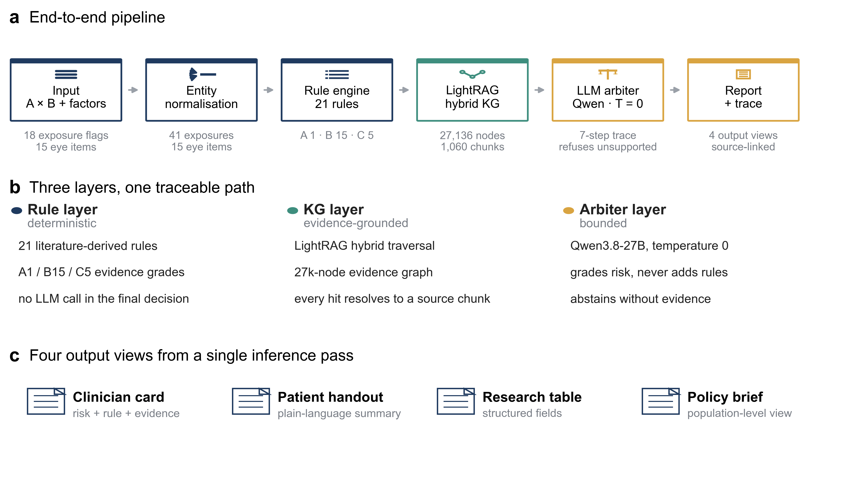
Figure 1. System architecture of Huiyan.
Figure 2
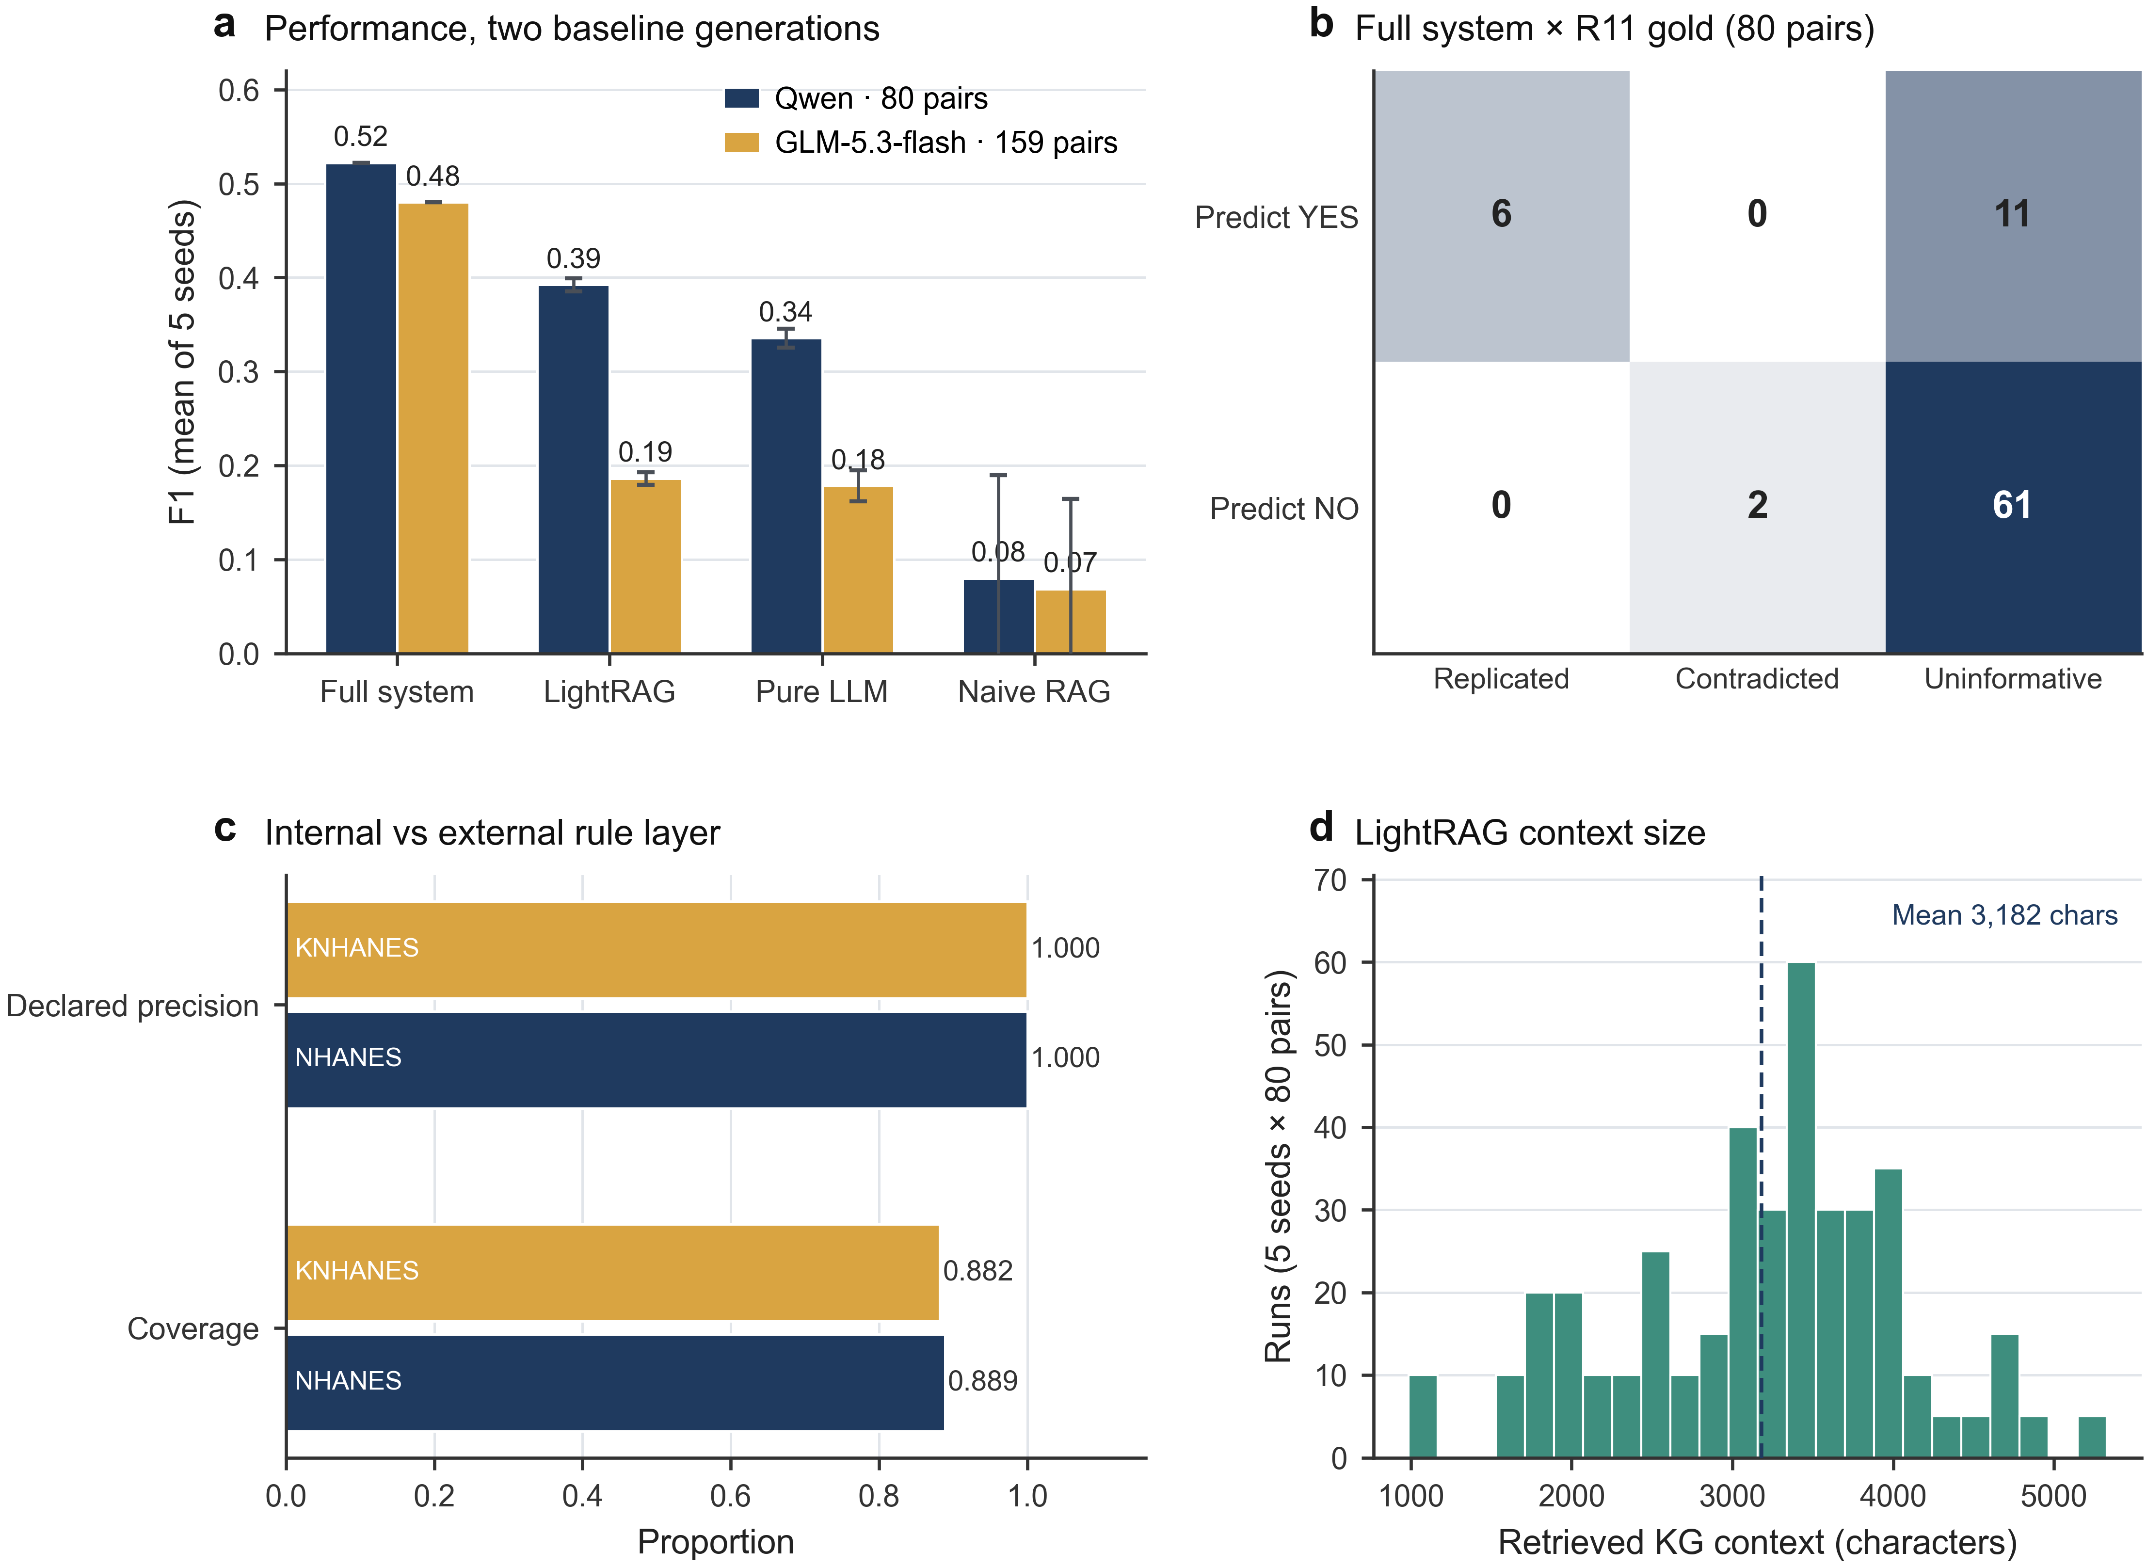
Figure 2. Huiyan (v1.2) vs three LLM baselines on NHANES pairs, in two baseline generations.
Figure 3
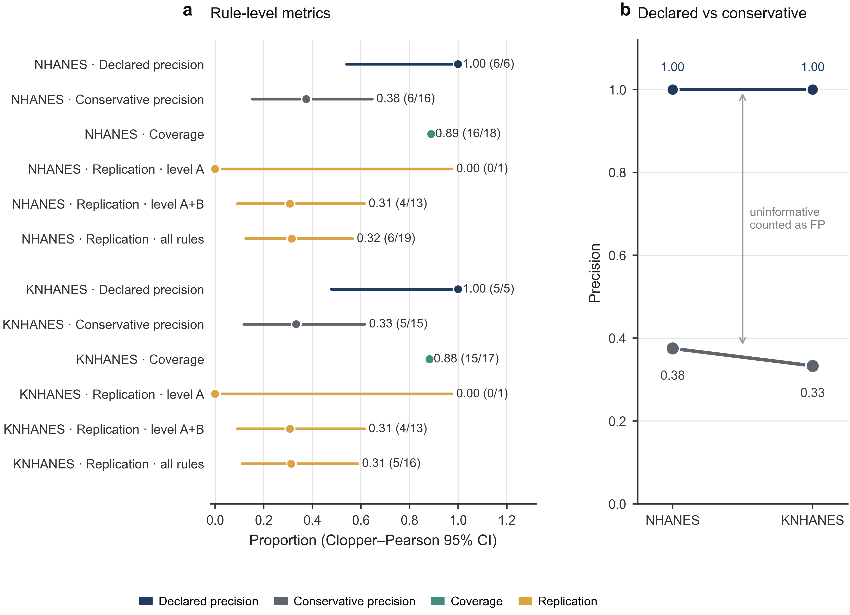
Figure 3. Rule-level evaluation under the R11 three-state protocol: precision, coverage and replication by evidence level.
Figure 4
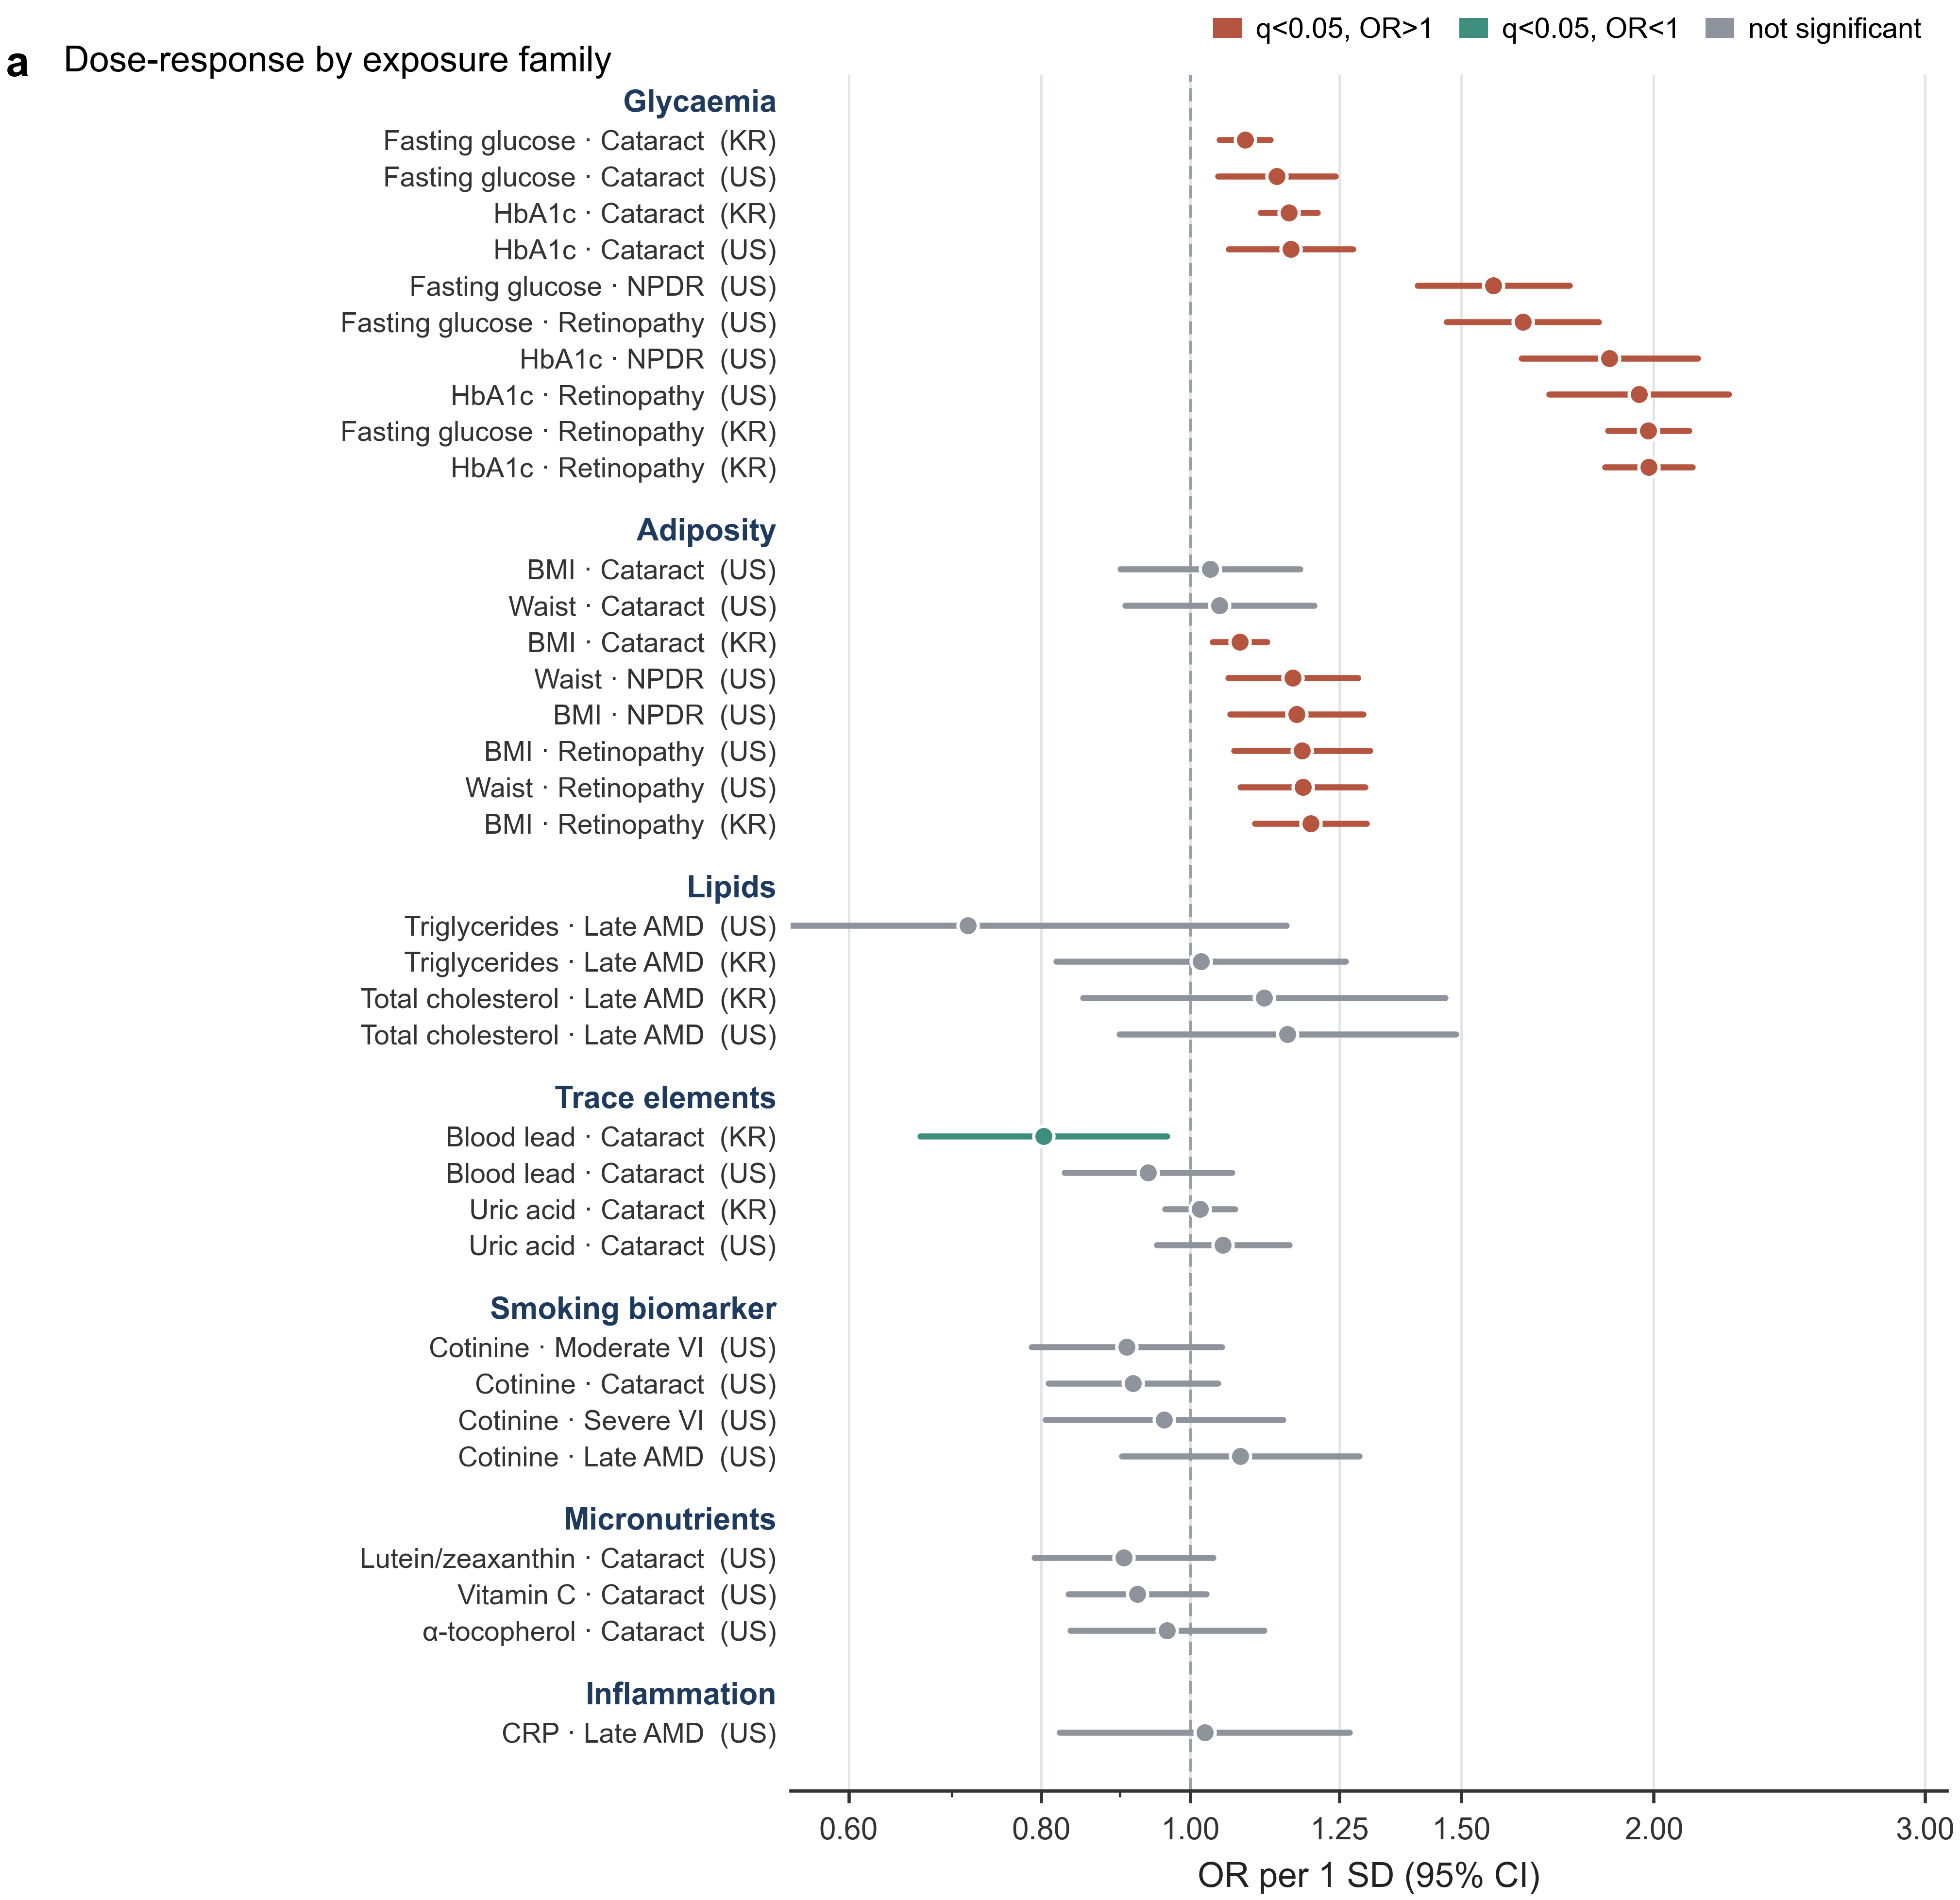
Figure 4. Continuous (per-1-SD) dose-response for rule-relevant pairs, survey-weighted.
Figure 5
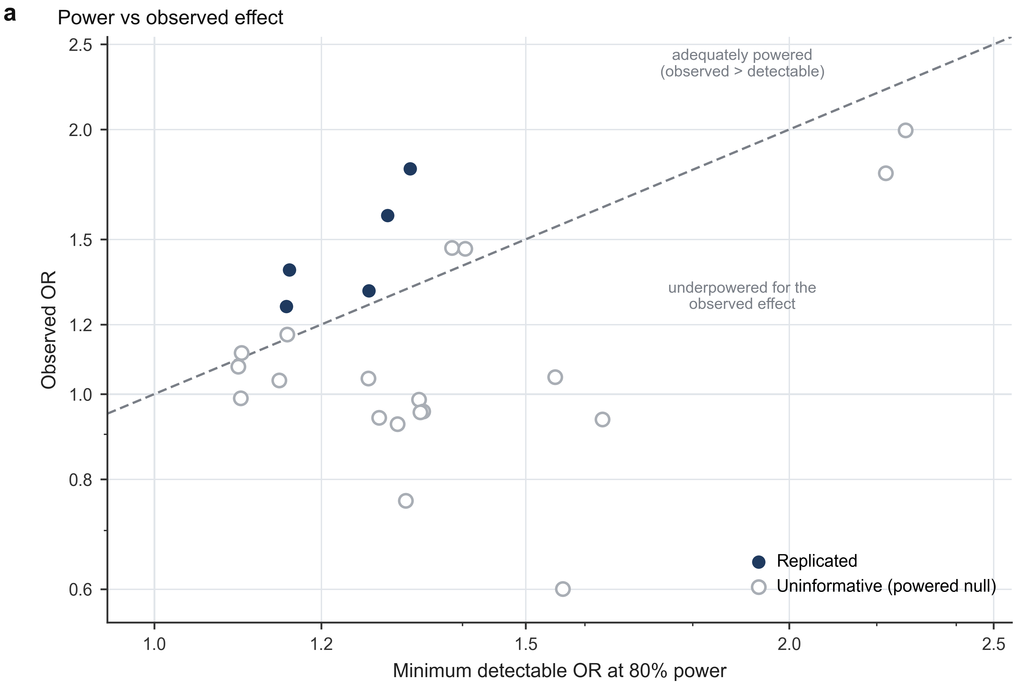
Figure 5. Power: minimum detectable OR (80%) versus observed OR for rule-relevant pairs.
Figure 6
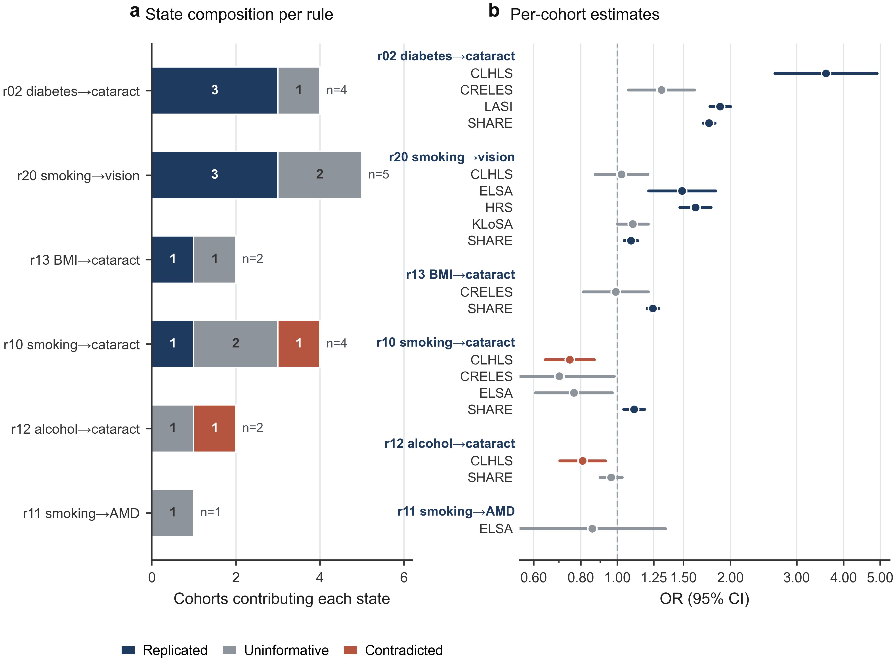
Figure 6. Cross-cohort transportability of the literature-derived exposome rules across eight ageing cohorts.

