1收藏表单：

sudo mysql -u root –p

mysql> use hello_mysql;

mysql> create table collect(id int auto_increment primary key,

-> collect varchar(40));

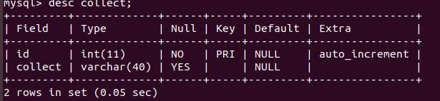

mysql> insert into collect(id,collect)

-> values(1,"11"),(2,"22"),(3,"33"),(4,"44");

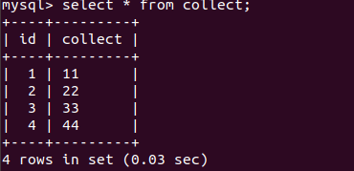

mysql> delete from collect where collect="44";

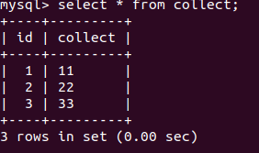

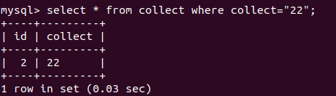

2 电影列表：

mysql> create table movie(id int auto_increment primary key,

-> name varchar(20),

-> year int,

-> director varchar(20),

-> grade int);

mysql> desc movie;

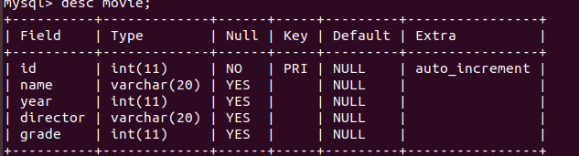

mysql> insert into movie(id,name,year,director,grade) values(1,"speed and passion 8","2017","f","7");

mysql> insert into movie(id,name,year,director,grade) values(2,"shawshank redemption","1994","frank","9.6");

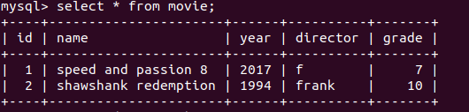

mysql> select * from movie where name like "%speed%";

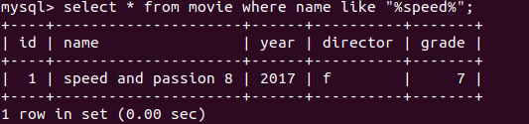

mysql> select * from movie where director like "frank%";

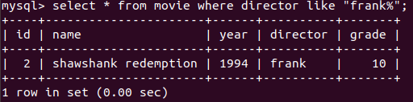

mysql> select * from movie where year="2017";

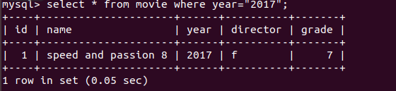

mysql> select * from movie where grade in(select max(grade) from movie);

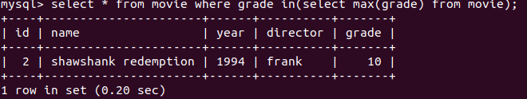

3.锄禾：

<!DOCTYPE **html**>  
<**html lang="en"**>  
<**head**>  
 <**meta charset="UTF-8"**>  
 <**title**>title</**title**>  
</**head**>  
<**body**>  
  
<**p**>《锄禾》</**p**>  
<**br** />  
<**p**>锄禾日当午</**p**>  
<**p**>汗滴禾下土</**p**>  
<**p**>谁知盘中餐</**p**>  
<**p**>粒粒皆辛苦</**p**>  
</**body**>  
</**html**>

4静夜思

<!DOCTYPE **html**>  
<**html lang="en"**>  
<**head**>  
 <**meta charset="UTF-8"**>  
 <**title**>title</**title**>  
</**head**>  
<**body**>  
  
<**p**>《静夜思》</**p**>  
<**br** />  
<**p**>床前明月光</**p**>  
<**p**>疑是地上霜</**p**>  
<**p**>举头望明月</**p**>  
<**p**>低头思故乡</**p**>  
</**body**>  
</**html**>