创建购物车表

whl@ubuntu:~$ sudo mysql -u root –p

mysql> use hello_mysql;

mysql> create table sc(id int auto_increment primary key, love varchar(30), dr varchar(30), wish11 varchar(20));

Query OK, 0 rows affected (0.32 sec)

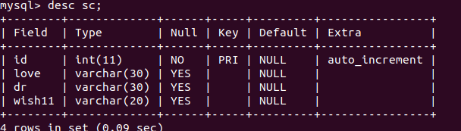

mysql> insert into sc(id,love,dr,wish11)

-> values(1,"niche","lap","lap2");

Query OK, 1 row affected (0.14 sec)

mysql> select * from sc;

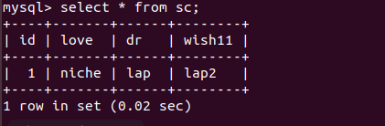

mysql> insert into sc(id,love,dr,wish11) values(2,"cute","12","23"),(3,"beautiful","34","56");

Query OK, 2 rows affected (2.33 sec)

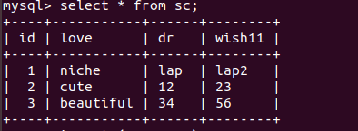

mysql> update sc set wish11="99" where wish11="23";

Query OK, 1 row affected (0.42 sec)

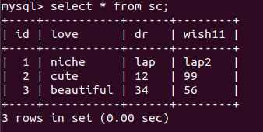

mysql> delete from sc where love="cute";

Query OK, 1 row affected (0.11 sec)

