1题：

openstack domain create InsightTech

openstack group create --domain InsightTech Operation

openstack user create --domain InsightTech James

openstack group add user Operation James

2题：

openstack project create proj-out

openstack role create outer

openstack suer create --project proj-out thomas

openstack role add --project proj-out --user thomas _member_

openstack role add --project proj-out --user thomas outer

4题：

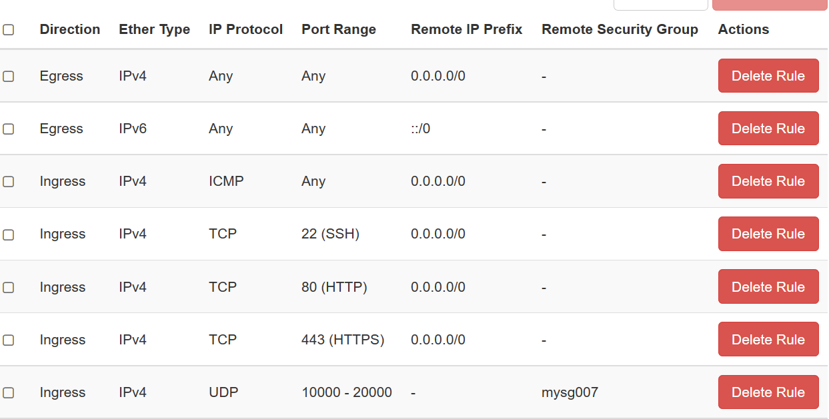

5题：

openstack image create --disk-format qcow2 --file /resources/tiny.qcow2 tiny2017

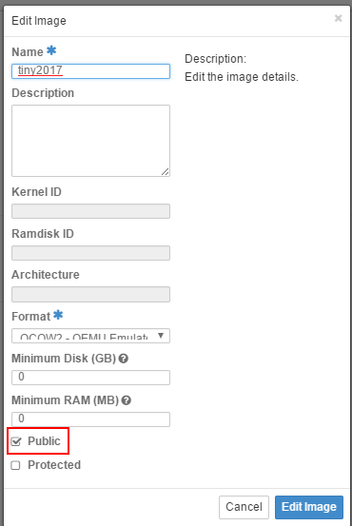

openstack image create --disk-format qcow2 --file /resources/all.qcow2 webimg

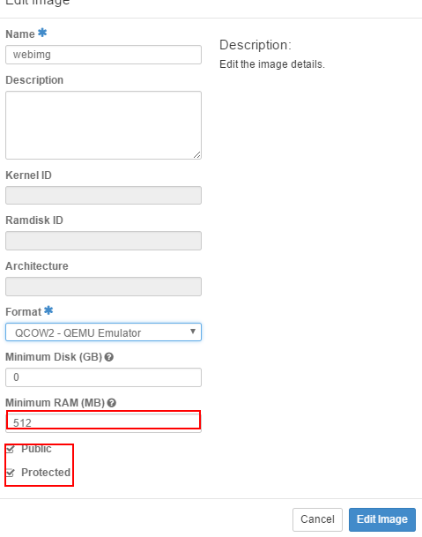

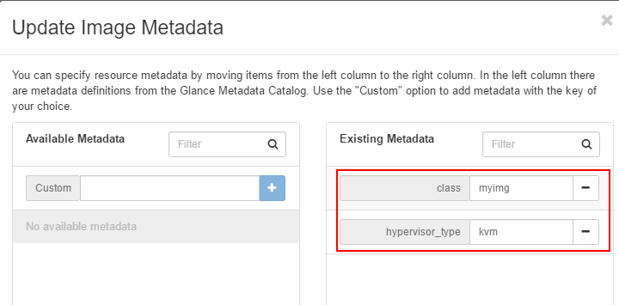

扩展题：

cp openrc jhonrc

vim jhonrc(修改用户名和project)

source jhonrc

openstack volume create --image 4 test(必须用命令行报错，才会有log)

cat /etc/hosts（获取cinder 的ip地址）

ssh到cinder的ip地址

cd /var/log/cinder/

cat api.log(复制log 粘贴到题目规定的文件里，根据关键字'cinder.volume.flows.api.create_volume.ExtractVolumeRequestTask;volume:create')

7题：

二代命令

heat stack-create -f /resources/single.yaml -e /resources/env.yaml stack

三代命令

openstack stack create -f yaml -t /resources/single.yaml -e /resources/env.yaml test