IHE Work Item Proposal (Detailed)

# Proposed Work Item: Structured Data Capture

Proposal Editor: Evelyn Gallego, Vijay Shah, & Hector Cintron

Work item Editor: Evelyn Gallego, Vijay Shah, & Hector Cintron

Date: October 25, 2013

Version: 1.0

Domain: Quality, Research and Public Health

**Summary**

With electronic health record (EHR) adoption rising globally the volume and detail of information captured by healthcare organizations and providers is growing exponentially. A Structured Data Capture profile will provide uniformity across EHR systems in regards to how data is captured, stored and retrieved.

Through a Structured Data Capture profile, a secure method for RFD would be utilized along with additional Common Data Element (CDE) guidance and Meta-model for Framework Interoperability (MFI) form compliance.

SDC has developed an extensive Use Case document, identified national standards for the structure of CDE’s and forms, developed guidance to assist in implementation and prepared pilots for evaluation of SDC.

An IHE profile is intended to provide implementation guidance for a set of standards from disparate sources. SDC will build upon the RFD base standard and as a profile could reference or be referenced by other IHE profiles, white papers or supplements.

1. **The Problem**

*Summary:* The utility of Electronic Health Record (EHR) data for supplemental purposes has been limited due to a lack of uniformity in the terminology and definitions of data elements. This limitation is compounded by the fact that clinician workflow often records patient information in unstructured free-text data well after the episodes of care. Linking EHR data with other data in a uniform and structured way will accelerate quality and safety improvement, population health and research. The consensus-driven community wants to reuse and provide additional constraints on IHE RFD for the Use Case described, as has been done before with CRD..

Structured Data Capture needs a Content Profile that defines a secure RFD and profile. The profile will define the structure for Common Data Elements that will be used to fill the specified forms or templates, the structure or design of the form or template (container), how EHRs interact with the form or template and auto-population of a form or template. This will expand on the RFD Profile by defining a secure RFD (transactions and auditing) as well as profiling definitions of a Form instance, for submitting completed Form Data, and for Data Element to Form Element mapping.’

The infrastructure will consist of four new standards that will enable EHRs to capture and store structured data leveraging defined standards and formats. These will consist of:

* A standard for the CDEs that will be used to fill the specified forms or templates;
* A standard for the structure or design of the form or template (container);
* A standard for how EHRs interact with the form or template – reusing/constraining RFD;
* A standard to enable these forms or templates to auto-populate with data extracted from the existing EHR.

*Value Statement:* The [Structured Data Capture (SDC) Initiative](http://wiki.siframework.org/Structured+Data+Capture+Initiative) focuses on the functionality and interoperability required to allow a Provider to retrieve a form, auto-populate data within the form, enter additional data into the form, store the additional data as part of the patient record (when functionality is implemented in the EHR system) and transmit the form to an external data repository in a standard format. The standard format could be used as a means to provide data to End-Users.

The Structured Data Capture will expand upon a natural stack that exists for Future Content Profiles needing RFD. It will provide a secure RFD (transactions and auditing) exist in one Profile. From this profile future Content Profiles using RFD need only their domain specifics.

This work will align with federal partner’s strategic objectives including ONC, NLM, AHRQ and the already existing work under the SDC initiative including a target SOAP/SAML IG to be adopted as an artifact.

# Use Cases

A Provider has identified a patient with a reportable condition.Using an existing EHR system, the Provider requests the reportable condition form electronically from the jurisdictional public health organization or entity. In the background, the EHR system sends information already collected about the patient to a forms manager. At the time of the request, the EHR indicates what archive option, if any, should be used. The archive maintains the data as read only so they are an indisputable and auditable record of the reporting. The archive may be maintained by the EHR or by an independent service in behalf of the provider. The archive option specifies information necessary to connect to the archive and may include any combination of the following: the information that was sent with the request; the form template; the form data returned after being auto-populated; and/or the form data as they were submitted.

The Provider now sees the jurisdictional public health reportable condition form inside his or her own EHR system. Conveniently, most of the data are already auto-populated in this form.The Provider verifies the auto-populated data, adds any missing data, and then submits the form.

The Provider receives a response that confirms that the report was submitted to Public Health electronically and received by the public health information system. If an archive option was specified then the response also confirms that the requested archive was created. A week after the report was made a question arises regarding the report. The provider is able to access the archived data (subject to appropriate security and confidentiality constraints) to document the submission; review the submission; and/or regenerate an exact copy of the submission.

**Solution Mechanism**

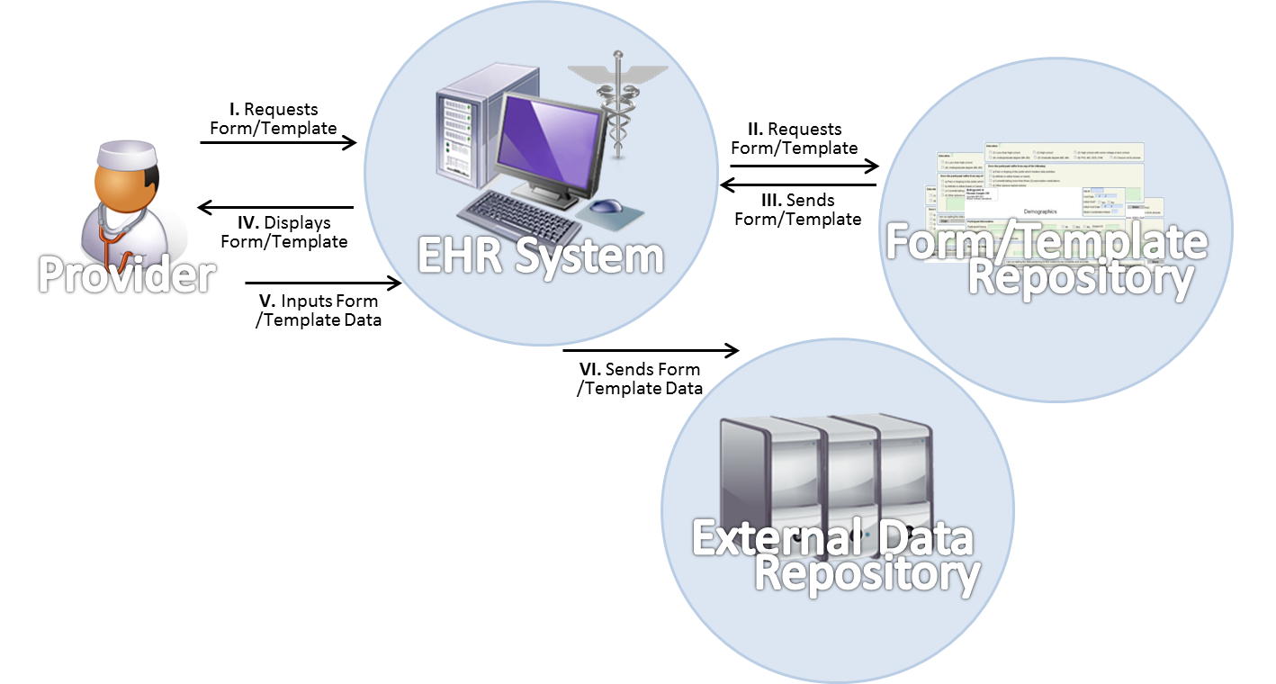

# Standards & Systems

The S&I SDC community went through [extensive standards selection process and consensus-building](http://wiki.siframework.org/Structured+Data+Capture+Use+Case+Harmonization+and+Standards+%28Implementation%29) to come to the final technical solution based on five information interchange transactions.

Content and Structure

* [XML Value Pairs](http://www.w3.org/XML/)
* [CDA Consent Directives](http://www.hl7.org/special/committees/projman/searchableprojectindex.cfm?action=edit&ProjectNumber=553)
* [ISO/IEC 11179](http://metadata-standards.org/11179/)
* [ISO/IEC 19763-13](http://www.iso.org/iso/home/store/catalogue_tc/catalogue_detail.htm?csnumber=63474)
* [IHE DEX](http://www.ihe.net/Technical_Framework/upload/IHE_QRPH_Suppl_DEX_Rev1-0_PC_2013-06-03.pdf)

Transport and Security

* IHE RFD
* [IHE ATNA](http://wiki.ihe.net/index.php?title=Audit_Trail_and_Node_Authentication)
* [SOAP](http://en.wikipedia.org/wiki/SOAP)
* [TLS v1.0 or higher](http://en.wikipedia.org/wiki/Transport_Layer_Security)
* [SAML](http://en.wikipedia.org/wiki/Security_Assertion_Markup_Language)

# Technical Approach

|  |  |  |  |
| --- | --- | --- | --- |
| **Information Interchange’s *(described below)*** | | | |
| **ID** | **System** | **Functional Role** | **Information Interchange Requirement Name** |
| II01 | Electronic Health Record System | Form/Template Requestor | Request for Form / Template |
| *II02* | *Electronic Health Record System (optional)* | *Form/Template Requestor* | *Request for form / template with relevant patient data* |
| II03 | Form / Template Repository | Sends form/template | Form/template |
| *II04* | *Form / Template Repository (optional)* | *Sends form/template* | *Form / template with populated patient data* |
| II05 | Electronic Health Record System | Sends completed form/template data | Completed form / template structured data |

Information Interchange (II’s)Form/Template Exchange (Figure 1)

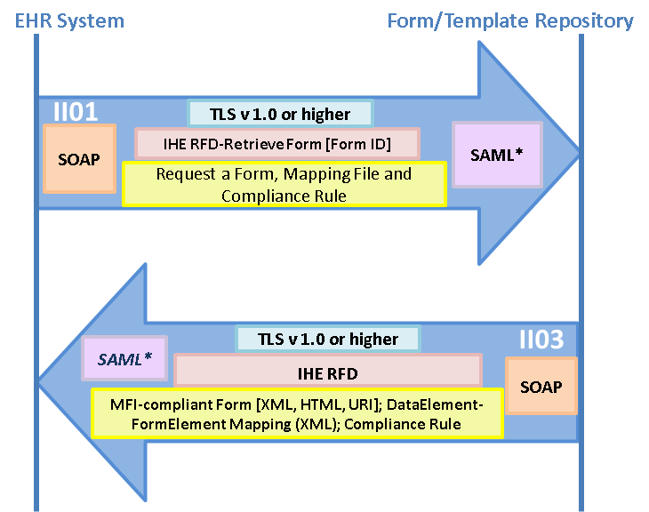

Form/Template Exchange with Patient Data (Figure 2)

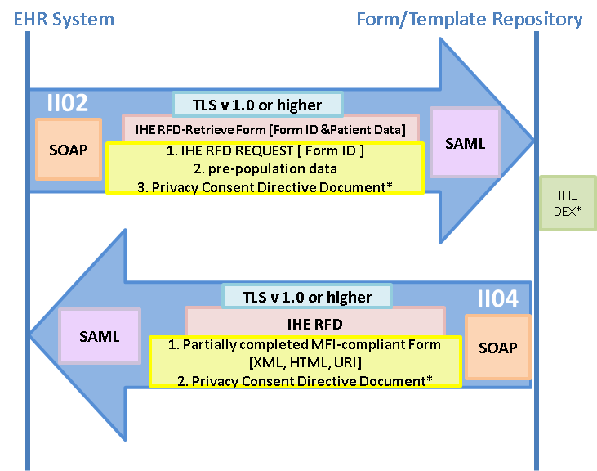

Complete Form/Template Structure Data Exchange (Figure 3)

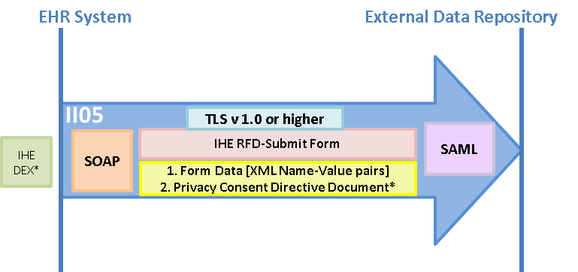

**New actors**

No new Actors

**Existing actors**

Form Filler

Form Manager

Form Processor

Form Archiver

Metadata source

Metadata consumer

**New transactions (standards used)**

No new transactions

**Impact on existing integration profiles**

Structured data capture is essentially an IHE RFD profile with added capabilities.

This content profiling raises awareness of the need to publish RFD grouped with ATNA as one profile document to be referenced by other content profiles.

For now, ATNA work will be embodied inside SDC content profile.

**New integration profiles needed**

In the future, a separate Secure RFD profile may be required.

Once such a profile becomes available, SDC content profile will reference it appropriately.

**Breakdown of tasks that need to be accomplished**

1. Specify Common Data Element definition and use
2. Specify MFI Form Model definition and related schema
3. Specify Transaction document sections and details
   1. Specify name-value pairs
4. Specify auto-population guidelines
5. Specify supporting document details
   1. Administrative Document details and sample XML
   2. MDR-Mapping Document details and sample XML
   3. Compliance Rule Document and sample XML
   4. Form Design Document and sample XML
6. Specify the grouping or binding to ATNA for all transactions
   1. Document the Audit Log messages for each transactions
7. Specify the grouping or binding to XUA (SAML assertion profile)

# Risks

One of the base standard – ISO 19763-13 (Metamodel for Form Registration) is currently going through balloting process and is expected to become Draft International Standard around June, 2014.

1. **Open Issues**

* Although, SDC profile is based on the RFD profile, it has two new components – Security and Form data. Sufficient time will be required to ensure that these components map very well to extend the base RFD profile
* Need to consider how Common Data Element (CDE) definition will be integrated within the profile

# Effort Estimates

We anticipate a moderate level of effort to develop this profile since we will be building on the current model provided by IHE RFD and most of the work will be performed as SDC Initiative under S&I Framework.

**Appendix**

Insure that IG is accurate and relevant to IHE. “Actors & Roles” section is below for general reference.

Actors & Roles

| Actor / System | Role |
| --- | --- |
| Provider / EHR System | * Identifies necessary form/template* * Inputs data into form/template* * Reviews and saves completed form/template* |
| EHR System | * Sends requests for form/template * Receives form/template * Displays form/template * Auto-populates form / template* * Stores complete form/template data* * Sends completed form/template data |
| Form/Template Repository | * Receives form/template request * Sends form/template |
| Enhanced Form/Template Repository | * Receives form/template request * Auto-populates form/template * Sends form/template |
| External data repository | * Receives completed form/template data |