vMR Big Picture Discussion/Proposal
Prepared by David Shields, Duke University
Last updated 2010-06-07

Purpose

Provide simplified and optimized data structure for CDS inputs and outputs

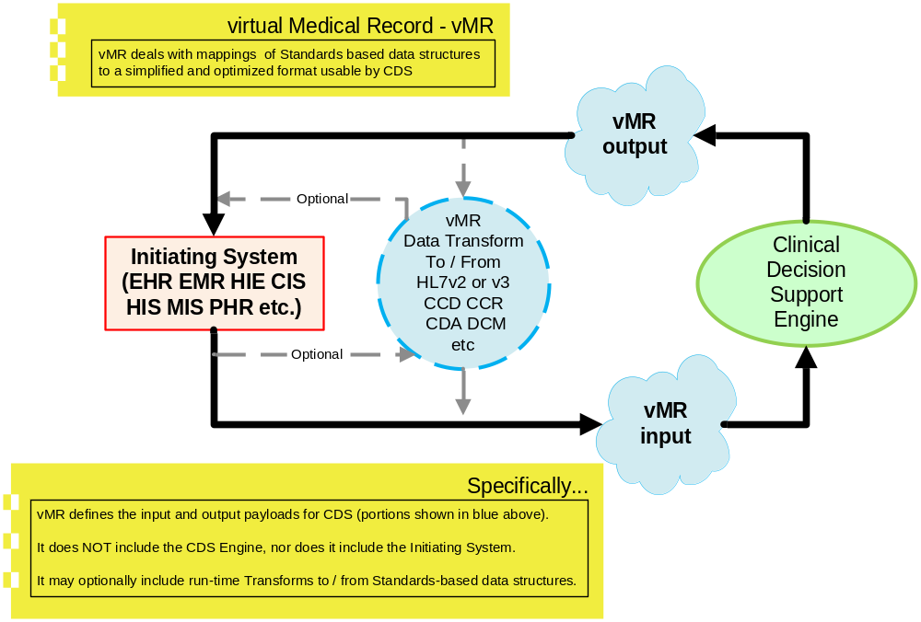

Features

Maps associated data elements from Standards-based data structures to vMR data structures, producing vMR schemas and associated mappings

Produces a defined vMR schema for each collection of associated vMR data elements

Typically, vMR data elements would include a date/time and a code as a minimum

However, in some cases, vMR data elements could get fairly complex

Each defined vMR schema should have a template Id, or similarly functioning ID, and be registered <somewhere (maybe IHE ?)>

Each vMR defined schema can be mapped from one or more Standards-based data structures, e.g.:

A single vMR schema may have mappings from any of a list of standards documents and messages, such as CDA, HL7v3 messages, HL7v2 messages, DCM, OpenEHR Archetypes, etc.

Each defined mapping is also assigned a template ID and registered <somewhere>

Mappings should be able to be “round-tripped” with no loss of semantic accuracy of the mapped data.

A standards-based schema may be mapped to more than one vMR schema (only one of which would be used for any given CDS interaction).

Example vMR target schemas mapped from the same standards-based source schema may include:

Simplified schema with just code and date

Extended schema adding associated medications, provider types, body site, etc.

Updated versions based on updated version of referenced source Standard

Mappings to patient demographic data could be as simple as an anonymized ID, or as complex as needed for particular CDS problems

Multiple Mapped vMR Segments can be combined together into a single vMR Message, as in the following example:

A simple patient mapping based on CDAr2 which only defines:
DOB
Administrative Gender

An immunization mapping based on POIZ that defines:
Vaccine code
Date of administration
Body Site
Administration Route
Vaccine Manufacturer
Lot Number

An adverse event mapping based on VAERS that defines:
Adverse Event Code
Date
Severity

The three vMR schemas above could then be assembled together, assigned a template ID for the set, and pointed to by a CDS provider and CDS consumer as a defined / named set

i.e., as what several HL7/OMG service specifications call a “Semantic Signifier”

GELLO and Arden Syntax
Properly designed vMR schemas should be mappable into GELLLO classes, or even into structures addressable by Arden Syntax, depending on the needs of the CDS Engine, and the ultimate marketplace.

Advantages

Agile
Allows creation of new mappings practically ad-hoc

No need to wait on balloted models, because in general, approach is based on models that are already balloted

Allows near immediate distribution and use of new template mappings

Whatever SDO functions as the template registry for vMR schema segments should accept any new template that meets the following requirements
Template is accurately and semantically mapped to a published standard by one of the approved SDOs, and the mapping itself is part of the registration
Template and mapping are “locked” once accepted, and cannot be changed. Updated mappings are assigned a new template ID.
Template is not a duplicate of an existing template.
Every effort is made to make new mappings go to an existing vMR schema template.

Simple
XML structures can be produced that don’t require a Ph.D. with an M.D. and 5 years of v3 experience to understand and implement

Notes:
This is deliberately an open-ended structure, designed to flexibly deal with the constantly evolving nature of medical information, and the need to be able to use new types of information quickly.

Questions and Issues:
Can we set up a mechanism for the rapid creation of Template IDs for mappings and for vMR schema as targets of those mappings?
Can we create an assembled message structure from a set of templates, and assign that message structure its own template?
Who would manage the registration of templates for the vMR schema, and for the mappings?
Other?

