Clinical Decision Support Consortium

KM Portal & Repository

CDSC KM Portal Users Guide

February, 2011

Table of Contents

Clinical Decision Support Consortium 1
KM Portal & Repository 1
CDSC KM Portal Users Guide 1
February, 2011 1
Table of Contents 2
About this Users Guide 3
About the Portal 3
Accessing the Portal 3
Accepting the “Terms of Use” 4
Initiating a Search 4
Text Search: Search Terms 5
Advanced Search: Searching by Filters 5
Date Range 5
Combining Search Methods 5
Starting Over – “Clear Selection” 6
Viewing Search Results 6
Reviewing the Results 6
Appendix: Knowledge Content on the KM Portal 8
Content Evolution: Versions and Specification Levels 8
Content Versioning 8
Specification Level 8
Derived-from 8
Content Metadata and “Filters” 9

About this Users Guide

This document is provided by the Clinical Decision Support Consortium (CDSC) which is supported by the United States government’s Agency for Healthcare Research and Quality (AHRQ).

This document:
- Provides a quick reference to the Clinical Decision Support Consortium (CDSC) Knowledge Management (KM) Portal.
- Is intended for users of the KM Portal who are seeking knowledge assets published by CDSC and who agree to the “Terms of Use” posted on the Portal.

More information on the CDSC can be found here:
http://www.partners.org/cird/cdsc

About the Portal

The Clinical Decision Support Consortium has created the KM Portal to provide wide access to clinical knowledge assets developed and published by CDSC member organizations. These assets are examples of “clinical content” developed for use in Clinical Decision Support (CDS) systems and services. This clinical content is not meant to provide clinical guidance, but instead to provide examples of the representation and development of clinical knowledge in accordance with the goals of the CDSC Consortium. Any consumer of portal content is fully responsible for their own use of CDSC KM Portal content.

Use of the Portal requires that users agree to the “Terms of Use” presented on initial entry to the KM Portal.

Clinical knowledge assets found in the portal are typically documents or files of common types including, but not limited to:
- Microsoft Office documents, spreadsheets, etc.
- Portable Document Format (PDF) files
- HTML or XML documents
- Simple text documents

Accessing the Portal

The CDSC KM Portal is freely available via the internet without the need for user registration or login credentials. Figure shows the initial entry page. Due to the nature of the clinical information available via the portal, users are required to accept CDSC KM Portal “Terms of Use” via an online form. Users must agree to the terms presented and this must be done once during each portal session. This acceptance is valid during the current session and for a limited period after the current session if the user re-enters the Portal from the same computer. User acceptance is considered to expire after a fixed period of time, and a user re-entering a portal session after expiration will be prompted to accept the terms again.

Access to the CDSC KM Portal is via this URL: http://cdsportal.partners.org/

Users can access the CDSC KM Portal from Internet Explorer browser version 6.0 and later. While not officially supported, other browsers including Firefox and Safari have been used successfully to access the portal.

Users are not able to search the portal prior to accepting the Terms of Use, but may view the general information available via the tab bar across the top of the KM Portal.

Accepting the “Terms of Use”
On initial entry to the KM Portal the user is presented with the “Terms of Use” agreement. The home page and the top of the Terms of Use are shown in Figure 1 below. Users are encouraged to read and understand the Terms of Use, and must agree to these terms by clicking on the “Agree” button in order to proceed. Clicking on the “Decline” button brings the user to the “Contact Us” page. From here the user may either submit a message to CDSC Support, or choose another action by clicking on another button in the top navigation bar.

Figure 1: Entry to Portal - Acceptance of Terms
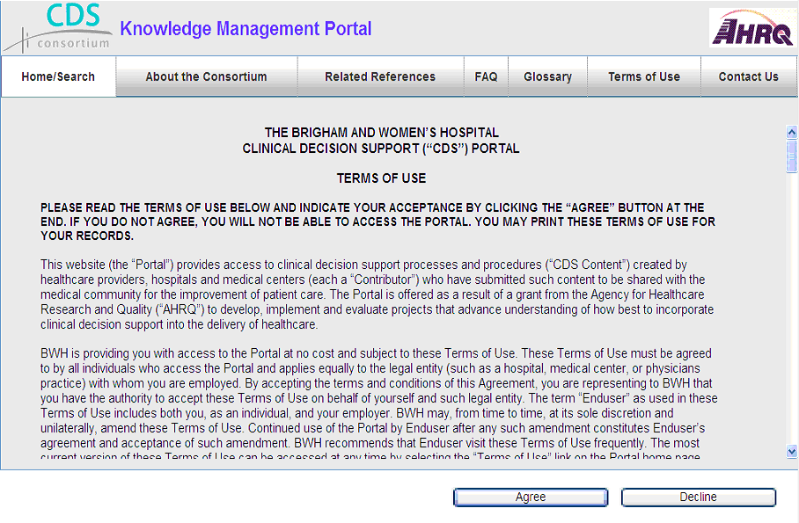

Initiating a Search
The CDSC KM Portal supports searching for content by different methods. Figure 2 below shows the initial search page.

- Text search - finds knowledge assets (content) that contain specific text (“Search Terms”) entered by the user.
- Advanced Search - finds content that has been tagged during the publication process with values that categorize the content.
- Date Range - a range of dates can be provided to limit the results returned from the search.

Figure 2: Initial Search Page
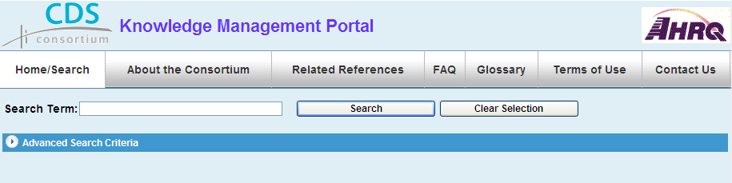

Text Search: Search Terms
Users may search for content containing specific text by entering the text in the “Search Term” box and then clicking on Search button or pressing the Enter key. The CDSC text search is implemented using the “Google Appliance”, so it operates like a Google search. It will return either a list of results or it will display this message: “There are no matching records”. The format of results page is described below in the ”Viewing Search Results” section.

Advanced Search: Searching by Filters
The Advanced Search (also called “Search by Filter”) capability is accessed by clicking anywhere along the horizontal “Advanced Search Criteria” bar. Prior to being published to the CDSC Portal, each content item has been ‘tagged’ with values that define the nature of the content. These values are also called content “metadata” or “data about data”. Figure 3 below shows the content filters that are available for advanced searching.

Users may select one or more values in one or more of the available filters to restrict the search results. Within a filter (such as “Specification Level”) the standard Microsoft conventions of “Control-Click” and “Shift-Click” are used to make multiple selections of individual or grouped items, respectively. Clicking on the “Search” button initiates the search, and the results are displayed.

Figure 3: Advanced Search Page
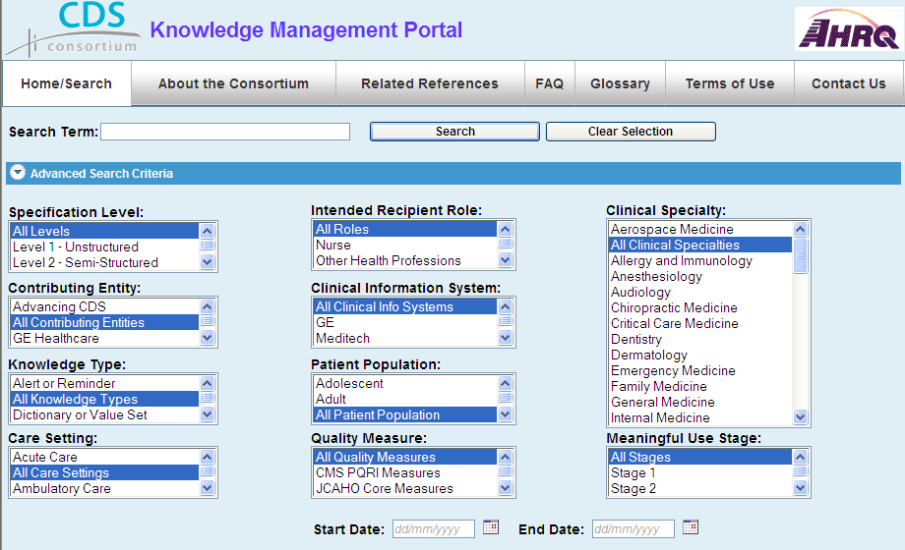

Date Range
A date range may be selected via the “Date From” and “Date To” fields in the lower right hand corner of the Advanced Search area. The content items’ “Last Modified Date” is used as the basis for this criterion.

Combining Search Methods
The text and filter search methods may be used independently or together. When used together, the method entered first produces an initial result set and then second method narrows the initial result set.

Starting Over – “Clear Selection”
The “Clear Selection” button must be clicked after a combined search to initialize the system for a new search.

Viewing Search Results
Figure 4 below shows a partial list of results from a search. The results are listed in table format and may be sorted by clicking on any of the four column headings. The column headings are:
- Title
- Specification Level
- Contributing Entity
- Knowledge Type

Figure 4: Search Results List
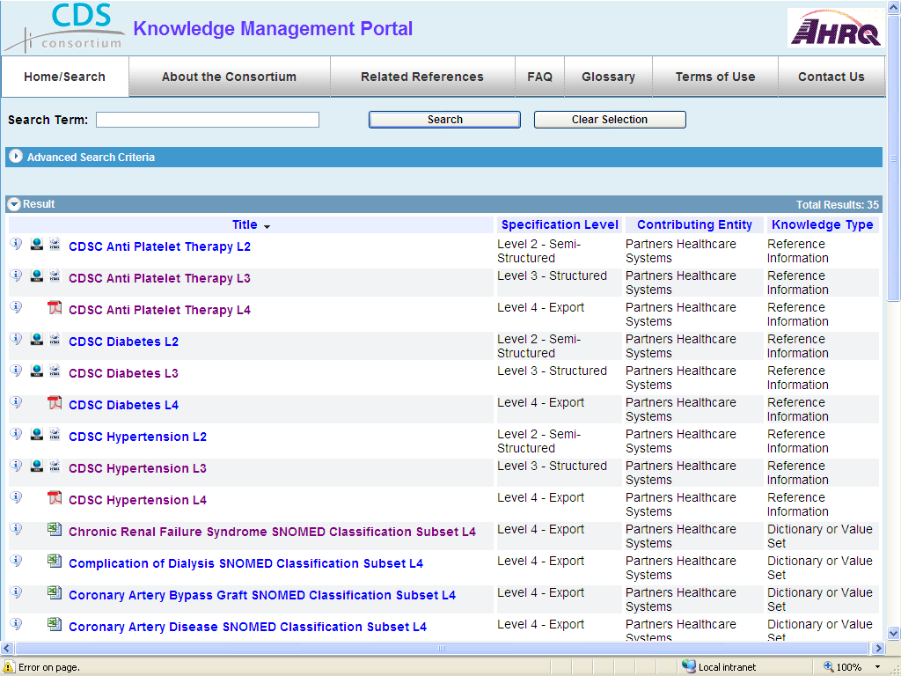

Reviewing the Results
To the left of the returned items, you may click on the different icons. For example, the Information button may be used to show more details (or metadata) about the item as shown in Figure 5 below. The document in the screen shot is Level 2 content which was derived from Level 1 content. The Derivation history is found in the “Derived-From” section of the content details.

Each item may be opened and downloaded by clicking on the document title. If there is only one format for the item, then it will open in that default format (Excel, PDF, etc.). If the item can be opened in multiple formats (Excel, PDF, HMTL, XML, etc.), then those icons will be displayed right after the Information button. The default format (HTML) will be displayed when you click on the title. An alternate format may be displayed when you click on that image (e.g., XML).

Figure 5: Search Results Details
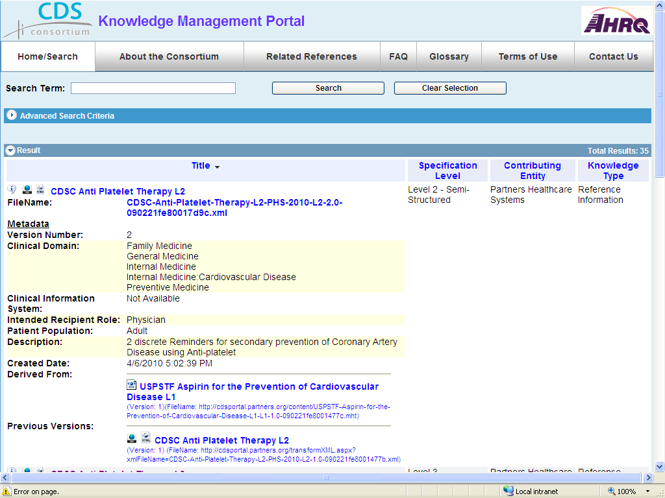

Appendix: Knowledge Content on the KM Portal
This section provides more detailed information on content within the KM Portal, particularly the metadata used to categorize content.

The KM Portal is the source for retrieving clinical knowledge content – also called clinical “knowledge assets” or “knowledge artifacts” – made available by the CDS Consortium. Knowledge artifacts are imported or developed by the consortium and published, when ready, to the KM Portal.

Content Evolution: Versions and Specification Levels
CDS Content evolves in two ways. It is important to understand this evolution in order to search effectively for content.

Content Versioning
Any knowledge asset may be modified for a variety of reasons such as the inclusion of new information or to provide greater clarity. Each re-publication of a modified asset results in a new, numbered version of that asset. Version numbering is based on whole integers starting at 1. All content versions are available via the portal, but the latest version is the default version returned from a search. Previous versions may be identified and accessed after clicking on the Information button on the search results page (see Previous Versions).

Specification Level
A research goal of the CDS Consortium is the translation and specification of knowledge expressed both in human readable form and in a form suitable for web services implementation. The CDSC has defined 4 levels of knowledge specification, from Level 1, “Unstructured” (human readable) through Level 4, “Executable”, which could potentially be fed into a clinical decision support system. There are 4 types of a Level 4 specification.

Each knowledge asset is tagged with a value that defines its position along this evolutionary line, or “Specification Level”:
- Level 1, Unstructured
- Level 2, Semi-structured
- Level 3, Structured
- Level 4, Description – of an existing Clinical Information System (CIS)
- Level 4, Executable – by a CIS
- Level 4, Exportable – to a spreadsheet, for example
- Level 4, Illustration – of a existing system, for example

Derived-from
As content evolves from one Specification Level to the next, it is important that more-evolved content (i.e., with a higher Specification Level) be traceable to the less-evolved specification on which it is based. The ‘derived-from’ metadata item provides a place for content authors to indicate the (lower-level) content from which a piece of content is derived.

The ‘derived-from’ value, if available, is displayed in the detailed view of the results page, but is not itself a filter for search.

Content Metadata and “Filters”
The CDSC Portal offers users a set of filters, described in Table 1, to narrow down the knowledge assets returned in a portal search.

Table 1: Content Metadata Filters
Metadata Item | Information / Constraints
Care Setting | The location or clinical setting identifies the context in which the content may be used.
Clinical Domain | Represents one or more medical specialties to which this content applies. Examples include Anesthesiology, Surgery, etc.
Clinical Information System | The clinical information system to which a level 4 content asset applies. The content may be executable by or importable to that system, descriptive/illustrative of that system, or exportable from that system.
Content Type | Examples of content type include: Order Set, Reference, and Reminder.
Contributing Entity | Represents the CDSC member organization that is providing this content.
Date From… To | Represents a date range that restricts returned results based on the date of last modification of a knowledge asset.
Intended Recipient Role | Type of consumer for which this content is oriented, for example: nurse, patient, physician, pharmacist.
Meaningful Use Stage | Indicates that the content relates to the requirements of a specific stage of Meaningful Use requirements.
Patient Population | Represents one or more age categories to which this content applies. The value ‘all’ is selectable and indicates that all other categories apply.
Quality Measure | Indicates that the content is consistent with specific measures.
Specification Level | Every content asset is assigned one specification level, according to the description provided above.

