Transformation of a UML logical model into one that is more “database-friendly”

Consider the model below. It has two features that are “unfriendly” to relational databases: a) a generalization between supertype and a subtype (aka inheritance), and b) complex datatypes. The example has one generalization, and several complex datatypes.

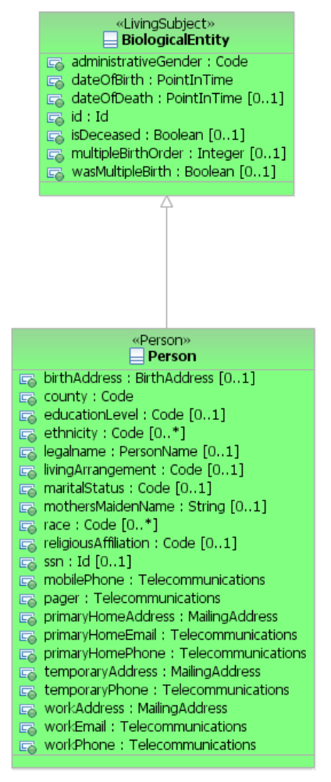

First, we run a script to “flatten” the generalization. There are four patterns that can be used for this task, as described by Martin Fowler in Analysis Patterns. We annotate the supertype to inform the script which pattern to use.

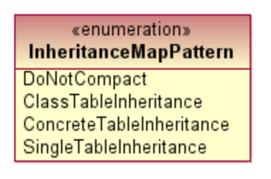

In this case, we use the Concrete Table Inheritance Pattern. This pattern produces the following:

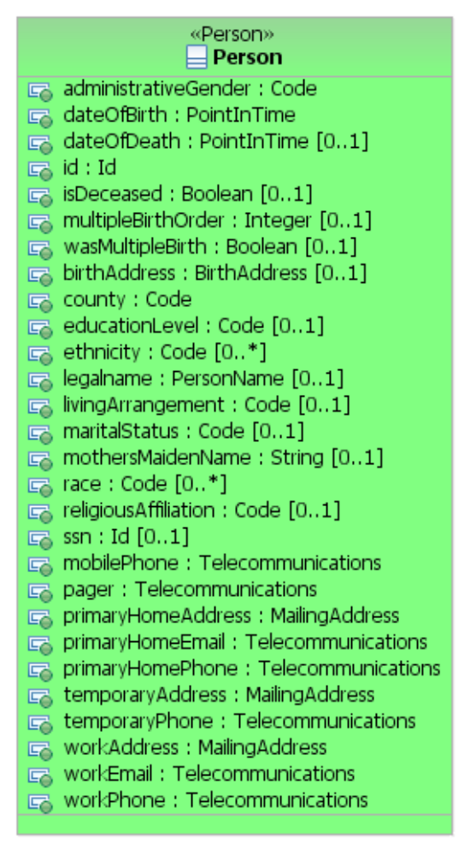

Note that the seven properties that were in Biological Entity have been copied into Person. So now we have a single class that could correspond to a single table in a database.
The next phase is to convert the complex datatypes in to simple datatypes suitable for a database table. There are seven datatypes in this example, in order of appearance: Code, PointInTime, Id, BirthAddress, PersonName, Telecommunications, and MailingAddress.

Before transforming these types, a series of substitutions needs to be performed. The Code and Id datatypes are abstract, and are not meant to be implemented directly. They are just placeholders so that modelers and subject matter experts can see that the concept should be represented by a kind of a code or a kind of id. Precisely which kind of code or id depends in part on the target platform (e.g., internal VA, HL7 v2, HL7 v3, etc.) and on the concept itself.

Similarly, the PointInTime datatype will also be substituted with another datatype depending on the target platform, and on whether or not the date might need to be able to accept “imprecise dates”.

In all three cases, the transformation logic is informed of the proper substitution to be made using additional metadata contained in the application of a UML Profile to the model. The UML Profile (in part) looks like this:

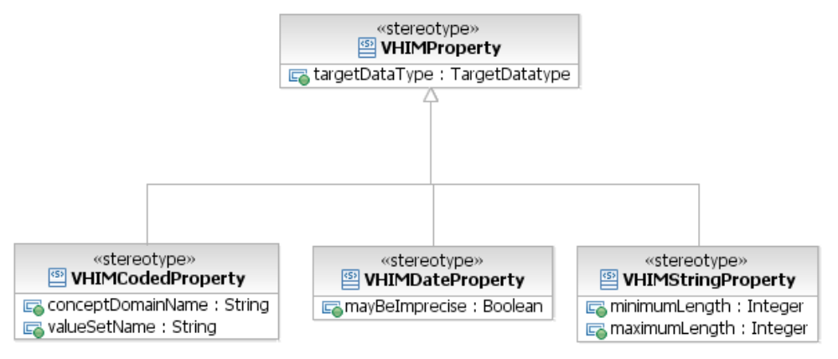

In the case of Code, we can substitute one of about forty possible “flavors” of code for the abstract Code datatype. Three of these “flavors” are shown below:

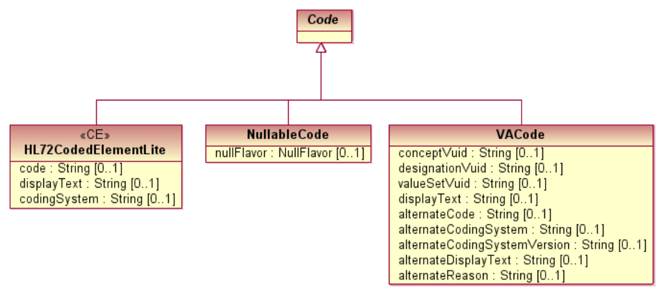

For example, in the screenshot below we applied the VHIMCodedProperty stereotype (green oval) to the administrativeGender (red oval) property of the Person class. Notice that there are three fields that can now be populated (turquoise oval). These fields are the same ones that are modeled in the UML Profile model above (see the VHIMCodedPropery class). One of these is the target data type, which, because it is an enumeration, is actually a pull-down list. In this case, we chose to represent the administrative gender with an HL7CodedElementLite structure. In other words, we are choosing which “flavor” of code that will be substituted for the abstract Code datatype through this mechanism.

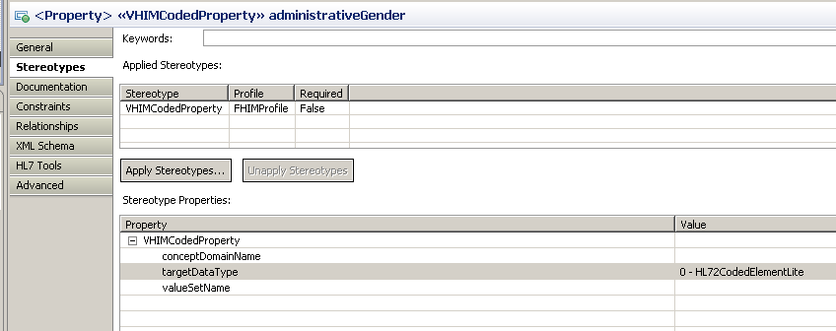

A similar process is followed for Id datatypes. For PointInTime datatypes, we would generally (depending on the platform) transform these into date/time stamps if the dates cannot be imprecise, or strings if they can be imprecise.
For the sake of simplicity, this illustration converts all Codes to HL72CodedElementLites, all Ids to HL73Ids, and all PointInTimes to dateTimes. It is noted that in real transformations, some codes might be transformed into one kind of flavor, while others might receive other flavors, depending on the nature of the particular data element.

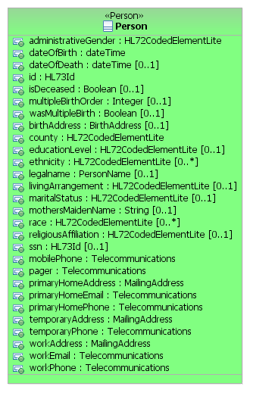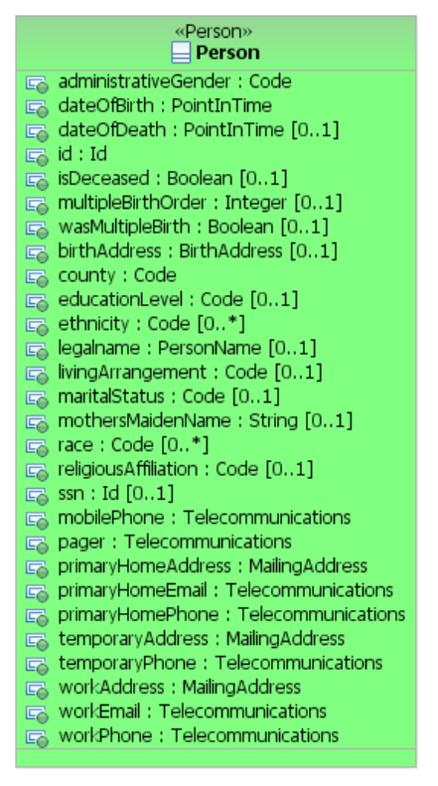

Finally, we expand the complex data types. The complex data types look like this:

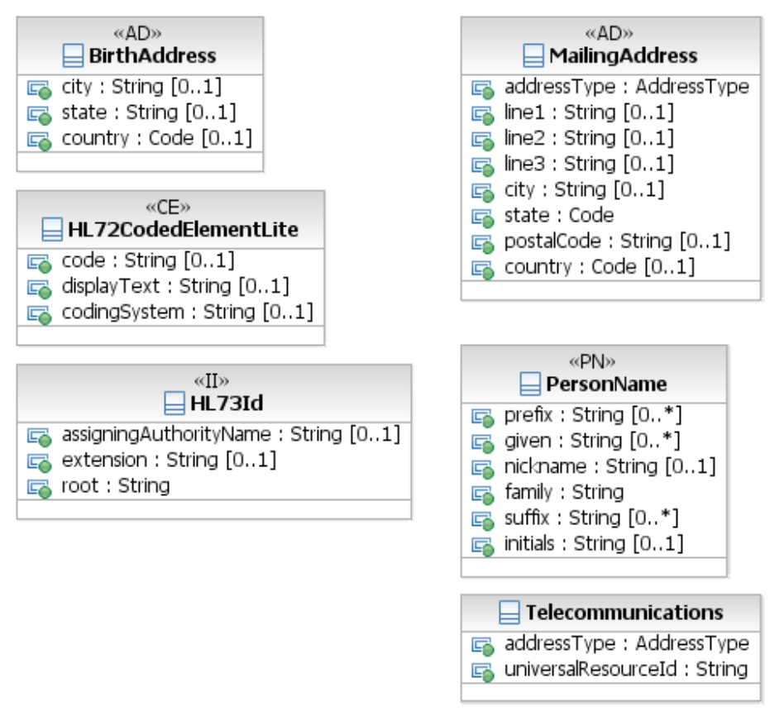

The transformation walks through each property, and if the datatype is complex, replaces that property with however many properties exist in the complex data type. This process is recursive, so if the complex datatype contains properties which themselves have complex datatypes, they too are expanded, until every property is a primitive type. In order to avoid name collisions, the name of the new property is the original property name plus the data type property name. For this illustration, an underscore separates the property name parts. This style could easily changed to reflect a different style as desired.

The resulting class is shown below. This structure is far more “database friendly” than the original one. Upon examination, there are repeating groups that might be more efficiently placed in other tables, such as the addresses and phone numbers. It would possible to do so using a script similar to the one that combined the subtype into the supertype.

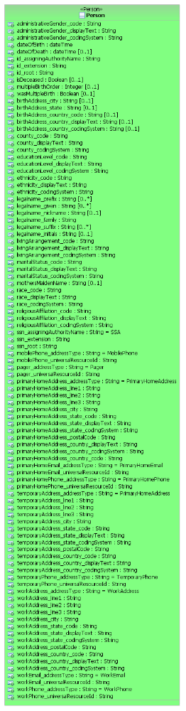
An additional item to note is the use of the Address Type codes. The VHIM uses a style that is a hybrid between the opposing design paradigms where either there is a structure with a piece of data and a type code to classify it, or each possible type is fully identified. For example, persons have identifiers, and the Person class above has a generic Id property, where the type of Id is known from the assigning authority. Nearly all persons in the United States has a Social Security Number, and it is a useful construct to name that identifier as a stand-alone property in the Person class. Not only does it make clear that the ssn property is to be used for Social Security Numbers, but it also makes clear that each Person should have one. The construct of having a generic id property where one of those ids might be an SSN leaves open to chance that none of the ids is an SSN.

So the VHIM Person class has a generic Id property which can handle any number and kind of ids*, and an ssn property that is specifically supposed to handle an SSN id. Similarly, the address and telecommunications datatypes have an address type code property to define what kind of address it holds. But the VHIM Person class calls out specific kinds of addresses such as work phone, home email, temporary (mailing) address, etc. Therefore, there are two mechanisms being employed to tell us what kind of data is in the property: a) it is a named property, and the name and definition of the property define the usage; or b) it is a generic property and the type code in the datatype defines the usage. Because of this, a mechanism must exist to convert from the one to the other. For example, the workPhone property (the last property in the original Person class) is transformed into two properties: workPhone_addressType and workPhone_universalResourceId. The workPhone_addressType is set to “WorkPhone”. This is done by setting metadata in the original Person class that instructs the transformation to set the appropriate address type.

*It is noted that the Person class contains some attributes which may repeat, among them the id property. In addition, some properties that are 0..1 have complex datatypes which have members that may repeat, for example, the given name in a person’s name is an ordered list of names. This transformation illustration did not attempt to resolve all such instances. A truly “database-friendly” version of the model will require another transformation (which might be fully automated or which might require manual intervention), in order to resolve this remaining aspect of the model.

