The EOC Data Model (v1.0)

D. Riaño

Research Group on Artificial Intelligence

Universitat Rovira i Virgili

Tarragona (Spain)

http://banzai-deim.urv.net

24 November 2010

Abstract
The Episode of Care (EOC) Data Model defines a structure of the data used by the Research Group on Artificial Intelligence of the Universitat Rovira i Virgili, in Tarragona (Spain). It is based on the concept that the whole treatment of a patient for a particular ailment (comorbidities are also considered) defines an episode of care that is composed of one or more encounters. Each single encounter is an appointment between the patient and a health care professional with the purpose of diagnosing, adjusting the treatment, performing a follow up, or discharging the patient. During an encounter several descriptors of the condition of the patient are captured, together with the professional measures taken (prescriptions, consultation orders, analytic requirements, starting procedures, recommendations, etc.).
This document provides a formal structure to represent all this information for computer exploitation of the data captured of several health care centers.
- Introduction
An Episode of Care (EOC) is defined as the actions performed to deal with a health problem from its first encounter with a health care provider through the completion of the last encounter [1]. A distinction can be made between the first encounter (i.e., admission), the last encounter (i.e., discharge), and the rest of intermediate encounters. This distinction can be seen in Figure 1.
…
ADMISSION
DISCHARGE
encounter 1
encounter n
encounter 2
encounter 3
encounter n-1
- Episode of care as a sequence of encounters.
All these encounters describe the interaction between the patient and some health care professional (e.g., family doctor, specialist, nurse, etc.) in a particular date and time. In the encounter, for each one of the comorbid diseases of the patient, the patient provides information describing his current condition (e.g., signs), the health care professional observe some additional information (i.e., signs and symptoms) and some anamestic information is searched in the Electronic Health Record (EHR) of the patient (e.g., current treatment, patient history, family antecedents, etc.).
All this information provides a concrete description of the current condition of the patient and it allows the health care professional to recommend some evidence-based health care actions for each one of the patient diseases. In some sense, the recommended actions should be supported by some of the information gathered during the encounter.
During the first encounter, the date is not only the date of the encounter, but also the date when the EOC starts. During the last encounter, the date is the EOC closing date.
- The EOC Data Model
The information that is managed during the EOC process described in section 1 can be structured in many different ways. Here, I provide the modeling of this information according to some specific formal structures that are the foundations for the development of multiple Artificial Intelligence techniques developed within the Research Group on Artificial Intelligence at Universitat Rovira i Virgili (Spain) to manage health care knowledge.
The model is based on the following elements:
- Health care terms
- Morbidities and Comorbidities
- Time and Identifiers
- Decisions and Actions
- Episodes and Encounters

The Space of Terms
The lower level of the EOC Data Model is the space of terms. These terms are the linguistic expressions of all the health care concepts that can be used in the description of an EOC.
Terms can be structured in hierarchies of concepts like SNOMED [2] or in specific health care coding systems as ICD10-CM, ATC, etc.
In the model, these terms are used to describe the patient condition and the actions recommended in the encounters.

Morbidities and Comorbidities
The EOC Data Model is used to represent the health care actions performed on a heterogeneous set of patients, each one dealing with a particular set of diseases. Therefore, EOCs can be (mono)morbid or comorbid.
A (mono)morbid EOC contains all the information used during the management of a patient with one single disease (e.g., hypertension).
Alternatively, a comorbid EOC describes the information used in the management of a patient for which several diseases coexist (e.g., hypertension and diabetes). This kind of EOCs is very common in patients with chronic diseases.

Time and Identifiers
In the EOC Data Model there are several concepts that require a time stamp representing the moment when that concept happened. The current version of the EOC Data Model has three sorts of time stamps: the start date and the end date related to an EOC, and the date related to an encounter.
The start date related to an EOC describes the admission date (and time) of the patient in that EOC. That is to say, the moment of the first encounter in the EOC.
The end date related to an EOC describes the discharge date (and time) of the patient in that EOC. It is equivalent to the moment of the last encounter when the EOC is closed, but it is unknown while new encounters are still possible.
The date related to an encounter describes the day (and time) when the encounter took place.
Any string describing a correct date is possible in the model. For example, the string "14 01 2009 12:00:00" represents the date January 14th, 2009 at noon.
In the EOC data model, there are also some concepts that are unique. For internal reference, these concepts are related to an identifier. The current version of the EOC Data Model has three sorts of identifiers: the patient (or EOC) identifier, the encounter identifier, and the disease (or morbidity) identifier.
The patient (or EOC) identifier determines univocally one patient EOC. The same patient could be involved in different EOCs (for different time intervals), and each one of these EOCs would receive a different identifier.
The encounter identifier represents the position of this encounter in the sequence of encounters of the EOC. It is expected that they follow a sequence 1, 2, 3, ... in each EOC. Therefore, they identify the encounters in a EOC, but not between several EOCs. That is to say, different encounters can have the same identifier if they occur in different EOCs, but they are different if they occur in the same EOC.
The disease identifier represents a code that is used to indicate the set of diseases that and EOC is managing, but also to distinguish which health care actions in an encounter are addressed to manage one disease or another.
The EOC Data Model admits any codification system of diseases: ICD10-CM, SNOMED D-group, ad hoc enumeration, etc. For example, hypertension could be codified as "HT", and diabetes as "DM".

Decisions and Actions
The terms in the space of terms of the EOC Data Model represent single decisions and actions. A term is said to be a decision term if it can be used to make decisions or if it describes evidence for a health care action. For example, the term "normal systolic blood pressure" can be the reason for the action "maintain drug dosage".
Any health care term is a potential decision term.
On the contrary, action terms are those terms in the space of terms of the EOC Data Model that describe a health care action. For example, "prescribe BARNIX 20MG 56 CAPSUL DURAS LIBERACION MODIFICADA-5".
Only a subset of the terms in the space of terms can be action terms. These are the terms describing prescriptions, consultations, laboratory analysis orders, ECGs, counsel, health care procedures, etc.

Episodes of Care and Encounters
Decision and action terms are combined with morbidities, times and identifiers to provide a structure to represent EOCs. This structure is depicted in Figure 2. It contains the EOC identifier, the start and the end dates, a set of morbidities (i.e., diseases managed in the EOC), and a sequence of encounters.
EPISODE OF CARE
ENCOUNTER 1
ENCOUNTER 2
ENCOUNTER 3
…
ENCOUNTER N

EOC identifier
start date
end date
set of morbidities

- EOC formal conceptual structure.
Each encounter in the EOC structure is also describing a formal structure whose conceptualization can be observed in Figure 3. It consists of a encounter identifier, the date of the encounter, and a variable list of morbidity managements. Each morbidity in the encounter is referred to a different disease, identified with the code of the disease. Observe that (mono)morbid patients do only have one morbidity substructure. Inside the morbidity substructures there are also a list of decision and action terms.
ENCOUNTER
decision term 1
decision term 2
decision term 3
…
decision term N1

encounter identifier
encounter date

MORBIDITY 1
action term 1
action term 2
action term 3
…
action term N’1

decision term 1
decision term 2
decision term 3
…
decision term N2

MORBIDITY 2
action term 1
action term 2
action term 3
…
action term N’2

decision term 1
decision term 2
decision term 3
…
decision term NK

MORBIDITY K
action term 1
action term 2
action term 3
…
action term N’K

…
morbidity identifier
morbidity identifier
morbidity identifier
- Encounter formal conceptual structure.
Decision terms must be interpreted as the evidence-based justification of the health care professional to perform the actions represented by the action terms, during the encounter.

The EOC Data Model
The EOC Data Model is conceived to contain a list of EOC structures and it provides a formal structure to represent the basic information describing the long term management of heterogeneous patients in a health care organization. It aims to be representative of many information systems of concrete hospitals and primary care centers for which it can incorporate the relevant information respect to the health care procedures that are followed by these centers on concrete patients.
This model has been implemented in a XML Schema.
- A XML Schema Representing the EOC Data Model
Figure 4 shows the current version of the XML schema that implements the EOC Data Model. It defines 10 elements (or tags): EOCFile, EOC, encounter, morbidity, state, decision, action, stateTerm, decisionTerm, and actionTerm.

Element EOCFile
EOCFile is the root element of any EOC XML data file. It appears only once, and contains an undefined number of EOC elements. None attribute is defined on this element.

Element EOC
EOC is the element name of the XML schema to host EOCs. It contains a list of encounter elements and it has the following attributes:
- patid contains a string representing the EOC identifier.
- start contains a date which is the date when this EOC started. For full EOCs this date is the same as the date of the first encounter in the EOC.
- end (optional) contains a date when the EOC was closed.
- comorbidity contains the list of diseases of the patient in this EOC.

Element encounter
Encounter is the container of all the information about an encounter. Internally, it comprises as many morbidity elements as different diseases the patient is visited for during the encounter. For example, the EOC of a comorbid patient with hypertension (HT) and diabetes (DM) can incorporate encounters in which the patient has been treated of only one of these diseases (i.e., these encounters contain only one morbidity element), or encounters considering both diseases (i.e., these encounters must have one morbidity element for each comorbid disease).
Moreover, the encounter element includes an optional state element to contain all the terms that describe the current condition of the patient.
The element encounter requires two attributes: encid to contain the encounter identifier, and date to contain the date and time when the encounter took place.Figure 1
<?xml version="1.0" encoding="ISO-8859-1" ?>
<xs:schema xmlns:xs="http://www.w3.org/2001/XMLSchema">

<xs:complexType name="stringAttr">
</xs:complexType>

<xs:complexType name="stateType">
<xs:sequence>
<xs:element name="stateTerm" maxOccur="unbounded" type="string">
</xs:sequence>
</xs:complexType>

<xs:complexType name="decisionType">
<xs:sequence>
<xs:element name="decisionTerm" maxOccur="unbounded" type="string">
</xs:sequence>
</xs:complexType>

<xs:complexType name="actionType">
<xs:sequence>
<xs:element name="actionTerm" maxOccur="unbounded" type="string">
</xs:sequence>
</xs:complexType>

<xs:complexType name="morbidityType">
<xs:sequence>
<xs:element name="decision" type="decisionType">
<xs:element name="action" type="actionType">
</xs:sequence>
<xs:attribute name="morid" type="string" use="required">
</xs:complexType>

<xs:complexType name="encounterType">
<xs:sequence>
<xs:element name="state" maxOccurs="1" type="stateType">
<xs:element name="morbidity" maxOccurs="unbounded" type="morbidityType">
</xs:sequence>
<xs:attribute name="date" type="date" use="required">
<xs:attribute name="encid" type="string" use="required">
</xs:complexType>

<xs:complexType name="eocType">
<xs:sequence>
<xs:element name="encounter" maxOccurs="unbounded" type="encounterType">
</xs:sequence>
<xs:attribute name="start" type="date" use="required">
<xs:attribute name="end" type="date">
<xs:attribute name="patid" type="string" use="required">
<xs:attribute name="HT" type="boolean">
<xs:attribute name="DM" type="boolean">
<xs:attribute name="DL" type="boolean">
<xs:attribute name="IC" type="boolean">
<xs:attribute name="CI" type="boolean">
</xs:complexType>

<xs:complexType name="eocFileType">
<xs:sequence>
<xs:element name="EOC" maxOccurs="unbounded" type="eocType">
</xs:sequence>
</xs:complexType>

<xs:element name="EOCFile" type="eocFileType">
</xs:schema>
- EOC XML Schema.

Element state
This is one of the elements inside an encounter element. It is optional, and it can only appear one time to contain all the terms that describe the current condition (i.e., state) of the patient in the encounter.

Element morbidity
Morbidity elements contain all the information about the health care assistance during one encounter for a single disease of the patient. This information is structured in two substructures: decision and action.
Morbidity elements have also the attribute morid that contain the string that identifies the disease that this morbidity element is about.

Element decision
This is an element to contain a set of decisionTerm elements. It is used to contain the health care evidence that justifies the actions that the health care professional took in an encounter. Each different morbidity element in the encounter element will have their own decision element. It can be empty, this meaning "there’s not an official reason available to the health care actions performed during the visit".

Element action
This element contains all the actionTerms that describe the health care measures taken during the encounter that contains the action element. It can be empty, this meaning "do nothing".

Elements stateTerm, decisionTerm, and actionTerm
These are the terms being part of state, decision, and action elements. State and decision terms can be any of the terms available in the space of terms described in section 1.1, but action terms are only those terms that represent some action performed by a health care professional (see section 1.4).
- Data in the EOC Data Model
XML files can be used to contain EOC data according to the formal structure represented by the XML schema depicted in Figure 3. An XSLT file was also implemented to display EOC XML files. This file can be found in "http://banzai-deim.urv.net/repositories/Models/EOC.xsl".
In order to use this visualization, the XML file containing the data that you want to display has to include the element
<?xml-stylesheet type="text/xsl" href="http://banzai-deim.urv.net/repositories/Models/EOC.xsl"?>
before the EOCFile element is opened.
Figure 5 shows the general appearance of the data contained in a EOC XML file.
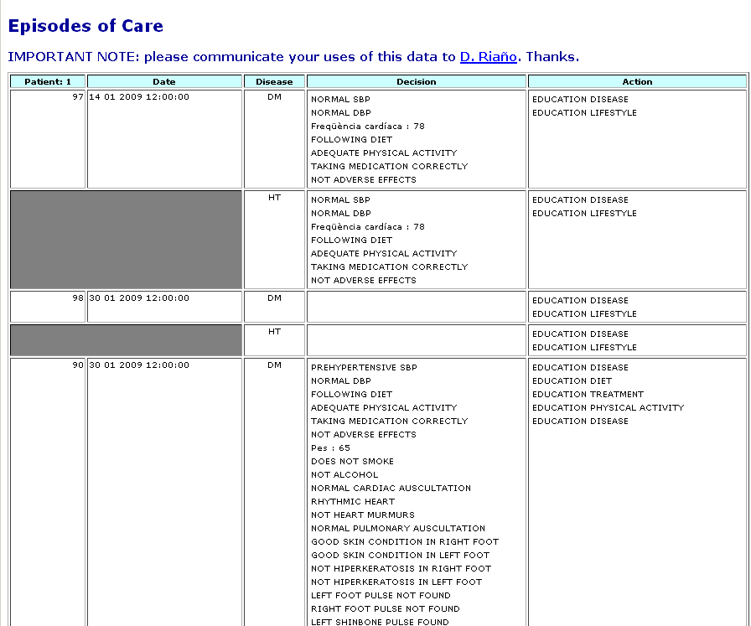
- Display of the data of a XML file with the use of XSLT.
- Identification of Data Problems and Future Actions
During the development of the EOC Data Model several problems have been identified that require further consideration. Here, we provide a list of them:
- The health care professional does not annotate all the important information (decision and action terms) during the encounter.
- The state element is not provided. A concrete use of the terms in the state element must be provided within the EOC Data Model, or the element state removed from the XML schema.
- A drug prescription appears in one encounter, but it is not in subsequent encounters. The reasons for this are: the physician forgot introducing it in the data, by default if nothing is said against the prescription is still valid, or the prescription is cancelled or replaced by another drug. A way of distinguish between these cases must be provided in the EOC data model.

Bibliography

- Henk Lamberts, Inge Hofmans-Okkes. Episode of Care: A Core Concept in Family Practice. J Fam Pract 1996;42:161-7.
- Roger A. Cote. Architecture of SNOMED: Its Contribution to Medical Language Processing. Proc Annu Symp Comput Appl Med Care, 1986.

At the moment this attribute is split across the Boolean attributes CI, DL, DM, HT, and IC, that stand respectively for Heart Failure, Dyslipidemia, Diabetes Mellitus, Hypertension, and Ischemic Heart Disease. With value "true" if the patient has the disease and "false", otherwise.

