D
Continuity of Care Record (CCR)

The Concept Paper of the CCR

Version 2.1b

Note: Development of the CCR is an ongoing process. Thus, the following information, in particular that related to the CCR’s content, is subject to change as a result of the consensus-building activities associated with the design of the CCR.

The CCR, or Continuity of Care Record, is a standard specification being developed jointly by ASTM International, the Massachusetts Medical Society (MMS), the Health Information Management and Systems Society (HIMSS), and the American Academy of Family Physicians (AAFP). It is intended to foster and improve continuity of patient care, to reduce medical errors, and to assure at least a minimum standard of health information transportability when a patient is referred or transferred to, or is otherwise seen by, another provider. The origins of the CCR stem from a Massachusetts Department of Public Health, three-page, NCR paper-based Patient Care Referral Form that has been in widespread use for many years in Massachusetts, and from other minimal data sets both electronic and paper-based.

The CCR is being developed and enhanced in response to the need to organize and make transportable a set of basic patient information consisting of the most relevant and timely facts about a patient’s condition. Briefly, these include patient and provider information, insurance information, patient’s health status (e.g., allergies, medications, vital signs, diagnoses, recent procedures), recent care provided, as well as recommendations for future care (care plan) and the reason for referral or transfer. This minimum data set will enhance the continuity of care by providing a method for communicating the most relevant information about a patient and providing both context and support for the electronic health record (EHR) through extensions.

Goal and Use of the CCR

The goal is to create a CCR that will enable the next provider to easily access the information outlined above at the beginning of a first encounter and easily update the information when the patient goes on to another provider, in order to support the safety, quality, and continuity of patient care. The CCR may be used as a vehicle to exchange clinical information among providers, institutions, or other entities. It may also be used by the patient as a brief summary of recent care.

The CCR will be completed by physicians, nurses, and ancillary providers (e.g., social work, physical therapy, occupational therapy) upon referral or transfer or other transition of a patient from one caregiver to another, whether it is outpatient, inpatient, or community based. Because the CCR is an XML standard document, it will be both machine and human readable, and the data content may be displayed or printed in a variety of formats, including by web browser, PDF reader, and word processor.

In case of a
- Referral: The referring provider/clinician should transmit the CCR information to the receiving provider in an electronic format, most likely utilizing secure email or HL7, and including the reason for referral along with the proposed minimum information.
- Transfer (from an inpatient or institutional setting): The discharging provider/clinician should transmit the CCR to the provider and new care setting where the patient is being sent (to arrive before or with the patient).
- Discharge (without obligatory referral or transfer): The CCR should be provided to the patient in paper or digital format for future use (including visits to the Urgent Care or Emergency Department) and to whomever the patient designates as the primary care physician or clinician who will be responsible for followup care, if needed.
- The CCR can also serve as a Personal Health Record, containing patient-entered information. A person may keep a copy of the most recent CCR and supplement it, for example, with alternative medicine information and other personal health information.

Technology and the CCR

The CCR standards consortium is currently focusing on selecting and defining the essential data elements. The CCR is intended to be technology neutral and vendor neutral in order to maximize its applicability. However, some partners of the consortium are working on an XML platform in order to offer multiple options for its presentation, modification, and transmittal, e.g., in a browser version, as an HL7 message, in a secure email, as a Word or other word processing document (electronic or paper). Thus, users will be able to access and view the document in the manner that they prefer and to extract the data as required. At the time of this writing, such efforts to offer technological platforms will not be part of the standard to be balloted.

It is envisioned that electronic health record (EHR) systems, both inpatient and outpatient, will both import and export all relevant data to and from the CCR document and enable automated transmission with minimal workflow disruption for individual caregivers.

Content of the CCR

At present, the CCR consists of six sections of mandated core elements. Each of these sections has the possibility of five extensions, where appropriate. The sections are:
- Header, or Document Identifying Information, contains required information about the referring or "from" clinician, as well as information about the referral or "to" provider, and document date. It also addresses the purpose for creating the document and reason for referral.
- Patient Identifying Information: This section includes the required information to identify and distinguish the patient throughout the referral process, transitioning to and from hospital, clinic, physician office, or home environments (any care setting). (Note: The CCR is not based on a centralized system or a national patient identifier. Rather, it is based on a federated or distributed identification system that links various providers and contains the minimal set of identifying information that could be used by any record system [paper or electronic] to assign the individual their own identifier.) Additional information in this section includes support contacts and advanced directives.
- Patient’s Insurance and Financial Information. The individual’s Medicare or commercial insurance information. Data elements include Insurance Company Name, Subscriber’s Name, Subscriber’s Date of Birth, Subscriber’s Member ID, and Other Insurance Information. These are the minimal data elements from which eligibility for insurance coverage may be determined.
- Health Status of the Patient: This section includes the following information:
- Diagnoses, Problems, and Conditions are preferably ranked by order of importance or in reverse chronological order. They are described in plain English and by code, according to the selected coding system. Also included are date of onset, date of most recent resolution, status, patient awareness of condition, family history, social history, and a source field.
- Adverse Reactions/Alerts lists allergies by agent and symptom with optional fields for source and date of last reaction, as well as other pertinent alerts about the patient.
- Current Medications are listed by brand name, generic name (optional), code system, code, start date, dose, schedule, refills, prescriber, status, and a comments field.
- Immunizations documentation includes information about each disease against which immunization was given, the date the immunization was received, and (optional) dose strength, unit and route of administration as well as manufacturer and lot#.
- Vital Signs documentation includes height, weight, blood pressure, temperature, respiratory rate, date vital signs were recorded, pulse oximetry, and optional peak expiratory flow rate (PEFR), as well as head circumference (for Pediatrics).
- Laboratory Results documentation includes blood sugar, urine protein, creatinine, sodium, potassium, hemoglobin, hematocrit, WBC, and the date the sample was taken.
- Procedures/Assessments documentation includes descriptions of procedures, code system, procedure code, procedure date and time, location, result and performed by whom. Also included here are assessments, such as mental health assessment, functional assessment.
- The Health Status section may be amplified in the optional “extension” for medical specialty-specific information. For instance, pediatric providers may want to include a growth chart in the CCR.
- Care Documentation: This section includes some detail on the patient-clinician encounter history, such as the dates and times of recent and pertinent visits and the purposes of the visits and names of clinicians or providers. This documentation section may be significantly expanded in the optional “extensions”.
- Care Plan Recommendation: The Care Plan is a free text entry section that includes planned or scheduled tests, procedures, or regimens of care.

Possible extensions of these six major sections include:
  - An extension for Enterprise and Institution-specific Information particularly regarding discharge or transfer, e.g., hospital to nursing and rehabilitation facilities or to home care agencies, and vice versa.
- An extension for minimum data sets oriented toward Medical Specialties, e.g., Pediatrics, Surgery, OB-GYN, Cardiology, Orthopedics, etc.
- An extension for Disease Management will accommodate recording specific disease management information, measures or guidelines, e.g., diabetes, congestive heart failure, asthma, etc. This extension may be utilized by health plans, pharmaceutical companies, patient advocacy groups, and others interested in promoting “best practices”
- An extension for Patient-entered, Personal Health Record use, e.g., for complementary and alternative medicine care documentation or other patient considerations such as private or sensitive health information a patient may be reluctant to share with certain practitioners or spouses.
- An extension for more comprehensive Payer-specific Information and possibly claims attachments.

Figure 1 below presents the Conceptual Model of the CCR, with mandated core elements on the left and potential extensions on the right.

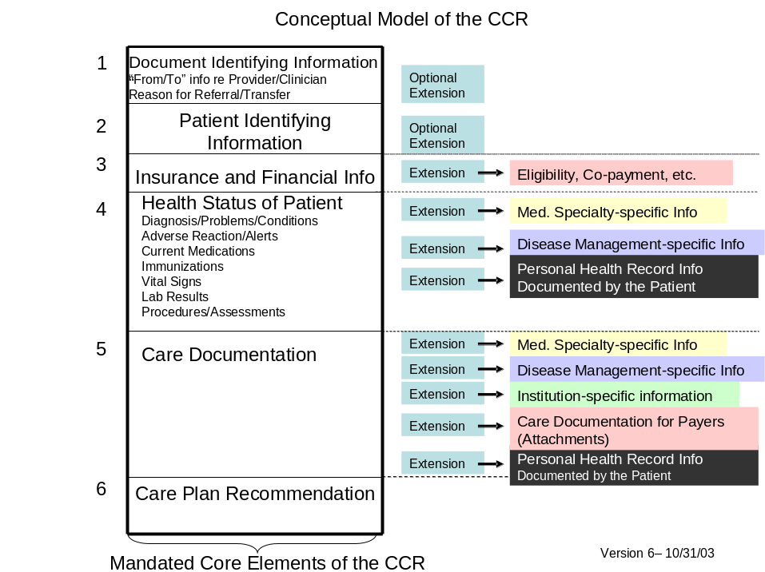
Figure 1: The Conceptual Model of the CCR. Mandated core elements are in the box on the left.

Distinguishing the CCR from Other Documents

The CCR is not a/an
- EHR: Although the CCR is meant to address the need for continuity of care from one provider or practitioner to any other practitioner, it is not designed to be a mini EHR. Lab and x-ray and other testing results are included only to the extent the provider completing the document finds them relevant. It does not list symptoms as its primary function. Rather it lists diagnoses and the “Reason for Referral” to the next provider or diagnostician. The “Reason for Referral” may include problems or symptoms but not in the manner in which a traditional EHR uses them as the starting point for a documentation of the SOAP-type note. Nor does it include a chronology of events, in the fashion expected in an EHR.
- Progress Note: Completion of the CCR should not be thought of as mandatory after every visit to a primary care physician (PCP) or specialist or other clinician who is delivering care to the patient. Thus, it is not replacing a progress note used in the traditional record. However, if the clinician is planning to refer the patient to another provider, then the CCR should be updated and prepared specifically for the next anticipated provider and customized to assist at the next “point of care”. Any relevant information for the next provider should be added to the CCR, just prior to the referral, if feasible.
- Discharge Summary: The CCR differs from the Discharge Summary mainly in that the CCR is much more concise, involves less narrative or free text, and emphasizes the brief care plan for the next steps to assist the patient to recover or be rehabilitated following the most recent episode of illness/care. The CCR highlights or spells out the next appointments and follow-up visits and instructions to assist the Visiting Nurse or other next caregiver regarding expectations of the followup encounter from the perspective of the clinician completing the form.
- Consultation Note: The CCR is not intended to replace the initial consultant’s note to the referring physician. There is, however, a potential for the CCR to be used in lieu of the consultant’s note back to the referring PCP after the second visit, provided the lengthier summary of findings and plan of care were documented after the first visit and sent to the original provider.

Benefits of the CCR

The CCR should have a great impact on the quality of care, on the reduction of medical errors, and on the containment of costs. The potential benefits are obvious:
- The next healthcare provider will not have to search for or guess about a patient’s allergies, medications, or current and recent past diagnoses and other pertinent information.
- The next healthcare provider will be informed about the patient’s most recent healthcare assessment and services.
- The next healthcare provider will be informed about recommendations of the caregiver who last treated the patient.
- As patient demographics will be provided, time and effort will be saved by not having to repeatedly ask a patient for demographic information in detail. Rather, this information can be more quickly and easily verified.
- A patient’s insurance status will be more easily established. Over time, this can be expanded within the system.
- Costs associated with the patient’s care will be reduced, for example through avoiding repetitive tests and basic information gathering.
- The effort required to update the patient’s most essential and relevant information will be minimized

Process of Developing the CCR

ASTM, MMS, HIMSS, and AAFP are hosting a series of consensus-building and content development meetings on the CCR, in order to involve government agencies, medical societies, other professional societies, state departments of public health, and others who may be interested in contributing to its development and adoption. Open meetings thus far include August 5, 2003, at the Massachusetts Medical Society, in Waltham, MA; September 29, 2003, in Washington, DC sponsored by the Agency for Healthcare Research and Quality (AHRQ); and October 23, 2003, at AAFP Headquarters in Kansas City. The next meeting is:

- November 17, 2003, Tampa, FL, in conjunction with ASTM E31 Committee on Health Informatics meetings (open meeting). This is planned as the final meeting before the core dataset will be balloted. You are invited to participate in the meeting. To register, visit http://www.astm.org/cgi-bin/SoftCart.exe/COMMIT/WEEKINFO/NovCW.htm?L+mystore+liue4449+1066758824 and register for Committee E31.

How to Become Involved

You need not be a member of ASTM, MMS, HIMSS, or AAFP in order to be informed, participate in meetings, and provide input about the CCR.

However, to participate in the balloting of the CCR as a standard requires membership in ASTM E31 Committee on Health Informatics. Annual dues are $75. To sign up as a member for ASTM Committee E 31, see www.astm.org or contact dsmith@astm.org.

For further information on these meetings and other activities related to development of the CCR, contact Dan Smith, E31 Staff Manager, at dsmith@astm.org, using the subject line “CCR” and indicating whether you want to join ASTM in order to participate as a member or prefer to be placed on the nonmember distribution list for meeting notices and progress reports.

Additional information about the CCR is available at http://www.astm.org/cgi-bin/SoftCart.exe/COMMIT/COMMITTEE/E31.htm?L+mystore+eaxl7272+1062625333, or you may contact any of the following:

Claudia Tessier, Executive Director of MoHCA, Co-chair, ASTM E31.28 CCR Work Group, telephone 202-659-2699 or email ctessi@attglobal.net
Tom Sullivan, MD, Co-chair, ASTM E31.28 CCR Work Group, email sullivan@massmed.org
Peter Waegemann, CEO of Medical Records Institute, ASTM E31 Chair, telephone 617-964-3969 or email peter@tepr.com
David Kibbe, MD, at AAFP, david.kibbe@canopysystems.com
Kathleen Bellisle at the Massachusetts Medical Society, telephone 800-332-2303 ext 7421 or email kbellisle@mms.org
Dan Smith, Staff Manager of ASTM E31, telephone 610-832-9727 or email dsmith@astm.org
Pam Brewer at HIMSS, telephone 734-973-6116 ext 115 or email pbrewer@himss.org

