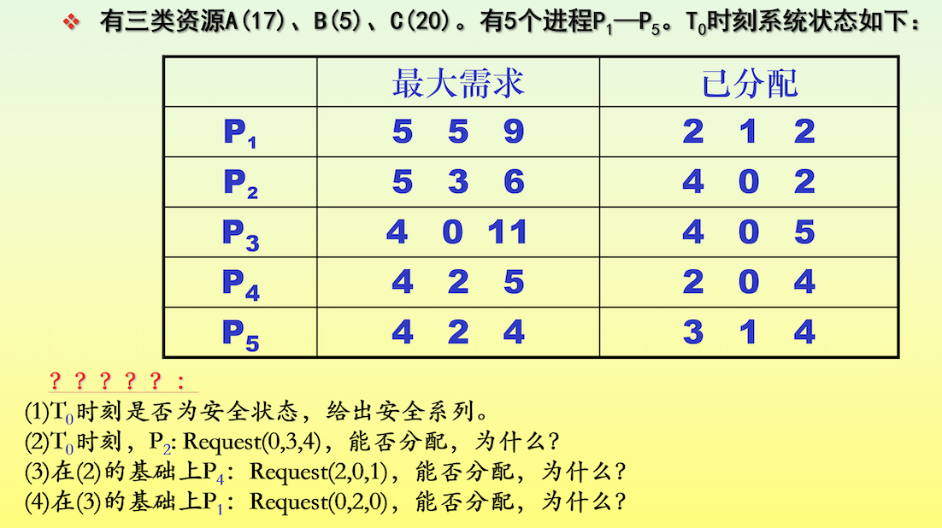
(1)
T0时。
 | max |  |  | allocation |  |  | need
 | A | B | C | A | B | C | A | B | C
P1 | 5 | 5 | 9 | 2 | 1 | 2 | 3 | 4 | 7
P2 | 5 | 3 | 6 | 4 | 0 | 2 | 1 | 3 | 4
P3 | 4 | 0 | 11 | 4 | 0 | 5 | 0 | 0 | 6
P4 | 4 | 2 | 5 | 2 | 0 | 4 | 2 | 2 | 1
P5 | 4 | 2 | 4 | 3 | 1 | 4 | 1 | 1 | 0

此时为安全状态，安全序列为p4 p2 p3 p5 p1
 | work |  |  | need |  |  | allocation |  |  | work+allocation |  |  | finish
 | A | B | C | A | B | C | A | B | C | A | B | C
P4 | 2 | 3 | 3 | 2 | 2 | 1 | 2 | 0 | 4 | 4 | 3 | 7 | true
P2 | 4 | 3 | 7 | 1 | 3 | 4 | 4 | 0 | 2 | 8 | 3 | 9 | true
P3 | 8 | 3 | 9 | 0 | 0 | 6 | 4 | 0 | 5 | 12 | 3 | 14 | true
P5 | 12 | 3 | 14 | 1 | 1 | 0 | 3 | 1 | 4 | 15 | 4 | 18 | true
P1 | 15 | 4 | 18 | 3 | 4 | 7 | 2 | 1 | 2 | 17 | 5 | 20 | true

(2)
Request2(0,3,4)<=Need2(1,3,4)
Request2(0,3,4)>Available(2,3,3)
令p2等待
不能分配
(3)
Request4(2,0,1)<=Need2(2,2,1)
Request4(2,0,1)<=Available(2,3,3)

若分配资源
 | max |  |  | allocation |  |  | need
 | A | B | C | A | B | C | A | B | C
P1 | 5 | 5 | 9 | 2 | 1 | 2 | 3 | 4 | 7
P2 | 5 | 3 | 6 | 4 | 0 | 2 | 1 | 3 | 4
P3 | 4 | 0 | 11 | 4 | 0 | 5 | 0 | 0 | 6
P4 | 4 | 2 | 5 | 4 | 0 | 5 | 0 | 2 | 0
P5 | 4 | 2 | 4 | 3 | 1 | 4 | 1 | 1 | 0
A,B,C 的 Available 为 0，3，2
给出一个安全序列：P4, P5, P1, P2, P3。
此时处于安全状态，所以能够实施资源分配
(4)
Request1(0,2,0)<=Need1(3,4,7)
Request1(0,2,0)<=Available(0,3,2)
若分配资源
 | max |  |  | allocation |  |  | need
 | A | B | C | A | B | C | A | B | C
P1 | 5 | 5 | 9 | 2 | 3 | 2 | 3 | 2 | 7
P2 | 5 | 3 | 6 | 4 | 0 | 2 | 1 | 3 | 4
P3 | 4 | 0 | 11 | 4 | 0 | 5 | 0 | 0 | 6
P4 | 4 | 2 | 5 | 4 | 0 | 5 | 0 | 2 | 0
P5 | 4 | 2 | 4 | 3 | 1 | 4 | 1 | 1 | 0
A,B,C 的 Available 为 0，1，2
此时不存在安全序列，所以不能实施资源分配

