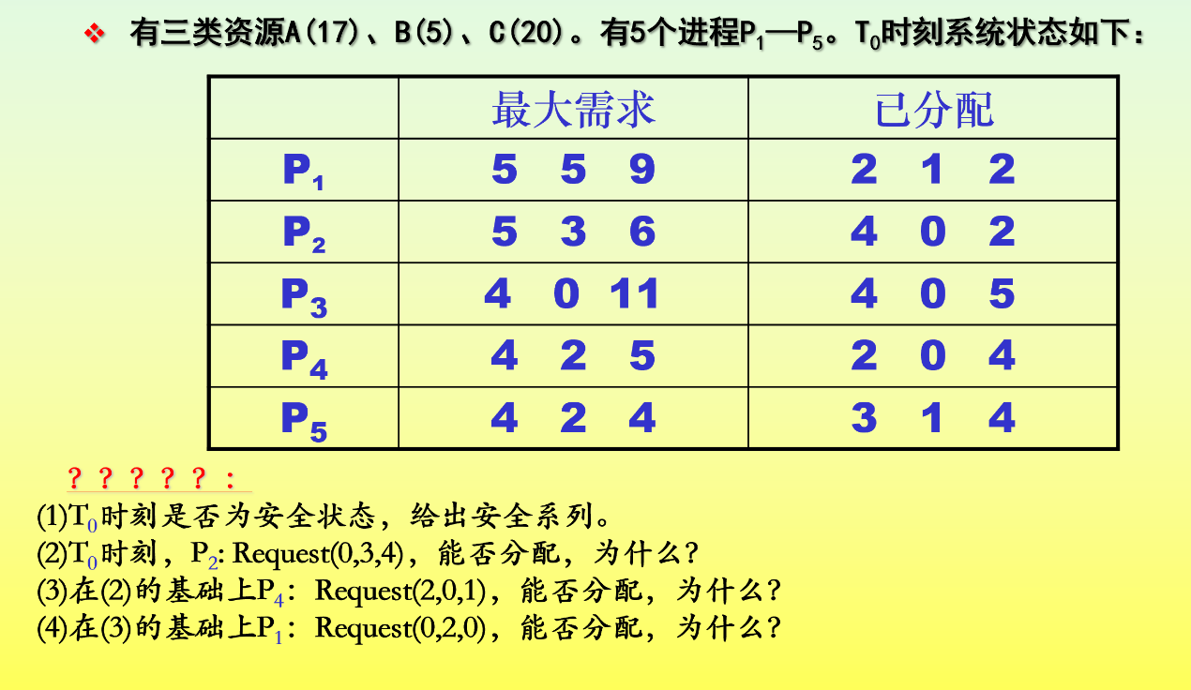

解：

（1）

|  |  |  |  |  |  |  |  |  |  |  |  |  |
| --- | --- | --- | --- | --- | --- | --- | --- | --- | --- | --- | --- | --- |
| 进  程 | Max | | | Allocation | | | Need | | | Available | | |
| A | B | C | A | B | C | A | B | C | A | B | C |
| P1 | 5 | 5 | 9 | 2 | 1 | 2 | 3 | 4 | 7 | 2 | 3 | 3 |
| P2 | 5 | 3 | 6 | 4 | 0 | 2 | 1 | 3 | 4 |  |  |  |
| P3 | 4 | 0 | 11 | 4 | 0 | 5 | 0 | 0 | 6 |  |  |  |
| P4 | 4 | 2 | 5 | 2 | 0 | 4 | 2 | 2 | 1 |  |  |  |
| P5 | 4 | 2 | 4 | 3 | 1 | 4 | 1 | 1 | 0 |  |  |  |

|  |  |  |  |  |  |  |  |  |  |  |  |  |  |
| --- | --- | --- | --- | --- | --- | --- | --- | --- | --- | --- | --- | --- | --- |
| 进程 | Work | | | Need | | | Allocation | | | Work+Allocation | | | Finsh |
| A | B | C | A | B | C | A | B | C | A | B | C | T |
| P4 | 2 | 3 | 3 | 2 | 2 | 1 | 2 | 0 | 4 | 4 | 3 | 7 | T |
| P2 | 4 | 3 | 7 | 1 | 3 | 4 | 4 | 0 | 2 | 8 | 3 | 9 | T |
| P3 | 8 | 3 | 9 | 0 | 0 | 6 | 4 | 0 | 5 | 12 | 3 | 14 | T |
| P5 | 12 | 3 | 14 | 1 | 1 | 0 | 3 | 1 | 4 | 15 | 4 | 18 | T |
| P1 | 15 | 4 | 18 | 3 | 4 | 7 | 2 | 1 | 2 | 17 | 5 | 20 | T |

由此可得：

所以，T0时刻处于安全状态，安全序列为<P4,P2,P3,P5,P1>

（2）Request2（0,3,4）≤Need2(1,3,4) 成立

Request2（0,3,4）≤Available(2,3,3) 不成立

因为，进程P2中请求量大于系统分配资源数

所以，不能实施资源分配

（3）Request4（2,0,1）≤Need4(2,2,1) 成立

Request4（2,0,1）≤Available(2,3,3) 成立

|  |  |  |  |  |  |  |  |  |  |  |  |  |
| --- | --- | --- | --- | --- | --- | --- | --- | --- | --- | --- | --- | --- |
| 进  程 | Max | | | Allocation | | | Need | | | Available | | |
| A | B | C | A | B | C | A | B | C | A | B | C |
| P1 | 5 | 5 | 9 | 2 | 1 | 2 | 3 | 4 | 7 | 0 | 3 | 2 |
| P2 | 5 | 3 | 6 | 4 | 0 | 2 | 1 | 3 | 4 |  |  |  |
| P3 | 4 | 0 | 11 | 4 | 0 | 5 | 0 | 0 | 6 |  |  |  |
| P4 | 4 | 2 | 5 | 4 | 0 | 5 | 0 | 2 | 0 |  |  |  |
| P5 | 4 | 2 | 4 | 3 | 1 | 4 | 1 | 1 | 0 |  |  |  |

|  |  |  |  |  |  |  |  |  |  |  |  |  |  |
| --- | --- | --- | --- | --- | --- | --- | --- | --- | --- | --- | --- | --- | --- |
| 进程 | Work | | | Need | | | Allocation | | | Work+Allocation | | | Finsh |
| A | B | C | A | B | C | A | B | C | A | B | C | T |
| P4 | 0 | 3 | 2 | 0 | 2 | 0 | 4 | 0 | 5 | 4 | 3 | 7 | T |
| P5 | 4 | 3 | 7 | 1 | 1 | 0 | 3 | 1 | 4 | 7 | 4 | 11 | T |
| P1 | 7 | 4 | 11 | 3 | 4 | 7 | 2 | 1 | 2 | 9 | 5 | 13 | T |
| P2 | 9 | 5 | 13 | 1 | 3 | 4 | 4 | 0 | 2 | 13 | 5 | 15 | T |
| P3 | 13 | 5 | 15 | 0 | 0 | 6 | 4 | 0 | 5 | 17 | 5 | 20 | T |

由此可得：

所以，此时刻处于安全状态，有安全序列<P4,P5,P1,P2,P3>

所以，系统能够实施资源分配

（4）Request1（0,2,0）≤Need1(3,4,7) 成立

Request1（0,2,0）≤Available(0，3,2) 成立

|  |  |  |  |  |  |  |  |  |  |  |  |  |
| --- | --- | --- | --- | --- | --- | --- | --- | --- | --- | --- | --- | --- |
| 进  程 | Max | | | Allocation | | | Need | | | Available | | |
| A | B | C | A | B | C | A | B | C | A | B | C |
| P1 | 5 | 5 | 9 | 2 | 1 | 2 | 3 | 4 | 7 | 0 | 3 | 2 |
| P2 | 5 | 3 | 6 | 4 | 0 | 2 | 1 | 3 | 4 | - 0 | 2 | 0 |
| P3 | 4 | 0 | 11 | 4 | 0 | 5 | 0 | 0 | 6 | 0 | 1 | 2 |
| P4 | 4 | 2 | 5 | 4 | 0 | 5 | 0 | 2 | 0 |  |  |  |
| P5 | 4 | 2 | 4 | 3 | 1 | 4 | 1 | 1 | 0 |  |  |  |

因为，此时剩余系统资源不能为任何一进程分配资源，不存在安全序列

所以，不能实施资源分配