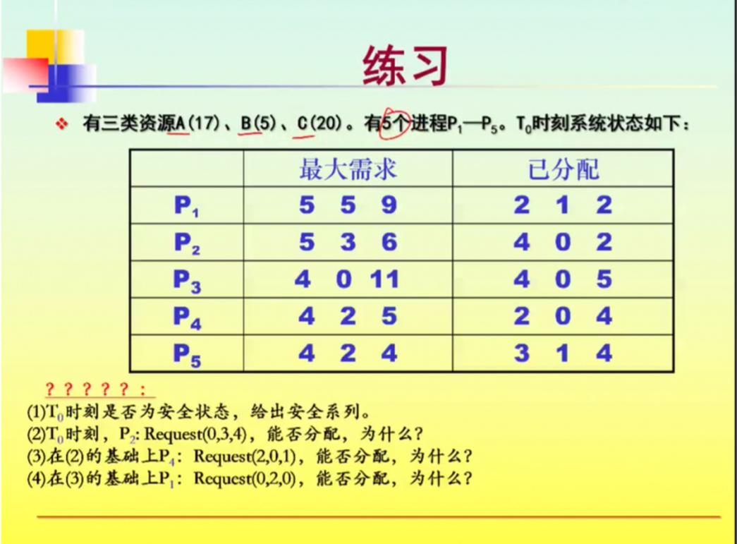

（1）

|  |  |  |  |  |  |  |  |  |  |  |  |  |
| --- | --- | --- | --- | --- | --- | --- | --- | --- | --- | --- | --- | --- |
|  | Max | | | Allocation | | | Need | | | Available | | |
| A | B | C | A | B | C | A | B | C | A | B | C |
| P1 | 5 | 5 | 9 | 2 | 1 | 2 | 3 | 4 | 7 | 2 | 3 | 3 |
| P2 | 5 | 3 | 6 | 4 | 0 | 2 | 1 | 3 | 4 |  |  |  |
| P3 | 4 | 0 | 11 | 4 | 0 | 5 | 0 | 0 | 6 |  |  |  |
| P4 | 4 | 2 | 5 | 2 | 0 | 4 | 2 | 2 | 1 |  |  |  |
| P5 | 4 | 2 | 4 | 3 | 1 | 4 | 1 | 1 | 0 |  |  |  |

T0时刻：

|  |  |  |  |  |  |  |  |  |  |  |  |  |  |
| --- | --- | --- | --- | --- | --- | --- | --- | --- | --- | --- | --- | --- | --- |
|  | Work | | | Need | | | Allocation | | | Work+Allocation | | | Finish |
| A | B | C | A | B | C | A | B | C | A | B | C | true |
| P4 | 2 | 3 | 3 | 2 | 2 | 1 | 2 | 0 | 4 | 4 | 3 | 7 | true |
| P2 | 4 | 3 | 7 | 1 | 3 | 4 | 4 | 0 | 2 | 8 | 3 | 9 | true |
| P3 | 8 | 3 | 9 | 0 | 0 | 6 | 4 | 0 | 5 | 12 | 3 | 14 | true |
| P5 | 12 | 3 | 14 | 1 | 1 | 0 | 3 | 1 | 4 | 15 | 4 | 18 | true |
| P1 | 15 | 4 | 18 | 3 | 4 | 7 | 2 | 1 | 2 | 17 | 5 | 20 | true |

安全序列P4,P2,P3,P5,P1，所以T0时刻安全。

（2）T0时刻：P2:Request(0,3,4)<Need(1,3,4) 成立

Request(0,3,4)<Available(2,3,3)不成立

不能分配进程

（3）：P4：Request(2,0,1)<Need(2,2,1)成立；

Request(2,0,1)<Available(2,3,3)成立

|  |  |  |  |  |  |  |  |  |  |  |  |  |
| --- | --- | --- | --- | --- | --- | --- | --- | --- | --- | --- | --- | --- |
|  | Max | | | Allocation | | | Need | | | Available | | |
| A | B | C | A | B | C | A | B | C | A | B | C |
| P1 | 5 | 5 | 9 | 2 | 1 | 2 | 3 | 4 | 7 | 0 | 3 | 2 |
| P2 | 5 | 3 | 6 | 4 | 0 | 2 | 1 | 3 | 4 |  |  |  |
| P3 | 4 | 0 | 11 | 4 | 0 | 5 | 0 | 0 | 6 |  |  |  |
| P4 | 4 | 2 | 5 | 4 | 0 | 5 | 0 | 2 | 0 |  |  |  |
| P5 | 4 | 2 | 4 | 3 | 1 | 4 | 1 | 1 | 0 |  |  |  |

根据银行家算法进行判断系统安全

|  |  |  |  |  |  |  |  |  |  |  |  |  |  |
| --- | --- | --- | --- | --- | --- | --- | --- | --- | --- | --- | --- | --- | --- |
|  | Work | | | Need | | | Allocation | | | Work+Allocation | | | Finish |
| A | B | C | A | B | C | A | B | C | A | B | C | true |
| P4 | 0 | 3 | 2 | 0 | 2 | 0 | 4 | 0 | 5 | 4 | 3 | 7 | true |
| P2 | 4 | 3 | 7 | 1 | 3 | 4 | 4 | 0 | 2 | 8 | 3 | 9 | true |
| P3 | 8 | 3 | 9 | 0 | 0 | 6 | 4 | 0 | 5 | 12 | 3 | 14 | true |
| P5 | 12 | 3 | 14 | 1 | 1 | 0 | 3 | 1 | 4 | 15 | 4 | 18 | true |
| P1 | 15 | 4 | 18 | 3 | 4 | 7 | 2 | 1 | 2 | 17 | 5 | 20 | true |

安全序列为P4,P2,P3,P5,P1，系统安全，可以将P4所申请的资源分配

（4）P1：Request（0,2,0）<Need（3,4,7）成立

Request（0,2,0）<Available（0,3,2）成立

|  |  |  |  |  |  |  |  |  |  |  |  |  |
| --- | --- | --- | --- | --- | --- | --- | --- | --- | --- | --- | --- | --- |
|  | Max | | | Allocation | | | Need | | | Available | | |
| A | B | C | A | B | C | A | B | C | A | B | C |
| P1 | 5 | 5 | 9 | 2 | 3 | 2 | 3 | 2 | 7 | 0 | 1 | 2 |
| P2 | 5 | 3 | 6 | 4 | 0 | 2 | 1 | 3 | 4 |  |  |  |
| P3 | 4 | 0 | 11 | 4 | 0 | 5 | 0 | 0 | 6 |  |  |  |
| P4 | 4 | 2 | 5 | 2 | 0 | 5 | 0 | 2 | 1 |  |  |  |
| P5 | 4 | 2 | 4 | 3 | 1 | 4 | 1 | 1 | 0 |  |  |  |

资源向量Available（0,1,2）不满足任何进程的资源分配，不存在安全序列，系统进入不安全状态，不可分配。