**银行家算法问题**

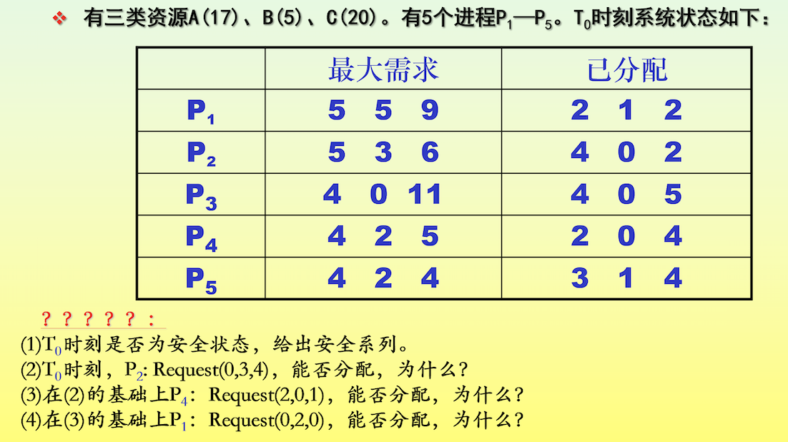

**解：**

**1)T0时刻资源分配情况**

|  |  |  |  |  |  |  |  |  |  |  |  |  |
| --- | --- | --- | --- | --- | --- | --- | --- | --- | --- | --- | --- | --- |
|  | **Max** | | | **Allocation** | | | **Need** | | | **Available** | | |
|  | **A** | **B** | **C** | **A** | **B** | **C** | **A** | **B** | **C** | **A** | **B** | **C** |
| **P1** | **5** | **5** | **9** | **2** | **1** | **2** | **3** | **4** | **7** | **2** | **3** | **3** |
| **P2** | **5** | **3** | **6** | **4** | **0** | **2** | **1** | **3** | **4** |  |  |  |
| **P3** | **4** | **0** | **11** | **4** | **0** | **5** | **0** | **0** | **6** |  |  |  |
| **P4** | **4** | **2** | **5** | **2** | **0** | **4** | **2** | **2** | **1** |  |  |  |
| **P5** | **4** | **2** | **4** | **3** | **1** | **4** | **1** | **1** | **0** |  |  |  |

**解：**

|  |  |  |  |  |  |  |  |  |  |  |  |  |  |
| --- | --- | --- | --- | --- | --- | --- | --- | --- | --- | --- | --- | --- | --- |
|  | **work** | | | **need** | | | **allocation** | | | **Work&allocation** | | | **finish** |
|  | **A** | **B** | **C** | **A** | **B** | **C** | **A** | **B** | **C** | **A** | **B** | **C** |
| **P4** | **2** | **3** | **3** | **2** | **2** | **1** | **2** | **0** | **4** | **4** | **3** | **7** | **true** |
| **P2** | **4** | **3** | **7** | **1** | **3** | **4** | **4** | **0** | **2** | **8** | **3** | **9** | **true** |
| **P3** | **8** | **3** | **9** | **0** | **0** | **6** | **4** | **0** | **5** | **12** | **3** | **14** | **true** |
| **P5** | **12** | **3** | **14** | **2** | **2** | **1** | **3** | **1** | **4** | **15** | **4** | **18** | **true** |
| **P1** | **15** | **4** | **18** | **3** | **4** | **7** | **2** | **1** | **2** | **17** | **5** | **20** | **true** |

**T0时刻，系统安全，安全序列为：P4-->P2-->P3-->P5-->P1**

**2)P2:Request2(0,3,4)，系统用银行家算法进行检查：**

**Request2(0,3,4)<=Need2(1,3,4)**

**Request2(0,3,4)>Available2(2,3,3)**

**P2等待，不能完成分配**

**3)在2)的基础上，P4:Request4(2,0,1)，系统用银行家算法进行检查**

**Request4(2,0,1)<=Need4(2,2,1)**

**Request4(2,0,1)<=Available(2,3,3)**

**系统先假定可为P4分配资源，并修改表格某些数据值，由此资源变化为：**

|  |  |  |  |  |  |  |  |  |  |  |  |  |
| --- | --- | --- | --- | --- | --- | --- | --- | --- | --- | --- | --- | --- |
|  | **max** | | | **allocation** | | | **need** | | | **available** | | |
|  | **A** | **B** | **C** | **A** | **B** | **C** | **A** | **B** | **C** | **A** | **B** | **C** |
| **P1** | **5** | **5** | **9** | **2** | **1** | **2** | **3** | **4** | **7** | **2** | **3** | **3** |
|  |  |  |  |  |  |  |  |  |  | **0** | **3** | **2** |
| **P2** | **5** | **3** | **6** | **4** | **0** | **2** | **1** | **3** | **4** |  |  |  |
| **P3** | **4** | **0** | **11** | **4** | **0** | **5** | **0** | **0** | **6** |  |  |  |
| **P4** | **4** | **2** | **5** | **2** | **0** | **4** | **2** | **2** | **1** |  |  |  |
|  |  |  |  | **4** | **0** | **5** | **0** | **2** | **0** |  |  |  |
| **P5** | **4** | **2** | **4** | **3** | **1** | **4** | **1** | **1** | **0** |  |  |  |

**再利用安全性算法检查此时系统是否安全：**

|  |  |  |  |  |  |  |  |  |  |  |  |  |  |
| --- | --- | --- | --- | --- | --- | --- | --- | --- | --- | --- | --- | --- | --- |
|  | **work** | | | **need** | | | **allocation** | | | **Work&allocation** | | | **finish** |
|  | **A** | **B** | **C** | **A** | **B** | **C** | **A** | **B** | **C** | **A** | **B** | **C** |
| **P4** | **0** | **3** | **2** | **0** | **2** | **0** | **4** | **0** | **5** | **4** | **3** | **7** | **true** |
| **P2** | **4** | **3** | **7** | **1** | **3** | **4** | **4** | **0** | **2** | **8** | **3** | **9** | **true** |
| **P3** | **8** | **3** | **9** | **0** | **0** | **6** | **4** | **0** | **5** | **12** | **3** | **14** | **true** |
| **P5** | **12** | **3** | **14** | **2** | **2** | **1** | **3** | **1** | **4** | **15** | **4** | **18** | **true** |
| **P1** | **15** | **4** | **18** | **3** | **4** | **7** | **2** | **1** | **2** | **17** | **5** | **20** | **true** |

**得到安全序列：P4-->P2-->P3-->P5-->P1**

**此时处于安全状态，可以进行分配。**

**4）在3）的基础上，P1:Request1(0,2,0)，系统用银行家算法进行检查**

**Request1(0,2,0)<=Need1(3,4,7)**

**Request1(0,2,0)<=Available(0,3,2)**

**系统假定给P1分配资源：**

|  |  |  |  |  |  |  |  |  |  |  |  |  |
| --- | --- | --- | --- | --- | --- | --- | --- | --- | --- | --- | --- | --- |
|  | **max** | | | **allocation** | | | **need** | | | **available** | | |
|  | **A** | **B** | **C** | **A** | **B** | **C** | **A** | **B** | **C** | **A** | **B** | **C** |
| **P1** | **5** | **5** | **9** | **2** | **1** | **2** | **3** | **4** | **7** | **2** | **3** | **3** |
|  |  |  |  | **2** | **3** | **2** | **3** | **2** | **7** | **0** | **3** | **2** |
|  |  |  |  |  |  |  |  |  |  | **0** | **1** | **2** |
| **P2** | **5** | **3** | **6** | **4** | **0** | **2** | **1** | **3** | **4** |  |  |  |
| **P3** | **4** | **0** | **11** | **4** | **0** | **5** | **0** | **0** | **6** |  |  |  |
| **P4** | **4** | **2** | **5** | **2** | **0** | **4** | **2** | **2** | **1** |  |  |  |
|  |  |  |  | **4** | **0** | **5** | **0** | **2** | **0** |  |  |  |
| **P5** | **4** | **2** | **4** | **3** | **1** | **4** | **1** | **1** | **0** |  |  |  |

**再利用安全性算法检查此时系统是否安全**

**当前Available(0,1,2)无法满足任何一个进程需求，系统不安全，故无法分配。**