Simulate Tool for QA team

--Ralf Wang

**The test tool has two parts:**

1. The web service “SyncToOtherSystem.asmx” is to simulate the 3rd system which receives the message from our PS system.
2. Result view tool is to verify the result for some web services.

**Note:**

**Do not write any information of this tool in test log to avoid the tool validation. We just use it in the inter-team.**

* Simulate the 3rd system API:

This function will create a web service in IIS in PS. It will receives the notification message from PS. We can use the ResultView to view the content of it.

1. Click the bat file "InstallPSAPI.bat" in PS server to install the web service. This script will add the service to IIS with default application pool and name as “3rdSystemAPI”.
2. Make sure the service can start successfully by using the URL like “http://localhost/3rdSystemAPI/SyncToOtherSystem.asmx”. There is a function named as “SynchronizeInfo”.

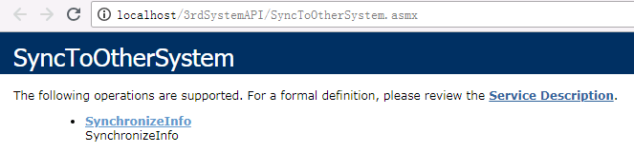

1. Delete the value of CSServerWechatPath4Parameter make it empty of the web configuration file which located in “C:\Program Files\GX Platform\GXWeb\WebApp\WebAPI\web.config”.
2. Open the PS configuration page with CSHSVC user, enable the Cloud film function and give exist hospital ID.
3. Enable the Notification module and change the server URL as http://localhost/3rdSystemAPI/SyncToOtherSystem.asmx

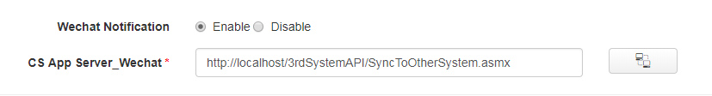

1. Change the 3rd system service log file path which located under the folder D:\3rdSystemAPI\PSAPI. Make sure the path is under the folder PSAPI and log name is “Service.log”.

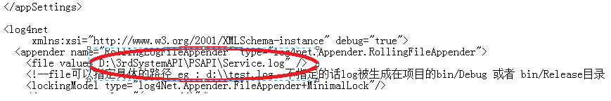

1. PS service will send the request with soap header, make sure the user id and password is correct which store in the configuration file.

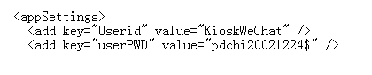

1. Restart the PS service with “lcservice” tool and restart the IIS service.
2. Open the Tool ResultView which located 3rdSystemAPI\PSAPI. We can view the result of the PS push notification message to 3rd system.

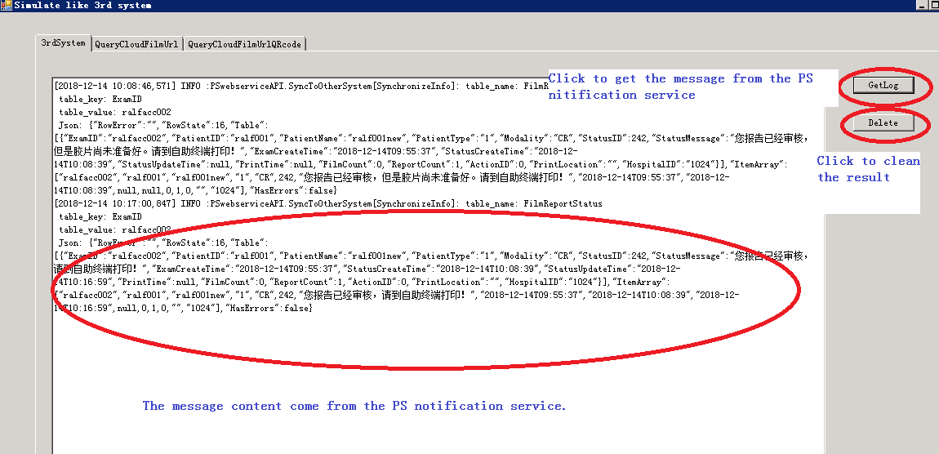

**Note:**

1. **The get log button to display the all context of the Service.log which has same path of the test tool. If you cannot get information please make sure the file is exist or the configuration is correct in step6.**
2. **Delete button will delete the Service.log file of same level folder. If new message come from PS, the log file will create new one. Clean it will help you to verify the context easily.**
3. **Make sure the log file exists and single. The default size is 20MB. You can also change it in the web configuration files as you need.**

* QueryCloudFilmUrl service tool:

This service will return the URL of patients to other system and it can visit our cloud film system by it.

1. Make the service can visit in PS by using the URL like:

http://localhost/NotifyServer/NotifyService.asmx?op=QueryCloudFilmUrl

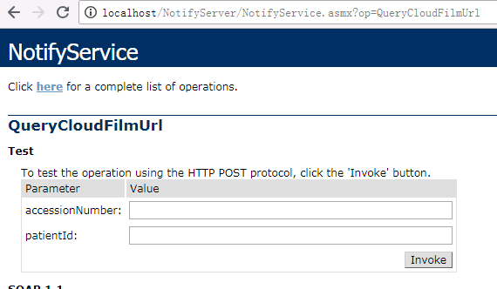

1. Open the Tool ResultView which located 3rdSystemAPI\PSAPI and click the table of service. We can simulate the other systems` operations.
2. Input the URL, patient id and accession number, click the button to get the result.

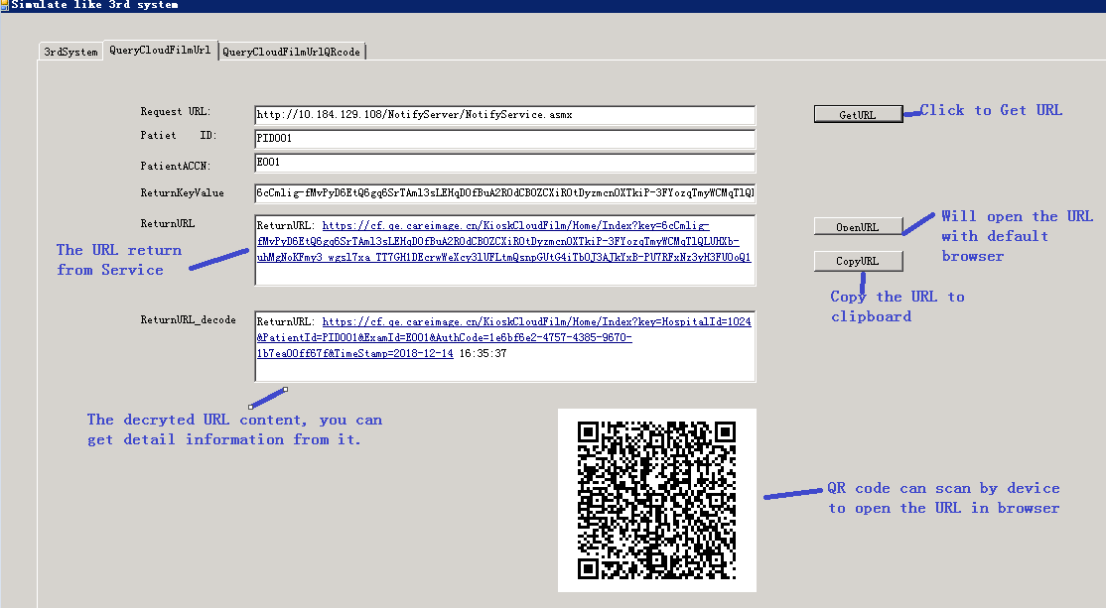

* QueryCloudFilmUrlForQrCode service tool:

This service will return the URL of patients to other system. Other system will transfer it to QR code and print with reports. Patient can scan it to login our cloud film system to view the e-film and report.

1. Make the service can visit in PS by using the URL like:

http://localhost/NotifyServer/NotifyService.asmx?op=QueryCloudFilmUrlForQrCode 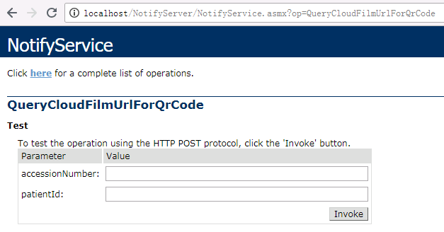

1. Open the Tool ResultView which located 3rdSystemAPI\PSAPI and click the table of this service. We can simulate the other systems` operations.
2. Input the URL, patient id and accession number, click the button to get the result.

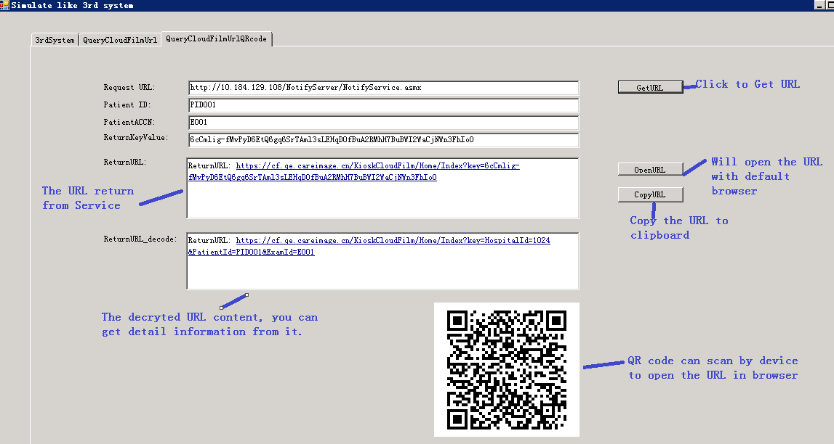

**Note:**

**Do not write any information of this tool in test log. We just use it in the inter-team.**