DICOM Print Sender

This tool is using to simulate to print DICOM files to our PS system. Then PS will recognize the DICOM with OCR process and archive the DICOM files. We can use it to simulate the print operations in hospitals when do the performance testing works.

The tool will start multiple threads and print the define DICOM files with dcmtk open source tool. We define multiple work rules to fit the different requirements.

The main work flow as follow:

1. The tools will init with parameters with configuration file.
2. Get the work model with the settings.
3. Try to create patient with integration service which define as the “local RIS”.
4. Add the water mark to DICOM files with small tool.
5. Print the DICOM file to destination PS system.

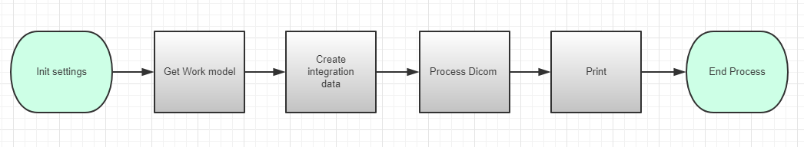

**Init Setting:**

Tool will reads the configuration file and get the parameters. It will create related work folder and change the default value to ensure tool can works well.

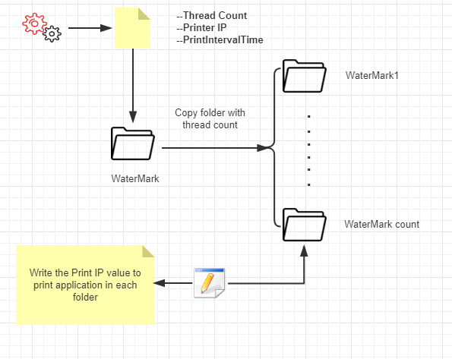

The application will do the follow operations during the init function:

1. Read the “App.config” in the applications.
2. Get the required parameters: ThreadCount, PrinterIP, PrintIntervalTime
3. Copy and create new watermark folder with thread count. The name style is as WaterMark1, WaterMark2……WaterMark[thread count].
4. Go to each WaterMark folder and change the print IP to the target PS. Change the **hostname** value of configuration file ..\SCU\dcmpstat.cfg.scu to the one which defined in your configuration file.

**Get work model:**

As design, the application has 3 work models and 1 loop rule. The 3 works modes are “Manual”, “count”, “Time”. If user chooses any of them, the application will execute with different rules.

