Kiosk integration install document

--Ralf Wang

The team need install the integration package in our daily works. It will cost some time to do that manually. I develop an application to support the install and configuration works. We just need do some simple choose to finish all work.

You can get the latest version from: \\10.184.129.236\kiosk\PUMA\Intergration\Integration(1.0.5.15619)\\

The application package is name as **[Auto_Integration_from_Ralf].**

The install and configuration steps as follow:

1. Copy the folder to local disk on PS system. We suggest to store in E disk partition.
2. Change the folder name to what you want like [Integration]. **Note: do not leave the empty space in the new folder name.**
3. Execute the application [**InstallInergrtion.exe**].
4. Select which version do you want to install: local or RIS:

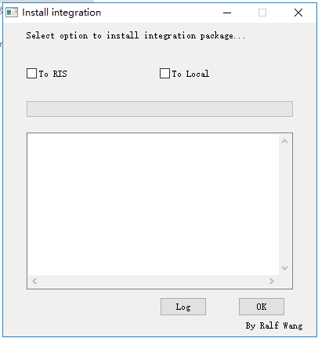

**To RIS:**

If you check on this option, the installed integration will connect to the RIS system in lab. The RIS system is local in lab and IP address is 10.184.129.206.

**To Local:**

If you check on this option, the installed integration will connect to the local database. The integration will use the table wggc.dbo.vi_KIOSK_ExamInfo_Order to sync the RIS data.

1. Select one option and click the OK button.
2. Wait the installation operation finished. The application will pop up the successfully message.

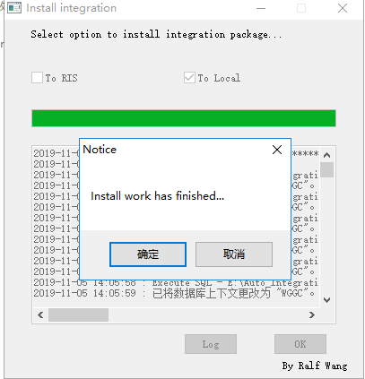

1. You can check the install log in the application UI or the log file in the same folder of application:

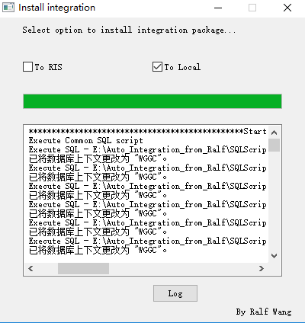

1. Go to the platform web site [http://IP/platform], switch to reconciliation page. Input the existed patient accession number or patient id in RIS. To local, select the patient in the table wggc.dbo.vi_KIOSK_ExamInfo_Order in database. You can insert the test data by this SQL Statement.



1. If the web site can query out the data, the installation operation is correct.

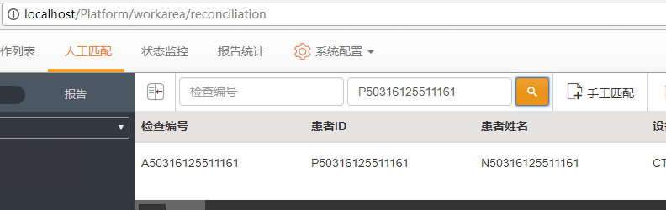

**Note:**

1. This application is used for PUMA system. The K1, K2 UI cannot use it.
2. The application installed integration does not support the hospital district module. You can reference the file in the folder [HospitalDistrict ] and develop the special integration module for customer.
3. This application can execute for several times, it will drop or uninstall the installed module automatically.