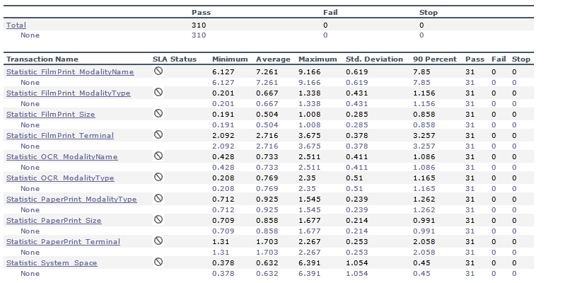

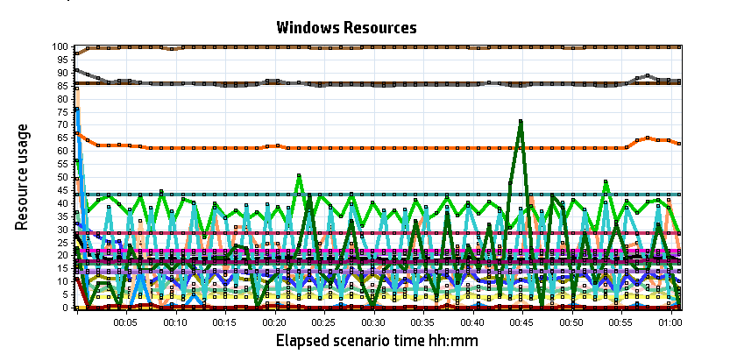

|  |  |  |  |  |  |  |
| --- | --- | --- | --- | --- | --- | --- |
| **Color** | **Scale** | **Measurement** | **Minimum** | **Average** | **Maximum** | **Std. Deviation** |
|  | 10 | % Disk Time (PhysicalDisk _Total):localhost | 0.298 | 0.767 | 34.608 | 1.194 |
|  | 1 | % Idle Time (PhysicalDisk _Total):localhost | 74.017 | 99.534 | 99.980 | 0.930 |
|  | 1000 | % Interrupt Time (Processor _Total):localhost | 0.000 | 0.020 | 0.521 | 0.055 |
|  | 10 | % Privileged Time (Processor _Total):localhost | 0.000 | 0.477 | 5.832 | 0.756 |
|  | 1 | % Processor Time (Processor _Total):localhost | 0.000 | 7.576 | 37.783 | 7.961 |
|  | 0.01 | Available MBytes (Memory):localhost | 1,964.000 | 2,045.869 | 2,346.000 | 40.995 |
|  | 0.001 | Avg. Disk Bytes/Transfer (PhysicalDisk _Total):localhost | 3,693.115 | 4,480.934 | 129,013.760 | 5,533.653 |
|  | 1000 | Avg. Disk Queue Length (PhysicalDisk _Total):localhost | 0.003 | 0.008 | 0.346 | 0.012 |
|  | 1 | Bytes Total/sec (Server):localhost | 0.000 | 0.000 | 0.000 | 0.000 |
|  | 1E-07 | Cache Bytes (Memory):localhost | 134,238,208.000 | 136,382,870.256 | 137,715,712.000 | 633,510.477 |
|  | 1E-08 | Committed Bytes (Memory):localhost | 1,793,695,744.000 | 2,102,367,542.126 | 2,187,894,784.000 | 42,426,431.327 |
|  | 0.01 | Context Switches/sec (System):localhost | 453.370 | 3,762.252 | 20,547.530 | 3,607.563 |
|  | 1 | Disk Transfers/sec (PhysicalDisk _Total):localhost | 10.952 | 19.030 | 82.761 | 5.566 |
|  | 0.01 | File Data Operations/sec (System):localhost | 17.234 | 1,114.034 | 5,558.162 | 1,249.002 |
|  | 0.0001 | Free Megabytes (LogicalDisk _Total):localhost | 433,493.000 | 433,494.959 | 433,497.000 | 1.370 |
|  | 0.01 | Interrupts/sec (Processor _Total):localhost | 260.406 | 1,258.860 | 6,346.427 | 1,200.046 |
|  | 0.01 | Page Faults/sec (Memory):localhost | 13.286 | 2,320.775 | 53,203.103 | 7,716.398 |
|  | 100 | Page Reads/sec (Memory):localhost | 0.000 | 0.026 | 11.285 | 0.366 |
|  | 10 | Pages/sec (Memory):localhost | 0.000 | 0.183 | 83.309 | 2.918 |
|  | 1E-06 | Pool Nonpaged Bytes (Memory):localhost | 85,757,952.000 | 85,846,084.545 | 86,962,176.000 | 63,718.366 |
|  | 0.0001 | Pool Nonpaged Bytes (Server):localhost | 169,307.000 | 169,307.000 | 169,307.000 | 0.000 |
|  | 1E-07 | Pool Paged Bytes (Memory):localhost | 217,198,592.000 | 217,519,648.183 | 218,017,792.000 | 27,789.651 |
|  | 0.001 | Pool Paged Bytes (Server):localhost | 28,392.000 | 28,392.000 | 28,392.000 | 0.000 |
|  | 1 | Pool Paged Failures (Server):localhost | 0.000 | 0.000 | 0.000 | 0.000 |
|  | 1E-08 | Private Bytes (Process _Total):localhost | 1,156,177,920.000 | 1,417,163,447.484 | 1,498,173,440.000 | 39,637,909.750 |
|  | 1 | Processes (System):localhost | 56.000 | 61.520 | 68.000 | 1.211 |
|  | 100 | Processor Queue Length (System):localhost | 0.000 | 0.188 | 7.000 | 0.691 |
|  | 10 | Split IO/Sec (PhysicalDisk _Total):localhost | 0.000 | 0.045 | 12.630 | 0.405 |
|  | 1E-07 | System Cache Resident Bytes (Memory):localhost | 134,238,208.000 | 136,383,084.251 | 137,715,712.000 | 633,458.417 |
|  | 0.1 | Threads (Objects):localhost | 811.000 | 859.789 | 925.000 | 12.742 |
|  | 1E-08 | Working Set (Process _Total):localhost | 1,403,551,744.000 | 1,777,876,600.790 | 1,886,232,576.000 | 46,983,256.031 |

|  |
| --- |
| **Description:**Displays a summary of the System Resources usage for each Windows based host. |
|  |