User Platform Client Installation

**Software Quality Team**

ABSTRACT

This usage guide document will briefly introduce the installation of TMP Client, this document will include following areas:

1. Client preparations
2. Client installs

REVISION HISTORY

|  |  |  |
| --- | --- | --- |
| REVISION | RELEASE DATE | COMMENTS |
| V1.0 | 9/10/2016 | Initial draft |
| V1.1 | 4/11/2017 | Jason Wang |
| V1.2 | 5/10/2019 | Jason Wang |
| V1.3 | 7/11/2022 | Jason Wang |
| V1.4 | 8/21/2024 | Software path update |

CONTENTS

1 Preparation for TMP Client 4

1.1 What is TMP Client 4

1.2 System requirements 4

1.2.1 Operation System requirements 4

1.2.2 Hard Ware suggestion 4

1.3 System setting (Linux only) 4

1.3 Dependent software and version 4

1.3.1 Python 4

1.3.2 Subversion 5

2 Install TMP Client 5

2.1 Export TMP Client build 5

2.2 Install TMP Client build 6

2.2.1 Install with wizard 6

2.2.2 Manually install 8

3 Appendix 8

# 1 Preparation for TMP Client

## What is TMP Client

TMP (Test Management Platform) Client is used to receive and run test case from TMP server, on the meanwhile client also support test suite run locally.

## System requirements

### Operation System requirements

The following are tested OS and we are not guarantee OS not list here

Window:

Win 7 or later.

Linux:

RedHat 6 or later

CentOS 7 or later

OpenSUSE 42 or later

Ubuntu 16 or later

### Hardware suggestion

CPU core number: 4

Physical memory: 8G

## System setting (Linux only)

TMP Client will launch many test cases concurrently (Depends on user setting in Menu 🡪 Setting 🡪 Preference 🡪 Max Threads) which will exceed the default user open files limitation (1024).

To avoid this limitation, we need to add following two lines into file /etc/security/limits.conf.

* soft nofile 32768

* hard nofile 65536

To verify this modification, you can type: ulimit –a

## 1.3 Dependent software and version

### 1.3.1 Python

TMP Client will invoke core script to launch every detail test case. Core script was built by Python software, so we need Python ready on your machine.

And some Python packages were required for some specific tasks.

Source:

\\lsh-smb04\sw\qa\qa_store\TMP_tools\depend_software\python_and_packages

Install Python:

1. Double click: python-3.8.7-amd64.exe (Windows) or unzip Python-3.8.7.tar.xz(Linux)
2. Put Python install path into environment ‘PATH’ variable

Install Python packages:

1. Copy ‘offline’ folder to your local machine
2. Go into ‘offline’ folder
3. Run following commands in console:
   1. python -m pip install --no-index --find-links . psutil==5.8.0
   2. python -m pip install --no-index --find-links . JIRA==2.0.0
   3. python -m pip install --no-index --find-links . openpyxl==3.0.7
   4. python -m pip install --no-index --find-links . pymysql==1.0.2

Check:

Run following commands in console:

1. python -- Python should be run with a correct version
2. import psutil -- Python package imported, no crash
3. import jira -- Python package imported, no crash
4. import openpyxl -- Python package imported, no crash
5. import pymysql -- Python package imported, no crash

*Optional python package (Suite file upload to TMP):*

1. capuchin
   1. Copy: \\lsh-smb04\sw\qa\qa_store\TMP_tools\depend_software\python_and_packages\capuchin-master
   2. Go into ‘capuchin-master’ dir
   3. Install: python setup.py install

### 1.3.2 Subversion

In most cases our core script and user case were stored in subversion. So TMP client need subversion ready on your machine.

Subversion version large than 1.6 is required.

Source:

\\lsh-smb04\sw\qa\qa_store\TMP_tools\depend_software

Install:

1. Double click: Setup-Subversion-1.6.6.msi (Windows)
2. Put SVN install path into environment ‘PATH’ variable

Check:

Run following commands in console:

1. svn –version --SVN should report correct version

# 2 Install TMP Client

## 2.1 Export TMP Client build

TMP Client build will follow the name rules as:

Tmp_client_a.bb_installer_ccc_ddd.dd

a: Public release version

b: Internal release version

ccc: bin/src, binary package or source package

ddd.dd: install platform which can be:

1. linux.run: package for Linux with install wizard.
2. windows.exe: package for windows with install wizard.
3. all.tar.gz: package for all platform with manually install.

For example:

1. tmp_client_216xx_installer_bin_linux.run:

Build for Linux (RedHat, Ubuntu, SUSE) install with wizard available.

1. tmp_client_216xx _installer_bin_windows.exe:

Build for Windows (win7 or later) install with wizard available.

1. tmp_client_216xx _installer_src_all.tar.gz:

Build for all platforms install without install wizard (manually install).

Please export the build according to your requirements:

See appendix for build location

## 2.2 Install TMP Client build

Source:

\\lsh-smb04\sw\qa\qa_store\TMP_tools\client_software

### 2.2.1 Install with wizard

TMP Client package offer general GUI setup, so you can simply follow with the wizard to install it.

Step 1: Double clicks install package.

Step 2: Confirm install build and click “Next”

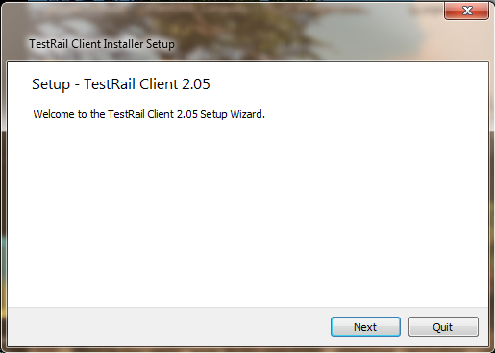

1. Confirm install build

Step 3: Select install type

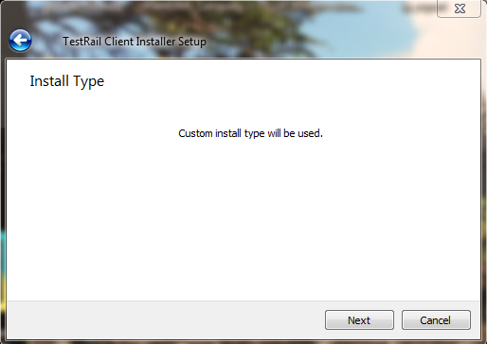

1. Select install type

Step 4: Select install folder

The default install path will be <User home>/TestRail_Client. You can select another path with “Browse” button.

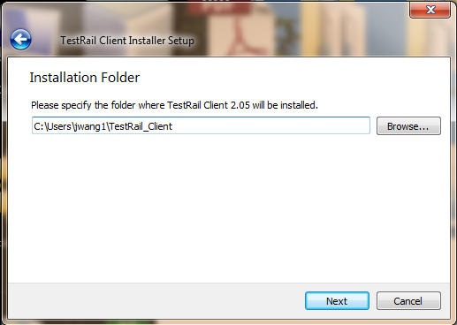

1. Select install folder

Step 5: Select install components

Please select install components, the core component “TMP core component” is the must item to install.

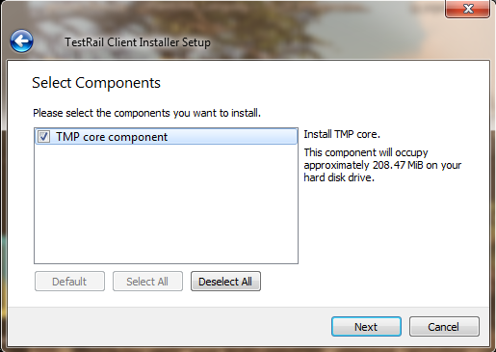

1. Install components select

Step 6 License agreement

Please accept the license before next step.

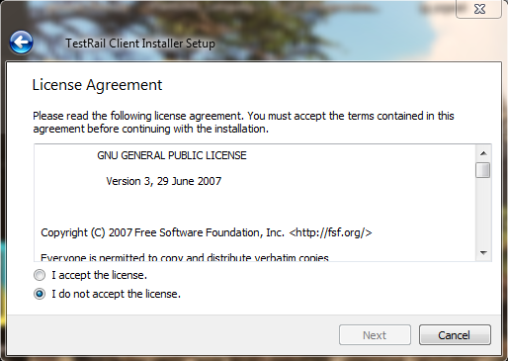

1. Accept the license

Step 7 Create Start Menu shortcuts (Windows)

On Windows platform, setup wizard will create shortcuts in “Start Menu” for your future launch.

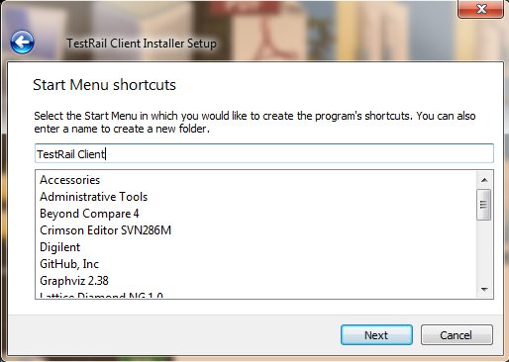

1. Start Menu shortcut create

Step 8 install

Click “install” button to install software.

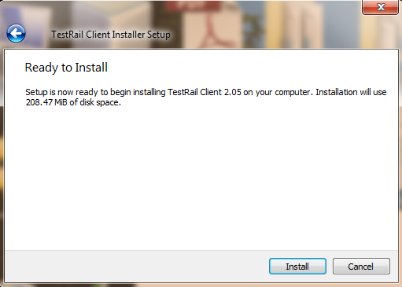

1. Install software

### 2.2.2 Manually install

If you download a source package like: tmp_client_2.16_installer_src_all.tar.gz

You can use 7zip extract the source code on windows or tar command line (tar -xv -f tmp_client_2.16_installer_src_all.tar.gz) on Linux.

Place the source folder as you want.

# Appendix

Software address: \\lsh-smb04\sw\qa\qa_store\TMP_tools\depend_software

TMP client build: Software QA SVN: /release/tmp_client/