User Platform Client usage

**Software Quality Team**

ABSTRACT

This usage guide document will briefly introduce the usage of TMP Client for software verification, this document will include following areas:

1. Client preparations
2. Client install
3. Client initial setting
4. Client run and result check

REVISION HISTORY

|  |  |  |
| --- | --- | --- |
| REVISION | RELEASE DATE | COMMENTS |
| V1.0 | 9/10/2016 | Initial draft |
| V1.1 | 4/11/2017 | Jason Wang |
| V1.2 | 5/10/2019 | Jason Wang |
| V1.3 | 03/05/2020 | Update based on Client version 2.09.xx |

CONTENTS

1 Preparation for TMP Client 5

1.1 What is TMP Client 5

1.2 System requirements 5

1.2.1 Operation System requirements 5

1.2.2 Hard Ware suggestion 5

1.3 System setting (Linux only) 5

1.3 Dependent software and version 5

1.3.1 Java 5

1.3.2 Python 5

1.3.3 Subversion 6

2 Install TMP Client 6

2.1 Export TMP Client build 6

2.2 Install TMP Client build 6

2.2.1 Install with wizard 6

2.2.2 Manually install 9

3 Launch TMP Client 9

3.1 TMP Client initial setting (console mode) 9

3.1.1 Software setting section 9

3.1.2 Machine setting section 9

3.1.3 Preference setting section 10

3.2 launch from Start Menu (Windows) 10

3.3 launch from command line 10

3.4 TMP Client initial setting (GUI mode) 11

3.4.1 Welcome setting 11

3.4.2 Client setting 11

3.4.3 Software setting 11

3.4.4 Preference setting 12

4 TMP Client usage 12

4.1 Main window introduction 12

4.1.1 Overview 12

4.1.2 Menu bar 13

4.1.3 Rejected queue panel 15

4.1.4 Captured queue panel 15

4.1.5 Watching task panel 16

4.1.6 Status bar 17

4.2 Launch a local test suite 17

4.2.1 import a standard suite file 17

4.2.2 import a suite path 18

4.3 Launch remote test suite 18

4.4 Report output 18

4.5 Client info and update 19

5 Appendix 19

# 1 Preparation for TMP Client

## What is TMP Client

TMP (Test Management Platform) Client is used to receive and run test case from TMP server, on the meanwhile client also support test suite run locally.

## System requirements

### Operation System requirements

The following are tested OS and we don’t guarantee OS not list here

Window:

Win 7 or later.

Linux:

RedHat 6 or later

CentOS 7 or later

OpenSUSE 42 or later

Unbuntu 16 or later

### Hard Ware suggestion

CPU core number: 4

Physical memory: 8G

## System setting (Linux only)

TMP Client will launch many test cases concurrently (Depends on user setting in Menu 🡪 Setting 🡪 Preference 🡪 Max Threads) which will exceed the default user open files limitation (1024).

To avoid this limitation, we need to add following two lines into file /etc/security/limits.conf.

* soft nofile 32768

* hard nofile 65536

To verify this modification you can type: ulimit –a

## 1.3 Dependent software and version

### 1.3.1 Java

TMP Client was built with Java 8 build121 32 bits. Although we have patched the whole JRE in the software build but we still suggest you install the JRE on your operation system (Especially on Linux platform).

Minimum Java version 1.8 is required, you can check Java version by type following command in console:

java –version

See appendix for java software.

### 1.3.2 Python

TMP Client will invoke core script to launch every detail test case. Core script was built by Python software, so we need Python ready on your machine.

Python version 2.7.x in 32 bits is required, you can check Python version by type following command in console:

Python –version

TMP client use a python package “psutil” to run system check, so we also need to install this package.

Python psutil version 5.0.0 in 32 bits is required.

TMP client use a python package “MySQL” to run suite file upload, if you need to upload a suite file, please install this package.

Python MySQLdb version 1.2.5 in 32 bits is required.

See appendix for Python software.

### 1.3.3 Subversion

In most case our core script and user case were stored in LSH subversion. So TMP client need subversion ready on your machine.

Subversion version large than 1.6 is required, you can check your version by type following command in console:

svn --version

See appendix for Subversion software.

# 2 Install TMP Client

## 2.1 Export TMP Client build

TMP Client builds will follow the name rules as:

Tmp_client_a.bb_installer_ccc_ddd.dd

a: Public release version

b: Internal release version

ccc: bin/src, binary package or source package

ddd.dd: install platform which can be:

1. linux.run: package for Linux with install wizard.
2. windows.exe: package for windows with install wizard.
3. all.tar.gz: package for all platform with manually install.

For example:

1. tmp_client_2.06_installer_bin_linux.run:

Build version 2.06 for Linux (RedHat, Ubuntu, SUSE) install with wizard available.

1. tmp_client_2.06_installer_bin_windows.exe:

Build version 2.06 for Windows (win7 or later) install with wizard available.

1. tmp_client_2.06_installer_src_all.tar.gz:

Build version 2.06 for all platform install without install wizard (manually install).

Please export the build according your requirements:

See appendix for build location

## 2.2 Install TMP Client build

### 2.2.1 Install with wizard

TMP Client package offer general GUI setups, so you can simply follow with the wizard to install it.

Step 1: Double click install package.

Step 2: Confirm install build and click “Next”

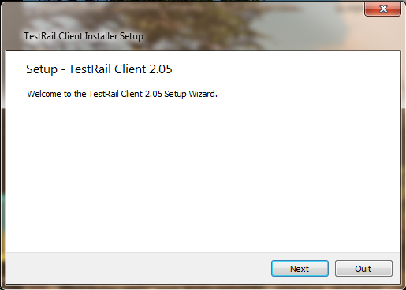

1. Confirm install build

Step 3: Select install type

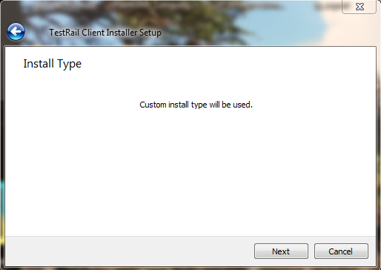

1. Select install type

Step 4: Select install folder

The default install path will be <User home>/TestRail_Client. You can select another path with “Browse” button.

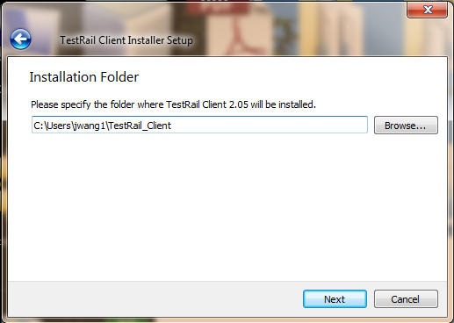

1. Select install folder

Step 5: Select install components

Please select install components, the core component “TMP core component” is the must item to install.

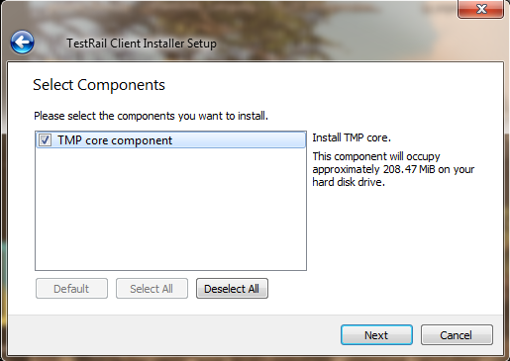

1. Install components select

Step 6 License agreement

Please accept the license before next step.

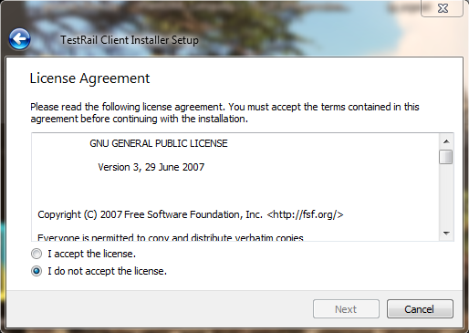

1. Accept the license

Step 7 Create Start Menu shortcuts (Windows)

On Windows platform, setup wizard will create shortcuts in “Start Menu” for your future launch.

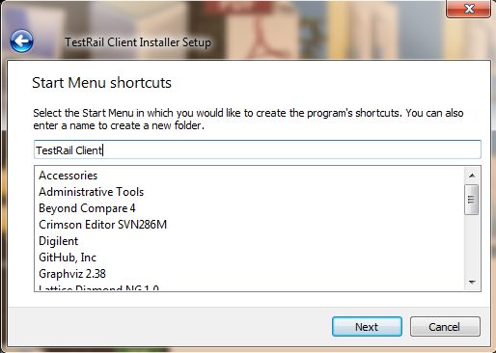

1. Start Menu shortcut create

Step 8 install

Click “install” button to install software.

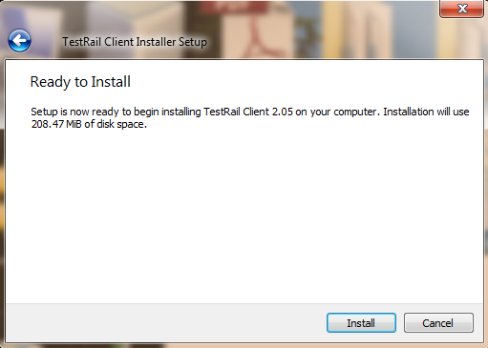

1. Install software

### 2.2.2 Manually install

If you download a source package like: tmp_client_2.05_installer_src_all.tar.gz

You can use 7zip extract the source code on windows or tar command line (tar -xv -f tmp_client_2.05_installer_src_all.tar.gz) on Linux.

Place the source folder as you want.

# Launch TMP Client

## TMP Client initial setting (console mode)

This section is for TMP Client run in console mode only. For GUI mode initial setting will be launched after GUI start.

We can find the initial setting file from:

1. First launch: <client_install_path>/conf/default.ini.
2. Future launch:<user_home_path>/client_conf/<machine_name>.ini

The xxx.ini file contains two kinds of sections:

1. Section without “tmp_” : Client software setting section
2. Section with “tmp_” : Client setting section.

### 3.1.1 Software setting section

Please use software name as the section name.

max_insts : used to define the maximum instance number this software can be launched.

scan_dir : Client will automatically scan this path to add new software build path.

version and path pair: user specify the software version and the path manually.

You can specify as much version path pair as you like.

### 3.1.2 Machine setting section

Group: setting the client group name.

Private: value can be “0” or “1”, the default name is “1” if not present.

“0”: public client will run assigned and matched task.

“1”: private client will run assigned task only.

Terminal: client name setting, client will scan machine name if not present.

Unattended: The value can be “0” or “1”. The default value is “0” if option not present.

“0”: Attended Mode. SW will do some special work (i.e. SW update) under user’s operation.

“1”: Unattended Mode. SW will do some special work (i.e. SW update) automatically.

Debug: Client run in debug mode or not.

“0”: Client will run in normal mode.

“1”: Client will run in debug mode.

### 3.1.3 Preference setting section

Link_mode: value can be “both”, “remote” and “local”. Client linked server select.

Max_threads: Maximum threads (test case) can be launched.

Thread_mode: value can be “auto” and “manual”

Task_mode: auto, serial and parallel.

Auto: client will take top priority level tasks and run parallel these tasks.

Serial: client will run task one by one according the task priority

Parallel: client will run tasks in parallel mode

Work_space: client work space, client will download and run case in this folder.

Save_space: client result save space. If not present client will skip copy case runtime results.

## 3.2 launch from Start Menu (Windows)

On Windows platform we can launch TMP client from start menu.

Please click “Start Menu” 🡪 “All Programs” 🡪 “TestRail Client” 🡪 “client”

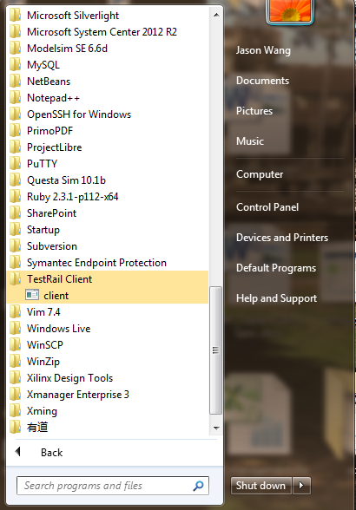

1. Launch from start menu

## 3.3 launch from command line

Please use following command lines to launch client:

1. <client_install_path>/bin/clientc.exe –c (console mode)
2. <client_install_path>/bin/client.exe (GUI mode)
3. Java –jar <client_install_path>/bin/client.jar –c (console mode)
4. Java –jar <client_install_path>/bin/client.jar (GUI mode)

## 3.4 TMP Client initial setting (GUI mode)

### 3.4.1 Welcome setting

You will be prompted a welcome setting dialog like following:

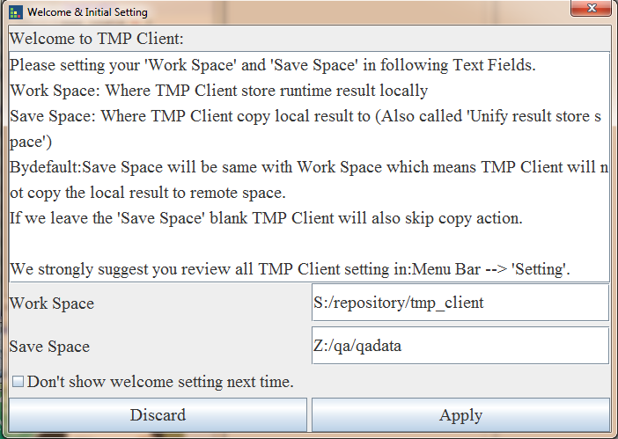

1. Welcome setting

You can specify ‘work space’ and ‘save space’ and click ‘Apply’ button to finish the setting.

Also you can click the “Don’t show welcome setting next time” check box to disable this dialog prompted next time.

### 3.4.2 Client setting

Click “Setting” 🡪 “Client…”

Run client setting in GUI way. Please refer 3.1.2 for details option descriptions.

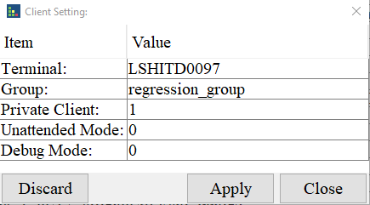

1. Client Setting

### 3.4.3 Software setting

Click “Setting” 🡪 “Software…”

Run software setting in GUI way. Please refer 3.1.1 for details option descriptions.

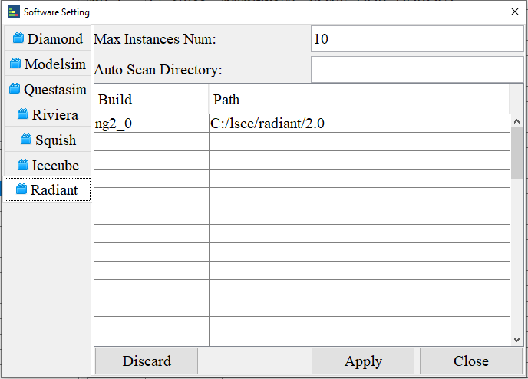

1. Software Setting

### 3.4.4 Preference setting

Click “Setting” 🡪 “Preference…”

Run Preference setting in GUI way. Please refer 3.1.3 for details

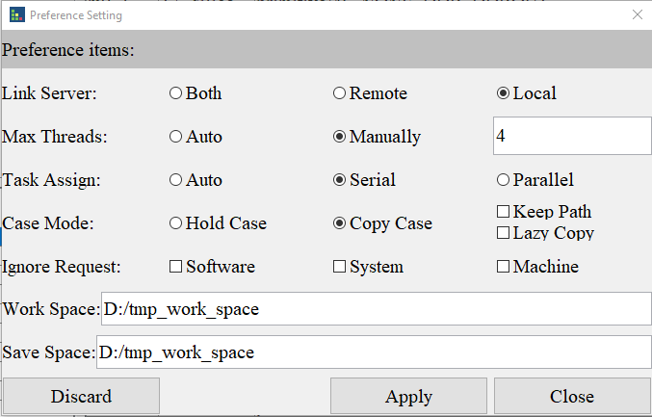

1. Preference Setting

# TMP Client usage

## 4.1 Main window introduction

### 4.1.1 Overview

Client main view constructed by 5 sections:

1. Menu bar
2. Rejected queue panel
3. Captured queue panel
4. Watching task panel
5. Status bar

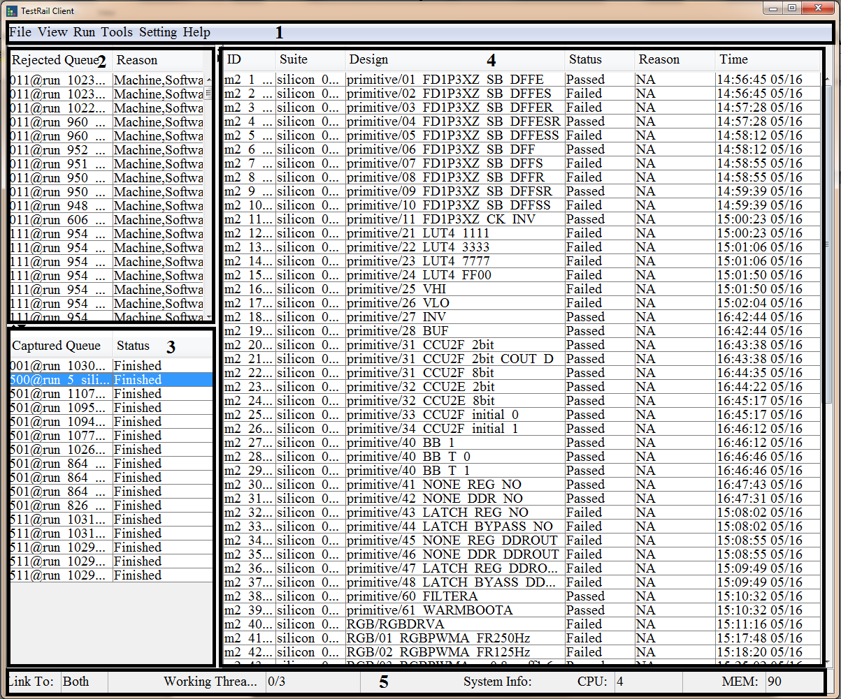

1. Client main view

### 4.1.2 Menu bar

#### 4.1.2.1 File menu

“Import…”: Allow you import and run a standard test suite (suite Excel file, suite path)

“Export…”: Export test report.

“Exit”: Exit/Close software. (If you just click close button on the main view, client will just close the window and hide. You can re-open the client window from system tray.)

#### 4.1.2.2 View menu

Actions for “watching task panel (4)”:

“All”: Show all task cases in this task.

“Waiting”: Show waiting task cases in this task.

“Processing”: Show processing task cases in this task.

“Failed”: Show failed task cases in this task.

“Passed”: Show passed task cases in this task.

“TBD”: Show TBD task cases in this task.

“Timeout”: Show timeout task cases in this task.

#### 4.1.2.3 Run menu

Actions for “Captured queue panel (3)” and “watching task panel (4)”

“Play”: action for “Captured queue panel (3)”, when there is a captured task selected, “Play” will restart this task.

“Pause”: action for “Captured queue panel (3)”, when there is a captured task selected, “Pause” will pause this task.

“Stop”: action for “Captured queue panel (3)”, when there is a captured task selected, “Stop” will stop this task.

“Retest” action for “watching task panel (4)”. Retest the test case in watching task according with the condition selected.

#### 4.1.2.4 Tools menu

##### 4.1.2.4.1 Upload

Integration tool allow you to update standard test suite to TMP server.

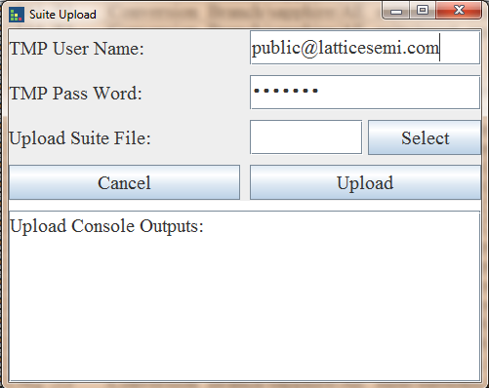

1. Suite upload dialog

Please input your user name and pass word given by TMP admin.

Use “Select” button to select test suite you want to upload to server.

Click “Upload” button to start upload.

All output lines will be shown in “Upload Console Outputs” window.

##### 4.1.2.4.2 Keygen

Integration tool allow you generate encryption code for your account and password which will be show on TMP website (auth_key = xxx)

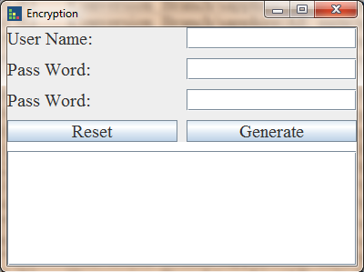

1. Key generate

#### 4.1.2.5 Setting menu

Client setting, refer to 3.4 section

#### 4.1.2.6 Control menu

Client control, we shutdown/restart client or host machine.

#### 4.1.2.7 Help menu

“Usage”: show this help document and some demo usage.

“Contact”: create email and send to Client developer.

“About”: show client version information

### 4.1.3 Rejected queue panel

All rejected task will be shown here with queue name and rejected reason.

You can select one queue and make a right click to popup a “popup menu”, click “Details” to show details information:

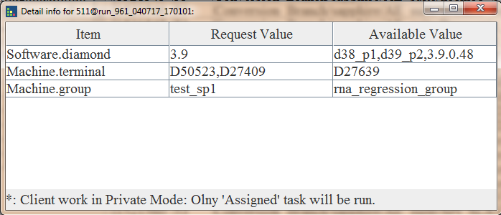

1. Detail rejects view

You will be shown request values and current client value.

### 4.1.4 Captured queue panel

All captured task will be shown here with queue name and current status.

You can select one queue and make a right click to popup a “popup menu” like following:

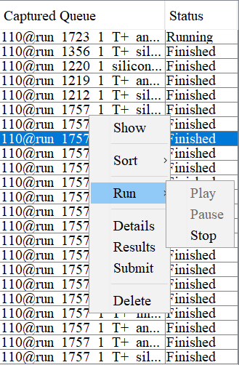

1. Captured panel popup menu

“Show”: click this button will show detail run case info in “watching task panel (4)”

“Sort 🡪 Priority”: Sorting captured queue according queue priority

“Sort 🡪 RunID”: Sorting captured queue according queue run ID

“Sort 🡪 Time”: Sorting captured queue according queue time

“Sort 🡪 Status”: Sorting captured queue according queue status

“Run 🡪 Play”: same function as 4.1.2.3 Run menu, make the select captured queue re-start

“Run 🡪 Pause”: same function as 4.1.2.3 Run menu, make the select captured queue pause

“Run 🡪 Stop”: same function as 4.1.2.3 Run menu, make the select captured queue stop

“Details”: Show detail information about this queue

“Results”: Open the run location for this queue

“Submit”: Generate the submit code (used for code check-in)

“Delete”: Delete this queue and it’s run results

### 4.1.5 Watching task panel

Watching task panel will show task queue data.

You can select one task case and make a right click to popup a “popup menu” like following:

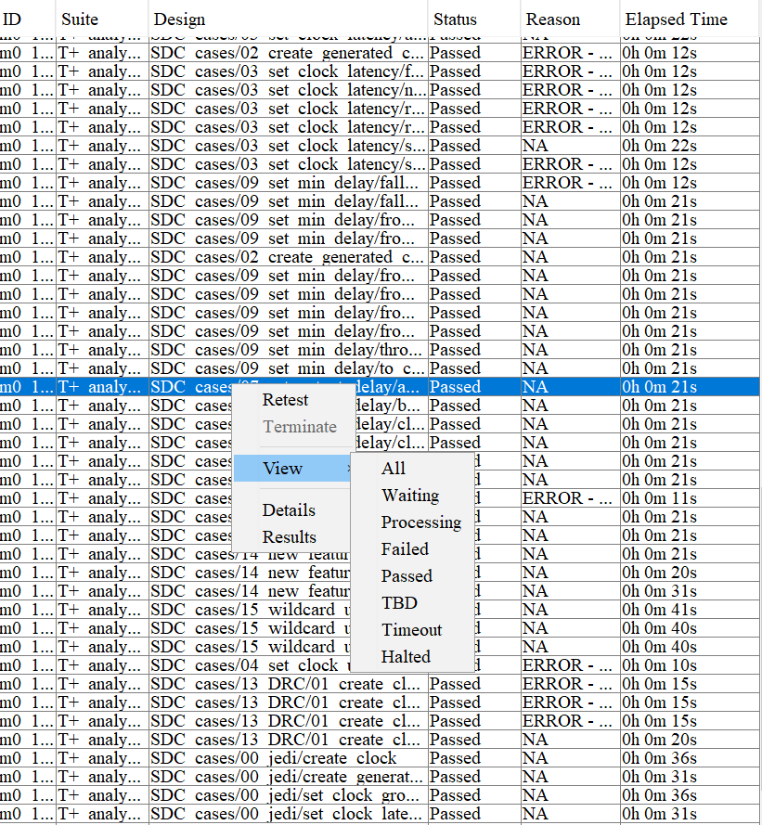

1. Task panel popup menu

“Retest”: will retest this case.

“Terminate”: will terminate the running case.

“View”: same function as 4.1.2.2 view menu.

“Details”: Show test case detail information.

“Results”: open the task case result folder.

### 4.1.6 Status bar

Status bar will show you current running threads number and current system info like MEM and CPU.

## 4.2 Launch a local test suite

Step 1: make sure your client not running in remote mode (Setting 🡪 Preference 🡪 link server)

Step 2: click File 🡪 import…

### 4.2.1 import a standard suite file

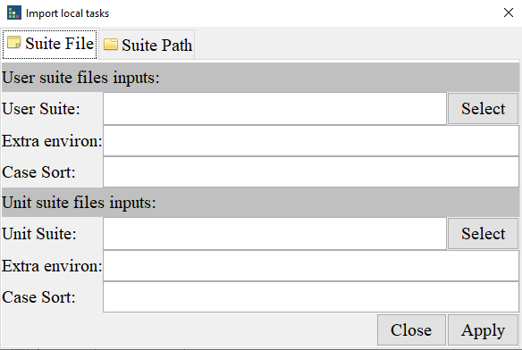

1. Import suite file

Here we have ‘User suite files inputs’ and ‘Unit suite files inputs’ the only difference is:

When you click ‘Select’ in ‘User suite files inputs’ Client will go to ‘<User home>’ directory.

When you click ‘Select’ in ‘Unit suite files inputs’ Client will go to ‘<client_install_path>/doc/ TMP_EIT_suites’ directory.

1. click ‘Select’ to find the suite file (Excel file)
2. if you have special environment to set, please put it in ‘Extra environ’
3. ‘Case Sort’ used to select test case, demo: ‘option1=value1, value2;option2=value1’ here option1 and option2 are titles in suite file
4. Click ‘Apply’ to start testing

### 4.2.2 import a suite path

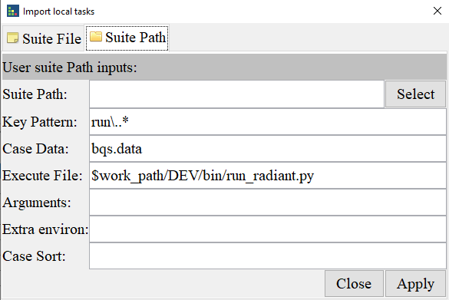

1. Import suite path

Client also support a suite path import. Client use ‘Key Pattern’ for test case identification and ‘Execute File’ for test script.

## 4.3 Launch remote test suite

Make sure your client not running in local mode (Setting 🡪 Preference 🡪 link server).

## 4.4 Report output

click File 🡪 Export….

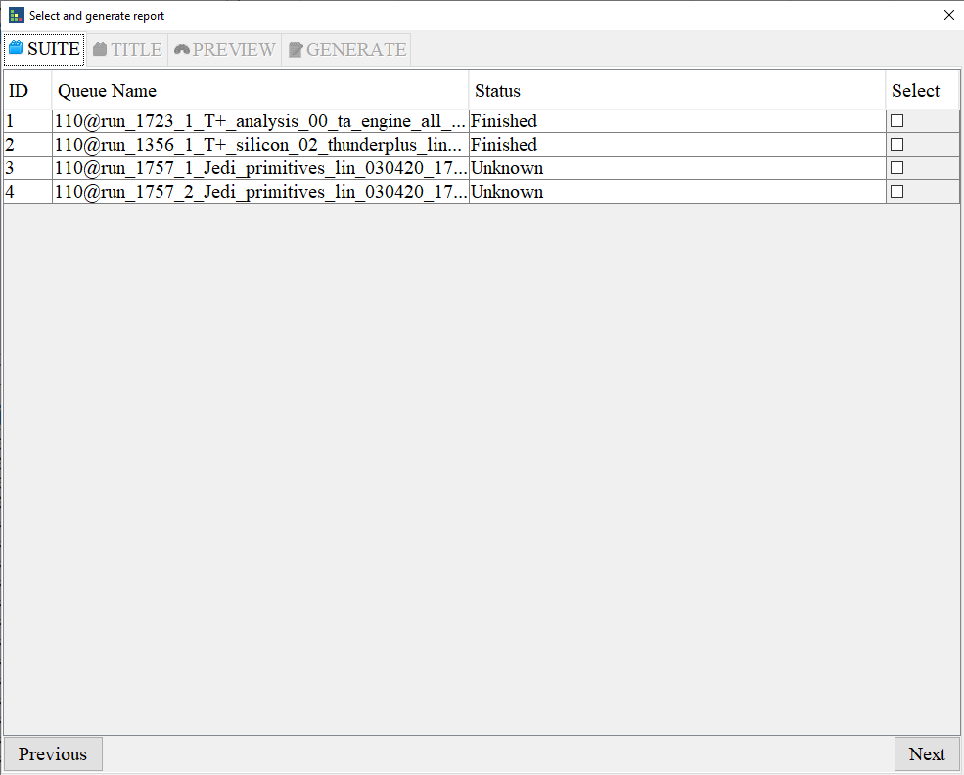

1. Export dialog

Select test queue and the titles for export and generate test report according the wizard.

## 4.5 Client info and update

Click ‘Help’ 🡪 ‘About’ you will see following picture.

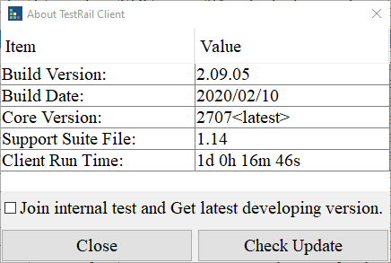

1. About dialog

In this dialog we can see the detail client version and build date.

Click ‘Check Update’ for new client update.

# Appendix

Software address: \\lsh-smb01\sw\qa\qa_store\TMP_tools\depend_software

TMP client build: Software QA SVN: /release/tmp_client/