 | SERVICE REQUEST FORM  工程服务单 | SR NO. :  WO-00416180
Version 4.00
Customer Company (公司名称) : 鼎泰匠芯  Contact (联系人) : 刘江梅  Phone (联系电话) : 177 0170 0405 | ❑ Factory Warranty  Ext. Warranty  IC Internal*
 | ❑ Agreement  Gratis  Trade*  Internal Agilent*
 | * PO# :
Serial Number (机台序号) : JP61370554 | Tester Type (机台型号) : N9100A
Problem Description (故障现象) : Installation
Delivery
Receive Date :  客户报修时间 2022/3/9 |  |  | On-site Date :  服务起始时间2022/3/9 10:00 |  | Finish Date :  服务结束时间2022/3/11 15:00
Service Action :
处理过程
- Connect the cable (cabinet & test head).
- Install the RMK, keyboard and mouse.
3. Power on.
4. Start PGU connection, config
5. Run diag ,all pass
○ Installation Deinstallation Relocation  Trace Cal Repair
Others: Account Mgt; Consulting; Customer Training; Soft Support; System Backup; Site Verification; Site Preparation; Upgrade
Labor Hour | 8 | Periods of Labor Time (On-site >1 day) |  | Periods of OT (On-site >1 day)
Travel Hour | 1
OT
Waiting Time
Parts Usage Parts Collection ID: _______
Part Number | Quantity | Used Code* | Failure Code* | Part Number | Quantity | Used Code* | Failure Code*
[所有零件均需归还库房, 如有无法归还之坏品(如消耗品)请另标注 “no return”于处理过程]
* 坏品归还: ‘C’ + Filure Code (38-坏品; 78-Service Note Upgrade;, 99-人为破坏)
* 好品归还/ 错装品 (WPIB)/ 误送品: ‘U’ + <空白>
* 坏品到货 (DOA): ‘U’ + 55-DOA
客户评价 ： 非常满意 满意 尚可 不满意* 原因* :
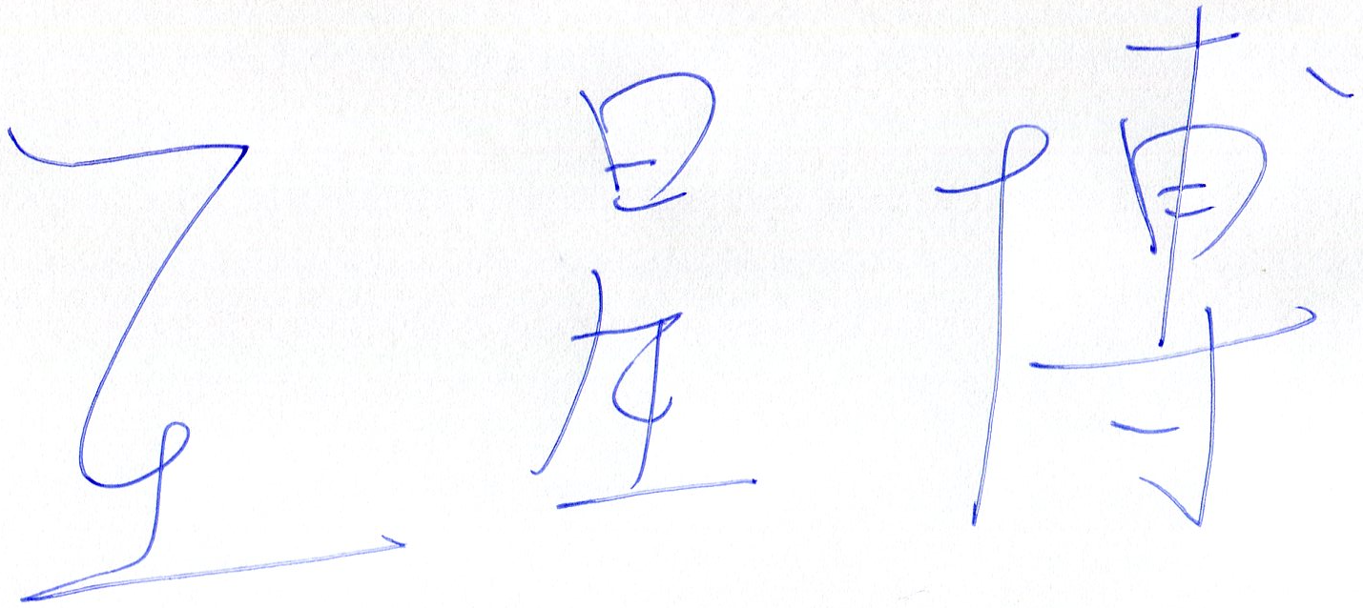
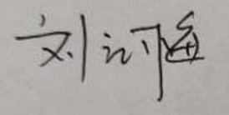

________
Keysight Service Engineer Signature Customer Signature / Date
Service Hotline: 800 -810-0189 E-mail: china-cs@keysight.com

