Methodology Report
SkyHub Airport — Power BI Dashboard

Data Visualisation & Business Intelligence Project

Wangi IKOLI & Anis Zouari Consulting
February 2025

Table des matières
1. Introduction and Overall Approach 2
1.1 Project Scope 2
1.2 Methodology 2
2. Data Quality and Power Query Transformations 3
2.1 Flights Table Transformations 3
2.2 Multi-Sheet Consolidation 3
2.3 DIM_Date — Calendar Table 4
3. Data Model 4
3.1 Star Schema Architecture 4
4
3.2 Relationships 4
3.3 Design Justification 5
4. DAX Measures and Calculations 5
5. Dashboard Design: Visual Choices and Page Logic 6
5.1 Home Page — Navigation Hub 6
5.2 Global View — Executive Summary 6
5.3 Air Operations — Operational Efficiency 7
5.4 Commercial Performance — Revenue and Pricing 7
5.5 Customer Experience — Satisfaction and Service Quality 7
5.6 Bagages — Baggage Claims Management 7
6. Storytelling and Narrative Structure 8
6.1 Narrative Progression 8
6.2 Cross-Page Analytical Insights 8
6.3 Visualisation Principles 8
7. Limitations and Difficulties Encountered 9
7.1 Data Quality Risks 9
7.2 Analytical Scope Decisions 9
7.3 Technical Debt 9
7.4 Fictional Data Constraints 9
8. Conclusion 10

1. Introduction and Overall Approach
This report documents the methodology employed in designing and building a Power BI dashboard for SkyHub Airport, a fictional airline operating out of Frankfurt Airport (FRA). The dataset spans three years of operational data (January 2022 to December 2024) and encompasses flight operations, passenger satisfaction, commercial performance, and baggage handling.
The primary objective was to transform nine heterogeneous raw data files into a coherent, interactive, and visually compelling dashboard that enables airline executives to monitor key performance indicators and derive actionable insights. The dataset comprises over 65,000 records across CSV, Excel, and TSV formats, each presenting distinct data quality challenges.

1.1 Project Scope
Source File | Format | Records | Description
flights_2022_2024.csv | CSV | 12,173 | Core flight operations: revenue, delays, cargo, fuel
delays_incidents.csv | CSV | 2,970 | Incident reports with severity, cost, resolution
ticket_sales.csv | CSV (;) | 1,077 | Monthly sales by destination with pricing data
satisfaction_surveys.csv | CSV | 5,000 | Passenger ratings across 10 service criteria
passengers.xlsx | Excel (2 sheets) | 43,807 | Business Class (6,549) + Economy Class (37,258)
crew.xlsx | Excel (2 sheets) | 210 | Cockpit Crew (60) + Cabin Crew (150)
baggage_claims.txt | TSV | 1,752 | Baggage claims with compensation and resolution data
destinations.csv | CSV | 30 | Destination reference table with geographic metadata
fleet.csv | CSV | 25 | Aircraft specifications and maintenance records

1.2 Methodology
Our approach followed a structured ETL-to-visualisation pipeline comprising four phases: (1) data profiling and quality assessment of all source files, (2) Power Query transformations for cleaning, type conversion, and table consolidation, (3) star schema data modelling with DAX measures for calculated KPIs, and (4) dashboard design across five analytical pages following a general-to-specific narrative progression as prescribed by the project guidelines.

2. Data Quality and Power Query Transformations
Thorough data profiling revealed several quality issues across the source files. All corrections were performed within Power Query Editor to ensure full traceability and reproducibility. The following table summarises the issues and their resolutions.
Issue | Source | Details | Resolution
Mixed date formats | flights | 11,432 rows YYYY-MM-DD + 741 rows DD/MM/YYYY | Locale set to FR, column type changed to Date
Text in numerics | crew, fleet | "EUR" suffix in 5 salary values; "hrs" in 2 flight hour values | Text replacement, then numeric conversion
Non-standard separator | ticket_sales | Semicolon (;) delimiter instead of comma | Delimiter parameter configured at import
Multi-sheet Excel | crew, passengers | Data split across 2 sheets per file (71–85% data loss if missed) | Both sheets imported and appended into unified tables
Structural nulls | surveys, flights | Lounge rating null for Economy; 360 null revenues (3%) | Preserved as null (analytically meaningful)
TSV with symbols | baggage_claims | Tab-separated .txt file with currency symbols in amounts | Tab delimiter configured, text cleanup on monetary columns

2.1 Flights Table Transformations
As the central fact table, flights_2022_2024 required particular attention. The date column posed the most significant risk: had the 741 European-format dates not been detected, a date like 05/03/2023 would have been silently parsed as May 3rd instead of March 5th, corrupting all monthly aggregations. The locale was set to French to ensure correct interpretation. Numeric columns (passengers, delay_minutes, fuel_consumption_kg, cargo_kg, distance_km, flight_revenue_eur, load_factor_pct) were explicitly cast to Decimal Number type, with null values preserved rather than replaced with zeros.

2.2 Multi-Sheet Consolidation
Both crew.xlsx and passengers.xlsx required careful handling. Default import behaviour in Power BI captures only the first sheet, which would have resulted in losing 150 out of 210 crew members (71% loss) and 37,258 out of 43,807 passenger records (85% loss). Each sheet was imported as a separate query, then appended into a unified table using Power Query's Append Queries function.

2.3 DIM_Date — Calendar Table
A dedicated date dimension was created using DAX CALENDAR(DATE(2022,1,1), DATE(2024,12,31)), enriched with derived columns: Year, Quarter, Month Number, Month Name, Annee_Mois (YYYY-MM for chronological sorting), and Trimestre (YYYY-Q format). This table serves as the single source of truth for all time-based filtering and aggregation, enabling consistent temporal analysis across all dashboard pages.

3. Data Model

3.1 Star Schema Architecture
The model follows a star schema with flights_2022_2024 as the central fact table, connected to dimension tables (DIM_Date, destinations, fleet) and satellite fact tables (delays_incidents, satisfaction_surveys, baggage_claims, passengers, ticket_sales) through foreign key relationships.

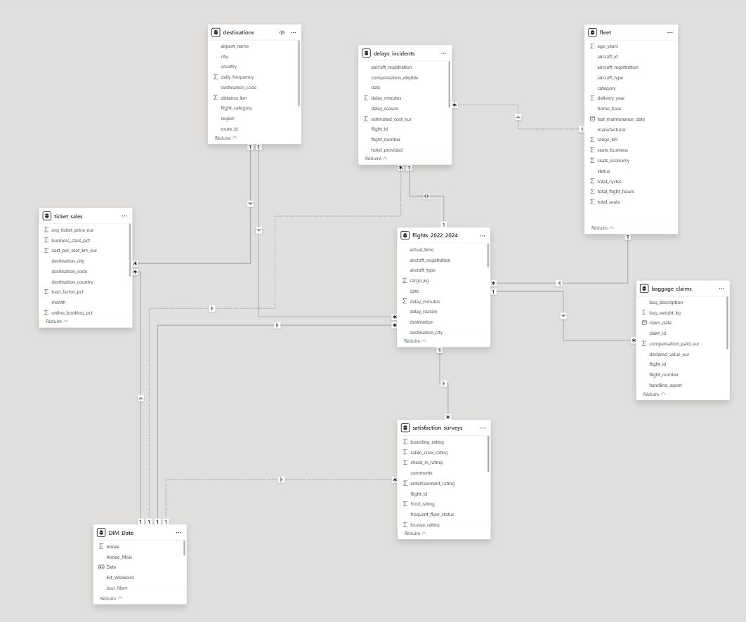

3.2 Relationships
From (Foreign Key) | To (Primary Key) | Cardinality | Filter Direction
flights.date | DIM_Date.date | Many-to-One | Single
flights.destination | destinations.destination_code | Many-to-One | Single
flights.aircraft_registration | fleet.registration | Many-to-One | Single
delays_incidents.flight_id | flights.flight_id | Many-to-One | Single
satisfaction_surveys.flight_id | flights.flight_id | Many-to-One | Single
baggage_claims.flight_id | flights.flight_id | Many-to-One | Single
passengers.flight_id | flights.flight_id | Many-to-One | Single

3.3 Design Justification
The star schema was chosen over alternatives (flat table, snowflake) for three reasons. First, Power BI's VertiPaq engine is specifically optimised for star schemas, resulting in faster DAX calculations and visual rendering. Second, single-direction filter propagation from dimensions to facts ensures predictable slicer behaviour without circular dependency issues. Third, separating dimensions from facts improves maintainability: adding a new destination only requires updating the 30-row dimension table, not the 12,173-row fact table.
The fleet and crew tables were intentionally excluded from dashboard visualisations. The fleet dataset contains only 25 aircraft with limited operational variation, and the crew table primarily offers static HR data (names, salaries, seniority) with no measurable causal link to flight performance within the available data. We determined that visualising these dimensions would not yield actionable insights proportionate to the visual space they would consume. The model relationships were nevertheless maintained for potential future drill-through analysis.

4. DAX Measures and Calculations
A total of 22 named DAX measures were created, organised by analytical domain. Explicit named measures ensure consistency, reusability, and centralised business logic across all dashboard pages. Two key design principles govern all measures: DIVIDE() is used instead of the arithmetic operator (/) to prevent division-by-zero errors, and CALCULATE() with row-level filters enables conditional aggregations.
Measure | DAX Formula | Page
CA Total | SUM(flights[flight_revenue_eur]) | Global, Air Ops
Nombre de Vols | COUNTROWS(flights_2022_2024) | Global, Air Ops
Passagers Total | SUM(flights[passengers]) | Global
Nb Destinations | DISTINCTCOUNT(flights[destination_city]) | Global
Taux Ponctualite | DIVIDE(CALCULATE(COUNTROWS(...), [status]<>"Delayed"), ...) | Global
CA par Vol | DIVIDE(SUM([revenue]), COUNTROWS(flights), 0) | Air Ops
Load Factor Moy | AVERAGE(flights[load_factor_pct]) | Air Ops
Taux Annulation | DIVIDE(CALCULATE(..., [status]="Cancelled"), ...) | Air Ops
Cargo Total | FORMAT(SUM([cargo_kg])/1000, "#,##0") & " T" | Air Ops
Distance Totale | FORMAT(SUM([distance_km])/1000, "#,##0") & " K km" | Air Ops
Cout Retards | SUM(delays_incidents[estimated_cost_eur]) | Air Ops
CA par Passager | DIVIDE(SUM([revenue]), SUM([passengers]), 0) | Commercial
% Business Class | AVERAGE(ticket_sales[business_class_pct]) | Commercial
% Reservation en ligne | AVERAGE(ticket_sales[online_booking_pct]) | Commercial
NPS Moyen | AVERAGE(surveys[nps_score]) | Customer
Satisfaction Moy | AVERAGE(surveys[overall_satisfaction]) | Customer
Taux Recommandation | DIVIDE(CALCULATE(..., [would_recommend]="Yes"), ...) | Customer
Taux Resolution Bagages | DIVIDE(CALCULATE(..., [status]="Resolved"), ...) | Bagages
Compensation Versee | SUM(baggage_claims[compensation_paid_eur]) | Bagages

5. Dashboard Design: Visual Choices and Page Logic
The dashboard comprises a home page and five analytical pages. Each page is built around a single business question, with visual types selected for their analytical appropriateness rather than aesthetic preference.

5.1 Home Page — Navigation Hub
The home page provides an intuitive entry point with five navigation buttons, each linking to an analytical page. A branded aviation background image establishes the visual identity of the report. This page contains no data visuals, maintaining a clean separation between navigation and analysis.

5.2 Global View — Executive Summary
Business question: "How is the airline performing overall?"
This page provides the high-level overview that a C-level executive consults first. Five KPI cards display the most critical metrics: Total Flights, Total Passengers, Total Revenue, Number of Destinations, and Punctuality Rate. An area chart tracks monthly revenue trends, with the area encoding emphasising cumulative magnitude while revealing seasonality. A donut chart breaks down revenue by geographic region, leveraging the part-to-whole relationship inherent to this chart type. A horizontal bar chart ranks the top destinations by revenue, with horizontal orientation chosen to accommodate long city names. Two interactive slicers (Region and Country) enable cross-filtering across all visuals.

5.3 Air Operations — Operational Efficiency
Business question: "Are our flights operationally efficient and punctual?"
The KPI cards on this page were deliberately chosen to avoid duplicating Global View metrics. Instead of revenue and passenger counts, the cards display operational indicators: Cancellation Rate, Cargo Volume, Total Distance, Fuel Consumption, Load Factor, and Revenue per Flight. A line chart tracks revenue evolution by quarter, with quarterly granularity chosen to smooth monthly noise while preserving seasonal patterns. A clustered bar chart identifies the most expensive delay causes, directly informing operational improvement priorities. Two donut charts show flight status distribution and incident severity breakdown. Two performance tables compare route categories (Short-haul, Medium-haul, Long-haul) across multiple metrics, enabling cross-category benchmarking.

5.4 Commercial Performance — Revenue and Pricing
Business question: "Which routes and segments are most profitable?"
This page exclusively leverages the ticket_sales table, which is not used in any other page, ensuring zero content redundancy. KPI cards display purely commercial metrics: Business Class percentage, Online Booking rate, Average Ticket Price, and Revenue per Passenger. A clustered bar chart reveals ticket pricing disparities across destinations, informing yield management decisions. A line chart tracks the online booking percentage over time, monitoring the digital transformation of sales channels. A bar chart compares cost-per-seat-km across route categories, providing unit economics visibility. A matrix table enables multi-dimensional profitability assessment by destination.

5.5 Customer Experience — Satisfaction and Service Quality
Business question: "Are our passengers satisfied, and what drives their experience?"
This page consolidates all passenger-facing metrics. KPI cards present NPS Score, Satisfaction Average, Recommendation Rate, Wifi Rating, and total Survey Count. Clustered column charts compare satisfaction levels by travel class and by individual service criteria (seat comfort, cabin crew, wifi), pinpointing specific dimensions for targeted improvement. A horizontal bar chart reveals regional variations in satisfaction. A line chart tracks NPS evolution over time, indicating whether the overall customer experience is improving or declining.

5.6 Bagages — Baggage Claims Management
Business question: "How effectively are we handling baggage incidents?"
This final page provides the most granular operational view. Four KPI cards frame the performance: Total Claims, Resolution Rate, Compensation Paid, and Average Resolution Days. A column chart maps claims by destination city, identifying routes with disproportionate baggage issues that may indicate handling partner problems at specific airports. A line chart shows the monthly claims trend over the three-year period, revealing whether baggage handling is improving or deteriorating over time.

6. Storytelling and Narrative Structure

6.1 Narrative Progression
The dashboard follows a general-to-specific narrative progression, mirroring how airline executives naturally consume information:
- Global View sets the scene with macro KPIs, answering the first question every executive asks: "Are we performing well overall?" The geographic slicers allow immediate exploration of areas of interest.
- Air Operations investigates the operational engine behind those numbers. If revenue is growing but punctuality is declining, this page reveals why — identifying the root causes of delays and their financial impact.
- Commercial Performance examines monetisation strategy. It answers the question that naturally follows operational analysis: "Given our capacity, are we extracting maximum value from it?"
- Customer Experience connects cause to effect. Delays and service quality directly impact passenger satisfaction — this page closes the analytical loop between operations and outcomes.
- Bagages provides the most actionable layer, translating abstract satisfaction scores into concrete process improvement targets with measurable resolution rates and compensation costs.

6.2 Cross-Page Analytical Insights
The dashboard enables cross-page reasoning that would be impossible with isolated reports. Delay causes identified on Air Operations can be correlated with satisfaction dips on Customer Experience. High-revenue routes on Global View can be evaluated against their pricing efficiency on Commercial Performance. Baggage claim hotspots can be mapped to specific destinations, revealing whether handling partners at certain airports are underperforming.

6.3 Visualisation Principles
Throughout the dashboard, we applied principles from established data visualisation literature: high data-ink ratio with minimal decorative elements (Few, 2012); purposeful use of colour as a preattentive attribute — consistent hues for consistent categories; and cognitive load management through a maximum of 6–7 KPI cards and 4–5 charts per page (Knaflic, 2015).

7. Limitations and Difficulties Encountered

7.1 Data Quality Risks
The mixed date formats in the flights table represented the most critical data quality risk. If undetected, it would have caused silent data corruption affecting all time-based analyses. The multi-sheet Excel files presented a similarly dangerous pattern: default import captures only the first sheet, which would have discarded 71% of crew records (150/210) and 85% of passenger records (37,258/43,807). These issues underscore the importance of systematic data profiling before transformation.

7.2 Analytical Scope Decisions
The fleet (25 aircraft) and crew (210 members) tables were excluded from visualisations. Fleet data offers insufficient variation for meaningful analysis, and crew data provides static HR information without measurable causal links to flight performance. This was a deliberate scope decision: incorporating low-value dimensions would have diluted the dashboard's analytical focus without generating proportionate insight.

7.3 Technical Debt
A small number of implicit aggregations (Sum/Min applied directly in visual field wells rather than through named measures) remain in secondary visuals. These should be replaced with explicit DAX measures in future iterations for full consistency. Additionally, some residual overlap exists between Global View and Air Operations: CA Total and Nombre de Vols appear on both pages, though they serve different purposes — headline KPIs on Global View versus route category comparison within tables on Air Operations.

7.4 Fictional Data Constraints
As the SkyHub dataset is entirely synthetic, observed patterns may not reflect real-world airline complexity. The even distribution of certain variables suggests synthetic generation, and the satisfaction sample (5,000 surveys over three years) is relatively small for robust statistical inference. These constraints limit the depth of analysis but do not compromise the methodological rigour of the dashboard design itself.

8. Conclusion
This project demonstrates the complete transformation of heterogeneous raw data into an interactive business intelligence dashboard. The methodology encompassed systematic data profiling, rigorous Power Query cleaning, principled star schema modelling, and purposeful visualisation design driven by clear business questions.
The resulting five-page dashboard guides users through a logical analytical journey — from executive overview through operational efficiency, commercial performance, customer experience, and baggage operations. Each page answers a distinct question, and the general-to-specific progression ensures that both high-level trends and granular operational insights are accessible.
Key design decisions — star schema architecture, DIVIDE-based DAX measures, page-level content segregation, and deliberate exclusion of low-value dimensions — reflect a methodology grounded in both industry best practices and pragmatic analytical judgement. While certain limitations remain, the dashboard provides a robust foundation for data-driven decision-making within the SkyHub Airport operational context.

