河南科技学院
2018届本科毕业论文（设计）

英文文献及翻译
Studying the evolution of PHP web applications

学生姓名： 王 佳

所在院系： 信息工程学院

所学专业： 计算机科学与技术

评阅意见： 导师签名:

英文原文：
PHP 7 Data Structures and Algorithms

1 Understanding selection sort
Selection sort is another comparison-based sorting algorithm, which looks similar to bubble sort. The biggest difference is that it takes fewer swapping than bubble sort. In selection sort, we first find the minimum/maximum item of the array and place it in the first place. If we are sorting in descending order, then we will take the maximum value from the array. For ascending order, we will take the minimum value. In the second iteration, we will find the second-most maximum or minimum value of the array and place it in second place. This goes on until we place each number into a correctly sorted position. This is known as selection sort. The pseudocode for selection sort looks like this:
procedure selectionSort( A : list of sortable items )
n = length(A)
for i = 1 to n inclusive do
min = i
for j = i+1 to n inclusive do
if A[j] < A[min] then
min = j
end if
end for
if min != i
swap(a[i],a[min])
end if
end for
end procedure
If we look at the preceding algorithm, we can see that, after iteration one in the outer loop, the first minimum item is stored in position one. During the first iteration, we selected the first item and then found the minimum value from the remaining items (from 2 to n). We assumed that the first item is the minimum value. If we find another minimum value, we would mark its position until we have scanned the remaining list and found a new minimum value. If no minimum value is found, then our assumption is correct, and that is indeed the minimum value. Here is a picture illustrating our 20, 45, 93, 67, 10, 97, 52, 88, 33, 92 arrays during the first two steps in selection sort:
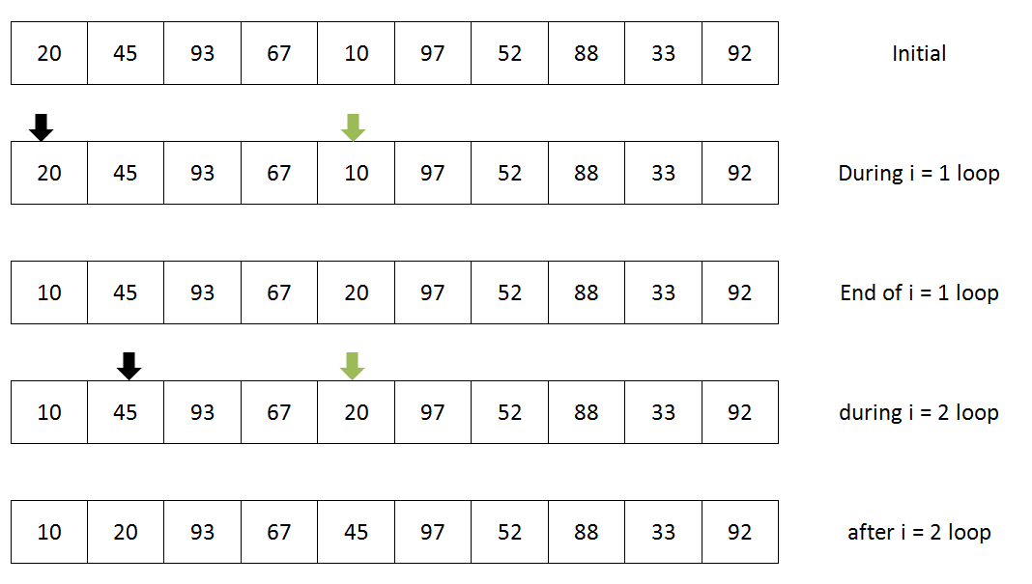
As we can see in the preceding image, we started with the first item in the list, which is 20. Then, we found the minimum value from the rest of the array, which is 10. At the end of the first iteration, we just swapped the values from two places (marked by arrows). As a result, at the end of the first iteration, we have the minimum value from the array stored in the first place. Then, we pointed to the next item, which is 45, and started finding the next smallest items compared to 45 from the right side of its position. We found 20 from the remaining items (as shown by two arrows). At the end of the second iteration, we are just swapping the second position number to the newly found smallest one from the remainder of the list. This continues until the last element, and, at the end of the process, we have a sorted list of arrays. Let's now convert the pseudocode into a PHP code.

1.1 Implementing selection sort
We will take the same approach as the bubble sort where our implementation will take an array as an argument and return a sorted array. Here is the implementation in PHP:
function selectionSort(array $arr): array {
$len = count($arr);
for ($i = 0; $i < $len; $i++) {
$min = $i;
for ($j = $i+1; $j < $len; $j++) {
if ($arr[$j] < $arr[$min]) {
$min = $j;
}
}
if ($min != $i) {
$tmp = $arr[$i];
$arr[$i] = $arr[$min];
$arr[$min] = $tmp;
}
}
return $arr;
}

As can be seen, this is the simplest way to sort an array in ascending order. If you want to do it in descending order, we just need to change the comparison $arr[$j] < $arr[$min] to $arr[$j] > $arr[$min] and replace $min with $max.

1.2 Complexity of selection sort
Selection sort also looks similar to bubble sort and has two for loops with 0 to n. The basic difference between bubble sort and selection sort is that, selection sort makes maximum n-1 number of swapping, whereas bubble sort can have n*n number of swapping, in the worst case scenario. However, in the selection sort, the best case, worst case, and average case have similar complexity. Here is the complexity chart for selection sort:
Best time complexity | Ω (n2)
Worst time complexity | O (n2)
Average time complexity | Θ (n2)
Space complexity (worst case) | O (1)

2 Understanding insertion Sort
So far, we have seen two comparison-based sorting algorithms. Now, we will explore another sorting algorithm that is somewhat efficient compared to the previous two. We are talking about the insertion sort. It has the simplest implementation compared to the other two sorting algorithms we have just seen. If the number of items is smaller, insertion sort works better than bubble sort and selection sort. If the data set is large, then it becomes inefficient, like bubble sort. Since the swapping is almost linear for insertion sort, it is recommended that you use insertion sort instead of bubble sort and selection sort.
As the name suggests, insertion sort works on the principle of inserting the number to its correct place on the left-hand side. It starts from the second item of the array and checks whether the items that are left to it are smaller than the current value or not. If so, it shifts the item and stores the smaller item in its correct position. Then, it moves to the next item, and the same principle continues until the full array is sorted. The pseudocode for insertion sort looks like this:
procedure insertionSort( A : list of sortable items )
n = length(A)
for i = 1 to n inclusive do
key = A[i]
j = i - 1
while j >= 0 and A[j] > key do
A[j+1] = A[j]
j--
end while
A[j+1] = key
end for
end procedure
If we consider our previous list of numbers used for bubble sort and selection sort, then we will have the following scenario for which we must do insertion sort.
The elements of our array were: 20, 45, 93, 67, 10, 97, 52, 88, 33, 92.
Let's start with the second item, which is 45. Now, we will start from the first item to the left of 45 and go to the beginning of the array to see whether there is a value greater than 45 on the left. As there is only 20, no insertion is required as the item so far is sorted until the second element (20,45). Now, we will move our pointer to 93, and it starts again, comparing left of the array starting from 45 and search if the value is bigger. Since 45 is not bigger than 93, it stops there, as previously, we concluded that the first two items are already sorted. Now, we have the first three items (20, 45, 93) sorted. Next, we have 67, and we start again by comparing from the left of the numbers. The first number to the left is 93, which is bigger, so it has to move one place. We move 93 to the position that was held by 67. Then, we move to the next item to the left of it, which is 45. 45 is smaller than 67, and no further comparison is required. Now, we will insert 67 at the position that was held by 93 and 93 will have to be moved to 67's position. This continues until the full array is sorted. This image illustrates the full sorting process using insertion sort at each step:
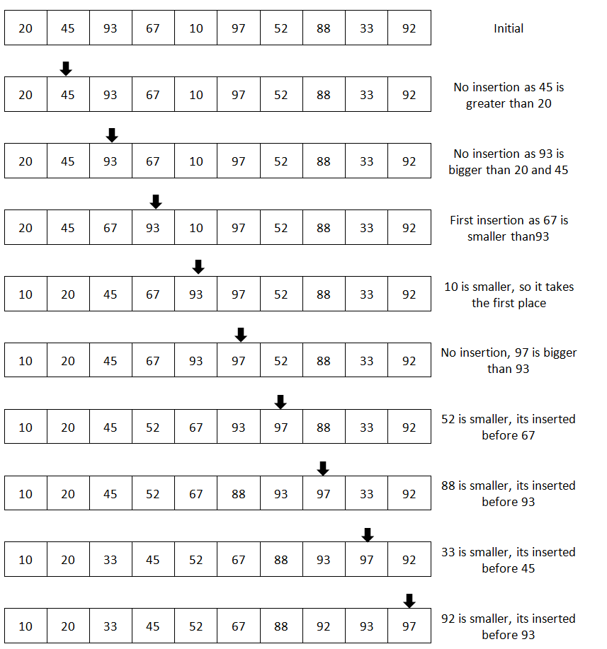

2.1 Implementing insertion sort
We will implement the insertion sort in a similar way to the other two sorts but with a subtle difference. This time, we will pass the array as a reference. By doing so, we will not require any return value from the function. We can also pass the argument by value and return the array at the end of the function if we want. Here is the code for this:
function insertionSort(array &$arr) {
$len = count($arr);
for ($i = 1; $i < $len; $i++) {
$key = $arr[$i];
$j = $i - 1;
while($j >= 0 && $arr[$j] > $key) {
$arr[$j+1] = $arr[$j];
$j--;
}
$arr[$j+1] = $key;
}
}
The parameter array is passed to the function by reference (&$arr). Thus, the original array, not a copy of it, will be modified directly. Now, we want to run the code and check the output. For this, we have to run the following code:
$arr = [20, 45, 93, 67, 10, 97, 52, 88, 33, 92];
insertionSort($arr);
echo implode(",", $arr);
This will produce the same output we had in the previous two cases. The only difference is that we are not expecting any return array from the function and not storing it into any new variable.

2.2 Complexity of insertion sort
Insertion sort has a complexity similar to bubble sort. The basic difference with bubble sort is that the number of swapping is much lower than bubble sort. Here is the complexity for insertion sort:
Best time complexity | Ω (n)
Worst time complexity | O (n2)
Average time complexity | Θ (n2)
Space complexity (worst case) | O (1)

中文翻译：
PHP 7数据结构与算法

1 理解选择排序
选择排序是另一种基于比较的排序算法，它看起来类似于冒泡排序。最大的不同是，它的交换比冒泡排序要少。在选择排序中，我们首先找到数组的最小或最大项并将其放在首位。如果按降序排序，那么从数组中取最大值。对于升序，取最小值。在第2个迭代中，我们将找到数组的第2最大值或最小值，并将其放在第2位。一直持续到把每个数放入一个正确排序的位置。这就是所谓的选择排序。选择排序的伪代码如下：
procedure selectionSort( A : list of sortable items )
n = length(A)
for i = 1 to n inclusive do
min = i
for j = i+1 to n inclusive do
if A[j] < A[min] then
min = j
end if
end for
if min != i
swap(a[i],a[min])
end if
end for
end procedure
如果我们看前面的算法，可以看到，外部循环迭代1次之后，第1个最小项存储在位置1中。在第1次迭代中，我们选择了第1项，然后从剩下的项中找到最小值（从2到n），我们假设第1个项是最小值。如果我们找到另一个最小值，我们将标记它的位置，直到我们扫描剩下的列表并找到一个新的最小值。如果没有找到最小值，那么我们的假设是正确的，这确实是最小值。这是一张图，展示了我们的20、45、93、67、10、97、52、88、33、92个数组在选择排序的前两个步骤：
正如我们在前面的图像中看到的，从列表中的第一项开始，也就是20。然后从数组的其余部分找到了最小值10，我们只是交换了两个位置的值（用箭头表示）。因此，在第一次迭代结束时，我们从存储的数组中获得最小值。然后指向下一个项目45，并开始寻找下一个最小的项目，从剩下的项目中找到了20（如两个箭头所示）。在第二个迭代结束时，我们只是将第二个位置编号替换为新发现的最小值。这将一直持续到最后一个元素，在这个过程的最后，我们有一个排序的数组列表。现在让我们将伪代码转换为PHP代码。

1.1实现选择排序
我们将采用与冒泡排序相同的方法，实现以数组作为参数，并返回一个已排序的数组。这里是PHP的实现：
function selectionSort(array $arr): array {
$len = count($arr);
for ($i = 0; $i < $len; $i++) {
$min = $i;
for ($j = $i+1; $j < $len; $j++) {
if ($arr[$j] < $arr[$min]) {
$min = $j;
}
}
if ($min != $i) {
$tmp = $arr[$i];
$arr[$i] = $arr[$min];
$arr[$min] = $tmp;
}
}
return $arr;
}
可以看到，这是对数组进行升序排序的最简单方法。如果你想按下降的顺序来做，我们只需要改变比较$arr[$j] < $arr[$min]到$arr[$j] > $arr[$min]，并以$max替换$min。

1.2选择排序的复杂性。
选择排序也类似于冒泡排序，并且有两个for循环，0到n。冒泡排序和选择排序之间的基本区别是，选择排序可以产生最大n-1的交换，而在最坏的情况下，冒泡排序可以有n*n的交换。然而，在选择排序中，最好的情况，最坏的情况，和平均情况都有相似的复杂性。这里是选择排序的复杂性图表:
最好情况下时间复杂度 | Ω (n2)
最坏情况下时间复杂度 | O (n2)
平均时间复杂度 | Θ (n2)
最坏情况下空间复杂度 | O (1)

2理解插入排序
到目前为止，我们已经看到了两种基于比较的排序算法。现在，我们将探索另一种排序算法，它比前两种算法更有效。我们讨论的是插入排序。与我们刚才看到的其他两种排序算法相比，它的实现是最简单的。如果项目的数量比较小，插入排序比冒泡排序和选择排序要好。如果数据集很大，那么它就会变得低效，就像冒泡排序一样。由于交换几乎是线性的插入排序，建议使用插入排序而不是冒泡排序和选择排序。
顾名思义，插入排序的工作原理是将数字插入到左边的正确位置。它从数组的第二项开始，检查剩下的项是否小于当前值。如果是这样的话，它会转移这个项目并将较小的项目放在正确的位置。然后，它移动到下一个项目，同样的原则将继续，直到完整的数组被排序。插入排序的伪代码如下所示:
procedure insertionSort( A : list of sortable items )
n = length(A)
for i = 1 to n inclusive do
key = A[i]
j = i - 1
while j >= 0 and A[j] > key do
A[j+1] = A[j]
j--
end while
A[j+1] = key
end for
end procedure
如果我们考虑之前用于冒泡排序和选择排序的数字列表，那么我们将会有如下场景，我们必须进行插入排序。
我们的数组元素是:20、45、93、67、10、97、52、88、33、92。
让我们从第二个项目开始，它是45。现在，我们从第一个项目开始到45的左边，然后到数组的开头，看看左边是否有一个大于45的值。由于只有20个，所以到目前为止，不需要插入到第二个元素（20，45）。现在，我们将指针移到93，它又开始了，比较数组的左边从45开始，如果值更大。因为45不大于93，它在那里停止，就像之前一样，我们总结出前两个项目已经排序。现在，我们有前三个项目（20，45，93）排序。接下来，我们有67，再从左边的数开始。左边的第一个数字是93，它更大，所以它必须移动一个位置。我们把93移动到67的位置。然后，我们移动到它左边的下一个项，也就是45。45小于67，不需要进行进一步的比较。现在，我们将在93和93的位置插入67将不得不移动到67的位置。这将继续，直到完整的数组被排序。这张图展示了在每一步中使用插入排序的完整排序过程：

2.1实现插入排序
我们将以类似的方式实现插入排序，但有细微的差别。这次，我们将把数组作为引用传递。通过这样做，我们将不需要任何函数返回值。我们也可以按值传递参数，并在函数的末尾返回数组。下面是代码:
function insertionSort(array &$arr) {
$len = count($arr);
for ($i = 1; $i < $len; $i++) {
$key = $arr[$i];
$j = $i - 1;
while($j >= 0 && $arr[$j] > $key) {
$arr[$j+1] = $arr[$j];
$j--;
}
$arr[$j+1] = $key;
}
}
参数数组通过引用传递给函数（&$arr）。因此，将直接修改原始数组，而不是它的副本。现在，我们要运行代码并检查输出。为此，我们必须运行以下代码:
$arr = [20, 45, 93, 67, 10, 97, 52, 88, 33, 92];
insertionSort($arr);
echo implode(",", $arr);
这将产生我们在前两种情况下的相同输出。唯一的区别是，我们不期望函数返回数组，而不是将它存储到任何新变量中。

2.2插入排序的复杂性。
插入排序的复杂度类似于冒泡排序。与冒泡排序的基本区别是，交换的数量远低于冒泡排序。这是插入排序的复杂性:
最好情况下时间复杂度 | Ω (n)
最坏情况下时间复杂度 | O (n2)
平均时间复杂度 | Θ (n2)
最坏情况下空间复杂度 | O (1)

