Graphical Abstract
Chemical Engineering Science submission
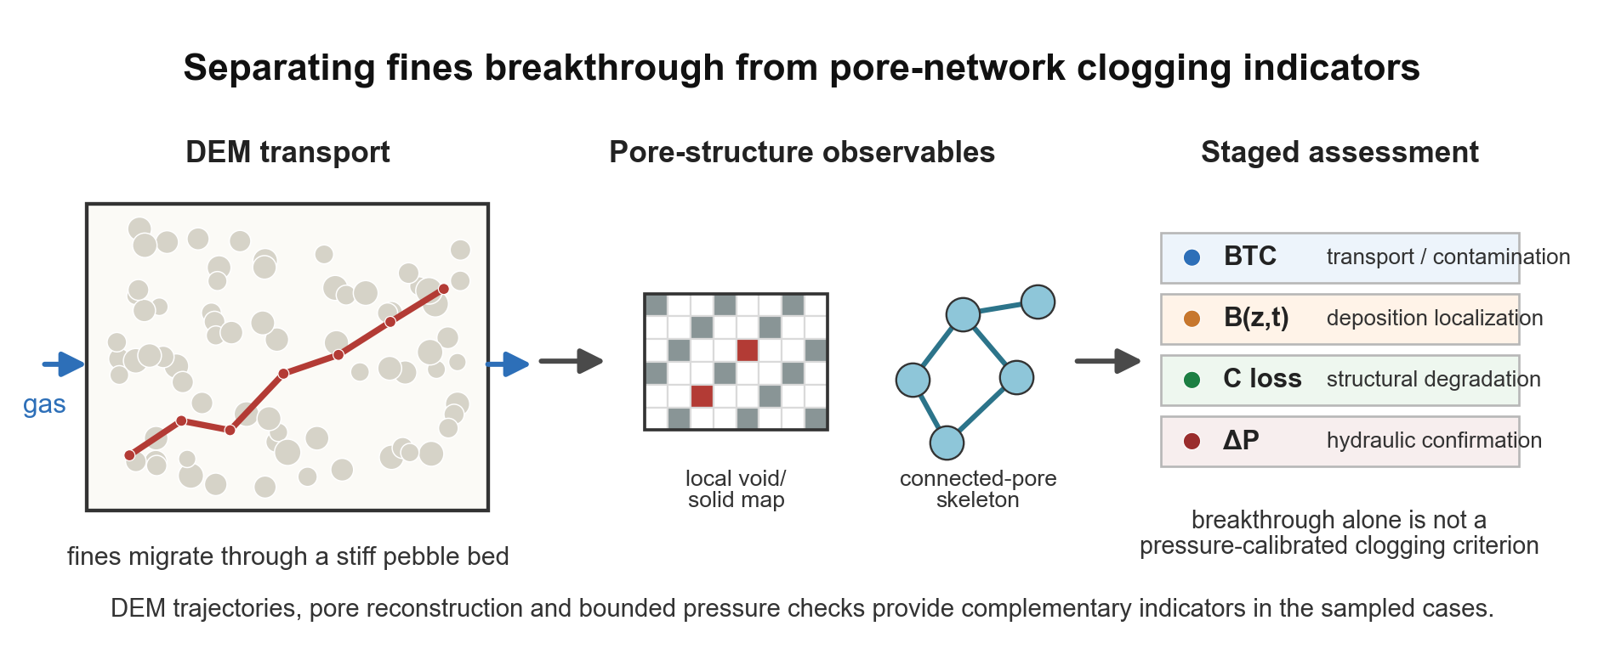
Graphical abstract. DEM trajectories, pore reconstruction and bounded pressure checks provide complementary indicators for interpreting fines breakthrough, local deposition, connected-pore loss and hydraulic confirmation in the sampled Li4SiO4 pebble-bed cases.
Scope note: The workflow is bounded to the studied parameter space, finite voxel resolution and present one-way DEM assumptions; it is not a universal transition law or pressure-calibrated safety criterion.

