安全框架

回复SpringSecurity

SpringSecurity
Spring Security是一个能够为基于Spring的企业应用系统提供声明式的安全访问控制解决方案的安全框架。它提供了一组可以在Spring应用上下文中配置的Bean，充分利用了Spring IoC，DI（控制反转Inversion of Control ,DI:Dependency Injection 依赖注入）和AOP（面向切面编程）功能，为应用系统提供声明式的安全访问控制功能，减少了为企业系统安全控制编写大量重复代码的工作。
摘自百度百科:
https://baike.baidu.com/item/spring%20security/8831652?fr=aladdin

认证模式

实现Basic认证
Basic认证是一种较为简单的HTTP认证方式，客户端通过明文（Base64编码格式）传输用户名和密码到服务端进行认证，通常需要配合HTTPS来保证信息传输的安全。

Maven依赖
<parent>
<groupId>org.springframework.boot</groupId>
<artifactId>spring-boot-starter-parent</artifactId>
<version>2.2.1.RELEASE</version>
</parent>
<dependencies>
<!-- springboot 整合web组件-->
<dependency>
<groupId>org.springframework.boot</groupId>
<artifactId>spring-boot-starter-web</artifactId>
</dependency>
<dependency>
<groupId>org.springframework.boot</groupId>
<artifactId>spring-boot-starter-security</artifactId>
</dependency>
</dependencies>

配置类
@Component
@EnableWebSecurity
public class SecurityConfig extends WebSecurityConfigurerAdapter {
/**
* 新增授权账户
*
* @param auth
* @throws Exception
*/
@Override
protected void configure(AuthenticationManagerBuilder auth) throws Exception {
/**
* 新增一个账户mayikt 密码也是为mayikt 可以允许访问所有的请求
*/
auth.inMemoryAuthentication().withUser("mayikt").password("mayikt").authorities("/");
}
/**
* 新增 HttpSecurity配置
*
* @param http
* @throws Exception
*/
@Override
protected void configure(HttpSecurity http) throws Exception {
/**
* 拦截 http 安全认证模式 设置为httpBasic模式
*/
http.authorizeRequests().antMatchers("/**").fullyAuthenticated()
.and().httpBasic();
}
@Bean
public static NoOpPasswordEncoder passwordEncoder() {
return (NoOpPasswordEncoder) NoOpPasswordEncoder.getInstance();
}
}

访问接口报错
http://127.0.0.1:8080/addMember
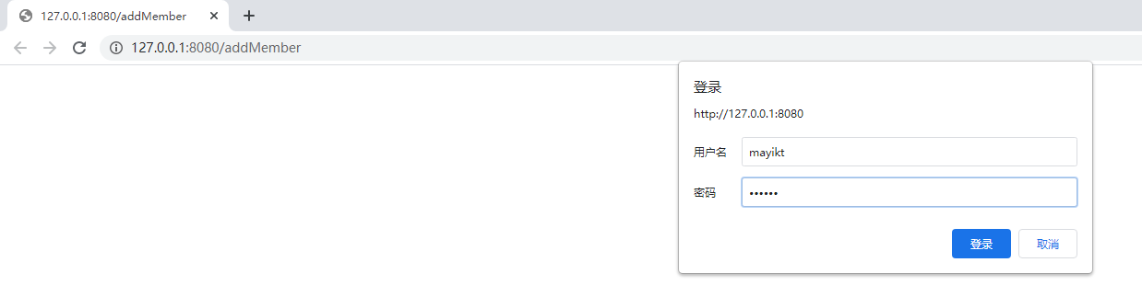

There is no PasswordEncoder mapped for the id "null"
原因:升级为Security5.0以上密码支持多中加密方式，恢复以前模式
/**
* There is no PasswordEncoder mapped for the id "null"
* 原因:升级为Security5.0以上密码支持多中加密方式，恢复以前模式
* @return
*/
@Bean
public static NoOpPasswordEncoder passwordEncoder() {
return (NoOpPasswordEncoder) NoOpPasswordEncoder.getInstance();
}

from 表单模式
From 表单模式 适合于传统模式项目 前端和后端都是我们java开发
人员自己实现，Vue+SpringBoot

protected void configure(HttpSecurity http) throws Exception {
// /**
// * 拦截 http 安全认证模式 设置为httpBasic模式
// */
// http.authorizeRequests().antMatchers("/**").fullyAuthenticated()
// .and().httpBasic();
/**
* 拦截 http 安全认证模式 设置为formLogin模式
*/
http.authorizeRequests().antMatchers("/**").fullyAuthenticated()
.and().formLogin();
}

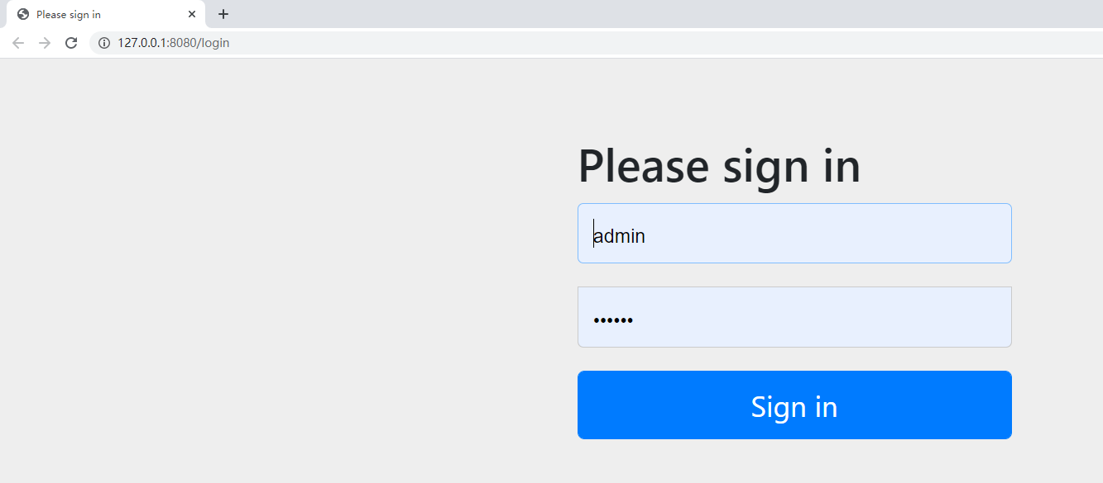

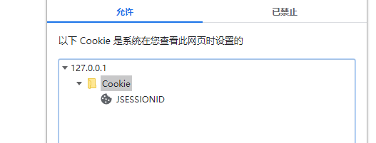

默认使用cookie存放内容。

配置权限策略
在企业管理系统平台中，会拆分成n多个不同的账号，
每个账号对应不同的接口访问权限，
比如
账号mayikt_admin 所有接口都可以访问；
mayikt_add账户 只能访问/addMember接口；
mayikt_show账户 只能访问/showMember接口；
mayikt_del账户 只能访问/delMember接口；

相关config配置

@Component
@EnableWebSecurity
public class SecurityConfig extends WebSecurityConfigurerAdapter {
/**
* 新增授权账户
*
* @param auth
* @throws Exception
*/
@Override
protected void configure(AuthenticationManagerBuilder auth) throws Exception {
/**
* 新增一个账户mayikt 密码也是为mayikt 可以允许访问所有的请求
*/
// auth.inMemoryAuthentication().withUser("mayikt").password("mayikt").authorities("mayikt");
/**
* 1.新增mayikt_admin mayikt_admin 权限可以访问所有请求
*/
auth.inMemoryAuthentication().withUser("mayikt_admin").password("mayikt_admin").authorities("addMember", "delMember"
, "updateMember", "showMember");
auth.inMemoryAuthentication().withUser("mayikt_admin").password("mayikt_admin").authorities("addMember"
, "delMember", "updateMember", "showMember");
auth.inMemoryAuthentication().withUser("mayikt_add").password("mayikt_add").authorities("addMember");
auth.inMemoryAuthentication().withUser("mayikt_del").password("mayikt_del").authorities("delMember");
auth.inMemoryAuthentication().withUser("mayikt_update").password("mayikt_update").authorities("updateMember");
auth.inMemoryAuthentication().withUser("mayikt_show").password("mayikt_show").authorities("showMember");
}
/**
* 新增 HttpSecurity配置
*
* @param http
* @throws Exception
*/
@Override
protected void configure(HttpSecurity http) throws Exception {
// /**
// * 拦截 http 安全认证模式 设置为httpBasic模式
// */
// http.authorizeRequests().antMatchers("/**").fullyAuthenticated()
// .and().httpBasic();
/**
* 拦截 http 安全认证模式 设置为formLogin模式
*/
// http.authorizeRequests().antMatchers("/**").fullyAuthenticated()
// .and().formLogin();
http.authorizeRequests().antMatchers("/addMember").hasAnyAuthority("addMember")
.antMatchers("/delMember").hasAnyAuthority("delMember")
.antMatchers("/updateMember").hasAnyAuthority("updateMember")
.antMatchers("/showMember").hasAnyAuthority("showMember").
antMatchers("/**").fullyAuthenticated()
.and().formLogin();
}
@Bean
public static NoOpPasswordEncoder passwordEncoder() {
return (NoOpPasswordEncoder) NoOpPasswordEncoder.getInstance();
}
}

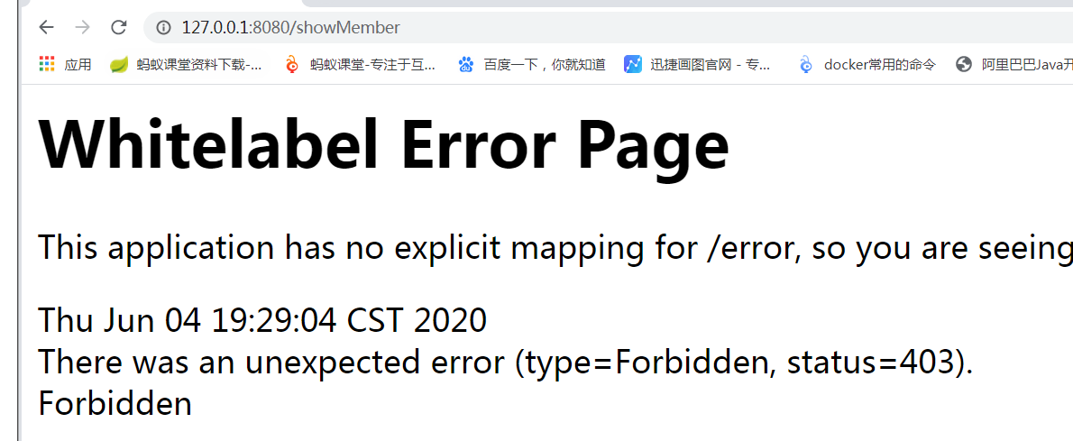
http://127.0.0.1:8080/updateMember

如何修改403权限不足页面
import org.springframework.boot.web.embedded.tomcat.TomcatServletWebServerFactory;
import org.springframework.boot.web.server.ErrorPage;
import org.springframework.boot.web.servlet.server.ConfigurableServletWebServerFactory;
import org.springframework.context.annotation.Bean;
import org.springframework.context.annotation.Configuration;
import org.springframework.http.HttpStatus;
/**
* 自定义SpringBoot 错误异常
*/
@Configuration
public class WebServerAutoConfiguration {
@Bean
public ConfigurableServletWebServerFactory webServerFactory() {
TomcatServletWebServerFactory factory = new TomcatServletWebServerFactory();
ErrorPage errorPage400 = new ErrorPage(HttpStatus.BAD_REQUEST, "/error/400");
ErrorPage errorPage401 = new ErrorPage(HttpStatus.UNAUTHORIZED, "/error/401");
ErrorPage errorPage403 = new ErrorPage(HttpStatus.FORBIDDEN, "/error/403");
ErrorPage errorPage404 = new ErrorPage(HttpStatus.NOT_FOUND, "/error/404");
ErrorPage errorPage415 = new ErrorPage(HttpStatus.UNSUPPORTED_MEDIA_TYPE, "/error/415");
ErrorPage errorPage500 = new ErrorPage(HttpStatus.INTERNAL_SERVER_ERROR, "/error/500");
factory.addErrorPages(errorPage400, errorPage401, errorPage403, errorPage404, errorPage415, errorPage500);
return factory;
}
}

import org.springframework.web.bind.annotation.RequestMapping;
import org.springframework.web.bind.annotation.RestController;
/**
* @ClassName ErrorController
* @Author 蚂蚁课堂余胜军 QQ644064779 www.mayikt.com
* @Version V1.0
**/
@RestController
public class ErrorController {
@RequestMapping("/error/403")
public String error() {
return "您当前访问的接口权限不足!";
}
}

如何修改fromlog页面

package com.mayikt.config;
import org.springframework.context.annotation.Bean;
import org.springframework.security.config.annotation.authentication.builders.AuthenticationManagerBuilder;
import org.springframework.security.config.annotation.web.builders.HttpSecurity;
import org.springframework.security.config.annotation.web.configuration.EnableWebSecurity;
import org.springframework.security.config.annotation.web.configuration.WebSecurityConfigurerAdapter;
import org.springframework.security.crypto.bcrypt.BCryptPasswordEncoder;
import org.springframework.security.crypto.password.NoOpPasswordEncoder;
import org.springframework.stereotype.Component;
/**
* @author 余胜军
* @ClassName SecurityConfig
* @qq 644064779
* @addres www.mayikt.com
* 微信:yushengjun644
*/
@Component
@EnableWebSecurity
public class SecurityConfig extends WebSecurityConfigurerAdapter {
/**
* 新增授权账户
*
* @param auth
* @throws Exception
*/
@Override
protected void configure(AuthenticationManagerBuilder auth) throws Exception {
/**
* 新增一个账户mayikt 密码也是为mayikt 可以允许访问所有的请求
*/
// auth.inMemoryAuthentication().withUser("mayikt").password("mayikt").authorities("mayikt");
/**
* 1.新增mayikt_admin mayikt_admin 权限可以访问所有请求
*/
auth.inMemoryAuthentication().withUser("mayikt_admin").password("mayikt_admin").authorities("addMember", "delMember"
, "updateMember", "showMember");
auth.inMemoryAuthentication().withUser("mayikt_admin").password("mayikt_admin").authorities("addMember"
, "delMember", "updateMember", "showMember");
auth.inMemoryAuthentication().withUser("mayikt_add").password("mayikt_add").authorities("addMember");
auth.inMemoryAuthentication().withUser("mayikt_del").password("mayikt_del").authorities("delMember");
auth.inMemoryAuthentication().withUser("mayikt_update").password("mayikt_update").authorities("updateMember");
auth.inMemoryAuthentication().withUser("mayikt_show").password("mayikt_show").authorities("showMember");
}
/**
* 新增 HttpSecurity配置
*
* @param http
* @throws Exception
*/
@Override
protected void configure(HttpSecurity http) throws Exception {
// /**
// * 拦截 http 安全认证模式 设置为httpBasic模式
// */
// http.authorizeRequests().antMatchers("/**").fullyAuthenticated()
// .and().httpBasic();
/**
* 拦截 http 安全认证模式 设置为formLogin模式
*/
// http.authorizeRequests().antMatchers("/**").fullyAuthenticated()
// .and().formLogin();
http.authorizeRequests().antMatchers("/addMember").hasAnyAuthority("addMember")
.antMatchers("/delMember").hasAnyAuthority("delMember")
.antMatchers("/updateMember").hasAnyAuthority("updateMember")
.antMatchers("/showMember").hasAnyAuthority("showMember")
// antMatchers("/**").fullyAuthenticated()
// .and().formLogin();
//并且关闭csrf 设置跳转到自定义login页面 放开权限
.antMatchers("/login").permitAll()
// 设置自定义登录页面
.antMatchers("/**").fullyAuthenticated().and().formLogin().loginPage("/login").and().csrf().disable();
}
@Bean
public static NoOpPasswordEncoder passwordEncoder() {
return (NoOpPasswordEncoder) NoOpPasswordEncoder.getInstance();
}
}

登陆页面
@Controller
public class LoginController {
@RequestMapping("/login")
public String login() {
return "login";
}
}

<!DOCTYPE html PUBLIC "-//W3C//DTD HTML 4.01 Transitional//EN" "http://www.w3.org/TR/html4/loose.dtd">
<html>
<head>
<meta http-equiv="Content-Type" content="text/html; charset=ISO-8859-1">
<title>Insert title here</title>
</head>
<body>
<h1>每特教育--权限控制登陆系统</h1>
<form action="/login" method="post">
<span>用户名称</span><input type="text" name="username"/> <br>
<span>用户密码</span><input type="password" name="password"/> <br>
<input type="submit" value="登陆">
</form>
<#if RequestParameters['error']??>
用户名称或者密码错误
</#if>
</body>
</html>

application.yml
spring:
freemarker:
settings:
classic_compatible: true #处理空值
datetime_format: yyy-MM-dd HH:mm
number_format: 0.##
suffix: .ftl
template-loader-path:
- classpath:/templates

Maven依赖

<dependency>
<groupId>org.springframework.boot</groupId>
<artifactId>spring-boot-starter-freemarker</artifactId>
</dependency>

动态权限控制
Rbac权限表设计

RBAC（基于角色的权限控制）模型的核心是在用户和权限之间引入了角色的概念。取消了用户和权限的直接关联，改为通过用户关联角色、角色关联权限的方法来间接地赋予用户权限（如下图），从而达到用户和权限解耦的目的。

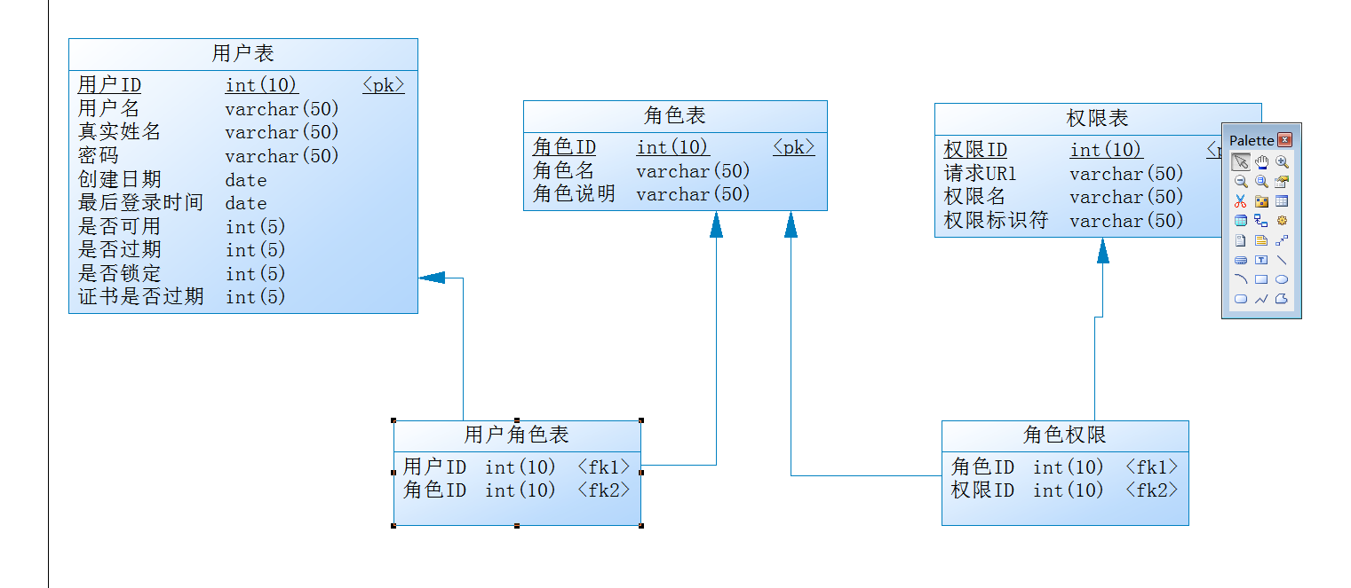

Maven依赖
<!-- springboot 整合mybatis框架 -->
<dependency>
<groupId>org.mybatis.spring.boot</groupId>
<artifactId>mybatis-spring-boot-starter</artifactId>
<version>1.3.2</version>
</dependency>
<!-- alibaba的druid数据库连接池 -->
<dependency>
<groupId>com.alibaba</groupId>
<artifactId>druid-spring-boot-starter</artifactId>
<version>1.1.9</version>
</dependency>
<dependency>
<groupId>mysql</groupId>
<artifactId>mysql-connector-java</artifactId>
</dependency>

配置文件
datasource:
name: test
url: jdbc:mysql://127.0.0.1:3306/mayikt_rbac
username: root
password: root
# druid 连接池
type: com.alibaba.druid.pool.DruidDataSource
driver-class-name: com.mysql.jdbc.Driver

Mapper接口
导入Mapper接口

动态根据账户名称查询权限
使用UserDetailsService实现动态查询数据库验证账号
@Component
@Slf4j
public class MemberDetailsService implements UserDetailsService {
@Autowired
private UserMapper userMapper;
@Override
public UserDetails loadUserByUsername(String userName) throws UsernameNotFoundException {
// 1.根据用户名称查询到user用户
UserEntity userDetails = userMapper.findByUsername(userName);
if (userDetails == null) {
return null;
}
// 2.查询该用户对应的权限
List<PermissionEntity> permissionList = userMapper.findPermissionByUsername(userName);
ArrayList<GrantedAuthority> grantedAuthorities = new ArrayList<>();
permissionList.forEach((a) -> {
grantedAuthorities.add(new SimpleGrantedAuthority(a.getPermTag()));
});
log.info(">>permissionList:{}<<",permissionList);
// 设置权限
userDetails.setAuthorities(grantedAuthorities);
return userDetails;
}
}

WebSecurity相关配置

@Component
@EnableWebSecurity
public class SecurityConfig extends WebSecurityConfigurerAdapter {
@Autowired
private MemberDetailsService memberDetailsService;
@Autowired
private PermissionMapper permissionMapper;
/**
* 新增授权账户
*
* @param auth
* @throws Exception
*/
@Override
protected void configure(AuthenticationManagerBuilder auth) throws Exception {
/**
* 新增一个账户mayikt 密码也是为mayikt 可以允许访问所有的请求
*/
// auth.inMemoryAuthentication().withUser("mayikt").password("mayikt").authorities("mayikt");
/**
* 1.新增mayikt_admin mayikt_admin 权限可以访问所有请求
*/
// auth.inMemoryAuthentication().withUser("mayikt_admin").password("mayikt_admin").authorities("addMember"
// , "delMember", "updateMember", "showMember");
// auth.inMemoryAuthentication().withUser("mayikt_add").password("mayikt_add").authorities("addMember");
// auth.inMemoryAuthentication().withUser("mayikt_del").password("mayikt_del").authorities("delMember");
// auth.inMemoryAuthentication().withUser("mayikt_update").password("mayikt_update").authorities("updateMember");
// auth.inMemoryAuthentication().withUser("mayikt_show").password("mayikt_show").authorities("showMember");
auth.userDetailsService(memberDetailsService).passwordEncoder(new PasswordEncoder() {
@Override
public String encode(CharSequence rawPassword) {
return MD5Util.encode((String) rawPassword);
}
@Override
public boolean matches(CharSequence rawPassword, String encodedPassword) {
String rawPass = MD5Util.encode((String) rawPassword);
boolean result = rawPass.equals(encodedPassword);
return result;
}
});
}
/**
* 新增 HttpSecurity配置
*
* @param http
* @throws Exception
*/
@Override
protected void configure(HttpSecurity http) throws Exception {
// /**
// * 拦截 http 安全认证模式 设置为httpBasic模式
// */
// http.authorizeRequests().antMatchers("/**").fullyAuthenticated()
// .and().httpBasic();
/**
* 拦截 http 安全认证模式 设置为formLogin模式
*/
// http.authorizeRequests().antMatchers("/**").fullyAuthenticated()
// .and().formLogin();
// http.authorizeRequests().antMatchers("/addMember").hasAnyAuthority("addMember")
// .antMatchers("/delMember").hasAnyAuthority("delMember")
// .antMatchers("/updateMember").hasAnyAuthority("updateMember")
// .antMatchers("/showMember").hasAnyAuthority("showMember")
//// antMatchers("/**").fullyAuthenticated()
//// .and().formLogin();
// //并且关闭csrf 设置跳转到自定义login页面 放开权限
// .antMatchers("/login").permitAll()
// // 设置自定义登录页面
// .antMatchers("/**").fullyAuthenticated().and().formLogin().loginPage("/login").and().csrf().disable();
List<PermissionEntity> allPermission = permissionMapper.findAllPermission();
ExpressionUrlAuthorizationConfigurer<HttpSecurity>.ExpressionInterceptUrlRegistry
authorizeRequests = http.authorizeRequests();
allPermission.forEach((p) -> {
authorizeRequests.antMatchers(p.getUrl()).hasAnyAuthority(p.getPermTag());
});
authorizeRequests.antMatchers("/login").permitAll()
// 设置自定义登录页面
.antMatchers("/**").fullyAuthenticated().and().formLogin().loginPage("/login").and().csrf().disable();
}
@Bean
public static NoOpPasswordEncoder passwordEncoder() {
return (NoOpPasswordEncoder) NoOpPasswordEncoder.getInstance();
}
}

MD5工具类
public class MD5Util {
private static final String SALT = "mayikt";
public static String encode(String password) {
password = password + SALT;
MessageDigest md5 = null;
try {
md5 = MessageDigest.getInstance("MD5");
} catch (Exception e) {
throw new RuntimeException(e);
}
char[] charArray = password.toCharArray();
byte[] byteArray = new byte[charArray.length];
for (int i = 0; i < charArray.length; i++)
byteArray[i] = (byte) charArray[i];
byte[] md5Bytes = md5.digest(byteArray);
StringBuffer hexValue = new StringBuffer();
for (int i = 0; i < md5Bytes.length; i++) {
int val = ((int) md5Bytes[i]) & 0xff;
if (val < 16) {
hexValue.append("0");
}
hexValue.append(Integer.toHexString(val));
}
return hexValue.toString();
}
public static void main(String[] args) {
System.out.println(MD5Util.encode("mayikt"));
}
}

整合oauth2
当前有一个开放接口 该接口
会被非常多的商户端来调用
管理商户端
开放接口平台设计

第三方支付接口 或者 第三方知名平台接口
微信 支付宝 等。

- 申请一个appid 和密码
Appid===QQ账户---终生无法变化
Apppwd====改=====QQ密码
- appid 和密码 获取token
- 需要使用该token调用接口
- Token 临时且唯一 2个小时 8个小时
Token 失效----刷新token

什么是oauth2
OAuth 2.0 是一个授权协议，它允许软件应用代表（而不是充当）资源拥有者去访问资源拥有者的资源。应用向资源拥有者请求授权，然后取得令牌（token），并用它来访问资源，并且资源拥有者不用向应用提供用户名和密码等敏感数据。

Oauth角色划分
1、Resource Server:被授权访问的资源
2、Authotization Server：OAUTH2认证授权中心
3、Resource Owner： 用户
4、Client：使用API的合作伙伴

Oauth应用场景
- 第三方联合登录 比如QQ/微信联合登录
- 开放接口 蚂蚁金服/腾讯开放接口

演示微信联合登录
appID
wx5c43fde3c9733d9e
appsecret
b8b217126c33a5fb7074927d5e72a81a
微信公众号联合登录演示

微信公众号测试平台：
https://mp.weixin.qq.com/debug/cgi-bin/sandbox?t=sandbox/login&token=1820792496&lang=zh_CN

- 下载微信公众号测试工具
https://developers.weixin.qq.com/miniprogram/dev/devtools/download.html
2.拼接授权地址
https://open.weixin.qq.com/connect/oauth2/authorize?appid=wx5c43fde3c9733d9e&redirect_uri=http://127.0.0.1:2000&response_type=code&scope=snsapi_userinfo&state=STATE#wechat_redire

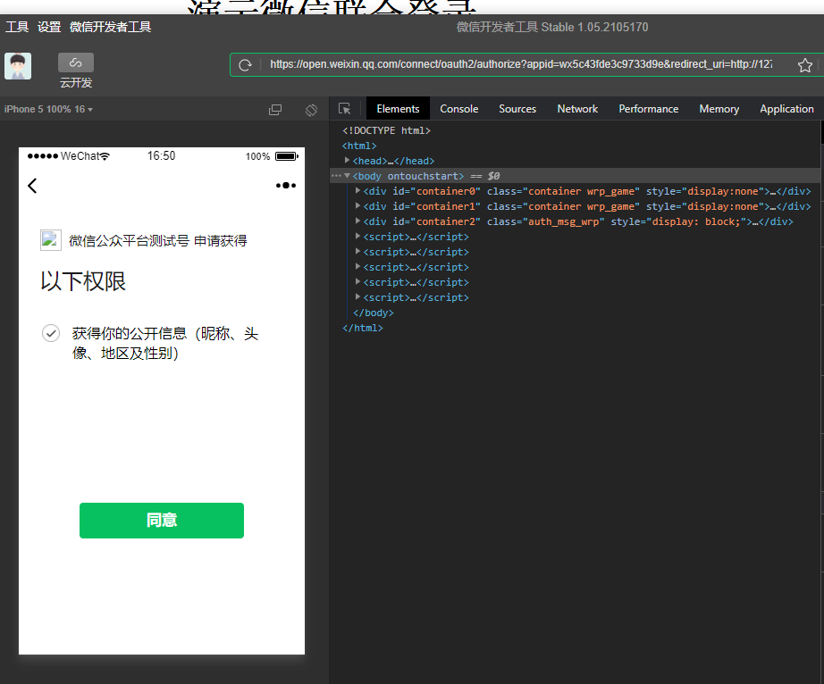
- 以浏览器的形式重定向 获取授权码 code
http://127.0.0.1:2000/?code=001Ed20w3zhdrW2ldC0w3E5xdY0Ed20v&state=STATE
- 通过授权码获取 accessToken
https://api.weixin.qq.com/sns/oauth2/access_token?appid=wx5c43fde3c9733d9e&secret=b8b217126c33a5fb7074927d5e72a81a&code=001Ed20w3zhdrW2ldC0w3E5xdY0Ed20v&grant_type=authorization_code

返回

{"access_token":"45_vC59fGYQYgKmlcAGGvxejECMp3VMfkY7zKUEqZillG2R9p_DyXRpdAIIOdF8hCqebG3ZSuZeMmbIxeTcfOyW8w","expires_in":7200,"refresh_token":"45_yKtzn1Ti1TV-n-qbpwvnJ9o-xEY5wbRcPcSN-fwRoOvMXuiPOJcaYV6e1UKAoB4gEkxBqHRsWFIg2NEVccMzGQ","openid":"okYSmtzp4wWCrDCncMfGSRECVSeM","scope":"snsapi_userinfo"}

- 根据accessToken+openid 获取用户的信息
https://api.weixin.qq.com/sns/userinfo?access_token=45_vC59fGYQYgKmlcAGGvxejECMp3VMfkY7zKUEqZillG2R9p_DyXRpdAIIOdF8hCqebG3ZSuZeMmbIxeTcfOyW8w&openid=okYSmtzp4wWCrDCncMfGSRECVSeM&lang=zh_CN

演示微信联合登录

Oauth2.0模式分类
- 授权码模式
- 简化模式
- 密码模式
- 客户端模式

授权码模式
- 需要提供appid和app密码
- 配置回调地址
- 验证token接口

整合代码

Maven依赖
<parent>
<groupId>org.springframework.boot</groupId>
<artifactId>spring-boot-starter-parent</artifactId>
<version>2.2.1.RELEASE</version>
</parent>
<dependencies>
<!-- SpringBoot整合Web组件 -->
<dependency>
<groupId>org.springframework.boot</groupId>
<artifactId>spring-boot-starter-web</artifactId>
</dependency>
<dependency>
<groupId>org.projectlombok</groupId>
<artifactId>lombok</artifactId>
</dependency>
<!-- springboot整合freemarker -->
<dependency>
<groupId>org.springframework.boot</groupId>
<artifactId>spring-boot-starter-freemarker</artifactId>
</dependency>
<!-->spring-boot 整合security -->
<dependency>
<groupId>org.springframework.boot</groupId>
<artifactId>spring-boot-starter-security</artifactId>
</dependency>
<!-- Spring Security OAuth2 -->
<dependency>
<groupId>org.springframework.security.oauth</groupId>
<artifactId>spring-security-oauth2</artifactId>
<version>2.2.1.RELEASE</version>
</dependency>
<dependency>
<groupId>io.jsonwebtoken</groupId>
<artifactId>jjwt</artifactId>
<version>0.6.0</version>
</dependency>
<dependency>
<groupId>com.alibaba</groupId>
<artifactId>fastjson</artifactId>
<version>1.2.62</version>
</dependency>
<dependency>
<groupId>org.apache.commons</groupId>
<artifactId>commons-lang3</artifactId>
</dependency>
</dependencies>

配置类
import org.springframework.context.annotation.Bean;
import org.springframework.security.config.annotation.authentication.builders.AuthenticationManagerBuilder;
import org.springframework.security.config.annotation.web.builders.HttpSecurity;
import org.springframework.security.config.annotation.web.configuration.EnableWebSecurity;
import org.springframework.security.config.annotation.web.configuration.WebSecurityConfigurerAdapter;
import org.springframework.security.crypto.bcrypt.BCryptPasswordEncoder;
import org.springframework.security.crypto.password.PasswordEncoder;
import org.springframework.stereotype.Component;
@Component
@EnableWebSecurity
public class SecurityConfig extends WebSecurityConfigurerAdapter {
@Bean
public PasswordEncoder passwordEncoder() {
return new BCryptPasswordEncoder();
}
/**
* 需要填写 认证账户 mayikt
* @param auth
* @throws Exception
*/
@Override
protected void configure(AuthenticationManagerBuilder auth) throws Exception {
auth.
inMemoryAuthentication()
.withUser("mayikt")
.password(passwordEncoder().encode("mayikt"))
.authorities("/*");
}
@Override
protected void configure(HttpSecurity http) throws Exception {
http.authorizeRequests()
.anyRequest().authenticated() //所有请求都需要通过认证
.and()
.httpBasic() //Basic登录
.and()
.csrf().disable(); //关跨域保护
}
}

import org.springframework.beans.factory.annotation.Autowired;
import org.springframework.security.crypto.password.PasswordEncoder;
import org.springframework.security.oauth2.config.annotation.configurers.ClientDetailsServiceConfigurer;
import org.springframework.security.oauth2.config.annotation.web.configuration.AuthorizationServerConfigurerAdapter;
import org.springframework.security.oauth2.config.annotation.web.configuration.EnableAuthorizationServer;
import org.springframework.security.oauth2.config.annotation.web.configurers.AuthorizationServerSecurityConfigurer;
import org.springframework.stereotype.Component;
/**
* 认证授权Server端
*/
@Component
@EnableAuthorizationServer
public class AuthorizationConfig extends AuthorizationServerConfigurerAdapter {
@Autowired
private PasswordEncoder passwordEncoder;
@Override
public void configure(AuthorizationServerSecurityConfigurer security) throws Exception {
//允许表单提交
security.allowFormAuthenticationForClients()
.checkTokenAccess("permitAll()");
}
/**
* appid mayikt secret= 123456
*
* @param clients
* @throws Exception
*/
@Override
public void configure(ClientDetailsServiceConfigurer clients) throws Exception {
clients.inMemory()
// appid
.withClient("mayikt")
// appsecret
.secret(passwordEncoder.encode("123456"))
// 授权码
.authorizedGrantTypes("authorization_code")
// 作用域
.scopes("all")
// 资源的id
.resourceIds("mayikt_resource")
// 回调地址
.redirectUris("http://www.mayikt.com/callback");
}
}

http://localhost:8080/oauth/authorize?client_id=mayikt&response_type=code

访问接口 Basic账户和密码
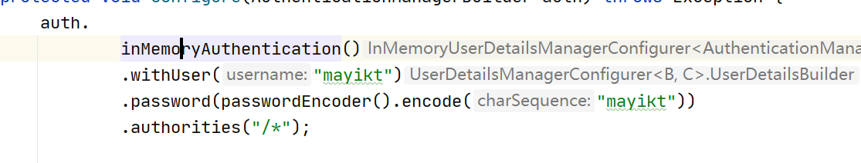

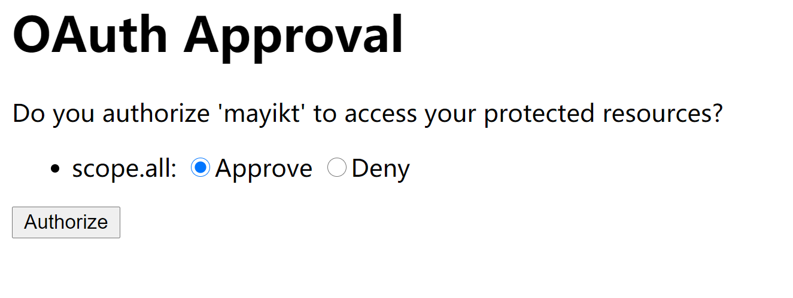

根据授权码获取accessToken

接口：http://localhost:8080/oauth/token
Code:授权码
grant_type:authorization_code
redirect_uri:回调地址
Scope: 作用域

http://localhost:8080/oauth/token?code=6s9qUj&grant_type=authorization_code&redirect_uri=http://www.mayikt.com/callback&scope=all

Basic账户和密码 appid和密码
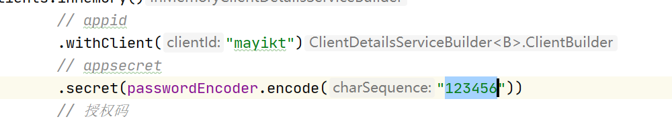

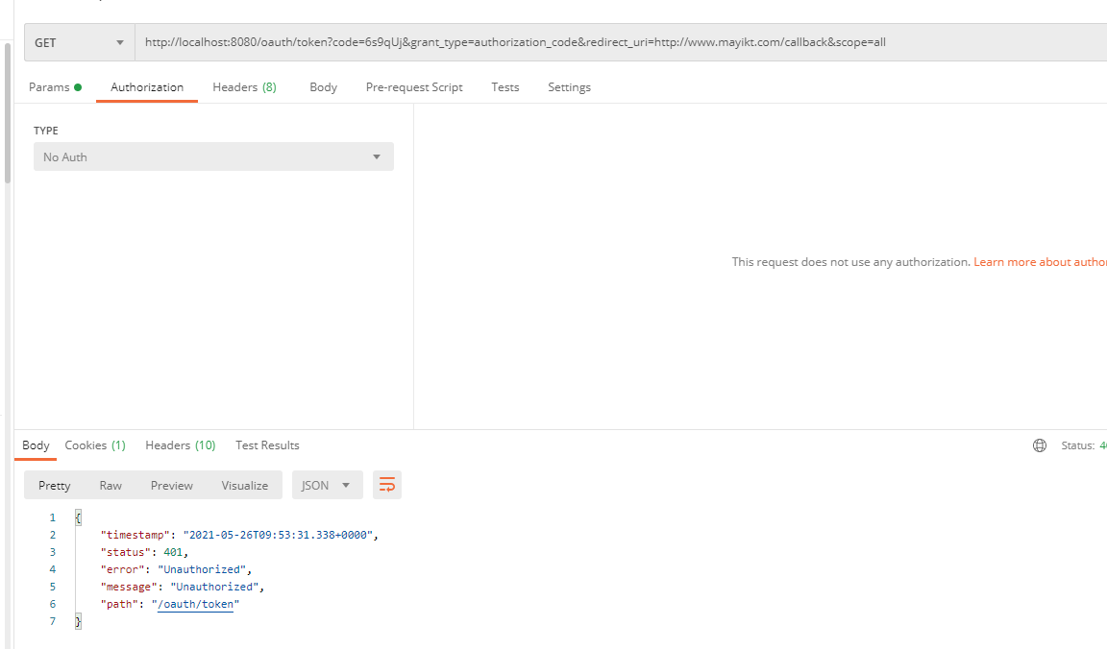

解决办法：
如果报错权限不足，需要单独Basic模式授权。

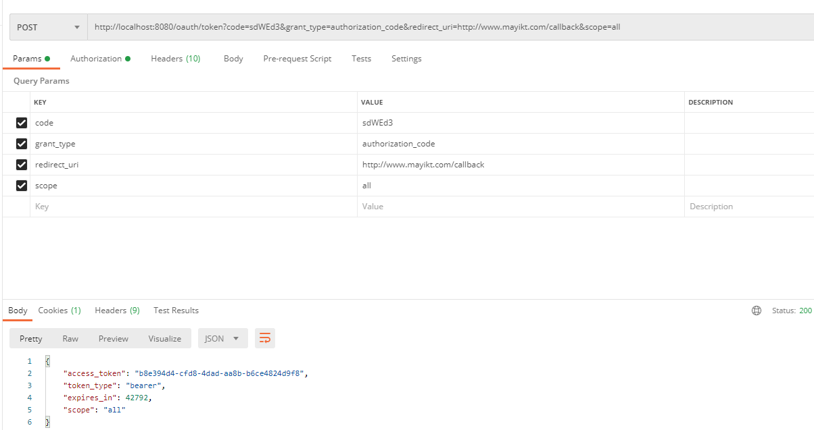

整合accessToken
- 单独创建一个项目mayikt-resources
- application.yml
mayikt:
appid: mayikt
appsecret: mayikt_secret
server:
port: 8081
- 相关配置
import org.springframework.beans.factory.annotation.Value;
import org.springframework.context.annotation.Bean;
import org.springframework.context.annotation.Configuration;
import org.springframework.context.annotation.Primary;
import org.springframework.security.config.annotation.web.builders.HttpSecurity;
import org.springframework.security.config.http.SessionCreationPolicy;
import org.springframework.security.crypto.bcrypt.BCryptPasswordEncoder;
import org.springframework.security.crypto.password.PasswordEncoder;
import org.springframework.security.oauth2.config.annotation.web.configuration.EnableResourceServer;
import org.springframework.security.oauth2.config.annotation.web.configuration.ResourceServerConfigurerAdapter;
import org.springframework.security.oauth2.config.annotation.web.configurers.ResourceServerSecurityConfigurer;
import org.springframework.security.oauth2.provider.token.RemoteTokenServices;
/**
* 资源Server端
*/
@Configuration
@EnableResourceServer
public class ResourceConfig extends ResourceServerConfigurerAdapter {
@Value("${mayikt.appid}")
private String mayiktAppId;
@Value("${mayikt.appsecret}")
private String mayiktAppSecret;
@Bean
public PasswordEncoder passwordEncoder() {
return new BCryptPasswordEncoder();
}
@Primary
@Bean
public RemoteTokenServices remoteTokenServices() {
final RemoteTokenServices tokenServices = new RemoteTokenServices();
//设置授权服务器check_token端点完整地址
tokenServices.setCheckTokenEndpointUrl("http://localhost:8080/oauth/check_token");
//设置客户端id与secret，注意：client_secret值不能使用passwordEncoder加密！
tokenServices.setClientId(mayiktAppId);
tokenServices.setClientSecret(mayiktAppSecret);
return tokenServices;
}
@Override
public void configure(HttpSecurity http) throws Exception {
//设置创建session策略
http.sessionManagement().sessionCreationPolicy(SessionCreationPolicy.IF_REQUIRED);
//@formatter:off
//所有请求必须授权
http.authorizeRequests()
.anyRequest().authenticated();
//@formatter:on
}
@Override
public void configure(ResourceServerSecurityConfigurer resources) {
resources.resourceId("mayikt_resource").stateless(true);
}
}

- 访问接口
import org.springframework.web.bind.annotation.GetMapping;
import org.springframework.web.bind.annotation.RestController;
@RestController
public class MemberService {
@GetMapping("/getMember")
public String getMember() {
return "我是会员服务接口";
}
}

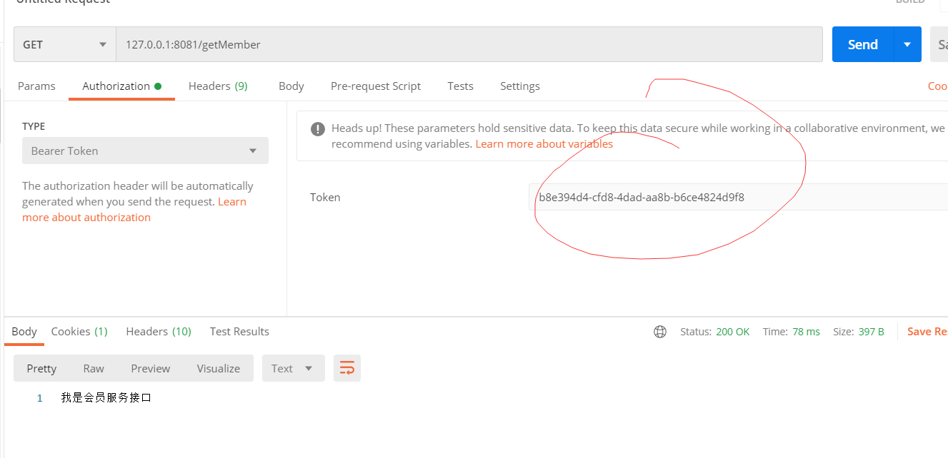
注意：appid和app密码 不能写错了哦！ 否则报错401

- 访问测试

1.获取access_token请求（/oauth/token）
http://localhost:8080/oauth/token?code=IDXeHy&grant_type=authorization_code&redirect_uri=http://www.mayikt.com/callback&scope=all
2.检查头肯是否有效请求（/oauth/check_token）
http://localhost:8080/oauth/check_token?token=ea2c1b1e-5541-4018-8728-07f1ac87e9e8
3.刷新token
http://localhost:8080/oauth/token?grant_type=refresh_token&refresh_token=fbde81ee-f419-42b1-1234-9191f1f95be9&client_id=demoClientId&client_secret=demoClientSecret

