**学院设置模块**

**开发人员：**

**陈文武 李杰**

一：前置条件

1用户已经登录；

2用户拥有管理学院的权限

二：输入输出

1点击学院设置，显示学院列表

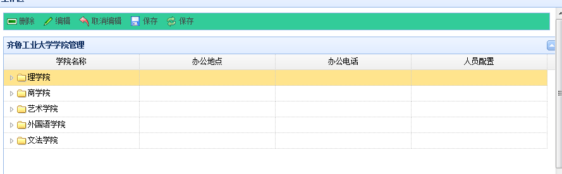

2点击学院名，树状的显示各机构

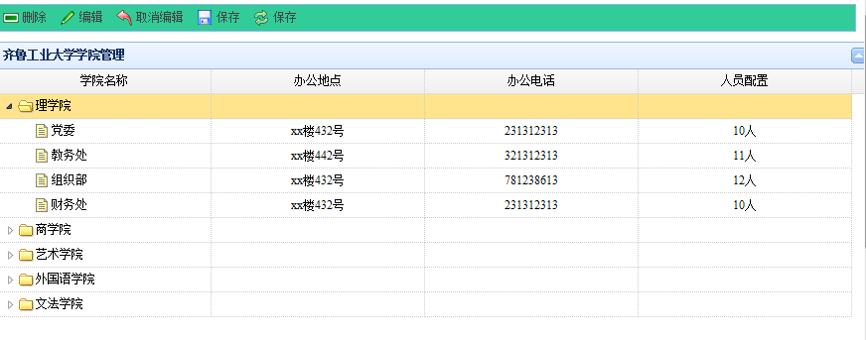

3点击增加机构

在选择节点下创建：

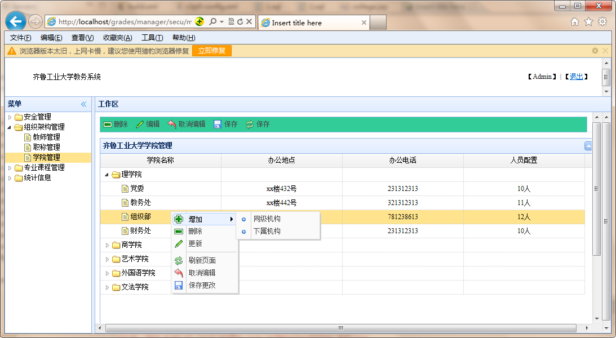

同级机构：

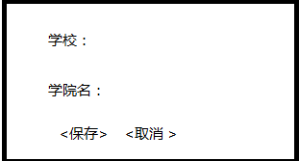

子机构：

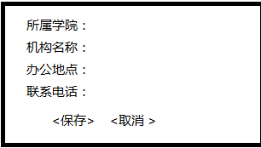

5点击编辑

即可直接编辑。然后直接保存

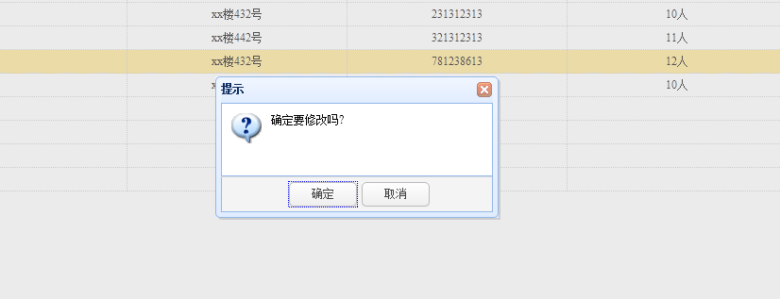

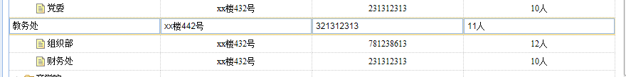

6点击取消编辑。即可取消编辑

点击保存，保存数据

7.删除当前行

没有选择行时

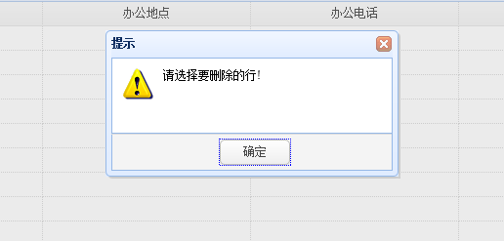

选择行后

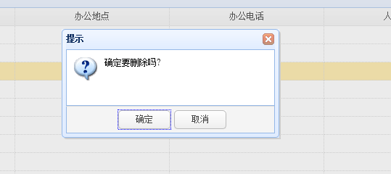

点击确定删除

三 表结构

Create:

**create** **table** colleges(

college_id **varchar**(32) **primary** **key**,

college_text **varchar**(50),

college_url **varchar**(100),

college_state **varchar**(10),

college_parent **varchar**(32),

college_addr **varchar**(50),

college_tel **varchar**(20),

college_person **varchar**(20)

);

Drop:

**Drop table colleges;**

Init:

**insert** **into** colleges **values**('C001','理学院','/secu','closed',**null**,**null**,**null**,**null**);

**insert** **into** colleges **values**('C002','党委','/secu','open','C001','xx楼432号','231312313','10人');

**insert** **into** colleges **values**('C003','教务处','/secu','open','C001','xx楼442号','321312313','11人');

**insert** **into** colleges **values**('C004','组织部','/secu','open','C001','xx楼432号','781238613','12人');

**insert** **into** colleges **values**('C005','财务处','/secu','open','C001','xx楼432号','231312313','10人');

**insert** **into** colleges **values**('C006','商学院','/secu','closed',**null**,**null**,**null**,**null**);

**insert** **into** colleges **values**('C007','党委','/secu','open','C006',**null**,**null**,**null**);

**insert** **into** colleges **values**('C008','教务处','/secu','open','C006',**null**,**null**,**null**);

**insert** **into** colleges **values**('C009','组织部','/secu','open','C006',**null**,**null**,**null**);

**insert** **into** colleges **values**('C010','财务处','/secu','open','C006',**null**,**null**,**null**);

**insert** **into** colleges **values**('C011','艺术学院','/secu','closed',**null**,**null**,**null**,**null**);

**insert** **into** colleges **values**('C012','党委','/secu','open','C011',**null**,**null**,**null**);

**insert** **into** colleges **values**('C013','教务处','/secu','open','C011',**null**,**null**,**null**);

**insert** **into** colleges **values**('C014','组织部','/secu','open','C011',**null**,**null**,**null**);

**insert** **into** colleges **values**('C015','财务处','/secu','open','C011',**null**,**null**,**null**);

**insert** **into** colleges **values**('C016','外国语学院','/secu','closed',**null**,**null**,**null**,**null**);

**insert** **into** colleges **values**('C017','党委','/secu','open','C016',**null**,**null**,**null**);

**insert** **into** colleges **values**('C018','教务处','/secu','open','C016',**null**,**null**,**null**);

**insert** **into** colleges **values**('C019','组织部','/secu','open','C016',**null**,**null**,**null**);

**insert** **into** colleges **values**('C020','财务处','/secu','open','C016',**null**,**null**,**null**);

**insert** **into** colleges **values**('C021','文法学院','/secu','closed',**null**,**null**,**null**,**null**);

**insert** **into** colleges **values**('C022','党委','/secu','open','C021',**null**,**null**,**null**);

**insert** **into** colleges **values**('C023','教务处','/secu','open','C021',**null**,**null**,**null**);

**insert** **into** colleges **values**('C024','组织部','/secu','open','C021',**null**,**null**,**null**);

**insert** **into** colleges **values**('C025','财务处','/secu','open','C021',**null**,**null**,**null**);