Mountain Top 计划中发射天线和接收天线是分开的。为仿效从飞行平台上发射波束，专门设计了逆相位中心偏置天线(Inverse Displaced Phase Center Array, IDPCA)用于发射。IDPCA 是由 16 个子阵构成的等效线阵，线阵轴线与水平面平行。工作时每个子阵沿阵轴线方向交替发射，如此得到的回波就近似等价于从运动平台上接收到的回波。MountainTop 计划中的接收天线由另一部名为 RSTER(Radar Surveillance Technology ExperimentalRadar, RSTER)的雷达负责。RSTER 固定不动，是工作于 UHF 波段的搜索雷达，天线宽 5米，高 10 米，是由 14 个等效阵元组成的相控阵天线，采用水平极化方式工作。RSTER每个阵元后面有独立的移相器、接收机和发射机。

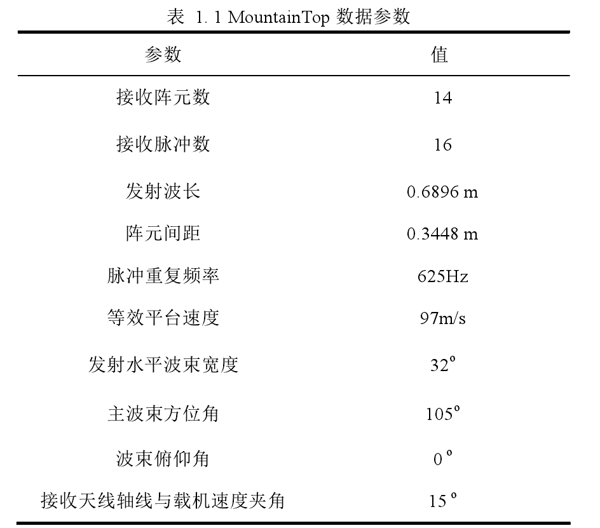

* **IDPCA原理**

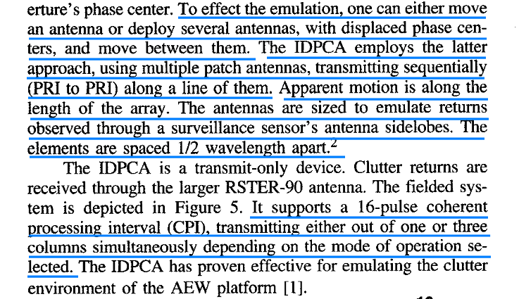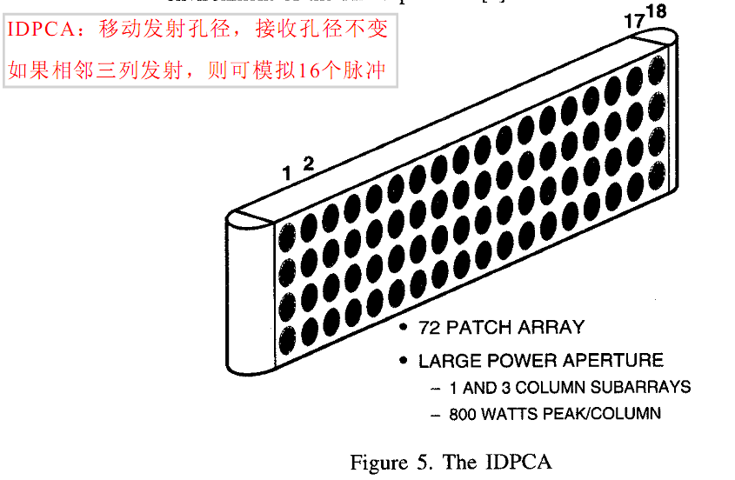

* **抗干扰实验**

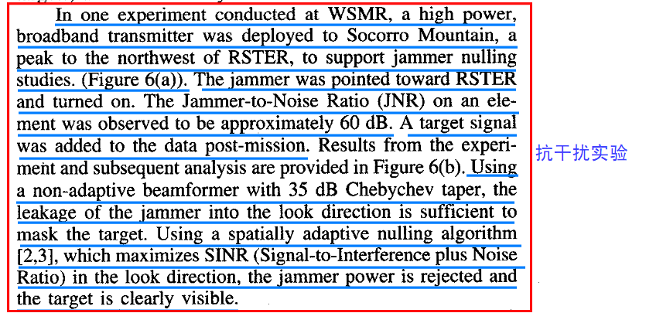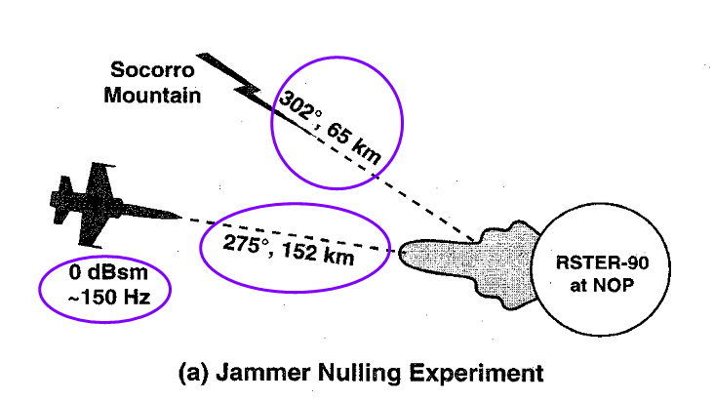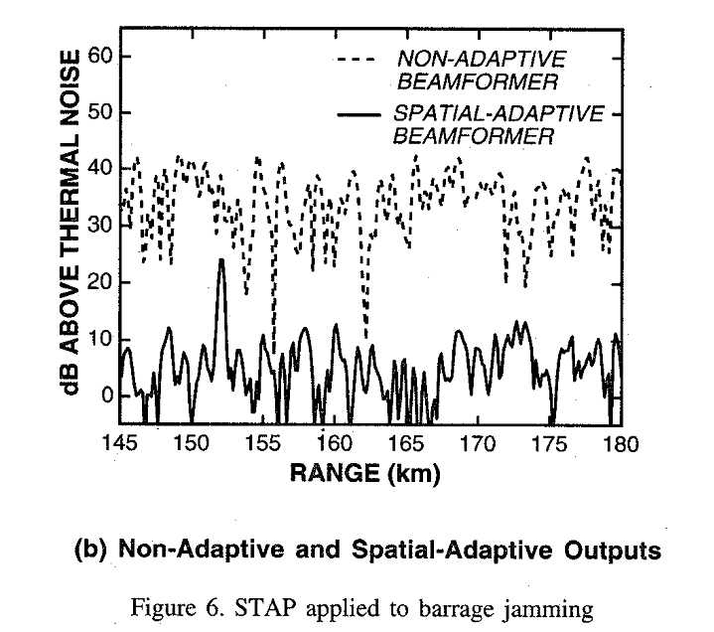

* **杂波抑制实验**

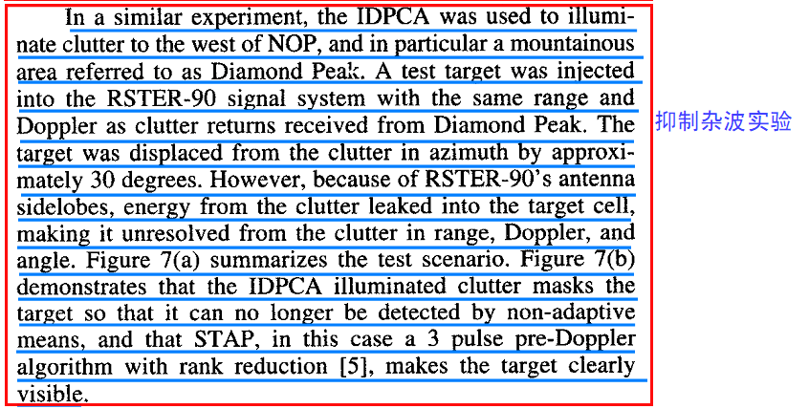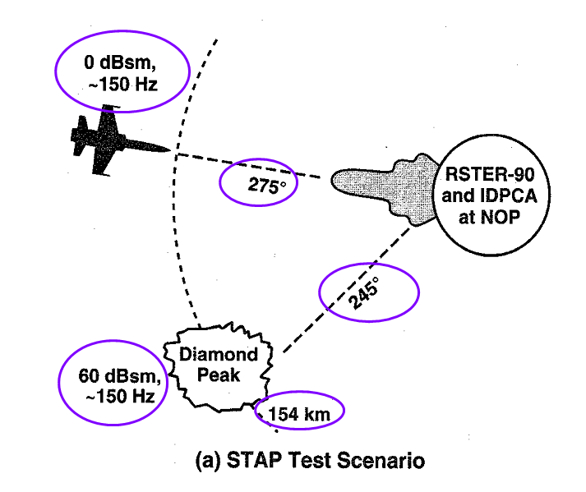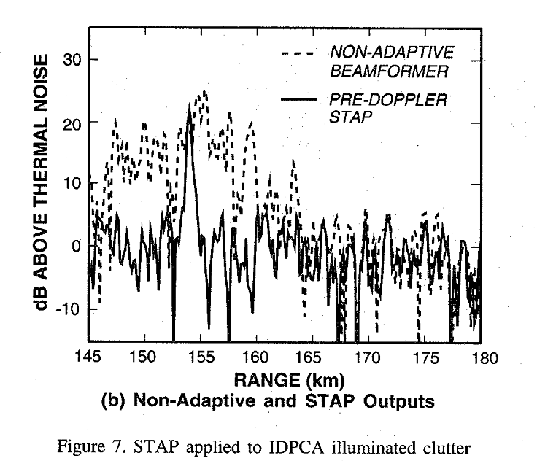

* **参考结果**

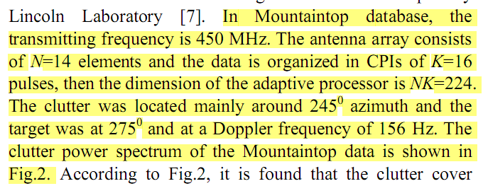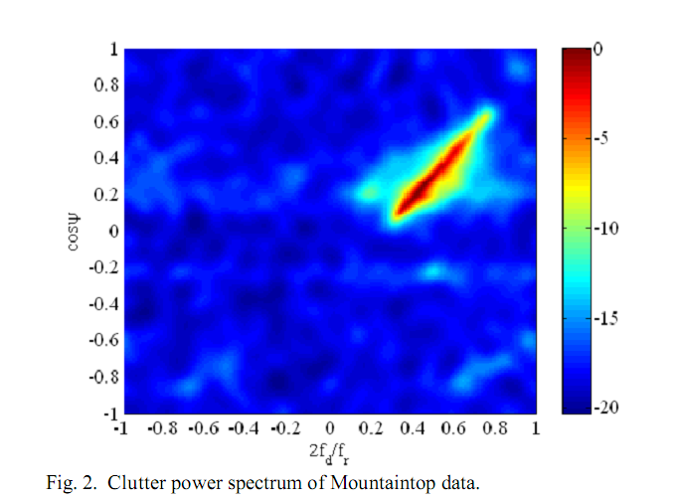

[**http://spib.rice.edu/spib/mtn_top.html#file1**](http://spib.rice.edu/spib/mtn_top.html#file1)

[**http://spib.rice.edu/spib/select_array.html**](http://spib.rice.edu/spib/select_array.html)

**Mountain Top Radar**

The Mountaintop data provided here were collected from a multiple element array, multiple coherent pulse instrumentation radar system. The system was designed to emulate a radar on an airborne moving platform. This document describes the project under which the data was collected and the associated Mountaintop data files (stored as compressed Matlab data files having a .mat.bin extension; save as .mat).

* [Overview](http://spib.rice.edu/spib/mtn_top.html#overview#overview)
* [Radar and Site Parameters](http://spib.rice.edu/spib/mtn_top.html#parameters#parameters)
* [Description and Download of First Datafile](http://spib.rice.edu/spib/mtn_top.html#file1#file1)
* [Description and Download of Second Datafile](http://spib.rice.edu/spib/mtn_top.html#file2#file2)

This work was sponsored by the Advanced Research Projects Agency under Air Force Contract F19628-95-C0002. Opinions, interpretations, conclusions and recommendations are those of the authors and are not necessarily endorsed by the United States Air Force.

Go back to [array data](http://spib.rice.edu/spib/select_array.html) selection.

Go back to [signal data directory](http://spib.rice.edu/spib/signal.html) selection.

Go back to [data directory](http://spib.rice.edu/spib/directory.html) selection.

Go back to SPIB's [main page](http://spib.rice.edu/spib.html).

**OVERVIEW OF THE MOUNTAINTOP PROGRAM**

**1. Introduction**

The Mountaintop Program is an ARPA/NAVY sponsored initiative started in 1990 to study advanced processing techniques and technologies required to support the mission requirements of next generation airborne early warning (AEW) platforms. More information about the program can be obtained from [MIT Lincoln Laboratory](http://www.ll.mit.edu/ll_arpa-sto/). Central to the effort is a surveillance radar measurements program executed from various mountaintop locations including field sites at the White Sands Missile Range (WMSR), New Mexico and the Pacific Missile Range Facility (PMRF), Hawaii. The program is collecting data to support the evaluation of Space-Time Adaptive Processing (STAP) algorithms and the characterization and modeling of monostatic and bistatic scattering. Some of the data collected is hosted in [CREST](http://wwwcrest.mhpcc.edu), the Common Research Environment for STAP, at the Maui High Performance Computing Center (MHPCC).

**2. Program Assets**

Central to the Mountaintop Program is the RSTER (Radar Surveillance Technology Experimental Radar), a UHF sensor originally designed as a surface based volume search radar, which was acquired by ARPA in December 1992 to support the Mountaintop Program. The antenna for the system is a 5 meter wide by 10 meter high horizontally polarized array made up of 14 column elements. Behind each element are an independent phase shifter, transmitter, and receiver.

WSMR and PMRF represent two excellent locations for evaluating AEW concepts. We deployed RSTER to North Oscura Peak (NOP) on WSMR in early 1993. NOP is at the northeast corner of WSMR, 8000 feet above sea level and approximately 3500 feet above the desert floor. The site offers virtually 360 degree visibility and line-of-site to a variety of terrain types including desert, bare and wooded hills, mountains, lava flows and small suburban areas. Very large clutter returns, sometimes exceeding 60 dBsm in a detection cell, were observed. As a result, interesting and challenging data has been collected to support STAP studies.

The sensor was deployed to Makaha Ridge at PMRF in October 1994. The ridge sits 1500 feet above sea level with a precipitous cliff and an unobstructed view of Niihau, a neighboring island, and the sea below. The site is well suited to address issues related to over-the-water AEW. A variety of targets including surface vessels and low-flying drones are available for Mountaintop tests.

A major challenge of the Mountaintop program is to provide a meaningful emulation of the airborne surveillance environment. Central to this effort is the Inverse Displaced Phase Center Array (IDPCA) designed to produce, from a fixed site, clutter returns with the same spatial and temporal characteristics as observed from an airborne surveillance platform. The concept behind the IDPCA is easily understood if one recognizes that the observed clutter profile in azimuth-Doppler space is due to the motion of the aperture's phase center. To effect the emulation, one can either move an antenna or deploy several antennas, with displaced phase centers, and move between them. The IDPCA employs the latter approach, using multiple patch antennas, transmitting sequentially (PRI to PRI) along a line of them. Apparent motion is along the length of the array. The antennas are sized to emulate returns observed through a surveillance sensor's antenna sidelobes. The clutter returns just span the Doppler space.

The IDPCA is a transmit-only device. Clutter returns are received through the larger RSTER-90 antenna. The IDPCA supports a 16-pulse coherent processing interval (CPI), transmitting either out of one or three columns simultaneously depending on the mode of operation selected. The IDPCA has proven effective for emulating the clutter environment of the AEW platform.

**3. Mountaintop Database**

As suggested previously, much of the data collected within the Mountaintop Program is hosted within the CREST database at the MHPCC. Technical direction for and maintenance of the capability is provided by Rome Laboratory. Although the current focus of the database is STAP, data to support studies in other areas of interest to AEW, such as target characterization and low altitude propagation, will be added as it becomes available and as resources permit. The CREST database is accessible via the World Wide Web (URL provided below). The Program's home page contains a description of the Program, its assets and test campaigns, and instructions for accessing the database. Also in the CREST is the ROME Laboratory STAP (RLSTAP), an on-line utility supporting the development and evaluation of STAP algorithms using Mountaintop data. Please see our home page for additional details.

**References (RSTER, Mountaintop)**

1. G. W. Titi and D. F. Marshall, "The ARPA/NAVY Mountaintop Program: Adaptive Signal Processing for Airborne Early Warning Radar," *1996 IEEE International Conference on Acoustics, Speech and Signal Processing*, Atlanta, Georgia, May 7-10, 1996.
2. G. W. Titi, "An Overview of the ARPA/NAVY Mountaintop Program," *1994 IEEE Long Island Section Adaptive Antenna Systems Symposium*, Melville, New York, November 7-8, 1994.
3. B. D. Carlson, L. M. Goodman, J. Austin, M. W. Ganz, and L. O. Upton, "An Ultralow-Sidelobe Adaptive Array Antenna," *The Lincoln Laboratory Journal*, **3**(2): 291-310, Summer 1990.

**References (Radar, general)**

1. M. I. Skolnik, editor, *Radar Handbook*, second edition, McGraw-Hill, New York, 1990.
2. G. W. Stimson, *Introduction to Airborne Radar*, Hughes Aircraft Company, El Segundo, California, 1983.

**Radar and Site Parameters**

The RSTER array is used as the receive array for the radar system; it can also be used for transmitting. There are separate receivers and record channels following each element, so that electronic receive beam formation and steering and adaptive nulling can be performed using the collected data files. For the purpose of data storage, the first antenna element is at the southernmost end of the array.

Although the radar system is installed at a fixed ground site, radar platform motion is emulated using the Inverse Displaced Phase Center array (IDPCA). This device, located near the RSTER receive array, transmits a sequence of coherent radar pulses from sequential subarrays (consisting of one or three elements) of a uniform linear horizontal array with a subarray phase center spacing of 12.2 inches. Thus the radar transmitter appears to move horizontally along the IDPCA array axis at a rate of 12.2 inches per PRI seconds, where PRI is the pulse repetition interval. Note that the maximum ground clutter Doppler is (12.2 in)/(PRI*wavelength); this is half of the value for a fully airborne radar because in the Mountaintop system the receiver is stationary, only the transmit phase center moves.

The IDPCA can be operated in a tracking mode where it applies successive phase shifts to the pulses which it transmits so that the Doppler of the clutter patch at which the RSTER receive beam is looking is shifted to 0 Hz. All other clutter patches' Dopplers are then shifted accordingly.

The pulse-to-pulse gain stability of the IDPCA is not as good as would be the case for an airborne radar which transmits all pulses out of a single antenna. At the time the clutter data described below was collected, there was a periodic component to the IDPCA's element-to-element gain; the effect of this is that large clutter scatterers will be replicated periodically in the Doppler dimension, with a period of 1/3 of the total Doppler dimension, but with a reduced gain of about -25 dB relative to the strength of the true clutter return. These artifacts will look like additional clutter scatterers to the beamforming signal processor.

**General radar system parameters:**

14 transmit/receive elements/record channels 14个接收通道

Antenna array is horizontally oriented with respect to the ground

Uniform linear element spacing of 0.333 meters 均匀线性阵元间距0.333米

Fixed vertical beam, pointed horizontally, beam width 6 degrees (3 dB)

水平指向（俯仰角为0），波束宽度6度

Horizontal polarization 水平极化

Element gain 17.5 dBi 阵元增益17.5dB

Operating frequency range 400 to 500 MHz

Transmitted pulse is 500 kHz Linear Frequency Modulated (LFM) pulse 500KHz 线性调频信号

Peak transmit power 100 kW

Transmit duty cycle 6% (max.) 发射占空比

Coherent Processing Interval (CPI) is 16 coherent pulses 16脉冲

PRF capability 250 to 1500 Hz

Receiver IF bandwidth 200 kHz (3 dB)(Gaussian filter)

Receiver noise figure 6 dB (including plumbing)

Receive system causes 3 phase reversals in the data; thus approaching

targets appear to have negative Doppler and vice versa.

Noise floor in recorded data ~48 dB (with respect to 1)

Calibration: 1 watt at a receive element gives 193 dB in the recorded

data (with respect to 1)

Effective range sampling interval (after demodulation) is 1 microsecond

**IDPCA parameters (in `3-column' mode): （相邻3列一组发射模式）**

16 transmit subarrays 16个发射子阵（用于模拟16脉冲）

Horizontally oriented with respect to the ground

Uniform linear subarray spacing of 12.2 inches

0.3099m（用于计算反推的平台速度，注意，因为单向，要除以2）

Horizontal beam width 32 degrees (3 dB)

Vertical beam width 28 degrees (3 dB)

Horizontal polarization

Subarray gain 16 dBi

Operating frequency range 430 to 440 MHz

Peak transmit power 2400 watts

Transmit beam steering capability +30, 0, -30 degrees wrt broadside

Transmitted pulse, duty cycle, CPI, PRF same as above

**Site Description:**

At WSMR, the radar system was sited on a cliff ~3500 feet above a desert area, with a river, suburban areas, and mountain ranges within the field of view. The use of this site, combined with the IDPCA motion emulation, was intended to emulate an airborne platform with an altitude of 3500 feet.

**Data cube description**

The radar data files are stored in MATLAB format. Each file contains a variety of variables which describe the data, in addition to one or more CPIs of data. The stored data has been demodulated, equalized across the system bandwidth in each channel, and calibrated from channel to channel. The data is not pulse compressed; satisfactory pulse compression may be obtained by constructing a matched filter based on the 500 kHz LFM transmit pulse.

A CPI of data has 3 dimensions: range sample, pulse, and receive element. Because MATLAB can only support 2-dimensional matrices, two of the data dimensions are packed into the matrix row dimension. The 14 columns of the data matrix correspond to the 14 receive channels. The number of range samples may be found from R = D/P where R is the number of range samples, D is the row dimension of the data matrix, and P is the number of pulses in the CPI (usually 16). Then, the first R rows of the data matrix are data for the R range samples corresponding to the first coherent pulse; the next R rows are the range samples for the second pulse, and so on.

**Significant file variables:**

**azxmit**: transmit/receive beam azimuth of the RSTER array, in degrees

relative to true north. When IDPCA is in tracking mode, this is the

azimuth at which the clutter will be shifted to 0 Hz Doppler.

**cpi1** (cpi2, etc.): data matrix containing a CPI of data.

**fxmit**: vector containing the transmit frequency (Hz) for each CPI

**npulses**: vector containing the number of coherent pulses for each CPI

(usually 16).

**pri**: vector containing the Pulse Repetition Interval (PRI) (seconds) for

each CPI

**tpulse**: vector containing the transmit pulse width (seconds) for each CPI

**trecord**: time delay (microseconds) from pulse transmission to beginning of

recording. Since the range samples are collected at 1 microsecond

intervals, the range corresponding to range sample S is approximately

given by

Range = 0.5*C*(trecord - 1 + S)

where C is the speed of light (in meters per microsecond).

**Description of Data File** **[stap3001](http://spib.rice.edu/spib/data/signals/array/stap3001v1.mat.gz) (1.47Mb)**

These data were collected at WSMR on March 28, 1994. A remotely sited broadband jammer provided the only signal which is present in the data; the radar was not transmitting. The jamming was not coherent with the radar. In addition to the signal observed in the jammer's direction, some terrain-scattered jamming energy may be observed in the data.

**Jammer parameters:**

Jamming signal was pseudo-random noise with a bandwidth of 600 kHz: this

signal is broadband relative to the radar's bandwidth, so it appears

as broadband barrage jamming.

The jammer was sited on a mountain at a range of 65 km from the radar,

and at an azimuth of 302 deg relative to true North, with respect to

the radar.

The jammer transmit frequency was 435 MHz

The jammer transmit power was 44 watts

Horizontal polarization

Jammer's antenna was pointed at the radar

Vertical beamwidth 70 degrees (3 dB)

Horizontal beamwidth 22 degrees (3 dB)

Jamming antenna gain 11 dBi

**Radar system parameters specific to this data:**

RSTER array broadside 260 degrees relative to true North

Pulse width N/A

Pulse Repetition Interval (PRI) 1600 microseconds

Range window 897 to 1300 microseconds (134 to 195 km)

**Description of Data File** **[t38pre01v1](http://spib.rice.edu/spib/data/signals/array/t38pre01v1_cpi_6.mat.gz), CPI 6 (0.73 Mb)**

These data were collected at WSMR on February 10, 1994. Radar pulses were transmitted using the IDPCA (only), so that ground clutter returns would be equivalent to those which would be observed from an airborne moving platform. No jamming sources were present. The RSTER system's internal test target generator was used to generate a simulated target signal.

The IDPCA transmit beam was steered to -30 degrees to illuminate a particular large clutter scatter (a mountain range), at a range at which clutter returns in most other directions were minimal due to shadowing by nearer-range mountains. Thus this data contains ground clutter primarily from a single large scatterer which is isolated in angle. The IDPCA was not in tracking mode (there was no artificial Doppler shift), so the clutter at -30 degrees off IDPCA broadside had a Doppler of (PRF/2)*sin(30 deg) = (PRF/4). The simulated target was placed at the same range and Doppler as this scatterer, but at a different azimuth. With nonadaptive beamformer processing, the target will be partially or completely obscured by sidelobe leakage from the clutter scatterer (unless a very low sidelobe taper is used). Adaptive nulling can be used to mitigate the clutter interference and clearly reveal the target.

Note that jamming may be included in this scenario by adding the jamming-only data described above to this data. The jamming data may be scaled to adjust its relative power level, and a linear phase progression may be applied to the element dimension to change the apparent direction of the jammer.

**Radar system parameters specific to this data:**

RSTER array broadside 260 degrees relative to true North

接收天线法线方向

IDPCA array broadside 275 degrees relative to true North

发射波束指向

IDPCA transmit beam steered to -30 degrees relative to IDPCA broadside

First pulse transmitted out of southernmost IDPCA element (apparent

direction of motion is south to north)

Transmit frequency 435 MHz

Pulse width 100 microseconds 脉冲宽度 100e-6 s

Pulse Repetition Interval (PRI) 1600 microseconds 625Hz

Range window 881 to 1283 microseconds (132 to 192 km) 为什么是132km？

**Simulated target parameters:**

Target range 152 km 目标距离

Target Doppler 156 Hz (PRF/4) 目标多普勒

Target azimuth 274 degrees relative to true North 目标相对正北的角度 （实际计算时要转化为相对于载机波束的角度）

Target Radar Cross Section (RCS) ~0 dBsm

*4/1/96*

**关于Data File** [**t38pre01v1**](http://spib.rice.edu/spib/data/signals/array/t38pre01v1_cpi_6.mat.gz) **的说明**



天线结构图

IDPCA方式发射脉冲，由南向北依次移动发射相位中心，等效于雷达由南向北飞行。

上文中【The IDPCA was not in tracking mode (there was no artificial Doppler shift), so the clutter at -30 degrees off IDPCA broadside had a Doppler of (PRF/2)*sin(30 deg) = (PRF/4).】实际上是由于，但由于，为阵元间距，所以。

关于导向矢量，时域导向矢量应写成exp(j*2*pi*(0:pulse_num-1).’*fd)；而空域导向矢量本文定义为exp(j*2*pi*(0:ch_num-1).'*fs)；在该种定一下，目标的角度对应的空域导向矢量则为exp(j*2*pi*(0:ch_num-1).'*cos(90-15))；此种假设即认为RSTER雷达阵元从北向南依次为1,2,3,…,14。