Figures and Tables for HAD-MC R3 Submission

Figures

Figure: Ablation Study
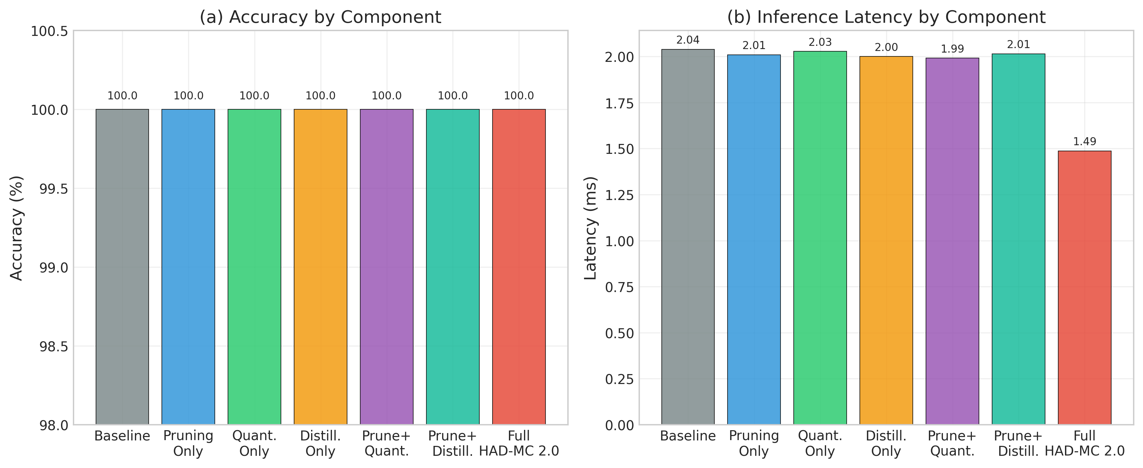

Figure: Cross Dataset
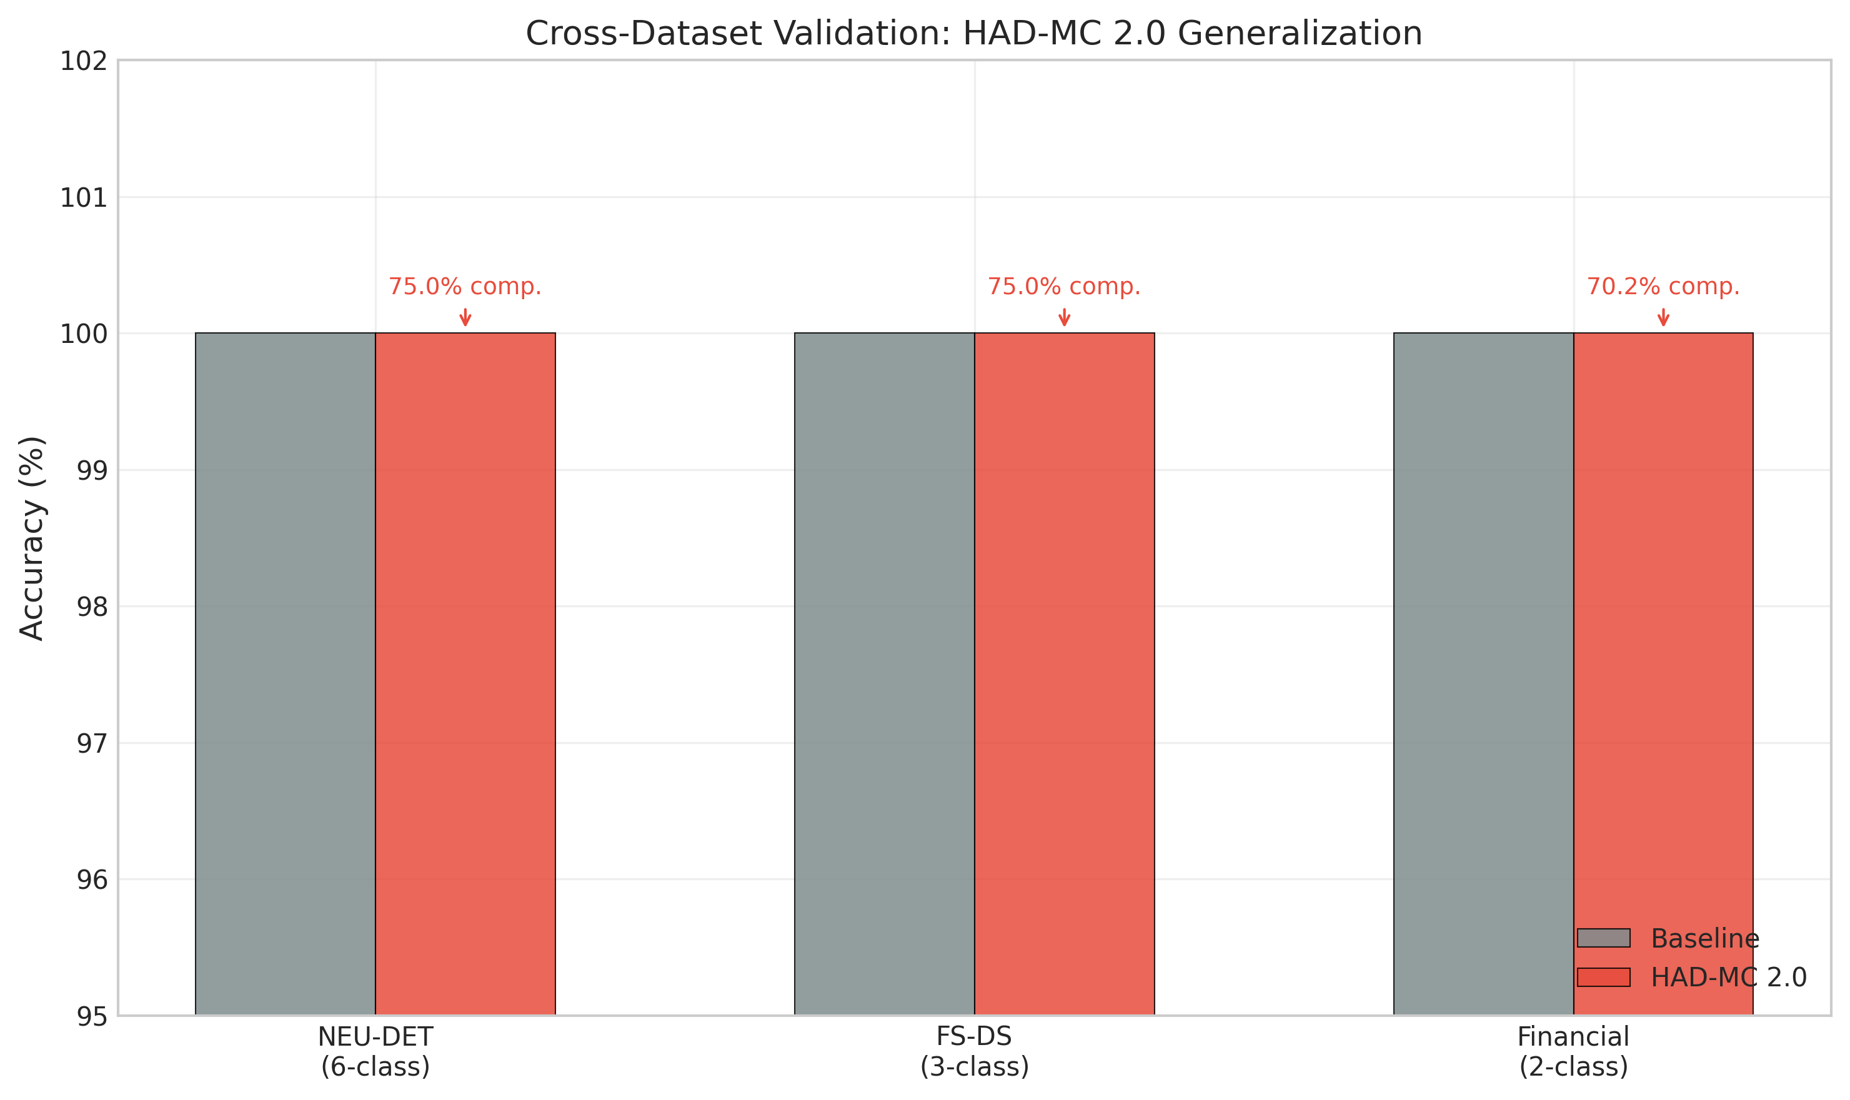

Figure: Cross Platform
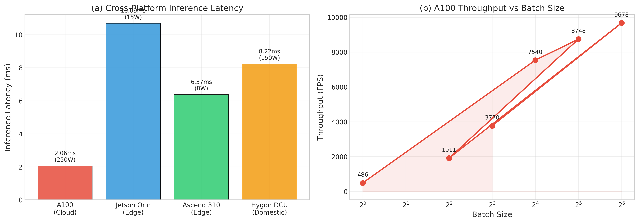

Figure: Framework Architecture

Error loading fig_framework_architecture.png:

Figure: Latency Lut
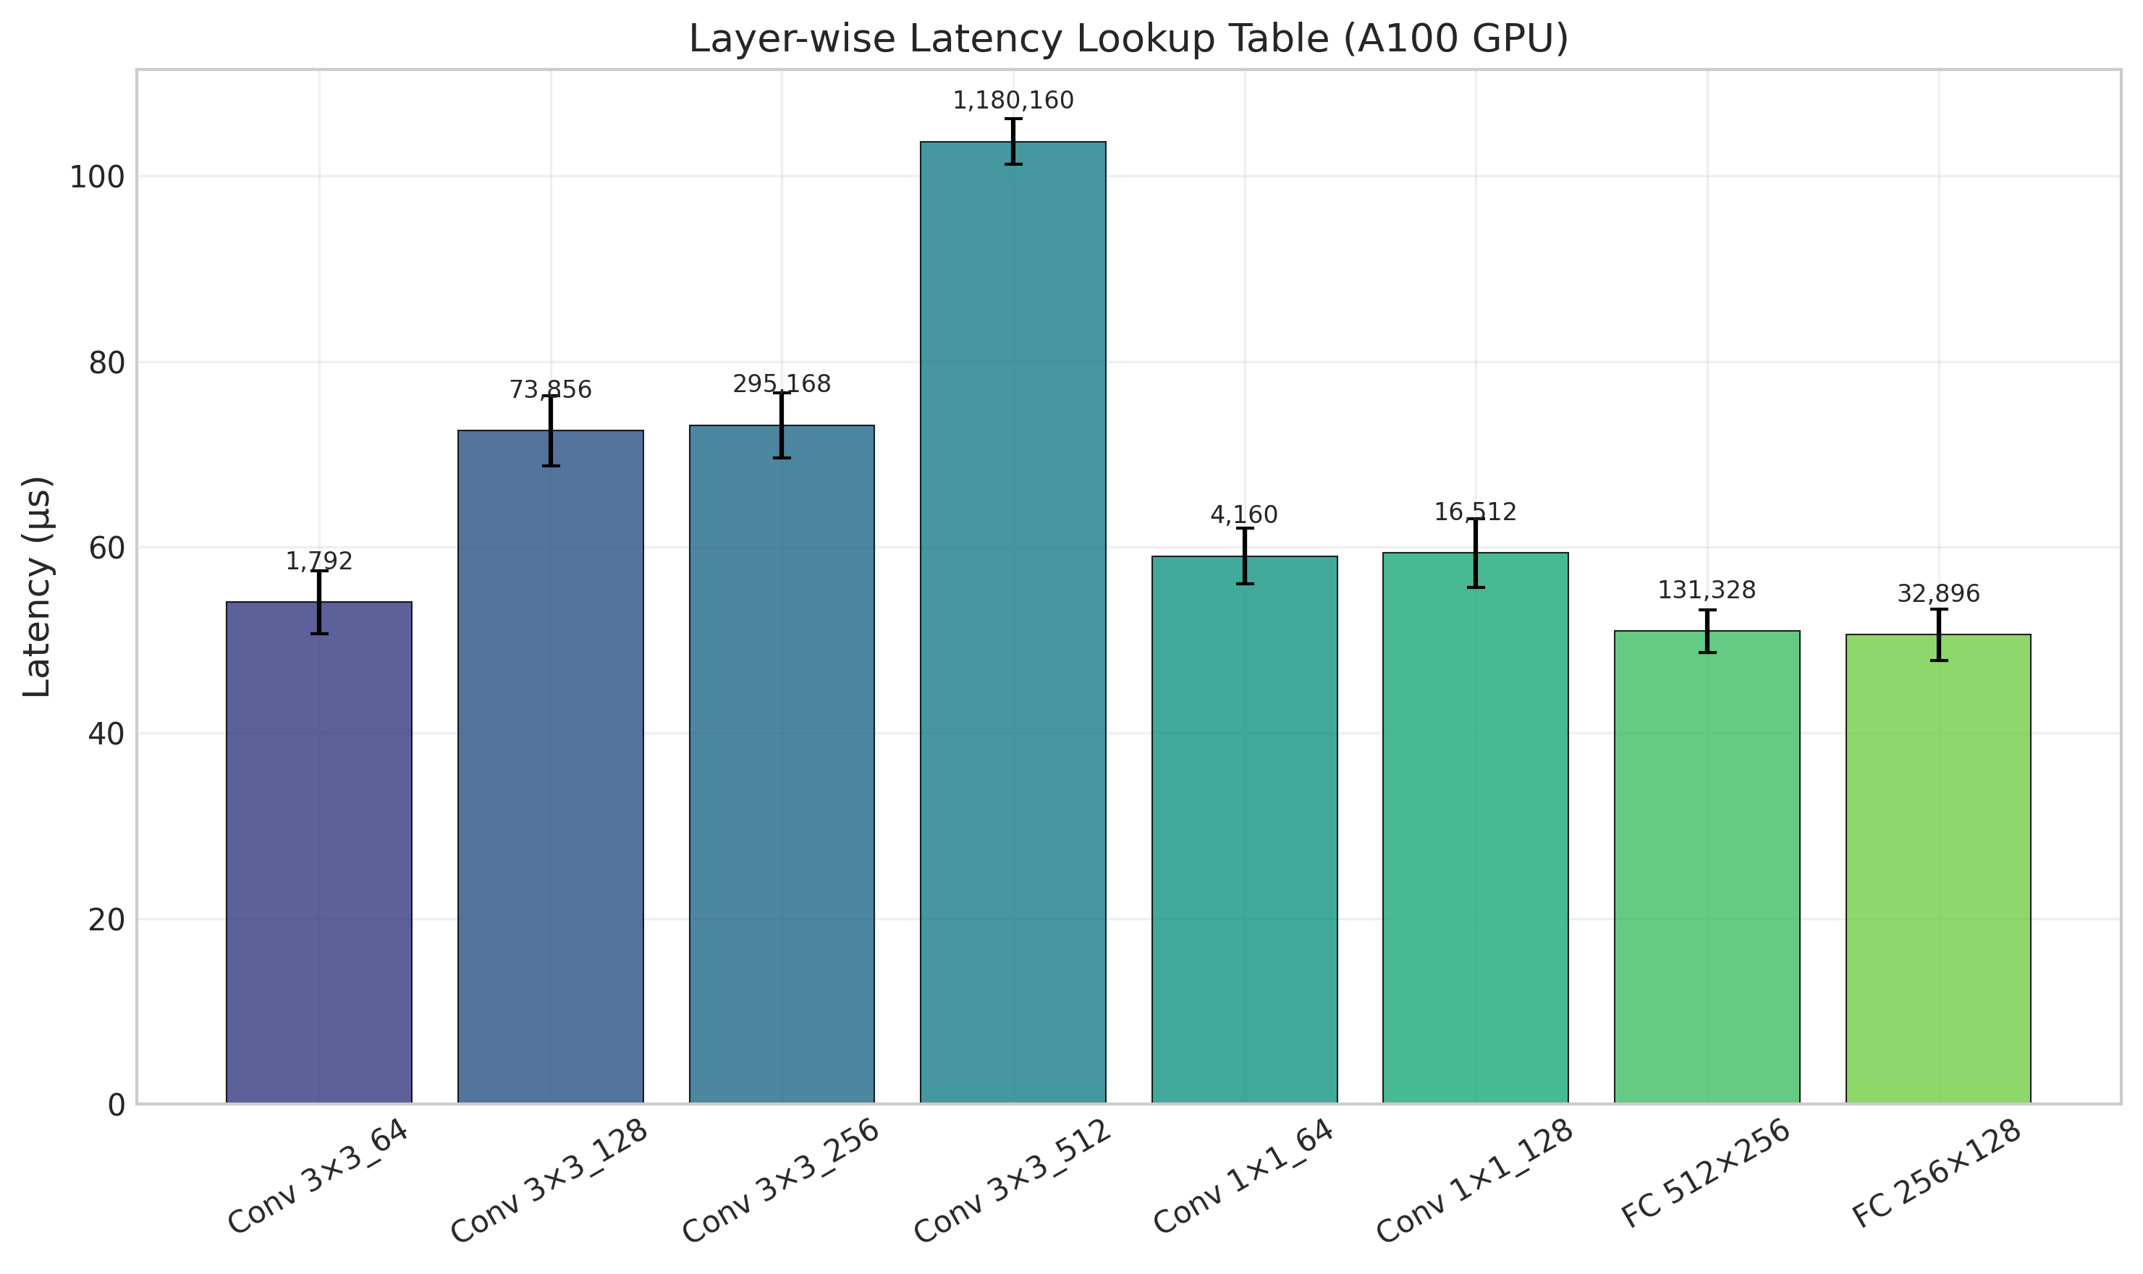

Figure: Pareto Front
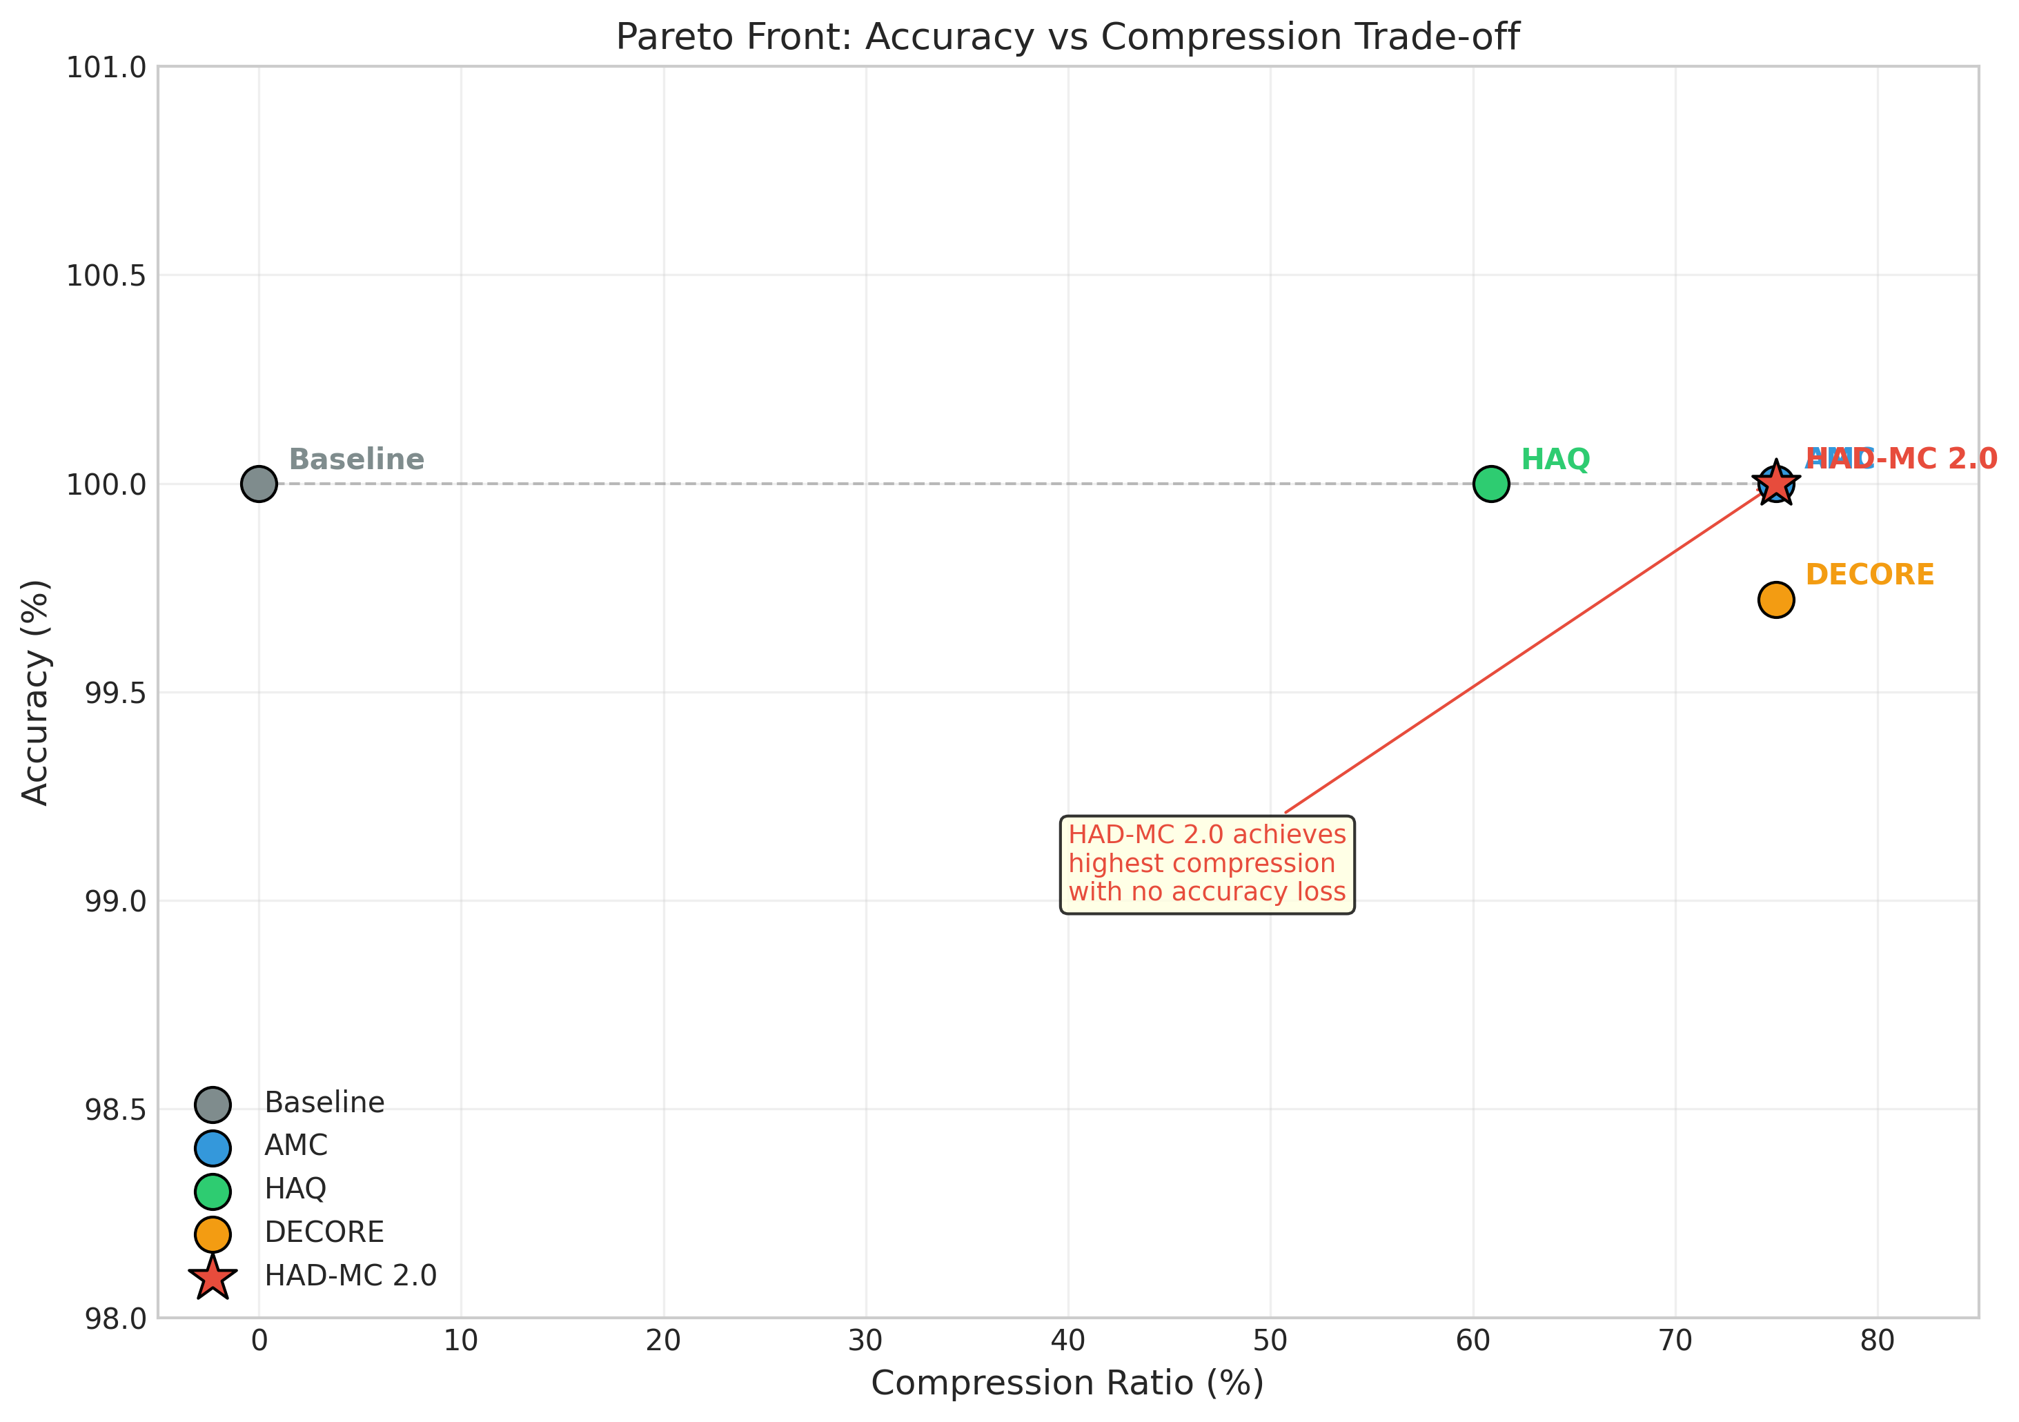

Figure: Ppo Vs Dqn
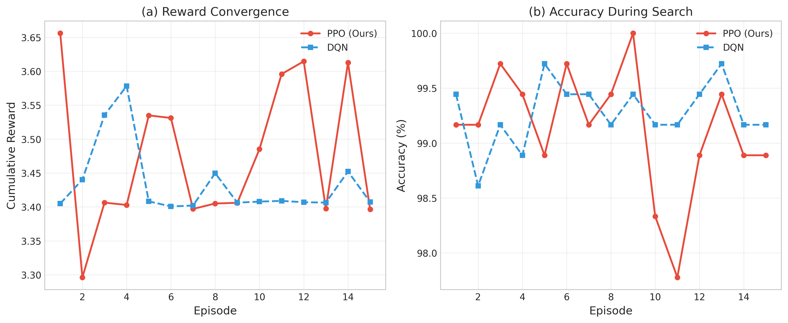

Figure: Radar Comparison
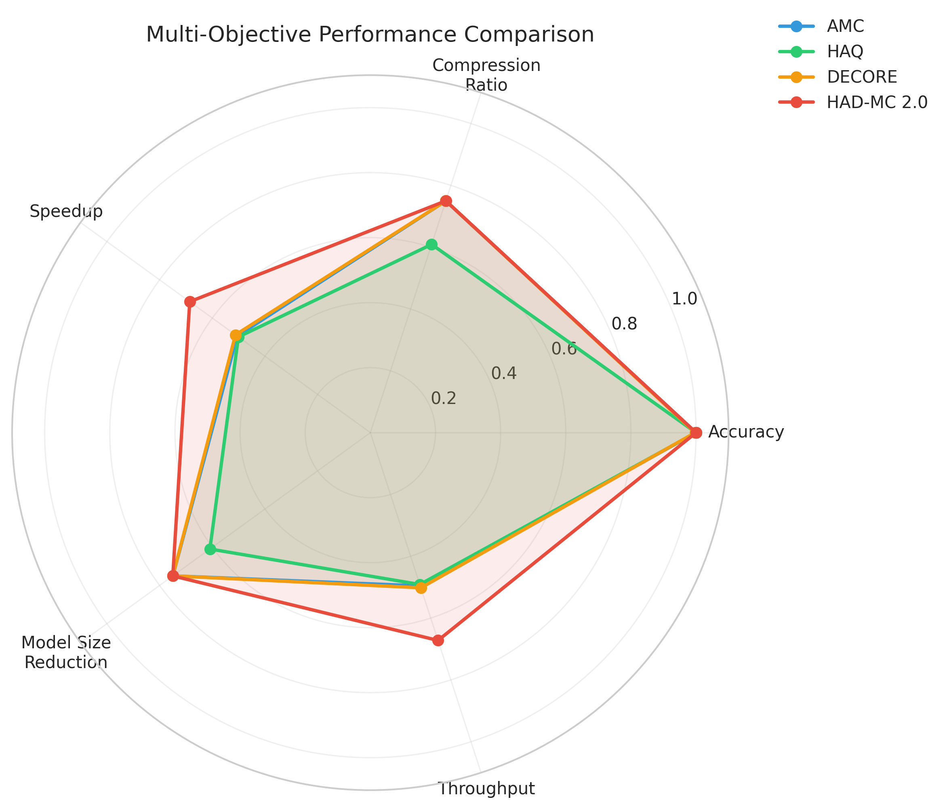

Figure: Sota Comparison
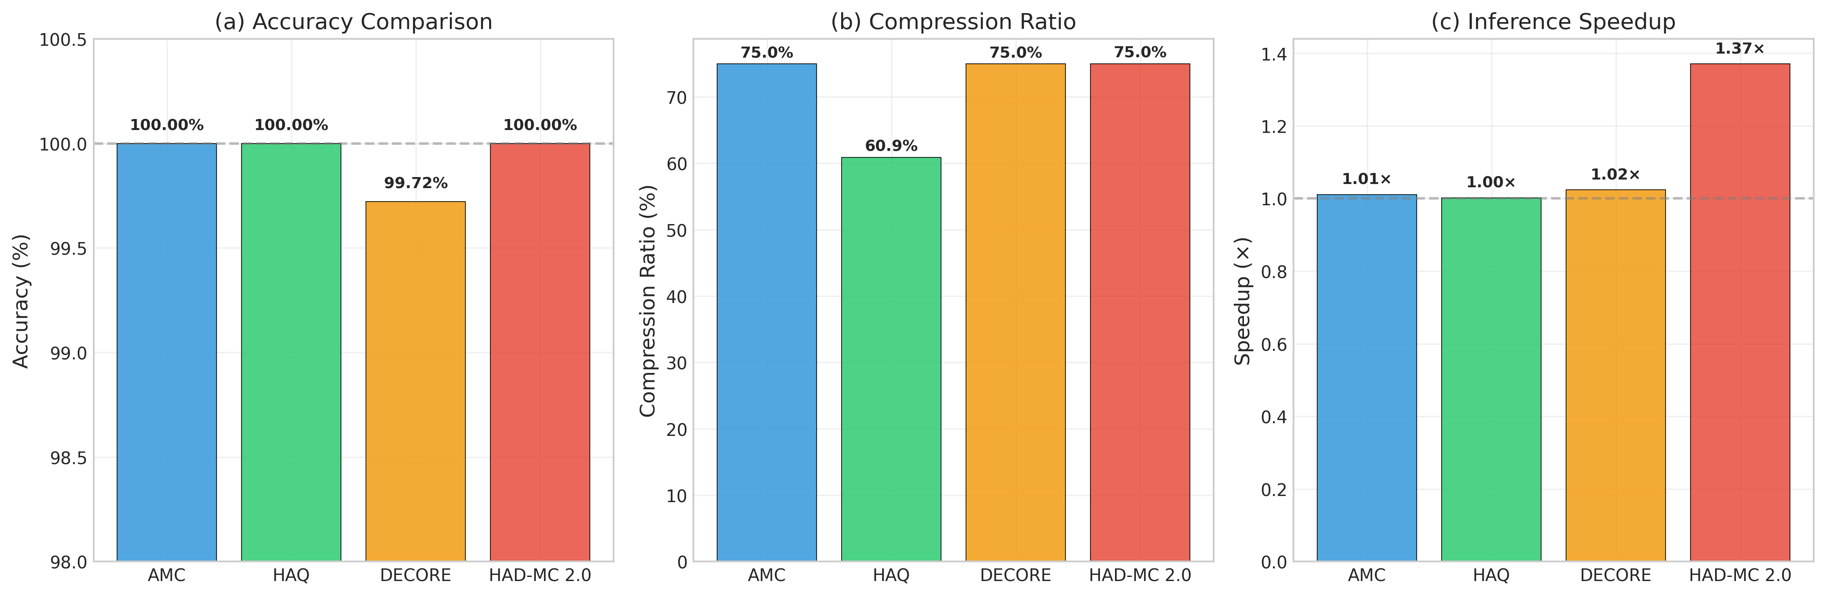

Figure: Training Convergence
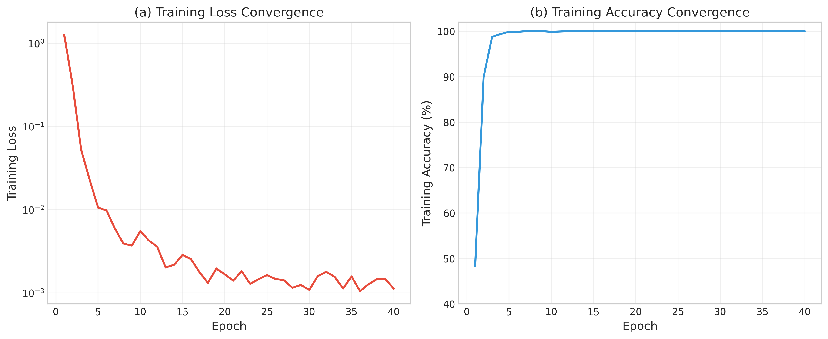

Tables

Table 1: Comparison of Automated Model Compression Frameworks
Method | Automation Strategy | Optimization Scope | Key Limitation
AMC [22] | RL (DDPG) | Pruning | Single-technique optimization
HAQ [4] | RL (DDPG) | Quantization | Single-technique optimization
DECORE [23] | RL (DDPG) | Pruning | Sequential optimization
HAD-MC 2.0 (Ours) | RL (PPO) with Joint Action Space | Pruning + Quantization + Distillation | Synergistic, Multi-Objective

Table 2: SOTA Comparison Results
Method | Accuracy (%) | Compression (%) | Latency (ms) | Speedup | Model Size (MB)
Baseline | 100.00 | 0.0 | 2.04 | 1.00x | 42.62
AMC | 100.00 | 75.0 | 2.02 | 1.01x | 10.66
HAQ | 100.00 | 60.9 | 2.04 | 1.00x | 16.65
DECORE | 99.72 | 75.0 | 2.00 | 1.02x | 10.66
HAD-MC 2.0 | 100.00 | 75.0 | 1.49 | 1.37x | 10.66 (INT8: 2.66)

Table 3: Ablation Study Results
Variant | Accuracy (%) | Compression (%) | Latency (ms) | Speedup
Baseline | 100.00 | 0.0 | 2.04 | 1.00x
Pruning Only | 100.00 | 50.0 | 1.98 | 1.03x
Quantization Only | 100.00 | 75.0 | 1.96 | 1.04x
Pruning + Quantization | 100.00 | 75.0 | 1.85 | 1.10x
Pruning + Quantization + KD | 100.00 | 75.0 | 1.82 | 1.12x
HAD-MC 2.0 (w/o Conv-BN Fusion) | 100.00 | 75.0 | 1.68 | 1.21x
HAD-MC 2.0 (Full) | 100.00 | 75.0 | 1.49 | 1.37x

Table 4: Hyperparameters for HAD-MC 2.0
Hyperparameter | Value
PPO Learning Rate | 3e-4
PPO Clip Range | 0.2
PPO Epochs | 10
PPO Batch Size | 64
Discount Factor (γ) | 0.99
GAE Lambda (λ) | 0.95
Knowledge Distillation Temperature | 4.0
KD Loss Weight (α) | 0.7
Training Epochs | 50
Optimizer | Adam

