Laravel
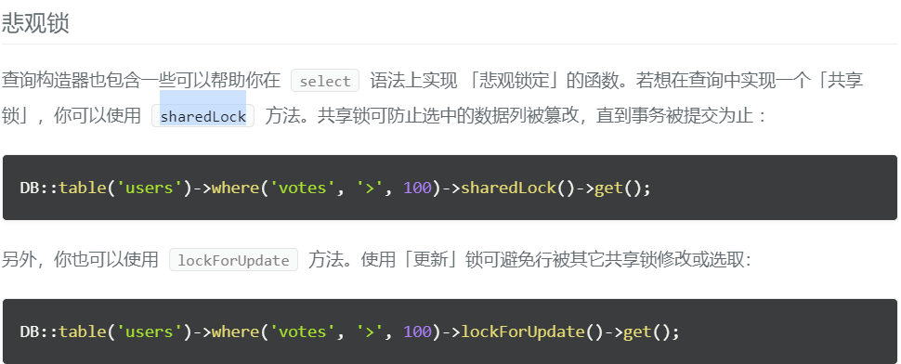

laravelLearn\vendor\laravel\framework\src\Illuminate\Database\Query\Builder.php

thinkPHP

