SeoulBikeData program
SeoulBikeData = read.csv('C:/Users/kevin/Desktop/SeoulBikeData.csv',header = TRUE)
head(SeoulBikeData)
## Date Rented.Bike.Count Hour Temperature.癈. Humidity...
## 1 01/12/2017 254 0 -5.2 37
## 2 01/12/2017 204 1 -5.5 38
## 3 01/12/2017 173 2 -6.0 39
## 4 01/12/2017 107 3 -6.2 40
## 5 01/12/2017 78 4 -6.0 36
## 6 01/12/2017 100 5 -6.4 37
## Wind.speed..m.s. Visibility..10m. Dew.point.temperature.癈.
## 1 2.2 2000 -17.6
## 2 0.8 2000 -17.6
## 3 1.0 2000 -17.7
## 4 0.9 2000 -17.6
## 5 2.3 2000 -18.6
## 6 1.5 2000 -18.7
## Solar.Radiation..MJ.m2. Rainfall.mm. Snowfall..cm. Seasons Holiday
## 1 0 0 0 Winter No Holiday
## 2 0 0 0 Winter No Holiday
## 3 0 0 0 Winter No Holiday
## 4 0 0 0 Winter No Holiday
## 5 0 0 0 Winter No Holiday
## 6 0 0 0 Winter No Holiday
## Functioning.Day
## 1 Yes
## 2 Yes
## 3 Yes
## 4 Yes
## 5 Yes
## 6 Yes
sum(is.na(SeoulBikeData))
## [1] 0
library(tidyverse)
## -- Attaching packages --------------------------------------- tidyverse 1.3.1 --
## v ggplot2 3.3.3 v purrr 0.3.4
## v tibble 3.1.2 v dplyr 1.0.6
## v tidyr 1.1.3 v stringr 1.4.0
## v readr 1.4.0 v forcats 0.5.1
## -- Conflicts ------------------------------------------ tidyverse_conflicts() --
## x dplyr::filter() masks stats::filter()
## x dplyr::lag() masks stats::lag()
SeoulBikeData <- SeoulBikeData %>% rename(
rental_count = Rented.Bike.Count,
Temperature = Temperature.癈.,
Humidity = Humidity...,
Wind_speed = Wind.speed..m.s.,
Visibility_in_10m = Visibility..10m.,
Dew_point_temperature = Dew.point.temperature.癈.,
Solar_Radiation = Solar.Radiation..MJ.m2.,
Rainfall_in_mm = Rainfall.mm.,
Snowfall_in_cm = Snowfall..cm.,
Functioning_Day = Functioning.Day
)
head(SeoulBikeData)
## Date rental_count Hour Temperature Humidity Wind_speed
## 1 01/12/2017 254 0 -5.2 37 2.2
## 2 01/12/2017 204 1 -5.5 38 0.8
## 3 01/12/2017 173 2 -6.0 39 1.0
## 4 01/12/2017 107 3 -6.2 40 0.9
## 5 01/12/2017 78 4 -6.0 36 2.3
## 6 01/12/2017 100 5 -6.4 37 1.5
## Visibility_in_10m Dew_point_temperature Solar_Radiation Rainfall_in_mm
## 1 2000 -17.6 0 0
## 2 2000 -17.6 0 0
## 3 2000 -17.7 0 0
## 4 2000 -17.6 0 0
## 5 2000 -18.6 0 0
## 6 2000 -18.7 0 0
## Snowfall_in_cm Seasons Holiday Functioning_Day
## 1 0 Winter No Holiday Yes
## 2 0 Winter No Holiday Yes
## 3 0 Winter No Holiday Yes
## 4 0 Winter No Holiday Yes
## 5 0 Winter No Holiday Yes
## 6 0 Winter No Holiday Yes
str(SeoulBikeData)
## 'data.frame': 8760 obs. of 14 variables:
## $ Date : chr "01/12/2017" "01/12/2017" "01/12/2017" "01/12/2017" ...
## $ rental_count : int 254 204 173 107 78 100 181 460 930 490 ...
## $ Hour : int 0 1 2 3 4 5 6 7 8 9 ...
## $ Temperature : num -5.2 -5.5 -6 -6.2 -6 -6.4 -6.6 -7.4 -7.6 -6.5 ...
## $ Humidity : int 37 38 39 40 36 37 35 38 37 27 ...
## $ Wind_speed : num 2.2 0.8 1 0.9 2.3 1.5 1.3 0.9 1.1 0.5 ...
## $ Visibility_in_10m : int 2000 2000 2000 2000 2000 2000 2000 2000 2000 1928 ...
## $ Dew_point_temperature: num -17.6 -17.6 -17.7 -17.6 -18.6 -18.7 -19.5 -19.3 -19.8 -22.4 ...
## $ Solar_Radiation : num 0 0 0 0 0 0 0 0 0.01 0.23 ...
## $ Rainfall_in_mm : num 0 0 0 0 0 0 0 0 0 0 ...
## $ Snowfall_in_cm : num 0 0 0 0 0 0 0 0 0 0 ...
## $ Seasons : chr "Winter" "Winter" "Winter" "Winter" ...
## $ Holiday : chr "No Holiday" "No Holiday" "No Holiday" "No Holiday" ...
## $ Functioning_Day : chr "Yes" "Yes" "Yes" "Yes" ...
ggplot(SeoulBikeData, aes(x=rental_count)) + geom_histogram(color="blue", fill="white")
## `stat_bin()` using `bins = 30`. Pick better value with `binwidth`.
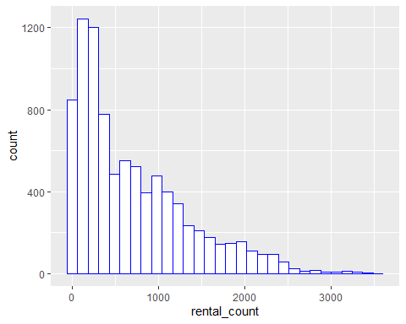
nrow(subset(SeoulBikeData, rental_count==0))
## [1] 295
SeoulBikeData %>% count(Functioning_Day)
## Functioning_Day n
## 1 No 295
## 2 Yes 8465
SeoulBikeData$Functioning_Day[SeoulBikeData$Functioning_Day == 'No'] <- 0
SeoulBikeData$Functioning_Day[SeoulBikeData$Functioning_Day == 'Yes'] <- 1
SeoulBikeData$Functioning_Day <- as.numeric(SeoulBikeData$Functioning_Day)
ggplot(SeoulBikeData, aes(x=rental_count, y=Functioning_Day)) +
geom_point() +
geom_smooth(method = "glm",
method.args = list(family = "binomial"),
se = FALSE)
## `geom_smooth()` using formula 'y ~ x'
## Warning: glm.fit: algorithm did not converge
## Warning: glm.fit: fitted probabilities numerically 0 or 1 occurred
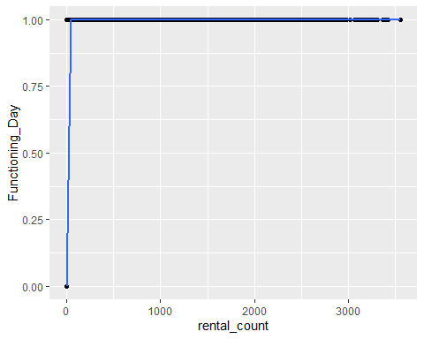
SeoulBikeData_nonFunction <- filter(SeoulBikeData, Functioning_Day == 0)
SeoulBikeData_nonFunction %>% count(rental_count)
## rental_count n
## 1 0 295
SeoulBikeData_nonFunction %>% count(Functioning_Day)
## Functioning_Day n
## 1 0 295
SeoulBikeData_Function <- filter(SeoulBikeData, Functioning_Day == 1)
str(SeoulBikeData_Function)
## 'data.frame': 8465 obs. of 14 variables:
## $ Date : chr "01/12/2017" "01/12/2017" "01/12/2017" "01/12/2017" ...
## $ rental_count : int 254 204 173 107 78 100 181 460 930 490 ...
## $ Hour : int 0 1 2 3 4 5 6 7 8 9 ...
## $ Temperature : num -5.2 -5.5 -6 -6.2 -6 -6.4 -6.6 -7.4 -7.6 -6.5 ...
## $ Humidity : int 37 38 39 40 36 37 35 38 37 27 ...
## $ Wind_speed : num 2.2 0.8 1 0.9 2.3 1.5 1.3 0.9 1.1 0.5 ...
## $ Visibility_in_10m : int 2000 2000 2000 2000 2000 2000 2000 2000 2000 1928 ...
## $ Dew_point_temperature: num -17.6 -17.6 -17.7 -17.6 -18.6 -18.7 -19.5 -19.3 -19.8 -22.4 ...
## $ Solar_Radiation : num 0 0 0 0 0 0 0 0 0.01 0.23 ...
## $ Rainfall_in_mm : num 0 0 0 0 0 0 0 0 0 0 ...
## $ Snowfall_in_cm : num 0 0 0 0 0 0 0 0 0 0 ...
## $ Seasons : chr "Winter" "Winter" "Winter" "Winter" ...
## $ Holiday : chr "No Holiday" "No Holiday" "No Holiday" "No Holiday" ...
## $ Functioning_Day : num 1 1 1 1 1 1 1 1 1 1 ...
ggplot(SeoulBikeData_Function, aes(x=rental_count)) + geom_histogram(aes(y=..density..),color="blue", fill="white") + geom_density()
## `stat_bin()` using `bins = 30`. Pick better value with `binwidth`.
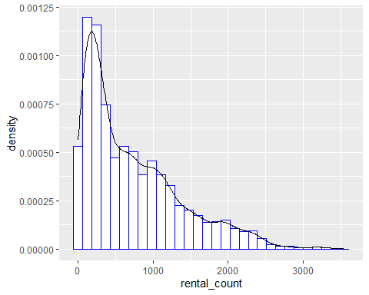
ggplot(SeoulBikeData_Function, aes(y=rental_count)) +
geom_boxplot()
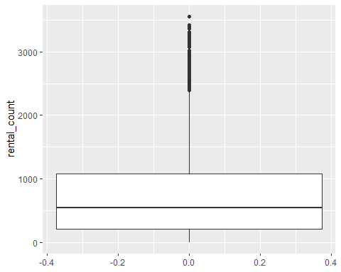
summary(SeoulBikeData_Function$rental_count)
## Min. 1st Qu. Median Mean 3rd Qu. Max.
## 2.0 214.0 542.0 729.2 1084.0 3556.0
summary(SeoulBikeData_Function$Temperature)
## Min. 1st Qu. Median Mean 3rd Qu. Max.
## -17.80 3.00 13.50 12.77 22.70 39.40
summary(SeoulBikeData_Function$Humidity)
## Min. 1st Qu. Median Mean 3rd Qu. Max.
## 0.00 42.00 57.00 58.15 74.00 98.00
summary(SeoulBikeData_Function$Wind_speed)
## Min. 1st Qu. Median Mean 3rd Qu. Max.
## 0.000 0.900 1.500 1.726 2.300 7.400
summary(SeoulBikeData_Function$Visibility_in_10m)
## Min. 1st Qu. Median Mean 3rd Qu. Max.
## 27 935 1690 1434 2000 2000
summary(SeoulBikeData_Function$Dew_point_temperature)
## Min. 1st Qu. Median Mean 3rd Qu. Max.
## -30.600 -5.100 4.700 3.945 15.200 27.200
summary(SeoulBikeData_Function$Solar_Radiation)
## Min. 1st Qu. Median Mean 3rd Qu. Max.
## 0.0000 0.0000 0.0100 0.5679 0.9300 3.5200
summary(SeoulBikeData_Function$Rainfall_in_mm)
## Min. 1st Qu. Median Mean 3rd Qu. Max.
## 0.0000 0.0000 0.0000 0.1491 0.0000 35.0000
summary(SeoulBikeData_Function$Snowfall_in_cm)
## Min. 1st Qu. Median Mean 3rd Qu. Max.
## 0.00000 0.00000 0.00000 0.07769 0.00000 8.80000
ggplot(SeoulBikeData_Function, aes(x=Seasons , y=rental_count, fill=Seasons)) +
geom_boxplot()
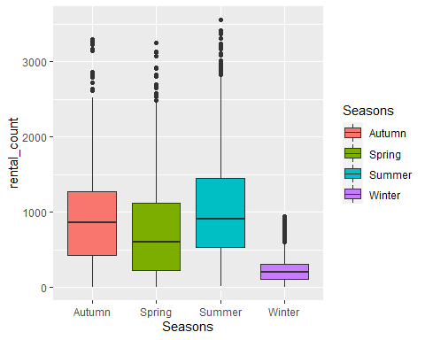
ggplot(SeoulBikeData_Function, aes(x=Holiday , y=rental_count, fill=Holiday)) +
geom_boxplot()
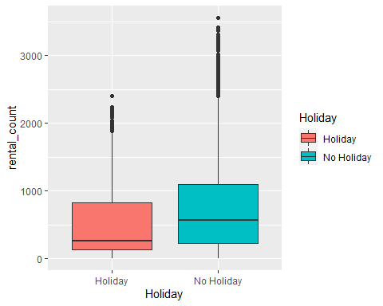
count_vs_hour <- SeoulBikeData_Function[2:3]
count_vs_hour$Hour <- as.character(count_vs_hour$Hour)
str(count_vs_hour)
## 'data.frame': 8465 obs. of 2 variables:
## $ rental_count: int 254 204 173 107 78 100 181 460 930 490 ...
## $ Hour : chr "0" "1" "2" "3" ...
ggplot(count_vs_hour,aes(x=Hour , y=rental_count,fill = Hour)) + geom_boxplot()
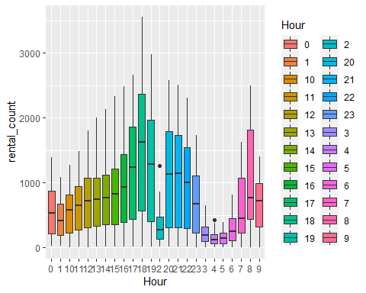
SeoulBikeData_Function$Seasons[SeoulBikeData_Function$Seasons == 'Winter'] <- 1
SeoulBikeData_Function$Seasons[SeoulBikeData_Function$Seasons == 'Spring'] <- 2
SeoulBikeData_Function$Seasons[SeoulBikeData_Function$Seasons == 'Summer'] <- 3
SeoulBikeData_Function$Seasons[SeoulBikeData_Function$Seasons == 'Autumn'] <- 4
SeoulBikeData_Function$Seasons <- as.numeric(SeoulBikeData_Function$Seasons)
SeoulBikeData_Function %>% count(Seasons)
## Seasons n
## 1 1 2160
## 2 2 2160
## 3 3 2208
## 4 4 1937
SeoulBikeData_Function %>% count(Holiday)
## Holiday n
## 1 Holiday 408
## 2 No Holiday 8057
SeoulBikeData_Function$Holiday[SeoulBikeData_Function$Holiday == 'Holiday'] <- 1
SeoulBikeData_Function$Holiday[SeoulBikeData_Function$Holiday == 'No Holiday'] <- 2
SeoulBikeData_Function$Holiday <- as.numeric(SeoulBikeData_Function$Holiday)
SeoulBikeData_Function %>% count(Holiday)
## Holiday n
## 1 1 408
## 2 2 8057
correlation_test <- SeoulBikeData_Function[2:11]
str(correlation_test)
## 'data.frame': 8465 obs. of 10 variables:
## $ rental_count : int 254 204 173 107 78 100 181 460 930 490 ...
## $ Hour : int 0 1 2 3 4 5 6 7 8 9 ...
## $ Temperature : num -5.2 -5.5 -6 -6.2 -6 -6.4 -6.6 -7.4 -7.6 -6.5 ...
## $ Humidity : int 37 38 39 40 36 37 35 38 37 27 ...
## $ Wind_speed : num 2.2 0.8 1 0.9 2.3 1.5 1.3 0.9 1.1 0.5 ...
## $ Visibility_in_10m : int 2000 2000 2000 2000 2000 2000 2000 2000 2000 1928 ...
## $ Dew_point_temperature: num -17.6 -17.6 -17.7 -17.6 -18.6 -18.7 -19.5 -19.3 -19.8 -22.4 ...
## $ Solar_Radiation : num 0 0 0 0 0 0 0 0 0.01 0.23 ...
## $ Rainfall_in_mm : num 0 0 0 0 0 0 0 0 0 0 ...
## $ Snowfall_in_cm : num 0 0 0 0 0 0 0 0 0 0 ...
cor(correlation_test)
## rental_count Hour Temperature Humidity
## rental_count 1.0000000 0.425255882 0.56274017 -0.2019727
## Hour 0.4252559 1.000000000 0.12274182 -0.2359372
## Temperature 0.5627402 0.122741816 1.00000000 0.1664252
## Humidity -0.2019727 -0.235937180 0.16642522 1.0000000
## Wind_speed 0.1250219 0.287779819 -0.03848085 -0.3373524
## Visibility_in_10m 0.2123228 0.103869318 0.02826206 -0.5485418
## Dew_point_temperature 0.4002628 0.004691479 0.91446695 0.5394024
## Solar_Radiation 0.2738616 0.144658482 0.35484355 -0.4572727
## Rainfall_in_mm -0.1286261 0.014344645 0.05214889 0.2369169
## Snowfall_in_cm -0.1516108 -0.022082499 -0.21774581 0.1101265
## Wind_speed Visibility_in_10m Dew_point_temperature
## rental_count 0.125021946 0.21232278 0.400262829
## Hour 0.287779819 0.10386932 0.004691479
## Temperature -0.038480848 0.02826206 0.914466952
## Humidity -0.337352380 -0.54854183 0.539402446
## Wind_speed 1.000000000 0.18042765 -0.177170126
## Visibility_in_10m 0.180427649 1.00000000 -0.182586445
## Dew_point_temperature -0.177170126 -0.18258645 1.000000000
## Solar_Radiation 0.326221868 0.15304614 0.098524979
## Rainfall_in_mm -0.024931327 -0.17035180 0.126812453
## Snowfall_in_cm -0.003789344 -0.12285973 -0.149759793
## Solar_Radiation Rainfall_in_mm Snowfall_in_cm
## rental_count 0.27386155 -0.128626093 -0.151610753
## Hour 0.14465848 0.014344645 -0.022082499
## Temperature 0.35484355 0.052148891 -0.217745811
## Humidity -0.45727269 0.236916912 0.110126502
## Wind_speed 0.32622187 -0.024931327 -0.003789344
## Visibility_in_10m 0.15304614 -0.170351798 -0.122859731
## Dew_point_temperature 0.09852498 0.126812453 -0.149759793
## Solar_Radiation 1.00000000 -0.074157271 -0.073379874
## Rainfall_in_mm -0.07415727 1.000000000 0.008604092
## Snowfall_in_cm -0.07337987 0.008604092 1.000000000
plot(correlation_test)
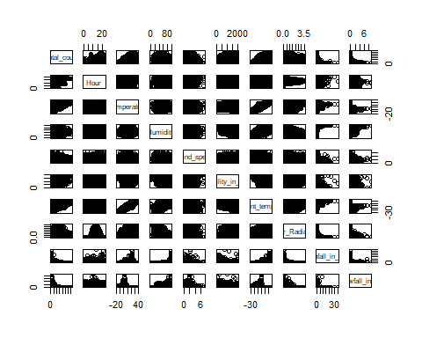
library(reshape2)
##
## 载入程辑包：'reshape2'
## The following object is masked from 'package:tidyr':
##
## smiths
melted<- melt(round(cor(correlation_test),2))
library(ggplot2)
ggplot(data = melted, aes(x=Var1, y=Var2, fill=value)) + geom_tile() +
theme(axis.text.x = element_text(angle = 45, vjust = 1, size = 12, hjust = 1))+ coord_fixed()
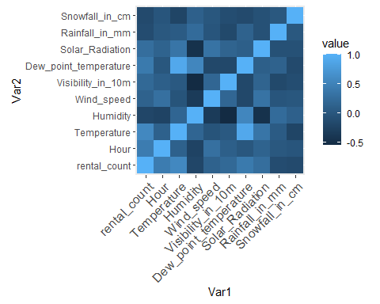
ggplot(correlation_test, aes(x=Temperature, y=Dew_point_temperature)) +
geom_point()+
geom_smooth(method=lm, se=FALSE)
## `geom_smooth()` using formula 'y ~ x'
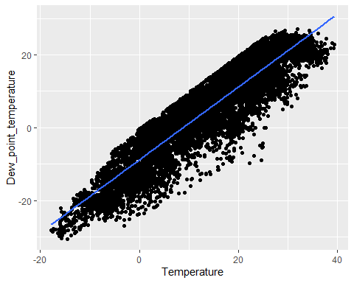
test_model_1 <- lm(Temperature~Dew_point_temperature,data = correlation_test)
summary(test_model_1)
##
## Call:
## lm(formula = Temperature ~ Dew_point_temperature, data = correlation_test)
##
## Residuals:
## Min 1Q Median 3Q Max
## -9.2582 -3.7426 -0.6475 3.1734 22.6494
##
## Coefficients:
## Estimate Std. Error t value Pr(>|t|)
## (Intercept) 9.473515 0.055553 170.5 <2e-16 ***
## Dew_point_temperature 0.835880 0.004021 207.9 <2e-16 ***
## ---
## Signif. codes: 0 '***' 0.001 '**' 0.01 '*' 0.05 '.' 0.1 ' ' 1
##
## Residual standard error: 4.898 on 8463 degrees of freedom
## Multiple R-squared: 0.8362, Adjusted R-squared: 0.8362
## F-statistic: 4.322e+04 on 1 and 8463 DF, p-value: < 2.2e-16
SeoulBikeData_Function_mlr <- SeoulBikeData_Function[c(2:7,9:13)]
head(SeoulBikeData_Function_mlr)
## rental_count Hour Temperature Humidity Wind_speed Visibility_in_10m
## 1 254 0 -5.2 37 2.2 2000
## 2 204 1 -5.5 38 0.8 2000
## 3 173 2 -6.0 39 1.0 2000
## 4 107 3 -6.2 40 0.9 2000
## 5 78 4 -6.0 36 2.3 2000
## 6 100 5 -6.4 37 1.5 2000
## Solar_Radiation Rainfall_in_mm Snowfall_in_cm Seasons Holiday
## 1 0 0 0 1 2
## 2 0 0 0 1 2
## 3 0 0 0 1 2
## 4 0 0 0 1 2
## 5 0 0 0 1 2
## 6 0 0 0 1 2
library(MASS)
##
## 载入程辑包：'MASS'
## The following object is masked from 'package:dplyr':
##
## select
library(leaps)
library(caret)
## 载入需要的程辑包：lattice
##
## 载入程辑包：'caret'
## The following object is masked from 'package:purrr':
##
## lift
train_control <- trainControl(method = "cv", number = 10,p = 0.75)
set.seed(903)
model_mlr <- train(rental_count~., data=SeoulBikeData_Function_mlr,method = "lm", trControl = train_control,metric = "RMSE")
model_mlr
## Linear Regression
##
## 8465 samples
## 10 predictor
##
## No pre-processing
## Resampling: Cross-Validated (10 fold)
## Summary of sample sizes: 7617, 7620, 7619, 7618, 7619, 7618, ...
## Resampling results:
##
## RMSE Rsquared MAE
## 438.2147 0.535284 326.9658
##
## Tuning parameter 'intercept' was held constant at a value of TRUE
summary(model_mlr)
##
## Call:
## lm(formula = .outcome ~ ., data = dat)
##
## Residuals:
## Min 1Q Median 3Q Max
## -1236.44 -278.37 -54.88 213.52 2231.49
##
## Coefficients:
## Estimate Std. Error t value Pr(>|t|)
## (Intercept) 57.345482 55.244293 1.038 0.299284
## Hour 28.706993 0.746413 38.460 < 2e-16 ***
## Temperature 26.609709 0.579858 45.890 < 2e-16 ***
## Humidity -8.431415 0.372911 -22.610 < 2e-16 ***
## Wind_speed 19.218473 5.236120 3.670 0.000244 ***
## Visibility_in_10m -0.007595 0.009984 -0.761 0.446853
## Solar_Radiation -79.693998 7.577910 -10.517 < 2e-16 ***
## Rainfall_in_mm -63.431446 4.375804 -14.496 < 2e-16 ***
## Snowfall_in_cm 18.817067 11.200192 1.680 0.092981 .
## Seasons 110.785998 5.623107 19.702 < 2e-16 ***
## Holiday 128.077284 22.298547 5.744 9.58e-09 ***
## ---
## Signif. codes: 0 '***' 0.001 '**' 0.01 '*' 0.05 '.' 0.1 ' ' 1
##
## Residual standard error: 437.8 on 8454 degrees of freedom
## Multiple R-squared: 0.536, Adjusted R-squared: 0.5354
## F-statistic: 976.5 on 10 and 8454 DF, p-value: < 2.2e-16
set.seed(903)
step_model <- train(rental_count~., data = SeoulBikeData_Function_mlr,
method = "lmStepAIC",
trControl = train_control,
trace = FALSE)
step_model
## Linear Regression with Stepwise Selection
##
## 8465 samples
## 10 predictor
##
## No pre-processing
## Resampling: Cross-Validated (10 fold)
## Summary of sample sizes: 7617, 7620, 7619, 7618, 7619, 7618, ...
## Resampling results:
##
## RMSE Rsquared MAE
## 438.212 0.5352863 326.8619
summary(step_model)
##
## Call:
## lm(formula = .outcome ~ Hour + Temperature + Humidity + Wind_speed +
## Solar_Radiation + Rainfall_in_mm + Snowfall_in_cm + Seasons +
## Holiday, data = dat)
##
## Residuals:
## Min 1Q Median 3Q Max
## -1239.21 -278.14 -54.79 213.14 2233.86
##
## Coefficients:
## Estimate Std. Error t value Pr(>|t|)
## (Intercept) 39.0364 49.7244 0.785 0.432443
## Hour 28.7498 0.7443 38.628 < 2e-16 ***
## Temperature 26.5632 0.5766 46.068 < 2e-16 ***
## Humidity -8.2726 0.3090 -26.773 < 2e-16 ***
## Wind_speed 18.8501 5.2135 3.616 0.000301 ***
## Solar_Radiation -78.3414 7.3662 -10.635 < 2e-16 ***
## Rainfall_in_mm -63.2961 4.3721 -14.477 < 2e-16 ***
## Snowfall_in_cm 18.9046 11.1993 1.688 0.091446 .
## Seasons 109.9105 5.5039 19.969 < 2e-16 ***
## Holiday 128.2228 22.2972 5.751 9.2e-09 ***
## ---
## Signif. codes: 0 '***' 0.001 '**' 0.01 '*' 0.05 '.' 0.1 ' ' 1
##
## Residual standard error: 437.8 on 8455 degrees of freedom
## Multiple R-squared: 0.536, Adjusted R-squared: 0.5355
## F-statistic: 1085 on 9 and 8455 DF, p-value: < 2.2e-16
subsets<-regsubsets(rental_count~.,
data=SeoulBikeData_Function_mlr, nbest=1)
sub.sum <- summary(subsets)
as.data.frame(sub.sum$outmat)
## Hour Temperature Humidity Wind_speed Visibility_in_10m Solar_Radiation
## 1 ( 1 ) *
## 2 ( 1 ) * *
## 3 ( 1 ) * * *
## 4 ( 1 ) * * *
## 5 ( 1 ) * * *
## 6 ( 1 ) * * * *
## 7 ( 1 ) * * * *
## 8 ( 1 ) * * * * *
## Rainfall_in_mm Snowfall_in_cm Seasons Holiday
## 1 ( 1 )
## 2 ( 1 )
## 3 ( 1 )
## 4 ( 1 ) *
## 5 ( 1 ) * *
## 6 ( 1 ) * *
## 7 ( 1 ) * * *
## 8 ( 1 ) * * *
library(rpart)
library(rpart.plot)
set.seed(903)
dt_model <- train(rental_count ~ .,
tuneLength = 10,metric = "RMSE", data = SeoulBikeData_Function_mlr, method = "rpart",trControl =train_control)
## Warning in nominalTrainWorkflow(x = x, y = y, wts = weights, info = trainInfo, :
## There were missing values in resampled performance measures.
print(dt_model)
## CART
##
## 8465 samples
## 10 predictor
##
## No pre-processing
## Resampling: Cross-Validated (10 fold)
## Summary of sample sizes: 7617, 7620, 7619, 7618, 7619, 7618, ...
## Resampling results across tuning parameters:
##
## cp RMSE Rsquared MAE
## 0.009541003 364.5774 0.6785039 259.3501
## 0.011345923 369.3711 0.6699230 263.2851
## 0.012109507 375.2878 0.6593205 267.7438
## 0.015410349 381.8530 0.6471406 273.2710
## 0.021076976 398.3559 0.6158454 287.3467
## 0.030598818 410.0091 0.5929280 300.4972
## 0.062278865 424.3441 0.5634851 313.4617
## 0.065964898 445.3929 0.5174085 330.9601
## 0.187538412 515.4791 0.3547558 380.1379
## 0.276927210 587.5918 0.2643416 452.1301
##
## RMSE was used to select the optimal model using the smallest value.
## The final value used for the model was cp = 0.009541003.
plot(dt_model)
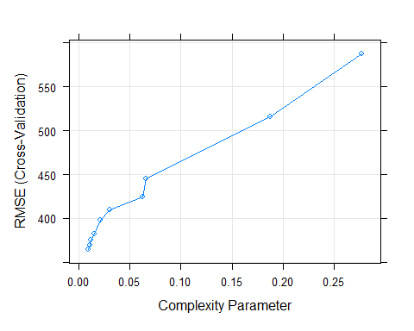
dt_model$finalModel
## n= 8465
##
## node), split, n, deviance, yval
## * denotes terminal node
##
## 1) root 8465 3492374000 729.1570
## 2) Temperature< 12.05 3976 484876500 370.0025
## 4) Seasons< 3 3112 194179300 283.6199 *
## 5) Seasons>=3 864 183834700 681.1400
## 10) Hour< 6.5 334 11483650 313.4581 *
## 11) Hour>=6.5 530 98742340 912.8491 *
## 3) Temperature>=12.05 4489 2040364000 1047.2680
## 6) Hour< 15.5 2882 649750900 762.0399
## 12) Solar_Radiation< 0.295 1344 163436500 468.1652 *
## 13) Solar_Radiation>=0.295 1538 268813300 1018.8460 *
## 7) Hour>=15.5 1607 735658700 1558.7960
## 14) Humidity>=83.5 159 35515400 416.1950 *
## 15) Humidity< 83.5 1448 469769300 1684.2610
## 30) Hour>=22.5 153 11268640 1123.3790 *
## 31) Hour< 22.5 1295 404681900 1750.5270
## 62) Temperature< 19.95 433 96791000 1495.5520 *
## 63) Temperature>=19.95 862 265600000 1878.6070
## 126) Hour< 16.5 148 29729470 1407.6890 *
## 127) Hour>=16.5 714 196246400 1976.2200 *
rpart.plot(dt_model$finalModel)
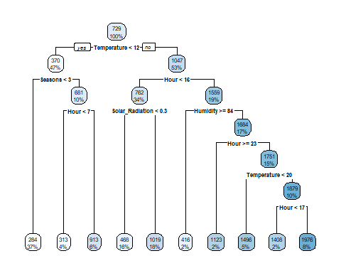
set.seed(903)
model_knn <- train(
rental_count~., data = SeoulBikeData_Function_mlr, method = "knn",
trControl = train_control,
preProcess = c("center","scale"),
tuneLength = 10)
plot(model_knn)
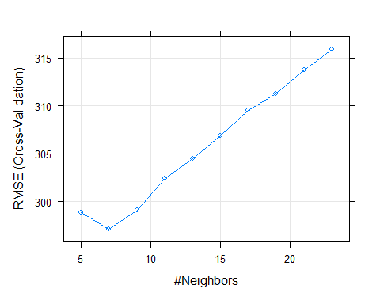
model_knn
## k-Nearest Neighbors
##
## 8465 samples
## 10 predictor
##
## Pre-processing: centered (10), scaled (10)
## Resampling: Cross-Validated (10 fold)
## Summary of sample sizes: 7617, 7620, 7619, 7618, 7619, 7618, ...
## Resampling results across tuning parameters:
##
## k RMSE Rsquared MAE
## 5 298.9053 0.7844021 192.3623
## 7 297.1353 0.7863595 194.3197
## 9 299.0939 0.7834965 197.6511
## 11 302.4515 0.7787076 200.7736
## 13 304.4817 0.7758977 203.0266
## 15 306.8399 0.7724442 204.9082
## 17 309.5172 0.7685921 207.8098
## 19 311.2797 0.7660385 209.7445
## 21 313.7222 0.7624218 211.8016
## 23 315.8738 0.7591868 213.7759
##
## RMSE was used to select the optimal model using the smallest value.
## The final value used for the model was k = 7.
model_knn$bestTune
## k
## 2 7

