## 引入maven依赖

<**dependency**>  
 <**groupId**>org.mybatis.generator</**groupId**>  
 <**artifactId**>mybatis-generator-core</**artifactId**>  
 <**version**>1.3.7</**version**>  
</**dependency**>

## Maven 新增generator插件

<**build**>  
<**plugins**>  
 <**plugin**>  
 <**groupId**>org.mybatis.generator</**groupId**>  
 <**artifactId**>mybatis-generator-maven-plugin</**artifactId**>  
 <**version**>1.3.2</**version**>  
 <**configuration**>  
 <**configurationFile**>${project.basedir}/src/main/resources/generator/generatorConfig.xml</**configurationFile**>  
 <**overwrite**>true</**overwrite**>  
 <**verbose**>true</**verbose**>  
 </**configuration**>  
 </**plugin**>  
</**plugins**>  
</**build**>

## 需要下载一个>mysql-connector-java

<**dependency**>  
 <**groupId**>mysql</**groupId**>  
 <**artifactId**>mysql-connector-java</**artifactId**>  
 <**version**>8.0.16</**version**>  
</**dependency**>

## 编写generatorConfig.xml

1. *<?***xml version**="1.0" **encoding**="UTF-8"*?>***<!DOCTYPE generatorConfiguration  
    PUBLIC** "-//mybatis.org//DTD MyBatis Generator Configuration 1.0//EN"  
    "http://mybatis.org/dtd/mybatis-generator-config_1_0.dtd"***>***<**generatorConfiguration**>  
    <!-- 数据库驱动:选择你的本地硬盘上面的数据库驱动包-->  
    <**classPathEntry location**="C:\Users\Administrator\.m2\repository\mysql\mysql-connector-java\8.0.16\mysql-connector-java-8.0.16.jar"/>  
    <**context id**="DB2Tables" **targetRuntime**="MyBatis3">  
    <**commentGenerator**>  
    <**property name**="suppressDate" **value**="true"/>  
    <!-- 是否去除自动生成的注释 true：是 ： false:否 -->  
    <**property name**="suppressAllComments" **value**="true"/>  
    </**commentGenerator**>  
    <!--数据库链接URL，用户名、密码 -->  
    <**jdbcConnection driverClass**="com.mysql.jdbc.Driver" **connectionURL**="jdbc:mysql://127.0.0.1/mysql" **userId**="root" **password**="123456">  
    </**jdbcConnection**>  
    <**javaTypeResolver**>  
    <**property name**="forceBigDecimals" **value**="false"/>  
    </**javaTypeResolver**>  
    <!-- 生成模型的包名和位置-->  
    <**javaModelGenerator targetPackage**="com.xiaoming.dto" **targetProject**="src/main/java">  
    <**property name**="enableSubPackages" **value**="true"/>  
    <**property name**="trimStrings" **value**="true"/>  
    </**javaModelGenerator**>  
    <!-- 生成映射文件的包名和位置-->  
    <**sqlMapGenerator targetPackage**="mapping" **targetProject**="src/main/resources/mapping">  
    <**property name**="enableSubPackages" **value**="true"/>  
    </**sqlMapGenerator**>  
    <!-- 生成DAO的包名和位置-->  
    <**javaClientGenerator type**="XMLMAPPER" **targetPackage**="com.xiaoming.dao" **targetProject**="src/main/java">  
    <**property name**="enableSubPackages" **value**="true"/>  
    </**javaClientGenerator**>  
    <!-- 要生成的表 tableName是数据库中的表名或视图名 domainObjectName是实体类名-->  
    <**table tableName**="t_user" **domainObjectName**="User" **enableCountByExample**="false" **enableUpdateByExample**="false" **enableDeleteByExample**="false" **enableSelectByExample**="false" **selectByExampleQueryId**="false"></**table**>  
    </**context**>  
   </**generatorConfiguration**>

## 生成代码

mvn mybatis-generator:generate

如果是在intellij 环境，直接鼠标点击即可

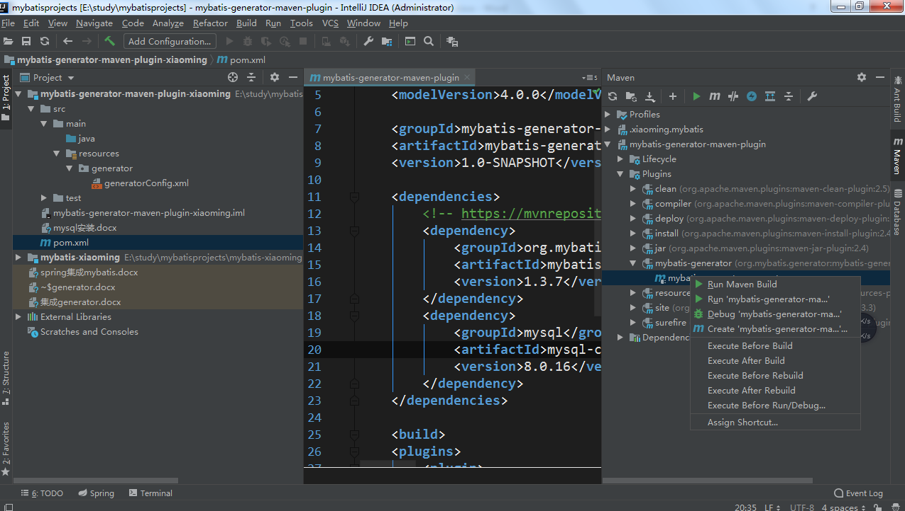

## 异常解决：

1. Mysql连接时区的问题

Caused by: org.apache.maven.plugin.MojoExecutionException: The server time zone value

解决：修改链接url包含时区参数

如：

**connectionURL**="jdbc:mysql://127.0.0.1/mysql?serverTimezone=GMT%2B8"