**Determination of *Persea Americana* Fruit Ripening Stage using Electronic Nose with Fuzzy Logic Algorithm**

by

**Julie Ann A. Parañal**

**Isauro Angelo S. Robles**

A Thesis Report Submitted to the School of EE – ECE –CpE

in Partial Fulfilment of the Requirements for the Degree

Bachelor of Science in Computer Engineering

Mapua University

December 2018

**Chapter 1**

**INTRODUCTION**

Ethylene is a small hydrocarbon gas that naturally occurring, but it can also occur as a result of combustion and other processes. Research has since demonstrated that ethylene has an important role in many plant development processes, including seed germination, vegetative growth, leaf abscission, flowering, senescence and fruit ripening. The determination of climacteric fruits ripening states since it harvest is becoming the very important issue for producers, sellers, food industries as well as consumers due to the delicate nature of the fruit. Fruit quality is judged by consumers primarily from their perception of the acceptability of fruits based on characteristics including visual appeal (lack of blemishes, color, size, and texture). Some fruit varieties vary widely in aroma characteristics because aroma is often the most valued characteristic determining fruit quality and consumer choice and is usually the best indicator of fruit flavor and ripeness especially to fruits that are not easily to determine through its skin color when ripe. Example of this are the *Persea Americana* or Avocado, this fruit is one of the climacteric fruits that does not produce large amount of ethylene on the tree, does not ripen until it is harvested and cannot be easily determined by human’s color vision when ripen. The advancement of technology has offered electronic nose or e-nose as a new alternative way to evaluate and grade fruits based from fruits aroma called the ethylene gas. These electronic nose is an intelligent sensing device that can sense aroma more effectively than the human sense of smell. Due to its non-destructive property it has been selected to be the ideal digital, electronic device for identifying, characterizing and grading fruits ripeness.

Different approaches in determining the ripeness of the fruits have been performed. One study used a new ultrasonic echo pulse method in order to study the feasibility of maturity assessment of orange fruit. (Aboudaoud et al., 2012). This research is conducted in order measure the ultrasonic parameters eventually velocity and attenuation in order to check the aptitude of this technique to determine the maturity degree of the fruit. Other researchers that determine the maturity of a fruit is by using near infrared spectroscopy (NIR) which is also a non-destructive method for determining the maturity degree of mango fruits during postharvest ripening (Mahayothee et al., 2014).

Most determination in other countries classify the degree of ripening is by automatic determining system, based on camera with computer-based technology is been widely explored for the quality analysis and grading of agricultural products in recent years. This is known as computer vision system or computerized image analysis technique and it has proven to be successful for objective measurement of various fruit crops. None of the previous researches have incorporated the idea of determining the ripeness of a climacteric fruit that can’t be easily determine by human’s color vision when ripe with the use of electronic nose and fuzzy logic algorithm.

The main objective of this study is to determine the ripeness stage of the avocado fruits using the Fuzzy Logic Classification in MATLAB. The specific objectives of the study are (1) To create an electronic nose that captures the aromas from gathered *Persea Americana* fruit samples. (2) To sort the ripeness stage of avocado fruits from unripe, ripe and overripe by using the fuzzy based classification algorithm. (3) To verify the accuracy of the system by comparing to a human expert grader of fruits.

This paper can be very helpful because of its non-destructive method, reliability and repeatable operation of ripeness stage determination. The system also homogenizes the “ripeness determination” through analysis of Volatiles emitted by a ripening fruit.

This study integrates gas sensors: 8 TGS from TGS from the Figaro Engineering Inc. though numerous forms of the sensor exist as 1) SAW — Surface Acoustic Wave, 2) QCM — Quartz Crystal Microbalance, 3) Optical, and 4) MEMS — Microelectromechanical Systems, 5) MQ Sensor. The study centers on the avocado and does not include the fruit handling prior the sampling. The study will focus only on the development and determination of the ripeness stage of the avocado using the fuzzy logic algorithm

**Chapter 2**

**REVIEW OF RELATED LITERATURE**

This chapter contains articles and researches from different studies that will serve as a guide or basis in fulfilling the objectives presented in previous chapter

**Electronic-Nose Applications for Fruit Identification, Ripeness and Quality Grading**

Fruits produce a wide range of volatile organic compounds that impart their characteristically distinct aromas and contribute to unique flavor characteristics. Fruit aroma and flavor characteristics are of key importance in determining consumer acceptance in commercial fruit markets based on individual preference. Fruit producers, suppliers and retailers traditionally utilize and rely on human testers or panels to evaluate fruit quality and aroma characters for assessing fruit salability in fresh markets. We explore the current and potential utilization of electronic-nose devices (with specialized sensor arrays), instruments that are very effective in discriminating complex mixtures of fruit volatiles, as new effective tools for more efficient fruit aroma analyses to replace conventional expensive methods used in fruit aroma assessments. We review the chemical nature of fruit volatiles during all stages of the agro-fruit production process, describe some of the more important applications that electronic nose (e-nose) technologies have

provided for fruit aroma characterizations, and summarize recent research providing e-nose data on the effectiveness of these specialized gas-sensing instruments for fruit identifications, cultivar discriminations, ripeness assessments and fruit grading for assuring fruit quality in commercial markets.

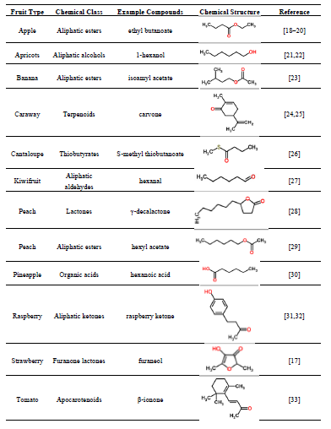

**Table 2.1 Chemical classes of VOCs that are principal components of distinctive fruit aromas.**

**Development of an E-Nose Using Metal Oxide Semiconductor Sensors for the Classification of Climacteric Fruits**

The present work deals with the development of an artificial olfactory system as a nondestructive instrument to be used for classification of different fruits and exploration of its application in measurement of fruit ripening stages. The fruits chosen for this study are Guava, Orange and Banana. The developed system comprises of an array of eight metal oxide semiconductor gas sensors, odor delivery system, interface circuit board, data acquisition card and self-programmed Data acquisition as well as analysis software using LabVIEW. The design of this tool focused on studying the response of a sensor array to various VOC vapors released by fruit during ripening and optimizing the data acquisition, signal preprocessing, storage, feature extraction parameters using principle component analysis. It was found that developed e-nose can discriminate the patterns of volatile organic compounds (VOCs) from three fruits taken for experimentation. These three fruits, as analyzed by the principal component analysis (PCA). With further validation and development, this e-nose may become very useful for monitoring the exhaled as a screening device for discriminating the fruits. This e-nose can also be used for classification and grading of different climacteric fruits on the basis of their ripening stages.

The sensor array employed in the design of the e-nose system is mainly composed of commercially available MQ series metal oxide semiconductor (SnO2) gas sensors by Parallax Engineering Inc. The sensing element of this gas sensors is a tin dioxide (SnO2) semiconductor which has low conductivity in clean air. In the presence of a detectable gas, the sensor's conductivity increases depending on the gas concentration in the air. A simple electrical circuit can convert the change in conductivity to an output signal which corresponds to the gas concentration. The sensors selected for target analytes are tabulated in Table 2.2 below.

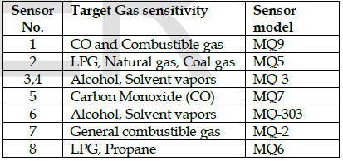

**Table 2.2 MQ series metal oxide gas sensors choose for e-nose array their application gases**

There are two types of printed Circuit Board used in E-Nose system i.) Senor holding P.C.B. ii.) Sensor signal interface P.C.B. as shown in block diagram. These PCBs were designed using OrCAD10 software. The complete fabricated E-Nose system is shown in fig.2.1

**Figure 2.1 Fabricated E-nose system**

**Monitoring Mango Fruit Ripening after Harvest using Electronic Nose (zNoseTM) Technique**

To monitor the ripening process in fruits during storage has become a very important issue to manage fruits because the quality of fruits and other properties are dependent on the ripening stages. There have been many methods or techniques to monitor the ripening of fruits during storage and most of them are basically dependent on firmness and texture. Some of the other techniques require destructive analysis of the samples which is one the major limitation or disadvantage and therefore, they are not practically feasible to use. Thus, the estimation of the right ripening stage is completely dependent on hands-on experience or visual observations such as colour change, which is sometimes less correlated with the actual ripening.

“Electronic nose systems are sensor arrays which mimic the operation of a human nose. When an atmosphere loaded with volatile components flows over it, each sensor generates a signal. The combined signal of all sensors is then statistically related to, e.g. the response of a human taste panel. Sensors that rely on chemical properties of the target molecule, whether it can adsorb at a particular surface or be oxidized or reduced, have been developed for a variety of analytes. Popular at present are sensors based on the conduction of semiconductors, such as in tin oxide, or polymers such as polypyrrole”

Kovats index of a sample component is defined as “a number, obtained by interpolation (usually logarithmic), relating the adjusted retention volume (time) or the retention factor of the sample component to the adjusted retention volumes (times) of two standards eluted before and after the peak of the sample component” (Table 2.3).

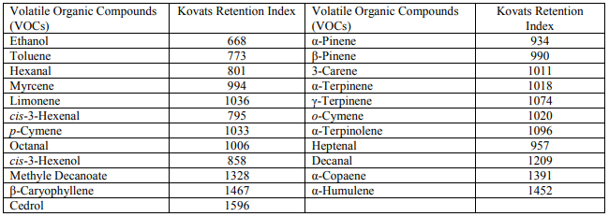**Table 2.3 List of volatile compounds verified during different ripening stages along with their corresponding Kovats Retention Index for DB-5 column**

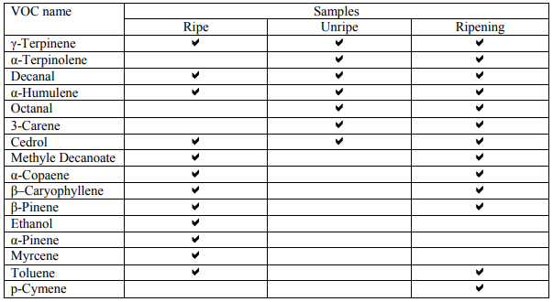The most probable reason for observing less VOCs than expected is that VOCs listed in table one is collectively liberated from different types of mangoes, whereas the mangoes tested in this experiment were all of one local type, i.e. ‘Chokanan’. Although some of the volatiles were uniquely liberated from the ripe and unripe mangoes (on the first day measurements), results obtained on the following days indicated that as unripe mangoes were ripening, some of the VOCs liberated from the ripe mangoes were also liberated from the ripening mangoes (Table 2.4).

**Table 2.4 List of VOCs liberated based on samples ripeness.**

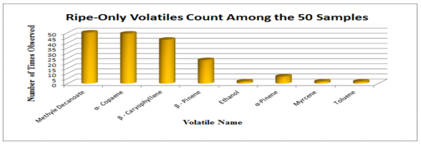However, this situation reverses in all but three of the ripe samples. Although the number of ripe mangoes’ volatiles is roughly twice as much as that of the unripe mangoes, of the eight volatiles observed specifically in the results obtained for the ripe samples, only Methyle Decanoate was present in all the 50 mangoes (Fig. 2.2).

**Figure 2.2 Ripe-Only Volatiles Count.**

**Evaluation of Peach Quality Attribute Using an Electronic Nose**

In this study, responses of a sensor array were examined to establish a quality index model for evaluating peach quality index. The results showed that the multiple linear regression model is effective for predicting quality index, with high correlation coefficients (R2 = 0.87 for compression force; R2 = 0.79 for sugar content; R2 = 0.81 for pH) and relatively low average percentage errors (9.66%, 7.68% and 3.6%, for compression force, sugar content and pH, respectively). The feed-forward neural network also provides an accurate quality index model with high correlations (R2 = 0.90, 0.81 and 0.87 for compression force, sugar content and pH, respectively) between predicted and measured values and relatively low average percentage errors (6.39%, 6.21% and 3.13% for compression force, sugar content and pH, respectively) for prediction. These results prove that the electronic nose has the potential to become a reliable instrument to assess fruit quality index.

The test material “Dabai” peaches were obtained from the “Niannian Mountain” orchard. The orchard is located in Yuhang, in the southeast of China. Peaches were picked on June 9, 16 and 23, 2006. Upon arrival at the laboratory, the peaches were inspected to ensure that they were uniform, undamaged and not infected with worms. Ninety peaches were used for the experiment (30 peaches for each picking date). All peaches were evaluated on the day they were picked.

The electronic nose consisted of a sensor array and a data acquisition card (NI USB-6009, National Instruments Corporation, USA). Eight commercial metal oxide sensors (6 TGS, Japanese manufacturer Figaro; MQ-3 and MQ-7 of metal oxide sensors, HANWEI Electronics Co., Ltd., Henan, China) were placed in a cycloidal chamber. Table 2.5 shows a list of all the sensors used and their main applications. This table contains currently known or specified reactions. To reach the working temperature (about 305°C), the sensors were heated by applying a 5 V DC voltage. The experimental setup is shown in Fig. 2.3. The response of the eight gas sensors was monitored using a data acquisition card (NI USB-6009) connected to a personal computer. With a pump, the

gaseous compounds were sucked through the sensor array (flow rate 100 ml/min). The experimental data was displayed in real-time on the computer screen and stored as text fi les on the disk for processing.

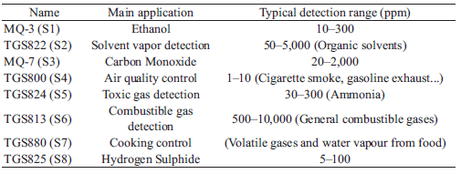

**Table 2.5 Array components, main applications and detection ranges.**

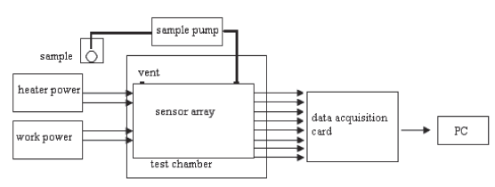

**Figure 2.3 Experimental setup**

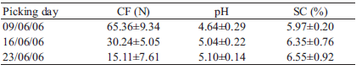 The mean values of the quality index are presented in Table 2. Regarding peach ripeness, the SC (mean value) increased from 5.97 to 6.55, an increase of 9.72% after 14 days. The pH of peaches increased during ripening from 4.64 to 5.10, with a total increase of 9.91% during the growth period of 14 days. The CF of peaches decreased with time from 65.36 to 15.11, with a total decrease of 76.88% during the growth period of 14 days. The peaches were picked on 23 June, which was optimum for eating, and on 16 June, which was optimum for transportation and storage, according to an expert’s experience.

**Table 2.6 Mean values (with standard deviation) of maturity indices for "Dabai" peaches**

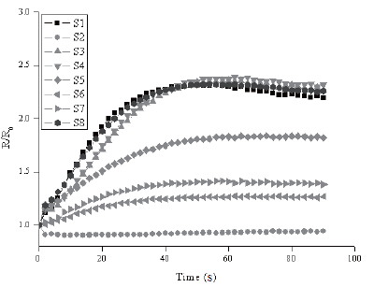Figure 2 shows a typical response of eight sensors for peaches. The gas response is given by R/R0, where R and R0 express the resistance of a sensor in clean air and in detecting gas, respectively. It was shown that after an initial period of low and stable conductivity (when only clean air crosses the measurement chamber), conductivity increases sharply and then stabilizes after a collection time of 45 s. In this research, stable signals (60 s) of each sensor were used in the analysis of the electronic nose.

**Figure 2.4 Typical response curves of sensor array for peach headspace**

**Application of Fuzzy Logic in Recognition of Tomato Fruit Maturity in Smart Farming**

The tomato crop (Solanum Lycopersicum L.) is of great importance in the world. It is useful not just for the livelihood it provides for farmers, but also for its health benefits. Tomato is also rich in vitamin C and lycopene. Lycopene can lower the risk of breast and prostate cancer, osteoporosis and it can also cure male infertility. With the help of Smart Farming technology, the production of tomato fruit in season or not is made possible. This study deals more of the appearance of the fruit because it is the most important characteristic because it defines the product's commercialization value. The tomato's good appearance as well as its good quality will only be met if it reaches its maturity. Tomato maturity is closely relevant to its surface color, so evaluating the tomato's level of maturity by visual recognition is a feasible mean (Choi et al., 1995; Gejima et al., 2004). Tomato color maturity is divided into six stages: Green stage, breakers stage, turning stage, pink stage, light red stage and red stage (USDA, 1991). The researchers used the color, size, and shape of tomato fruit to be the basis of its maturity using the knowledge of fuzzy logic under smart farming implementation.

According to S. Ghosh et.al., (1998), Fuzzy Logic is a decision system approach that works similarly to human control logic. It is a useful technique since it uses human language to describe inputs and outputs and provides a simple method for reaching a conclusion from imprecise, vague or ambiguous input information. Fuzzy-logic systems include a fuzzy-rule set to define the relationship between the input and output variables. Furthermore, just a few data samples can provide quite accurate results. Fuzzy rule refers to the use of "if-then" or "and" and "or" statement. The figure below shows the process of fuzzy logic system, wherein the crisp inputs are put in the fuzzifier to activate the set rules, after that, the defuzzifier will produce the output.

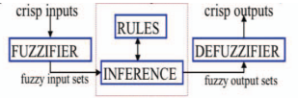

**Figure 2.5 Fuzzy Logic System**

**Machine Vision Based Techniques for Automatic Mango Fruit Sorting and Grading Based on Maturity Level and Size**

Machine vision and image processing techniques have been found increasingly useful in the fruit industry, especially for applications in quality inspection and defect sorting applications. Thus, fruit produced in the garden are sorted according to quality and maturity level and then transported to different standard markets at different distances based on the quality and maturity level. Sorting of fruits according to maturity level is most important in deciding the market it can be sent based on transportation delay.

A schematic diagram of electronic vision-based system for automatic mango fruit sorting and grading is shown in Fig. 1. The camera used in the study was a 10-megapixel CCD (charge-coupled device) camera for capturing the video image. Then the still frame is extracted using MATLAB software from the video images with frame rate of 30 frames/sec. The camera was interfaced with a computer through USB port. The proposed algorithm was implemented in Lab VIEW_Real Time Environment for automatic sorting and grading. Light intensity inside the closed

image capturing chamber was kept at 120 lux, measured with the help of lux meter (Instek-GLS-301) and was controlled automatically by the light sensor along with light intensity controller and light source supplier. The automated fruit sorting and grading system consists of a motor driven

conveyer belt to carry the fruits serially. The fruit placer places one fruit at a time on the conveyer belt and the belt carries it to the imaging chamber where the video image of fruit is captured by the computer through CCD camera. The proposed algorithm runs into the computer automatically to classify the fruit based on four different maturity level like raw (M1), semi-matured (M2), matured (M3) and over matured (M4) and then give a direction to the sorting unit to place the mango in appropriate bin. The sorting unit consists of four solenoid valves driven by respective drive units, which are controlled by the computer. The time delay in between image capturing of a fruit and the triggering the solenoid valve is estimated by the computer on the basis of conveyer 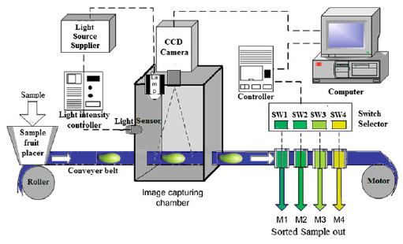belt speed.

**Figure 2.6 Proposed model of machine vision based automated mango fruit sorting and grading system**

**Application of fuzzy logic to determine the odour intensity of model gas mixtures using electronic nose**

One of the parameters that characterize the smell is an odour intensity. It is one of the most commonly determined odour parameters. It is defined as the perceived strength of odour sensation that will be triggered by a specific stimulus. Quantitative odour intensity determinations are typically based on sensory analysis in which a sensory panel determines the intensity of the odour using a verbal point scale. An example of such a scale is the seven-point scale described in German Standard VDI 3940.Degrees corresponding to the respective odour intensity are shown in Table 2.7. The paper presents the possibility of fuzzy logic application to determine the odour intensity of model ternary gas mixtures using electronic nose prototype. As the ingredients of the mixtures three substances were selected: α-pinene, toluene and triethylamine. These substances have low odour thresholds and have been identified in the air nearby waste water treatment plant or landfill. The results obtained using fuzzy logic algorithms were compared with the values obtained using 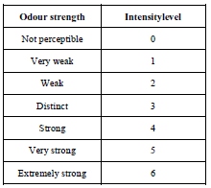multiple linear regression model and sensory analysis.

**Table 2.7 Odour intensity scale described in German Standard VDI 3940.**

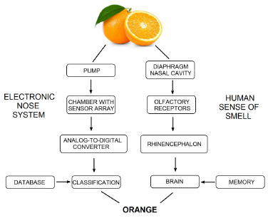 E-noses in their functioning resemble the sense of human smell (Figure 2.7). Sensors are the analogs of the olfactory receptors. They are turning the chemical information into an analytically useful signal. Then the signal is sent to the recognition system, which in the case of human is the brain, and in the case of e-nose is the appropriate mathematical algorithm. The most commonly used data processing methods are: principal component analysis (PCA), principal component regression (PCR), partial least square regression (PLS), fuzzy logic and artificial neural networks (ANN).

**Figure 2.7 Diagram of the electronic nose operation along with human sense of smell.**

One of the most interesting approaches in the field of e-nose data analysis is fuzzy logic. Classical logic system is based on the two values, mostly represented by 0 and 1, or true and false. The boundary between them is unambiguously defined and unchanging. Fuzzy logic is an extension of the classical approach to approach closer to human brain -it introduces additional values between standard 0 and 1. Blurring the boundaries between them gives the opportunity to come up with values between this interval (eg. almost false, half-truth). An example of fuzzy and non-fuzzy sets is shown in Figure 2.8.

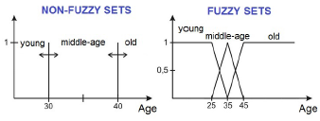

**Figure 2.8 An example of fuzzy and non-fuzzy sets**.

In the case of non-fuzzy sets, the membership function is rectangular. It is set to 0 (no membership in the set) or one (membership in the set). In case of fuzzy sets, other membership functions, such as trapezoid, triangular, gaussian, sigmoidal are used. In this work, trapezoid functions were used. In the Figure 2.9, the defined fuzzy set for the e-nose sensor signal value is shown as an example. The chosen values were selected using optimization methods.

**Classification of Maturity level of Fuji Apple Fruit with Fuzzy Logic Method**

Data used in this research is secondary data in the form of 20 pieces fuji apples image that has been in categories based on the content of the color into the category of fuji apples raw, partially cooked, cooked. such data is the data which is used in research and Irmansyah buono (2009). This study is divided into three stages, namely preprocessing, fuzzy logic modeling and design using gui matlab classification system (figure 2.10). preprocessing is done to get the rgb values. Fuzzy modeling is used to get a fuzzy rule base and testing the model. classification system design is the creation of a user interface that is used for the classification process fuji apples.

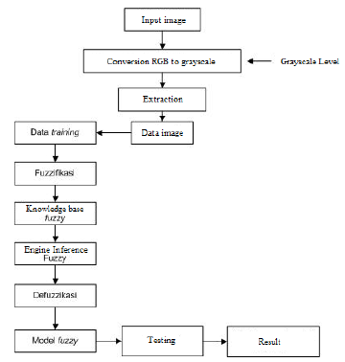

**Figure 2.10 The stages of research**

The development of the identification system utilizing the classification model in the form of fuzzy inference system results from the training data. Grafical-based identification system developed user interface (GUI) on a device MATLAB. (Figure 2.11). The system can be used easily by the user to perform the classification.

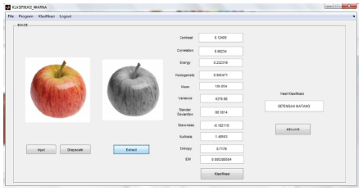

**Figure 2.11 The identification of the image of fuji apples**

**Development of electronic nose for fruits ripeness determination**

A batch of *Harumanis* mango was acquired from the Perlis State Department of Agriculture and placed into the experiment chamber. The chamber contains two ventilation fans and a PCB comprising array of sensors. Figure 2.12 show this experimental set up. The fans are vital to control the air flow inside the chamber during the purging process. Each time new reading is to be taken, the existing air inside the chamber needs to be flush out to make sure the air is back to the background condition. The sensor system comprises of eight tin oxide gas sensors purchased from Figaro Engineering Inc. Japan (see table 2.8) and integrated into the chamber. In general, the resistance of the sensors will decrease when exposed to appropriate gasses or volatile organic compounds (VOC), and are sensitive enough to determine the smell of the *Harumanis.* Measurement is taken by alternating between taking the aroma samples of *Harumanis* for 300 seconds and purging out the air inside the chamber which takes about 60 seconds. Measurements were recorded 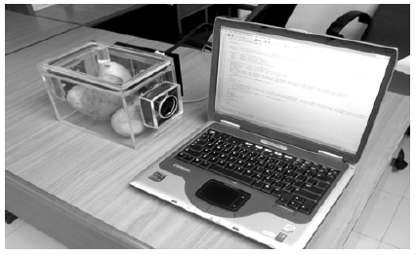over a period of ten days. Data acquisition and storage system uses LabVIEW software.

**Figure 2.12 The experimental set-up used to analyze the aroma of Harumanis**

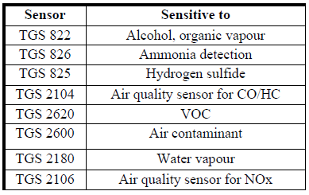

**Table 2.8 Metal oxide sensors used in the electronic nose**

**Evaluation of Fruit Ripeness using Electronic Nose**

As fruits ripen, the concentration of volatile compound called ethylene increases. Its presence activates the ripening process and the ripening process produces more ethylene in climacteric fruit (such as pears, apples, and peaches). The discharge of these volatiles is that one the consumers smell when eating ripe fruit, contributing to their enjoyment of the fruit. This aroma profile of a fruit can be measured non-destructively by placing the fruit in a sealed container, such as a glass jar or a plastic bag and the concentration of ethylene can be sensed with the help of an 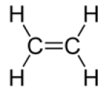ethylene gas sensor. Figure 2.13 shows the ethylene structure.

**Figure 2.13 Ethylene (C2H4)**

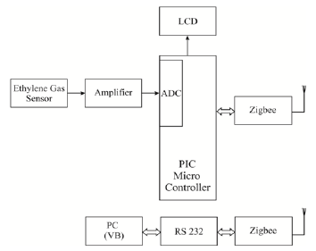The ethylene concentration thus obtained in terms of parts per million (ppm) is displayed in the LCD display. Also, classification and coding mechanisms are coded into MCU so that this setup serves the purpose of classifying the maturity stages of the fruit based on the ethylene concentration. The various modules of the system are described below in figure 2.14.

**Figure 2.14 Block diagram of E-nose using PIC16F877A**

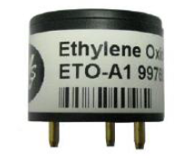Ethylene gas sensor is capable of sensing that is released from the fruits. The fabrication and design process are simple, the sensor senses the ethylene and produces a voltage output. The produced analog output is proportional to the concentration of the ethylene. With the help of simple circuitry, the obtained voltage output from the sensor is converted to a digital value. This sensor senses ethylene in the range of 20-2000 ppm. It is used for continuous monitoring and they have longer life.

**Figure 2.15 Ethylene Gas Sensor**

**Fuzzy Logic based Odour Classification System in Electronic Nose**

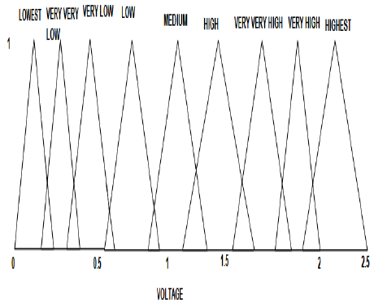The first step in applying Sugeno based fuzzy logic algorithm is to fuzzify the inputs using membership functions. A membership function (MF) is a curve that defines how each input is mapped to a membership value (or degree of membership) between 0 and 1. The input values refer to the voltage levels given by the sensors. The inputs are fuzzified using nine triangular shaped member functions. The fuzzification of the input voltage levels is shown in figure 2.16.

**Figure 2.16 Fuzzification of the Input Voltage Level**

**Identification of Volatile Compounds in Cantaloupe at Various Developmental Stages Using Solid Phase Microextraction**

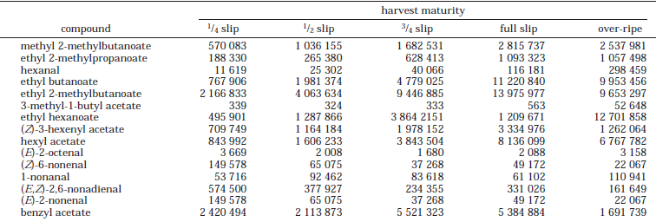Using an automated rapid headspace solid phase microextraction (SPME) method for volatile extraction in cantaloupes, 86 compounds already reported for muskmelons were recovered and an additional 53 compounds not previously reported were identified or tentatively identified. The SPME method extracted a copious number of volatiles that can be analyzed to clearly differentiate between variety, growth stage, and stage of harvest ripeness. Most of the newly reported compounds in cantaloupe were esters and aldehydes that have already been demonstrated as flavor-related compounds in other products. All esters believed to have flavor impact increased progressively after pollination, and this trend continued with increasing harvest maturity. However, compound recovery often decreased when fruits were harvested over-ripe. Most aldehydes increased during early growth stages and then tapered off with increasing harvest maturity. The SPME method suitably recovered most compounds reported to impart characteristic flavor/aroma in muskmelons. SPME offers experimental flexibility and the ability to discover more compounds and address flavor quality changes in fresh-cut cantaloupe.

**Table 2. 9 Change in Integrated Area Counts for Selected Compounds Recovered in Cv. Sol Real Cantaloupe Harvested at Five Distinct Maturities**

**Ripening state determination of guava fruit (Psidium guajava) using e-nose with fuzzy logic as pattern recognition tool**

An application specific electronic nose system is developed and employed to obtain the odor patterns from the headspace of guava fruit samples. Fig.1 shows schematic block diagram of developed e-nose system. The e-nose system based on an array of eight different SnO2 based commercially available Taguchi gas sensors from Figaro Engineering, Japan. The MOS sensors conductivity changes due to adsorption of odor molecules on surface of sensing material causes subsequent surface reactions. These types of sensors show a certain degree of affinity towards a specific odor but are sensitive towards a wide spectrum of gases with overlapping sensitivities.

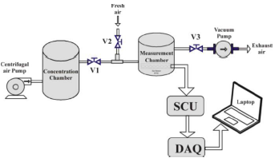

**Figure 2.17 Block diagram of E-Nose system**

During data acquisition, electronic solenoid valves, centrifugal air pump and vacuum air pump are automatically controlled via DAQ cards digital I/O’ s as per requirement. The LabVIEW based software handle the overall operation. A separate software GUI program is written for measurement of the air and odor volatile response of sensor array. Figure 2.18 shows the front panel user interface of the software. This GUI is used to acquire the signals from sensor modules during air and odor sensing. The signals are nothing but the voltages across the load resistor RL. The voltages are then internally converted into sensor conductance value. The front panel of the software continuously show real time plot of the change in voltages and conductance of the sensor array. The numerical values of the acquired data at a particular instant is also displayed in table window on front panel. This GUI automatically control the overall operation of odor sensing 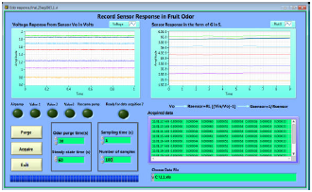system during measurement via DAQ’s DIO.

**Figure 2.18 Data acquisition interface of developed software**

**Temperature Compensated Electronic Nose for Fruit Ripeness Determination Using Component Correction Principal Component Analysis**

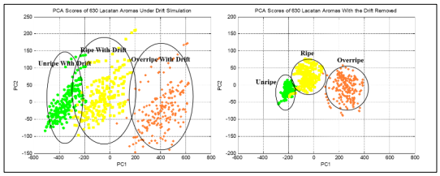

**Figure 2.19 PCA bi–plot (Scores) of Lacatan aromas (a) with the temperature drift prior CCPCA and (b) with the removal of temperature drift.**

Component correction–removal of unwanted temperature drift, is done by sampling clean environment air from 32 ̊C to 38 ̊C and their projection on 2 orthogonal features of maximum variance. Since from the 32nd to the 38th sampling temperature, the clean air continuously flows underneath the chemoreceptors, it is presumed that the amount of variance spanned on both PC1 and PC2 is accounted to the temperature drift. Thus, in the drift removal, the VCal is a column vector containing the eigenvectors PC1 and PC2. In using CCPCA for drift removal, this study assumes that the drift approximated in the drift simulation of this clean air is also existent upon the sampling of unripe, ripe, and overripe Lacatan banana samples and thus could generalize the drift pattern in the 3 clusters. The uncorrected, with the drift, and the corrected, without the drift, PCA Scores of Lacatan aromas are demonstrated on Figure 2.19. Apparently, on Fig. 2.20, the bi–plot of the Lacatan aroma scores with the temperature drift removed is more condensed than the bi–plot with the unwanted drift component.

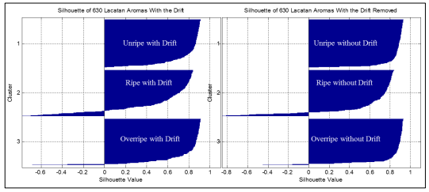  
**Figure 2.20** **Silhouette of unripe, ripe, and overripe clusters (a) with the temperature drift and (b) without temperature drift.**

This is indicated on the scores silhouette as the 1st cluster (unripe) is improved from 0.7903 to 0.8571, the 2nd cluster (ripe) from 0.5358 to 0.6080, and the 3rd (overripe) from 0.7784 to 0.8357. The enhancement brought by removal of drift can be observed by a side-by-side comparison of the silhouette and mean silhouette indices of measurements taken prior and after CCPCA, this is demonstrated in Fig. 2.20 (Silhouette plot).

**Post-harvest Quality Evaluation of Grapes using Non-destructive Electronic Nose**

Three different kinds of grapes; green grapes, red grapes and black grapes, which were freshly brought from the supermarket, are selected and bought for experimental analysis. The grapes are sorted and selected according to similar colour and uniform size approximately. All the grapes are washed, dried and then stored in an airtight 50 ml cylindrical glass tube. Four hundred and eighty green grapes are divided into 120 groups (4 grapes in one group) and stored in 120 tubes. The same procedures were followed for red grapes and black grape. Each tube is individually numbered and stored in the refrigerator of constant temperature of 40 Celsius. Every day 12 tubes of green grapes, red grapes and black grapes are taken out for analysis for 10 consecutive days.

The constructed electronic nose consists of mainly five parts; sensor chamber, sample chamber, data acquisition system & control unit, power supply and a computer containing a graphic user interface (GUI) as shown in Fig 2.17. The GUI was developed using Borland C++ which provides a real-time display of all the sensor responses during the data acquisition. There is a total of 14 thick film metal oxide sensors in the sensor chamber. However, only 8 of these sensors are used in this experiment for faster and better analysis. An additional sensor, LM35DZ, was used to monitor the temperature of the system during the data acquisition.

Principal Component Analysis (PCA) was performed on each type of grapes to investigate the electronic nose’s performance and the ability to distinguish different ripeness stages. Fig. 2.21 shows the projection of PCA result on the analysis of the green grapes. For each plot the samples were grouped together into 4 clusters, day 1-3, day 4-6, day 7-9 and day 10-11. The figure shows the analysis result in the two-dimensional plane, principal component 1 and principal component 2. The first principal component (PC1) of the green grapes explains 71.64% of the variance, while the second principal component (PC2) explains 13.10% of the variance.

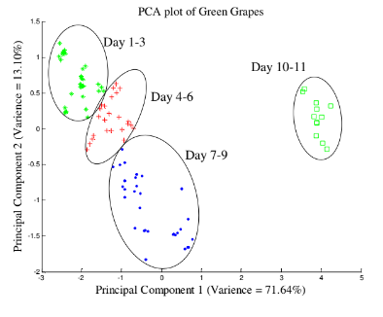

**Figure 2.21** - PCA analysis for green grapes.

**Ripeness Classification of Cocoa Through Acoustic Sensing and Machine Learning**

In Cocoa harvesting, the perceived hollow sound from tapping the Cocoa pod is the conventional way of determining ripeness. In this paper, acoustic sensing device was used to record noiseless acoustic signals generated from tapping cocoa pods while on tree. Acoustic data were collected from cocoa pods of two classifications, namely, ripe and unripe. Frequency-domain analysis was used using Fast Fourier Transform (FFT) in extracting the spectral characteristics, namely, the first three dominant resonant frequencies, their corresponding amplitudes, and their power spectral densities. Time-domain features particularly the Short-time Energy and Zero-Crossing Rate were also used in this study.

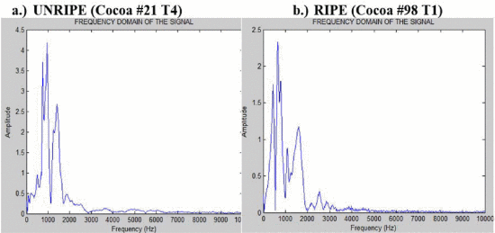

**Figure 2.22** **FFT waveforms of amplitude vs. Frequency.**

While searching for the best classification model, several investigations were made by combining features into feature vectors, and the one with highest overall accuracy, was when FR1 and FR2 features were selected using SVM tool. Its overall accuracy and confusion matrix are shown in Fig. 12 where the overall accuracy of 95.6 % is much higher compared to using the 11 features with 93.8%. In its confusion matrix, the RIPE class, only 127 were correctly classified, and 9 were misclassified as UNRIPE with an error percentage of 3.3%. However, 133 were correctly classified and only 3 were misclassified as RIPE with an error percentage of 1.1%.

**Chapter 3**

**Determination of Ripening Stage of Avocado Fruits using Fuzzy Logic Classification**

**Methodology**

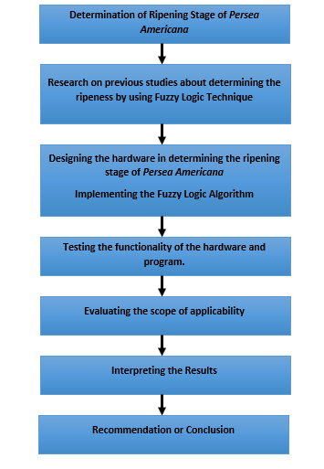

**Figure 3.1 –** Research methodology flow

This section discusses the procedure that will be followed to conduct the study in determining the ripening stage of *Persea Americana* s that is shown in **Figure 3.1**. The process includes designing its hardware in determination of the ripening stage of *Persea Americana*, implementing the fuzzy logic classification for the ripening stage, testing the functionality of hardware and program, evaluating the scope of applicability, and interpreting the results using the MATLAB’s fuzzy logic toolbox.

**Conceptual Framework**

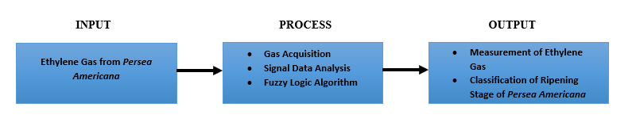

**Figure 3.2** – Conceptual Framework

The given figure **Figure 3.2** shows the conceptual framework of the study. The figure shows the proposed ‘IPO’ of the hardware and software system which will be used to determine the ripeness stage of *Persea Americana* fruits by the use of Electronic Nose. In the input, the gas sensors will be used to capture the concentration of the ethylene gas released from the fruit.

The recorded data from the gas sensor will be then characterized using signal data analysis pattern recognition and the Fuzzy Logic Algorithm. After using the process, all the gathered information from the fruit aroma will be utilized for the identification of ripeness stage of the fruits.

**Hardware Development***Proposed Chamber Design*

The setup of the propose hardware is made up of acrylic glass with a size of 1000x700mm, inside of the glass consists of eight gas sensors, a small dish where the sample fruit is place. Its sensor head was set up vertically and sense 90 towards the skin of the *Persea Americana* fruit with a distance of 70mm to acquire the data from the citrus fruit and it’s fiber optic cable is placed inside the plastic pipe to connect in Raspberry Pi.

*Block Diagram*

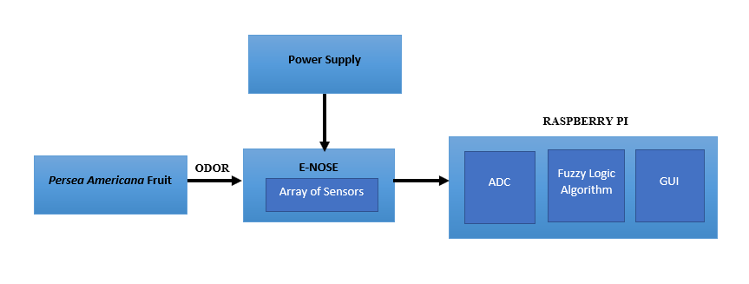

**Figure 3.3 –** Block Diagram of the System

The block diagram of the system comprises of the (1) prepared fruit (2) the sensing mechanism that will determine the type of gas sensed and (2) the single board computer, Raspberry Pi which will serve as microcomputer and compute for the ethylene levels via Fuzzy Logic Algorithm. Lastly, (3) the Raspberry Pi will display and observe the output.

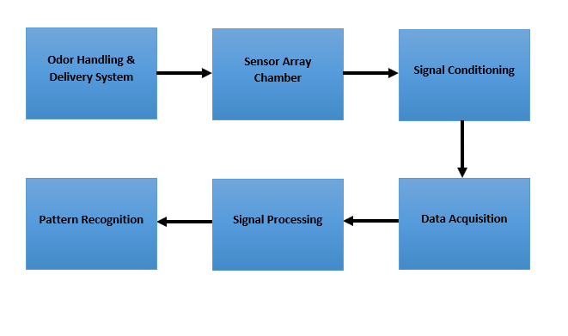**Figure 3.4 –** Block Diagram of E-Nose

The **Figure 3.4** shows the block diagram of an e-nose. It illustrates the sensing concept of the E-nose. The e-nose comprises of functional blocks such as the odour handling, and delivery system, sensor array chamber, signal conditioning, data acquisition, signal processing and pattern recognition.

*Schematic Diagram of Electronic Nose*

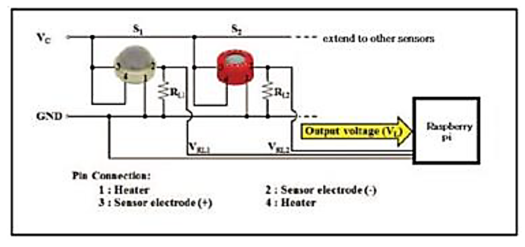**Figure 3.5 –** Sample Circuit Design of E-Nose

In **Figure 3.5** the sample circuit diagram for electronic nose is shown. The analog output reading of the sensors will be sent to the raspberry pi and will be then characterized using the Fuzzy Logic Algorithm.

**Connecting e-nose circuit to the ADC**

The output of the e-nose circuit is connected to an Analog-to-Digital Converter (ADC). The ADS1015 is used to serves as the converter of the signal from analog to digital which is required by the Raspberry Pi.

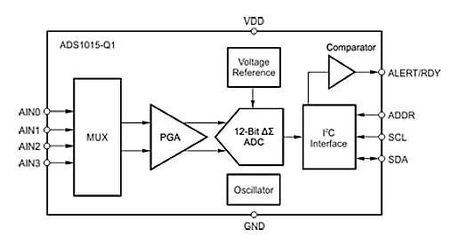

**Figure 3.6 –** Schematic Diagram of ADS 1015

**Figure 3.6** shows the schematic diagram of the ADS1501. The output of the e-nose is connected to any of the analog input of the ADC.

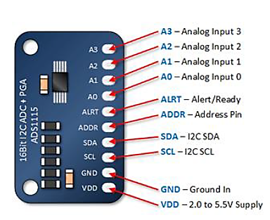

**Figure 3.7 –** Pin configuration of ADS1015

The circuit requires the connection of the ADS1015 to Raspberry Pi. In **Figure 3.7** it shows the pin configuration of the ADS1015.

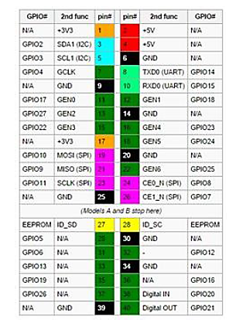

**Figure 3.8 –** Pin configuration of Raspberry Pi

The **Figure 3.8** shows the pin configuration of a Raspberry Pi. This serves as the reference for the pin connections of the ADC to the Raspberry Pi.

*Prototype Development*

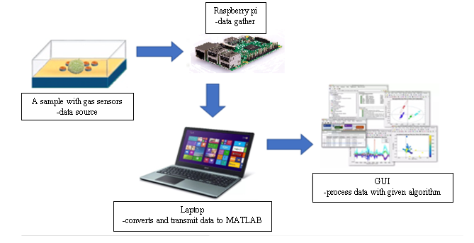

**Figure 3.9 –** Proposed Fuzzy Logic Chamber

The researchers will build a sensing device with fuzzy logic-controlled algorithm. The first process, as a data source, it illustrates the function of gas sensors in getting the value of an Ethelyn compounds and other chemical substances in a form of aroma to feed on the Arduino uno and outputs the accurate measurement of the specific data. Arduino uno will be the middle device that gathers the amount of all compounds present in the fruit based upon the type of gas sensors in the chamber. In the third process, the data in the Arduino uno will be pass to the laptop to proceed in the GUI or MATLAB for processing the fuzzy logic and displays the classification of the sample.

**Lists of Components**

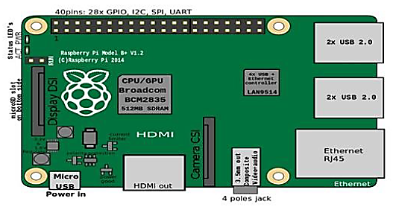

**Figure 3.10 –** Raspberry Pi Microcomputer

In **Figure 3.10**, shows an example of a physical raspberry pi that will be used in the system as the microcomputer. Furthermore, it has General Purpose Input Output (GPIO) pins including +3.3V, +5V and GND supply. The pins can be used in connecting the sensors. In addition, it has four USB 2.0 connector that directly connects laptop computer and the Raspberry Pi. Figure 3.14 shows the pin numbering of the Raspberry Pi.

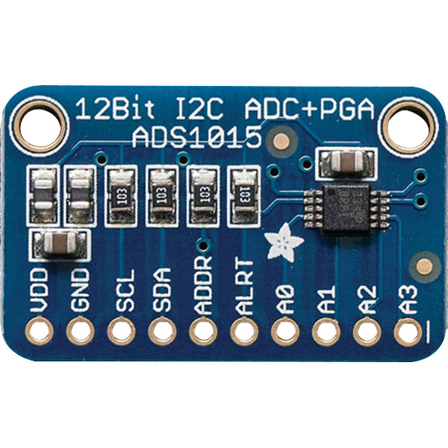

**Figure 3.11 –** ADS1015

For microcontrollers without an analog-to-digital converter or when you want a higher-precision ADC, the ADS1015 provides 12-bit precision at 3300 samples/second over I2C. The chip can be configured as 4 single-ended input channels, or two differential channels

**Hardware Specifications**

|  |  |  |  |
| --- | --- | --- | --- |
| Name of Components | Item/s | Features | Price |
| Raspberry Pi | 1 | * SoC: Broadcom BCM2837 (roughly 50% faster than the Pi 2) * CPU: 1.2 GHZ quad-core ARM Cortex A53 (ARMv8 Instruction Set) * GPU: Broadcom Video Core IV @ 400 MHz * Memory: 1 GB LPDDR2-900 SDRAM * USB ports: 4 * Network: 10/100 MBPS Ethernet, 802.11n Wireless LAN, Bluetooth 4.0 | **₱3,732.38** |
| ADS1015 | 1 | * Wide supply range: 2.0V to 5.5V * Low current consumption: Continuous Mode: Only 150µA Single-Shot Mode: Auto Shut-Down * Programmable data rate: 128SPS to 3.3kSPS * Internal low-drift voltage reference * Internal oscillator * Internal PGA * I2C interface: Pin-Selectable Addresses * Four single-ended or two differential inputs * Programmable comparator * This board/chip uses I2C 7-bit addresses between 0x48-0x4B, selectable with jumpers | **$9.95** |
| TGS 813 | 1 | * General purpose sensor with sensitivity * to a wide range of combustible * gases * High sensitivity to methane, propane, * and butane * Long life and low cost * Uses simple electrical circuit | **$12.69** |
| TGS 821 | 1 | * High sensitivity and selectivity to hydrogen * gas * Good repeatability in measurement and * excellent stability * Uses simple electrical circuit * Ceramic base resistant to severe * environment | **£79.74** |
| TGS 822 | 1 | * High sensitivity to organic solvent vapors * such as ethanol * High stability and reliability over a long * period * Long life and low cost * Uses simple electrical circuit | **€9.41** |
| TGS 825 | 1 | * High sensitivity to low concentration of * hydrogen sulfide * Good repeatability in measurement * Uses simple electrical circuit * Ceramic base resistant to severe * environment | **$91.00** |
| TGS 826 | 1 | * High sensitivity to ammonia * Quick response to low concentrations of * ammonia * Uses simple electrical circuit * Ceramic base resistant to severe * environment | **€66.10** |
| TGS 830 | 1 | * High sensitivity to R-113, * Refrigerant leak detectors * R-22, R-11, and R-12 * Low sensitivity to hydrogen and alcohol * vapors * Uses simple electrical circuit * Ceramic base resistant to severe * environment | **$8.00** |
| TGS 2600 | 1 | * Low power consumption * High sensitivity to gaseous air * contaminants * Long life and low cost * Uses simple electrical circuit * Small size | **$3.07** |
| TGS 2620 | 1 | * Low power consumption * High sensitivity to alcohol and organic * solvent vapors * Long life and low cost * Uses simple electrical circuit | **$8.14** |
| LM35 | 1 | * Calibrated Directly in Celsius (Centigrade) * Linear + 10-mV/°C Scale Factor * 0.5°C Ensured Accuracy (at 25°C) * Rated for Full −55°C to 150°C Range * Suitable for Remote Applications * Low-Cost Due to Wafer-Level Trimming * Operates From 4 V to 30 V * Less Than 60-μA Current Drain * Low Self-Heating, 0.08°C in Still Air * Non-Linearity Only ±¼°C Typical * Low-Impedance Output, 0.1 Ω for 1-mA Load | **₱97.88** |

**Table 3.1 –** Hardware Specifications

There are a total 8 metal oxide gas sensor in the sensor chamber to be used in the experiment for faster and better analysis. An additional sensor, LM35, is going to use to monitor the temperature of the system during the data acquisition. The lists of sensors and their corresponding sensitivity to a particular gas are shown in **Table 3.1.**

**Software Development**

In this section the study discusses about software application and how it will be used to further analyze the research proceedings.

*Program Flowchart*

**FALSE**

**TRUE**

**Start**

**ADS1015()**

**Raspberry Pi()**

**Fuzzy Logic Algorithm()**

**Output**

**Measure Again?**

**End**

**Fuzzy Logic Algorithm**

**Fuzzy Inference System**

**(FIS Editor)**

**Membership Function Editor**

**Rule Editor**

**Rule Viewer**

**(Defuzzification)**

**Return**

**Figure 3.14** – Main Program Flowchart **Figure 3.15** – Fuzzy Logic Algorithm Module

*ADC Flowchart*

**NO**

**YES**

**ADS1015**

**Receive gases from the measurement unit through gas sensor**

**Convert sensor analog signal to digital signal**

**Is this a digital signal?**

**Transmit signal to Raspberry Pi**

**Return**

**Figure 3.12 –** Flowchart of ADC

The **Figure 3.12** shows the flowchart of an ADC. The ADC flowchart starts the process when the signal from the array of the gas sensors is received by the ADC module. The signal from the sensors will undergo to the process of conversion from an analog signal to a digital signal. Then the digital signal will be then transmitted to the Raspberry Pi. The Raspberry pi only accept digital inputs so the signals from the sensors must be converted to digital signals.

*Raspberry Pi Flowchart*

**Raspberry Pi**

**Receives the data of gas sensors from ADS1015**

**Reads the data signal**

**Passes the data to the Fuzzy Logic Algorithm via laptop**

**Return**

**Figure 3.13** - Process of Raspberry Pi Flowchart

The **Figure 3.13** shows the flowchart of the Raspberry Pi. The process in the Raspberry Pi starts when the signal coming from the e-nose is transmitted. If the signal is not received, then the process will address the issue regarding the connection and fix the connection and on the other hand when the signal is received it will start to process the signal in the program and the algorithm to the microcontroller to produce the desired output

The responses of a few gas sensors to different fruit samples are experimentally collected at a constant temperature. From the experimentally recorded data sets, an array of eight sensors is selected. The responses of the sensors to the introduced sample of fruits are measured as voltage variations. This experimentally collected voltage data set lie within a range of 0 to 2.5 volt. The response of the sensors is expressed in the form of histograms.

The classification of the gases is done using fuzzy logic-based approach. The member functions and rules of the fuzzy inference system are defined. The inputs applied to the eight sensors are combined by AND operations. By applying the rules to the FIS, the outputs are obtained. A fixed parameter is assumed for a gas sample. The output obtained from the system is verified based on the closeness of the obtained output to the assumed fixed value.

**Figure 3.16** – Histogram of the Sensors

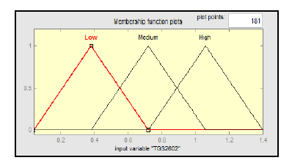 The first step in applying Sugeno based fuzzy logic algorithm is to fuzzify the inputs using membership functions. A membership function (MF) is a curve that defines how each input is mapped to a membership value (or degree of membership) between 0 and 1. The input values refer to the voltage levels given by the sensors.

**Figure 3.17 –** Fuzzification of the Input Voltage Level

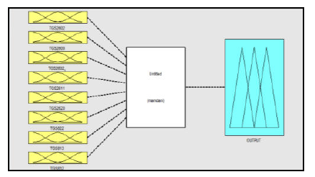 The relationship between the input of the eight sensors and the ripening stage is determined by the fuzzy rules in the inference system. A fuzzy control rule refers to a fuzzy conditional statement in which the antecedent is a condition in the application domain and the consequent is a control action for the system.

**Figure 3.18 –** Sample Fuzzy Inference System

In the **Figure 3.18**, the defined fuzzy set for the e-nose sensor signal value is shown as an example. The chosen values were selected using optimization methods.

The decided range of three outputs linguistic term is shown in **table 3.2**

|  |  |
| --- | --- |
| **Linguistic Term** | **Range** |
| Unripe | 0-20-40 |
| Ripe | 20-40-60 |
| Overripe | 40-60-80 |

**Table 3.2 –** Range Values of Output Linguistic Variables

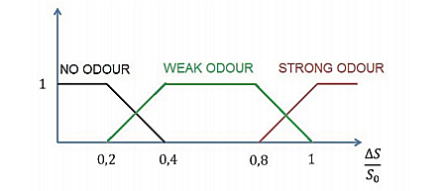

**Figure 3.19** Example of fuzzy and non-fuzzy set

The output value is calculated by the fuzzy system, using a set of rules, based on the input values. Thus, the determined odour intensity corresponds to a specific set of sensor signal values. In the application process, a set of rules based on conjunctive operations is applied.

 eq. (1)

A typical rule in a Sugeno fuzzy model has the form, if Input 1 is x and Input 2 is y, then Output is z = ax + by + c. For a zero-order Sugeno model, the output level z is a constant (a = b = 0). Each rule weights its output level, zi, by the firing strength of the rule, wi. For example, for an AND rule with Input 1 = x and Input 2 = y, the firing strength is

 eq. (2)

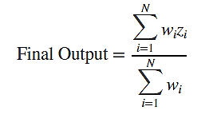 The final output of the system is the weighted average of all rule outputs, where N is the number of rules. Computed as:

eq. (3)

After creating the membership functions of the inputs and outputs, the fuzzy inference rules **Figure 3.19** of the fruits will be created to determine the ripening stage of avocados. In order to create the rule, we will refer to a maturity index of avocado.

**Rule Statement**

* If (TGS826 is Low) and (TGS2600 is Low) and (TGS826_1 is Low) and (TGS813 is Low) and (TGS2620 is Low) and (TGS822 is Low) and (TGS813 is Low) and (TGS830 is Low) then (output is Unripe)
* If (TGS826 is Low) and (TGS2600 is Low) and (TGS826_1 is Low) and (TGS813 is Medium) and (TGS2620 is Low) and (TGS822 is Low) and (TGS813 is Low) and (TGS830 is Low) then (output is Ripe)
* If (TGS826 is Medium) and (TGS2600 is Medium) and (TGS826_1 is Medium) and (TGS813 is Medium) and (TGS2620 is Medium) and (TGS822 is Low) and (TGS813 is Low) and (TGS830 is Low) then (output is Overripe)
* If (TGS826 is Medium) and (TGS2600 is Medium) and (TGS826_1 is Medium) and (TGS813 is Medium) and (TGS2620 is Medium) and (TGS822 is Medium) and (TGS813 is Medium) and (TGS830 is Low) then (output is Overripe)
* If (TGS826 is Medium) and (TGS2600 is Medium) and (TGS826_1 is Medium) and (TGS813 is Medium) and (TGS2620 is Medium) and (TGS822 is Low) and (TGS813 is Medium) and (TGS830 is Low) then (output is Overripe)
* If (TGS826 is Medium) and (TGS2600 is Medium) and (TGS826_1 is Medium) and (TGS813 is Medium) and (TGS2620 is Medium) and (TGS822 is Medium) and (TGS813 is Low) and (TGS830 is Low) then (output is Overripe)

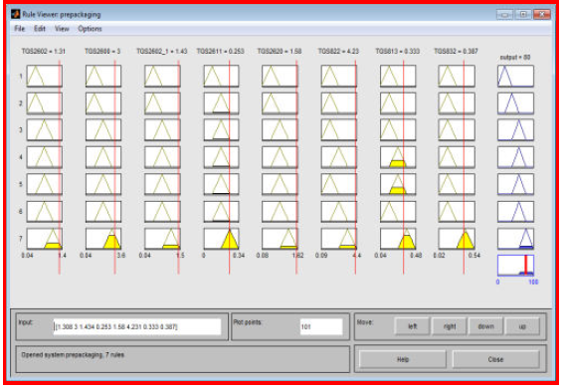 Then on **Figure 3.20** shows the defuzzification result from the rule editor, where the first to third column is the inputs which are the values of gas sensor, the last column is the result of the ripeness of the fruit then the last row of the last column shows the defuzzification result where the level of ripeness is obtained. After these processes, the program will now ask if you will want to measure again if True it will go back to the fuzzy logic module, if False it will end to system.

**Figure 3.20 –** Proposed Defuzzification Result from the Rule Viewer

**System Testing**

**Calibration of Electronic Nose**

The purpose of this test is to determine the chemical compounds present in the fruit to differentiates the amount of Ethelyn.

Procedure:

1. Place a target fruit on the proposed chamber.

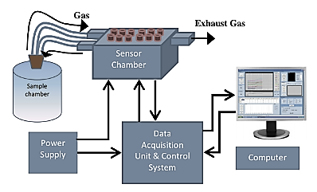

**Figure 3.21 –** Electronic Nose System

1. After the gas sensors sensed the gases inside the mixing chamber, the ADC module will convert the analog signals into digital signals so that the raspberry pi can read the signals from the gas sensors.
2. The raspberry pi will be able to send the diagnosis through cabled connection to the laptop computer and in the monitor it will display the result.

**Calibration of Sensors**

|  |  |  |  |
| --- | --- | --- | --- |
| *TGS 813 Sensor* |  |  |  |
| **Calibration Gas:** | **Measurement (mg/L)** | **System Response**  **(V)** | **Gas Calibration Error (% of calibration span)** |
| **Combustible Gases (methane, propane, butane)** |  |  |  |
| **TRIAL 1** |  |  |  |
| **TRIAL 2** |  |  |  |
| **TRIAL 3** |  |  |  |
| *TGS 821 Sensor* |  |  |  |
| **Calibration Gas:** | **Measurement (mg/L)** | **System Response**  **(V)** | **Gas Calibration Error (% of calibration span)** |
| **Hydrogen** |  |  |  |
| **TRIAL 1** |  |  |  |
| **TRIAL 2** |  |  |  |
| **TRIAL 3** |  |  |  |
| *TGS 822 Sensor* |  |  |  |
| **Calibration Gas:** | **Measurement (mg/L)** | **System Response**  **(V)** | **Gas Calibration Error (% of calibration span)** |
| **Organic Solvent Vapours (ethanol)** |  |  |  |
| **TRIAL 1** |  |  |  |
| **TRIAL 2** |  |  |  |
| **TRIAL 3** |  |  |  |

|  |  |  |  |
| --- | --- | --- | --- |
| *TGS 825 Sensor* |  |  |  |
| **Calibration Gas:** | **Measurement (mg/L)** | **System Response**  **(V)** | **Gas Calibration Error (% of calibration span)** |
| **Organic Solvent Hydrogen Sulphide** |  |  |  |
| **TRIAL 1** |  |  |  |
| **TRIAL 2** |  |  |  |
| **TRIAL 3** |  |  |  |
| *TGS 826 Sensor* |  |  |  |
| **Calibration Gas:** | **Measurement (mg/L)** | **System Response**  **(V)** | **Gas Calibration Error (% of calibration span)** |
| **Ammonia** |  |  |  |
| **TRIAL 1** |  |  |  |
| **TRIAL 2** |  |  |  |
| **TRIAL 3** |  |  |  |
| *TGS 830 Sensor* |  |  |  |
| **Calibration Gas:** | **Measurement (mg/L)** | **System Response**  **(V)** | **Gas Calibration Error (% of calibration span)** |
| **Chlorofluorocarbons** |  |  |  |
| **TRIAL 1** |  |  |  |
| **TRIAL 2** |  |  |  |
| **TRIAL 3** |  |  |  |

|  |  |  |  |
| --- | --- | --- | --- |
| *TGS 2600 Sensor* |  |  |  |
| **Calibration Gas:** | **Measurement (mg/L)** | **System Response**  **(V)** | **Gas Calibration Error (% of calibration span)** |
| **Air Contaminants (hydrogen, carbon monoxide)** |  |  |  |
| **TRIAL 1** |  |  |  |
| **TRIAL 2** |  |  |  |
| **TRIAL 3** |  |  |  |
| *TGS 2620 Sensor* |  |  |  |
| **Calibration Gas:** | **Measurement (mg/L)** | **System Response**  **(V)** | **Gas Calibration Error (% of calibration span)** |
| **Alcohol and Solvent Vapours** |  |  |  |
| **TRIAL 1** |  |  |  |
| **TRIAL 2** |  |  |  |
| **TRIAL 3** |  |  |  |

**Table 3.3 –** Gas Sensors Calibration

The **Table 3.3** shows the electronic nose response in Combustible Gases (methane, propane, butane), Hydrogen, Organic Solvent Vapours (ethanol), Hydrogen Sulphide, Ammonia, Chlorofluorocarbons, Air Contaminants (hydrogen, carbon monoxide), Alcohol and Solvent Vapours. The calibration gas is reference gas used as comparative standard in the calibration analytical instrument such as gas sensors.

**Testing**

*Table for Fruit Aroma based on the Sensors Reading*

|  |  |  |  |  |  |  |  |  |  |  |  |  |
| --- | --- | --- | --- | --- | --- | --- | --- | --- | --- | --- | --- | --- |
| **TRIAL** | **Persea Americana** | **TGS 813** | **TGS 821** | **TGS 822** | **TGS 825** | | **TGS 826** | **TGS 830** | | **TGS 2600** | **TGS 2620** | **LM 25** |
|  |  | **(V)** | **(V)** | **(V)** | | **(V)** | **(V)** | | **(V)** | **(V)** | **(V)** | **(V)** |
|  |  |  |  |  |  | |  |  | |  |  |  |
|  |  |  |  |  |  | |  |  | |  |  |  |
|  | **A** |  |  |  |  | |  |  | |  |  |  |
|  |  |  |  |  |  | |  |  | |  |  |  |
|  | **B** |  |  |  |  | |  |  | |  |  |  |
|  |  |  |  |  |  | |  |  | |  |  |  |
|  | **C** |  |  |  |  | |  |  | |  |  |  |
|  |  |  |  |  |  | |  |  | |  |  |  |
|  | **D** |  |  |  |  | |  |  | |  |  |  |
|  |  |  |  |  |  | |  |  | |  |  |  |
| **1** | **E** |  |  |  |  | |  |  | |  |  |  |
|  |  |  |  |  |  | |  |  | |  |  |  |
|  | **F** |  |  |  |  | |  |  | |  |  |  |
|  |  |  |  |  |  | |  |  | |  |  |  |
|  | **G** |  |  |  |  | |  |  | |  |  |  |
|  |  |  |  |  |  | |  |  | |  |  |  |
|  | **H** |  |  |  |  | |  |  | |  |  |  |
|  |  |  |  |  |  | |  |  | |  |  |  |
|  | **I** |  |  |  |  | |  |  | |  |  |  |
|  |  |  |  |  |  | |  |  | |  |  |  |
|  | **J** |  |  |  |  | |  |  | |  |  |  |
|  |  |  |  |  |  | |  |  | |  |  |  |
|  | **A** |  |  |  |  | |  |  | |  |  |  |
|  |  |  |  |  |  | |  |  | |  |  |  |
|  | **B** |  |  |  |  | |  |  | |  |  |  |
|  |  |  |  |  |  | |  |  | |  |  |  |
|  | **C** |  |  |  |  | |  |  | |  |  |  |
|  |  |  |  |  |  | |  |  | |  |  |  |
|  | **D** |  |  |  |  | |  |  | |  |  |  |
|  |  |  |  |  |  | |  |  | |  |  |  |
| **2** | **E** |  |  |  |  | |  |  | |  |  |  |
|  |  |  |  |  |  | |  |  | |  |  |  |
|  | **F** |  |  |  |  | |  |  | |  |  |  |
|  |  |  |  |  |  | |  |  | |  |  |  |
|  | **G** |  |  |  |  | |  |  | |  |  |  |
|  |  |  |  |  |  | |  |  | |  |  |  |
|  | **H** |  |  |  |  | |  |  | |  |  |  |
|  |  |  |  |  |  | |  |  | |  |  |  |
|  | **I** |  |  |  |  | |  |  | |  |  |  |
|  |  |  |  |  |  | |  |  | |  |  |  |
|  | **J** |  |  |  |  | |  |  | |  |  |  |
|  |  |  |  |  |  | |  |  | |  |  |  |

**Table 3.4 -**Data Gathered in E-nose

In Table 3.4, fruits that are subjected for testing their ethylene gas.

*Histogram for the Sensors*

**Table 3.5** Histogram of the Sensors

Response level in voltage of the sensors is shown on **Table 3.5.**

*Table for the Range Values of Sensors Array Response of Avocado*

|  |  |  |  |  |  |  |  |  |  |  |  |
| --- | --- | --- | --- | --- | --- | --- | --- | --- | --- | --- | --- |
| **Ripening Stage** | **Sensor Response** | **TGS813** | **TGS821** | **TGS822** | **TGS825** | **TGS826** | **TGS830** | **TGS2600** | | **TGS2620** | |
| Unripe | Min |  |  |  |  |  |  |  |  |  |
| Max |  |  |  |  |  |  |  |  |  |
| Ripe | Min |  |  |  |  |  |  |  |  |  |
| Max |  |  |  |  |  |  |  |  |  |
| Overripe | Min |  |  |  |  |  |  |  |  |  |
| Max |  |  |  |  |  |  |  |  |  |

**Table 3.6 -** Range Values of Sensors Array Response of Avocado

Table 3.6 shows the range values of eight gas sensors used for Unripe, Ripe and Overripe ripening stage of avocado fruit.

*Table of Fruit Ripening Stage*

|  |  |
| --- | --- |
| **Fruit** | **Ripening Stage of the Fruit** |
|  |  |
|  |  |
|  |  |
|  |  |
|  |  |
|  |  |
|  |  |

**Table 3.7 –** Ripening Stage of Avocado

*Table for the Human Expert for Grading the Level of Ripeness*

|  |  |  |  |  |  |
| --- | --- | --- | --- | --- | --- |
| **Number of Avocado used** | **Number of Samples** | | **Determination** | | **Performance %** |
| **Training** | **Testing** | **Expert** | **System** |
|  |  |  |  |  |  |
|  |  |  |  |  |  |
|  |  |  |  |  |  |

**Table 3.8 -** Ripeness Level Result by Human Expert

This **Table 3.8** is for the comparison of human expert fruit graders and the proposed fuzzy logic system to know if using the fuzzy logic has a high potential of accurateness.

**Statistical Analysis**

The confusion matrix contains data that were classified results from Human Grader and Electronic Nose system. The performance of the system will be evaluated using the data in the confusion matrix.

|  |  |  |  |  |
| --- | --- | --- | --- | --- |
|  |  | **Actual Class** | | |
|  | **N = 50** | **Unripe** | **Ripe** | **Overripe** |
| **Predicted Class** | **Unripe**  **(E-Nose Determination)** |  |  |  |
| **Ripe**  **(E-Nose Determination)** |  |  |  |
| **Overripe**  **(E-Nose Determination)** |  |  |  |

**Table 3.9 –** Confusion Matrix

In **Table 3.9**, the confusion matrix was shown. In this confusion matrix, it has 50 fruit samples distributed into the matrix to visualize the performance of the algorithm. Each row of the matrix represents the determination of electronic nose in classifying the 50 fruit samples whether it is unripe, ripe or overripe while its corresponding column represents the human fruit grader in classifying the 50 fruit samples whether it unripe, ripe or overripe. In this case, it can easily observe the error regarding to whether how many errors the electronic nose has been classified by representing the data as true positives, true negatives false negatives and false positives

**References**

Baietto, M., & Wilson, A. D. (2015, January 6). Electronic-nose applications for fruit identification, ripeness and quality grading. *Sensors (Basel, Switzerland), 15(1), 899-931. doi:10.3390/s150100899*

Kanade, A., Shaligram, A.D.D. (2014, February). Development of an E-Nose Using Metal Oxide Semiconductor Sensors for the Classification of Climacteric Fruits. *International Journal of Scientific & Engineering Research*

Nouri, F.G., Chen, Z., Maqbool, M. (2014). Monitoring Mango Fruit Ripening after Harvest using Electronic Nose (zNoseTM) Technique. *International Conference on Food Engineering and Biotechnolog*

Zhang, H., Wang, J., (2009, July 10). Evaluation of Peach Quality Attribute Using an Electronic Nose. *Sensors and Materials,* Vol. 21, No. 8 (2009) 419–431

Dimatira, J.B.U., et al., (2016). Application of Fuzzy Logic in Recognition of Tomato Fruit Maturity in Smart Farming. *IEEE Region* 10 *Conference*

Nandi, C.S., Tudu, B., Koley, C., (2014). Machine Vision Based Techniques for Automatic Mango Fruit Sorting and Grading Based on Maturity Level and Size. *Sensing Technology: Current Status and Future Trends II*

Szulczynski, B., Gebicki, J., Namiesnik, J., (2018). Application of fuzzy logic to determine the odour intensity of model gas mixtures using electronic nose. *Air Protection in Theory and Practice*

Mulyani, E.D.S., Susanto, J.P., (2017, October 30). Classification of Maturity level of Fuji Apple Fruit with Fuzzy Logic Method. *IIEE*, *International Conference on Cyber and IT Service Management*

Salim, S.N.M., et al., (2005, November 23). Development of electronic nose for fruits ripeness determination. *International Conference on Sensing Technology (Palmerston North, New Zealand)*

Geethapriya, M.N., Praveena, S.M.D., (2017, May). Evaluation of Fruit Ripeness using Electronic Nose. *International Journal of Advanced Information Science and Technology*

Sharma, J., et al., (2013, September). Fuzzy Logic based Odour Classification System in Electronic Nose. *International Journal of Computer Applications*

Beaulieu, J.C., Grimm, C.C., (2001). Identification of Volatile Compounds in Cantaloupe at Various Developmental Stages Using Solid Phase Microextraction. *J. Agric. Food Chem., 49, 1345-1352*

Kanade, A., Shaligram, A., (2018, April). Ripening state determination of guava fruit (Psidium guajava) using e-nose with fuzzy logic as pattern recognition tool. *International Journal of Scientific Research Engineering & Technology (IJSRET), ISSN 2278 – 0882 Volume 7, Issue 4*

Lim, J.V.M., Linsangan, N.B., Cruz, F.R.G., Chung, W., (2016, September). Temperature Compensated Electronic Nose for Fruit Ripeness Determination Using Component Correction Principal Component Analysis. *International Journal of Computer and Communication Engineering, Volume 5, Number 5*

Dela Cruz, J.C., et.al., (2017, December). Ripeness classification of cocoa through acoustic sensing and machine learning. *HNICEM 2017 - 9th International Conference on Humanoid, Nanotechnology, Information Technology, Communication and Control, Environment and Management*

Rajin, S.M.A., Samad, S.A., Muad, A.M. (2015, October). Post-harvest Quality Evaluation of Grapes using Non-destructive Electronic Nose. *Journal of Electrical and Electronics Engineering*