

**软件测试技术第二次实验报告**



**学 院 智能与计算学部**

**专 业 软件工程**

**年 级 2016级**

**姓 名 王磊**

**2019年 3 月 26 日**

# 软件测试技术第二次实验报告

1. 需求分析

用eclipse安装selenium驱动火狐浏览器，并测试所给网站信息与文件中的信息是否相匹配。

1. 概要设计
2. 引入selenium包，安装环境，驱动火狐浏览器。
3. 编写函数登录系统并获取相关信息。
4. 获取excel文件中的个人信息，返回字符串。
5. 编写junit测试类，测试网页中的信息与excel中的信息是否匹配。
6. 得出实验结果。
7. 详细设计

1、安装环境：

创建项目，下载selenium的jar包引入项目；

下载驱动；

编写程序驱动火狐浏览器；

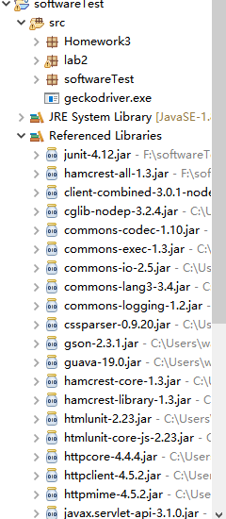

1. 编写drive类驱动浏览器登录网页并获取信息返回字符串。
2. 编写read类，把表格中信息粘贴到read类中，并把每个人的信息分离出来返回字符串。
3. 编写测试类，用for循环，测试每个人的信息，一共分成4次测试，第一次测试0到20，第二次测试20到60，第三次测试60到100，第4次测试100到143。得出测试结果。

程序源代码：

Drive.java类：

**package** lab2;

**import** org.openqa.selenium.By;

**import** org.openqa.selenium.WebDriver;

**import** org.openqa.selenium.firefox.FirefoxDriver;

**public** **class** Drive {

**public** **static** **void** main(String[] args) {

// **TODO** Auto-generated method stub

}

**public** String getResult(**int** i) {

WebDriver driver;

System.*setProperty*("webdriver.firefox.marionette", "C:\\AppData\\geckodriver.exe");

driver=**new** FirefoxDriver();

driver.get("http://121.193.130.195:8800");

driver.findElement(By.*name*("id")).sendKeys(Read.*login*(i));

driver.findElement(By.*name*("password")).sendKeys(Read.*logpw*(i));

driver.findElement(By.*id*("btn_login")).click();

String stuName = driver.findElement(By.*id*("student-name")).getText();

String stuGit = driver.findElement(By.*id*("student-git")).getText();

String stuId = driver.findElement(By.*id*("student-id")).getText();

driver.findElement(By.*id*("btn_logout")).click();

driver.findElement(By.*id*("btn_return")).click();

driver.close();

**return** stuId+","+stuName+","+stuGit;

}

}

Read.java类：

**package** lab2;

**import** java.util.TreeMap;

**public** **class** Read {

**static** String *data* = "3016218051,邓杰,https://github.com/popboykingdjko\r\n" +

"3016218052,董小璇,https://github.com/xiaoxuaoj\r\n" +

"3016218053,范立水,https://github.com/nbdfls\r\n" +

"3016218054,黄逸群,https://github.com/hyqzz1\r\n" +

"3016218055,霍欣芷,\r\n" +

"3016218056,李陈,https://github.com/FBIbaby\r\n" +

"3016218057,李今,https://github.com/riginAI/test\r\n" +

"3016218058,李凯,https://github.com/likai3016218058\r\n" +

"3016218059,李亚康,https://github.com/forAragaki/Software-Testing.git\r\n" +

"3016218060,刘崇玮,https://github.com/liuchongwei1998\r\n" +

"3016218061,刘岳森,https://github.com/liuyuesen\r\n" +

"3016218062,楼林,https://github.com/loulin206\r\n" +

"3016218063,彭昱菡,https://github.com/acan777\r\n" +

"3016218064,石善炜,https://github.com/Winbeeone/Hello-GitHub\r\n" +

"3016218065,唐颂,https://github.com/tangsongTJU\r\n" +

"3016218066,万子航,https://github.com/LITTLEEEEE/st.git\r\n" +

"3016218067,王晨,https://github.com/WangChen0902\r\n" +

"3016218068,王冠,https://github.com/skye0207\r\n" +

"3016218069,王磊,https://github.com/wanglei201810/HHH.git\r\n" +

"3016218070,文健玮,\r\n" +

"3016218072,熊清鸥,https://github.com/Panda216\r\n" +

"3016218073,许炳秋,https://github.com/AQITF/software-testing-course\r\n" +

"3016218075,许致远,https://github.com/Tyrusmacv\r\n" +

"3016218076,张聪,https://github.com/Tyrusmacv\r\n" +

"3016218077,张凯炫,https://github.com/DanielKZhang\r\n" +

"3016218078,邹其锋,https://gitee.com/zqfgly\r\n" +

"3016230028,夏子霞,https://github.com/XiaZiXia\r\n" +

"3016204130,樊鹏,\r\n" +

"3016218079,白钰清,\r\n" +

"3016218080,蔡阳阳,https://github.com/cyytju\r\n" +

"3016218081,陈健,\r\n" +

"3016218083,傅淏,https://github.com/HaoFuTju\r\n" +

"3016218084,勾子懿,https://github.com/Ziyiiii\r\n" +

"3016218085,郭培溟,https://github.com/guopeiming\r\n" +

"3016218086,侯钦瀚,\r\n" +

"3016218087,李晓鹏,https://github.com/brightknight177\r\n" +

"3016218088,李志杰,https://github.com/zhijielee\r\n" +

"3016218089,刘美华,https://github.com/guguguzi\r\n" +

"3016218090,刘奕男,https://github.com/EchoLiuYinan\r\n" +

"3016218091,卢昊,https://github.com/iiTachi/\r\n" +

"3016218092,蒙扬,\r\n" +

"3016218093,欧阳毅铮,https://github.com/SouperO\r\n" +

"3016218094,丘岳华,https://github.com/qyhxxx\r\n" +

"3016218096,孙重阳,https://github.com/SunCubeIsMyID\r\n" +

"3016218097,王春力,https://github.com/passerw\r\n" +

"3016218098,王天,https://github.com/old-yellow\r\n" +

"3016218099,王一博,https://github.com/yibowang98\r\n" +

"3016218100,魏锰,https://github.com/Landy0524\r\n" +

"3016218101,曾晓东,https://github.com/nkaccounting\r\n" +

"3016218102,张程奕,https://github.com/PlatinumYi\r\n" +

"3016218103,张凯,https://github.com/zk990202\r\n" +

"3016218104,张蔚珩,https://github.com/Zwh0508\r\n" +

"3016218105,张颖异,https://github.com/newyingyi\r\n" +

"3016218106,赵家琛,https://github.com/uareagay\r\n" +

"3016218107,钟丽,https://github.com/LeilaniZ\r\n" +

"3016204310,何书豪,https://github.com/hshsilver/softwaretest\r\n" +

"3016207516,刘梓璇,\r\n" +

"3016218108,蔡晴,https://github.com/Barbra0613\r\n" +

"3016218109,陈诺,https://github.com/Nicole1772\r\n" +

"3016218110,陈森林,https://github.com/csl784513390\r\n" +

"3016218111,陈子豪,https://github.com/czhxbz\r\n" +

"3016218112,崔歌,https://github.com/whyNotwh\r\n" +

"3016218113,高文腾,https://github.com/tjugwt\r\n" +

"3016218114,葛坦,https://github.com/tjugwt\r\n" +

"3016218115,胡博,https://github.com/BoHuyyy\r\n" +

"3016218116,黄兴宇,https://github.com/mangoSteve\r\n" +

"3016218117,季可琛,https://github.com/mangoSteve\r\n" +

"3016218118,季杨盛,https://github.com/AndrewJYS\r\n" +

"3016218119,李鹏华,https://github.com/liphcpp\r\n" +

"3016218120,李峙钢,https://github.com/tju-lzg\r\n" +

"3016218121,林然,https://github.com/Nfboys\r\n" +

"3016218122,吕勇梁,https://github.com/tcklll/software-testing.git\r\n" +

"3016218123,马昊阳,https://github.com/MHYpony\r\n" +

"3016218124,孟繁博,https://github.com/FANBoMeng3016218124/swTest.git\r\n" +

"3016218125,王惠民,https://github.com/tjwhm\r\n" +

"3016218126,王宇玄,https://github.com/hnwyx/software-testing\r\n" +

"3016218127,王怡婷,https://github.com/wwwwangyiting\r\n" +

"3016218128,肖业凡,https://github.com/HNSHongTian/SoftwareTesting\r\n" +

"3016218129,许凌涵,https://github.com/linghanxu-tju/software_testing.git\r\n" +

"3016218130,杨旺,https://github.com/YWlancer\r\n" +

"3016218131,张嘉芮,https://github.com/oikawamomo/software_test\r\n" +

"3016218133,赵健,https://github.com/ZJ921\r\n" +

"3016218134,赵艺茹,https://github.com/zzzyyyrrr\r\n" +

"3016218135,窦淑洁,https://github.com/tjudoubi\r\n" +

"3014218120,李明,https://github.com/SoSoSorry\r\n" +

"3016218136,艾孜合尔·哈木提,https://github.com/users/azzr997/projects/1\r\n" +

"3016218137,范林峰,https://github.com/SryTo/SoftwareTesting.git\r\n" +

"3016218138,冯晴,https://github.com/STHARUKI\r\n" +

"3016218139,郭睿,https://github.com/skadoodleR\r\n" +

"3016218140,郭皓华,https://github.com/Potmon/STT2016.git\r\n" +

"3016218141,何雨璇,https://github.com/everlastingstars\r\n" +

"3016218142,加莎热提·买买提依明,https://github.com/Lothric19\r\n" +

"3016218143,李培城,https://github.com/bxsj/\r\n" +

"3016218144,李书瀚,https://github.com/0-Avalon-0\r\n" +

"3016218145,李文旭,https://github.com/mssjliwenxu\r\n" +

"3016218146,梁哲粼,https://github.com/MaoMaoChina\r\n" +

"3016218147,刘春阳,https://github.com/LiuChunY\r\n" +

"3016218148,刘智,https://github.com/liuzhidemaomao\r\n" +

"3016218149,娄宇欣,https://github.com/Lou11300306?tab=projects\r\n" +

"3016218150,马力,https://github.com/Horsepower8888\r\n" +

"3016218151,潘芳旭,https://github.com/Skypfx/softwareTesting\r\n" +

"3016218152,石晓霖,https://github.com/colindying\r\n" +

"3016218153,史丹阳,https://github.com/htmmd27\r\n" +

"3016218154,史鹏,https://github.com/tjuspAIC/Software-Testing\r\n" +

"3016218155,孙玮,https://github.com/Vincent-Sun\r\n" +

"3016218156,谭淮联,https://github.com/980801\r\n" +

"3016218157,邢桢,https://github.com/ChenHsing\r\n" +

"3016218158,杨猛,https://github.com/yangmeng19980420\r\n" +

"3016218159,张环禹,https://github.com/Ives66\r\n" +

"3016218160,张煌,https://github.com/zhuang12/SoftwareTest.git\r\n" +

"3016218161,张亚文,https://github.com/michellezyw\r\n" +

"3016218162,周菁涛,https://github.com/Cyphexl\r\n" +

"3016218163,朱梓毓,https://github.com/lazygirlyu/homework\r\n" +

"3016218164,祝晶晶,https://github.com/GZhuJJ/SoftwareTestingCourse\r\n" +

"3016207275,李朝晖,https://github.com/Lzhaohui\r\n" +

"3016214077,赵明洋,https://github.com/ZhaoMingYang-tju\r\n" +

"3016218165,艾孜哈尔·艾合买提,https://github.com/azhar241892\r\n" +

"3016218166,邓皓岩,https://github.com/husuhusuhusu\r\n" +

"3016218167,方诚彦,https://github.com/DemonTimor\r\n" +

"3016218168,韩晨,https://github.com/JoHnHC\r\n" +

"3016218169,何昊,https://github.com/ritian-hh\r\n" +

"3016218170,黄冬梅,https://github.com/hdm926\r\n" +

"3016218171,黄正文,https://github.com/AWenXiong\r\n" +

"3016218172,李沛霖,https://github.com/SSFDLware/software-testing\r\n" +

"3016218173,刘梦真,https://github.com/yangyi66\r\n" +

"3016218174,刘文海,https://gitee.com/tju_hei/software_test.git\r\n" +

"3016218175,刘洋,https://github.com/liuyang806\r\n" +

"3016218176,莫纯谊,mcyatom@gmail.com\r\n" +

"3016218177,邱足天,https://github.com/ElegantQiu\r\n" +

"3016218178,宋琦琪,https://github.com/sqq7777\r\n" +

"3016218179,隋名本,https://github.com/suimingben\r\n" +

"3016218180,孙琦淞,https://github.com/sqis777?tab=repositories\r\n" +

"3016218181,孙昊,https://culturepanda.github.io/SoftwareTesting/\r\n" +

"3016218182,王志航,https://github.com/YourBrotherTT/softwareTesting.git\r\n" +

"3016218183,吴可歆,https://github.com/guuuuji/Software-test.git\r\n" +

"3016218184,谢荣升,https://github.com/fallentree\r\n" +

"3016218186,叶翰华,https://github.com/MarcusNerva\r\n" +

"3016218187,依力格尔·麦提尼亚孜,https://github.com/ilgarrr\r\n" +

"3016218188,岳明宇,https://github.com/githaub/homework.git\r\n" +

"3016218189,张永佳,https://github.com/llmgpty/tjuscsst.git\r\n" +

"3016218190,赵仲琳,https://github.com/ZhonglinZ\r\n" +

"3016218191,祝开元,https://github.com/ZHUKAIYUAN0/test\r\n" +

"3016218192,邹璐文,https://github.com/jianxin-YL\r\n";

**public** **static** **void** main(String[] args) {

}

**public** String Eresult(**int** i) {

String[] lines = *data*.split("\r\n");

**return** lines[i];

}

**public** **static** String login(**int** i) {

String[] lines = *data*.split("\r\n");

String[] item = lines[i].split(",");

String str = item[0];

**return** str;

}

**public** **static** String logpw(**int** i) {

String[] lines = *data*.split("\r\n");

String[] item = lines[i].split(",");

String str = item[0];

**char**[] chs = str.toCharArray();

**char**[] paw = **null**;

String passw = "2";

**for**(i=5;i<10;i++) {

passw = passw + chs[i];

}

**return** passw;

}

}

DriveTest.java类：

**package** lab2;

**import** **static** org.junit.Assert.*;

**import** org.junit.Test;

**public** **class** DriveTest {

@Test

**public** **void** test() {

**for**(**int** i=100;i<143;i++) {

Drive d = **new** Drive();

Read r = **new** Read();

*assertEquals*(r.Eresult(i),d.getResult(i));

d = **null**;

r = **null**;

}

}

}

1. 调试分析
2. 问题：使用的selenium版本和eclipse版本不兼容。

解决：下载了selenium3.0.1版本和火狐5.4版本。

1. 问题：学号尾号为164的同学，git地址后多一个空格。

解决：删掉空格。

1. 测试结果

按照上述源代码分4次测试。

测试第0到20的同学：

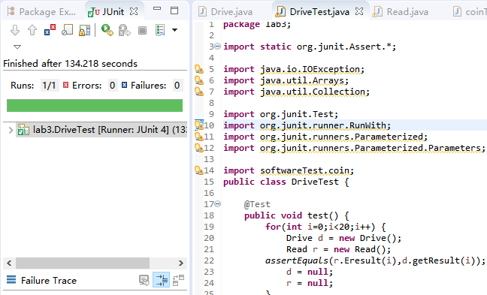

测试20到60的同学：

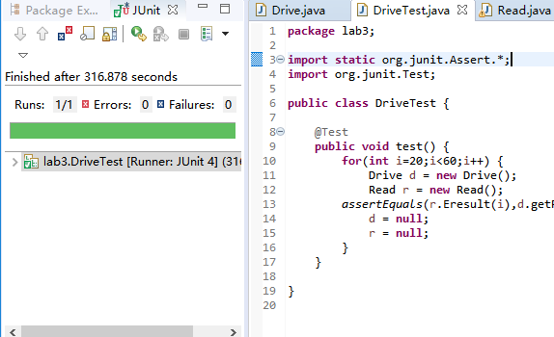

测试60到100的同学：

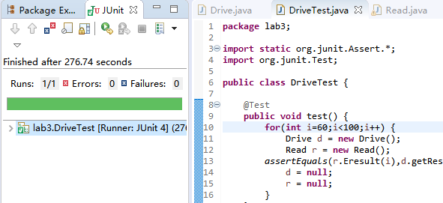

测试100到143的同学：

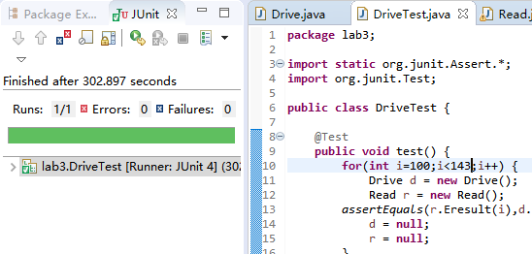

1. 总结

本次实验让我对网页测试有了一些认识，加深了我对web的了解。

也知道了selenium不仅可以测试java程序，还可以测试网页程序。

通过这次实验，我也发现selenium等软件对版本都比较敏感，在安装使用前，还是要充分了解。