**README**

1. **Installation**

"collect-best-images.zip" is self-contained, which contains an OpenJDK-13 custom JRE. You just need to unzip it to the folder where you want to run this utility from.

1. **Preparation**

* Change the directory to above folder, you will see following files:

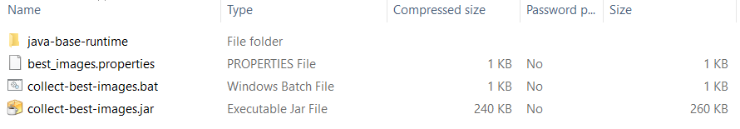

* Open best_images.properties file, modify the folders to reflect the real locations where the images saved;

1. **Usage**

* From above folder, run **collect-best-images.bat,** the best image file list will be created in the path defined in “PATH_TO_BEST_IMAGE_LIST” property.

As per the request from Control-M, the format of generated “best images file list” is as below:

