1) Tracking Speed Test for Internal Feed Back (variable)
power value is 1.29 dBm
Tracking method: variable
Step Sizes minimum: 12;
Step Sizes maximum: 18;
Threshold: 0;
AD average: 2;
Feedback Delay: 5;
Fluctuation is 0.009283 dB (<0.1dB)

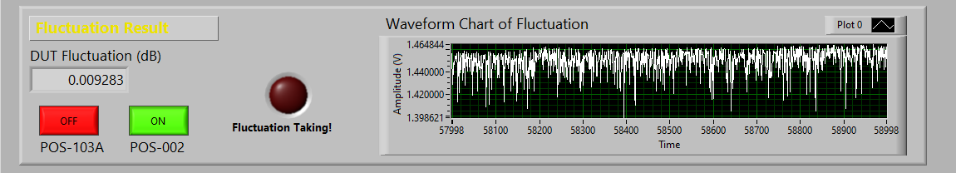

2) Recovery Time Test for Internal Feed Back(variable)
power value is 1.29 dBm
Tracking method: variable
Step Sizes minimum: 12;
Step Sizes maximum: 18;
Threshold: 0;
AD average: 2;
Feedback Delay: 5;
Average Recovery Time is 0.878358 ms (<1.5ms)
Maximum Recovery Time is 3.0 ms (<5ms)

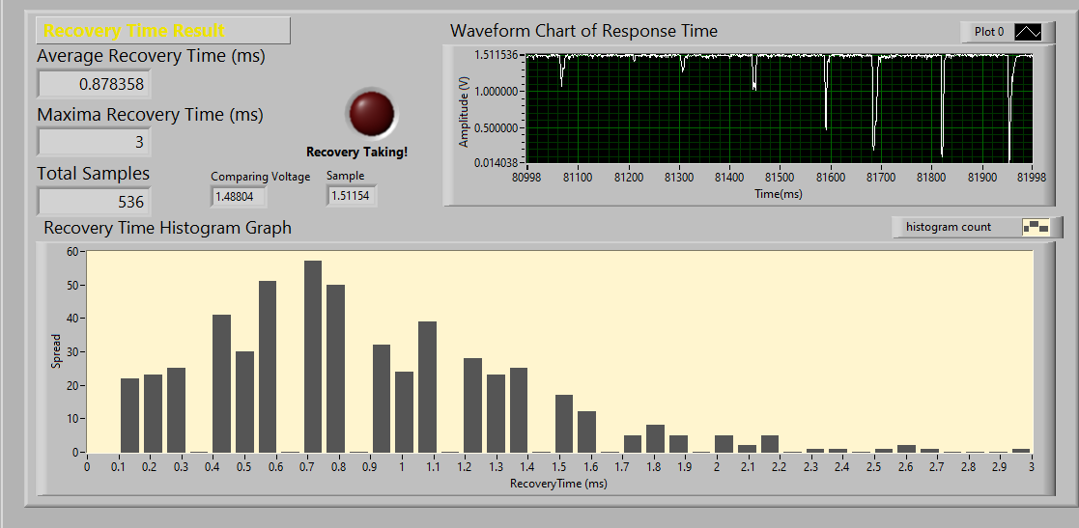

3) Tracking Speed Test for Internal Feed Back (fixed )
power value is 1.29 dBm
Tracking method: fixed
Step Sizes minimum: 12;
Step Sizes maximum: 18;
Threshold: 0;
AD average: 2;
Feedback Delay: 5;
Fluctuation is 0.010632 (<0.1dB)

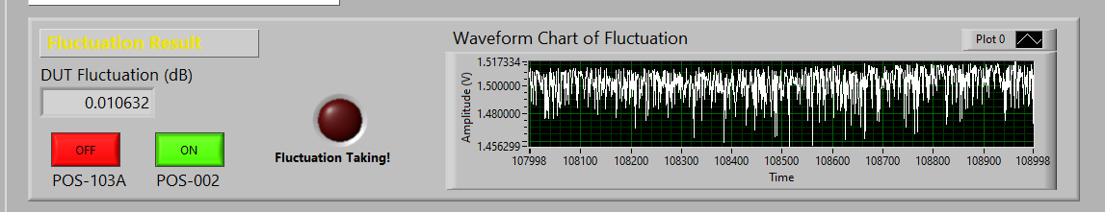

4) Recovery Time Test for Internal Feed Back (fixed )
power value is 1.29 dBm
Tracking method: fixed
Step Sizes minimum: 12;
Step Sizes maximum: 18;
Threshold: 0
AD average: 2;
Feedback Delay: 5;
Average Recovery Time is 0.940187 ms (<1.5ms)
Maximum Recovery Time is 2.5 ms (<5ms)

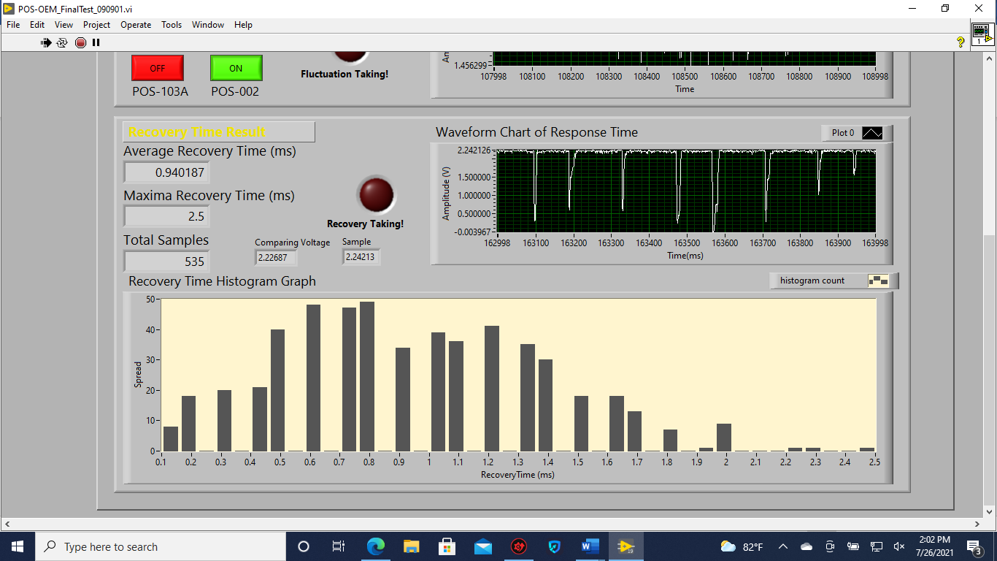

5) Tracking Speed Test for External Feed Back (variable)
power value is 1.29 dBm
Tracking method: variable
Step Sizes minimum: 12;
Step Sizes maximum: 18;
Threshold: 0;
AD average: 2;
Feedback Delay: 5;
Fluctuation is 0.018005 dB (<0.1dB)

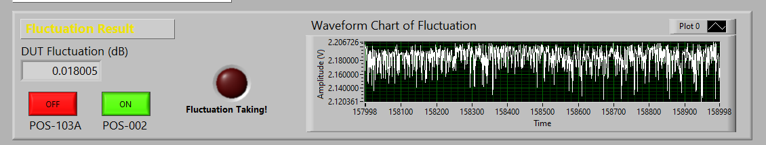

6) External Feed Back Recovery Time Test (variable)
power value is 1.29 dBm
Tracking method: variable
Step Sizes minimum: 12;
Step Sizes maximum: 18;
Threshold: 0;
AD average: 2;
Feedback Delay: 5;
Average Recovery Time is 0.857273 ms (<1.5ms)
Maximum Recovery Time is 2.7 ms (<5ms)

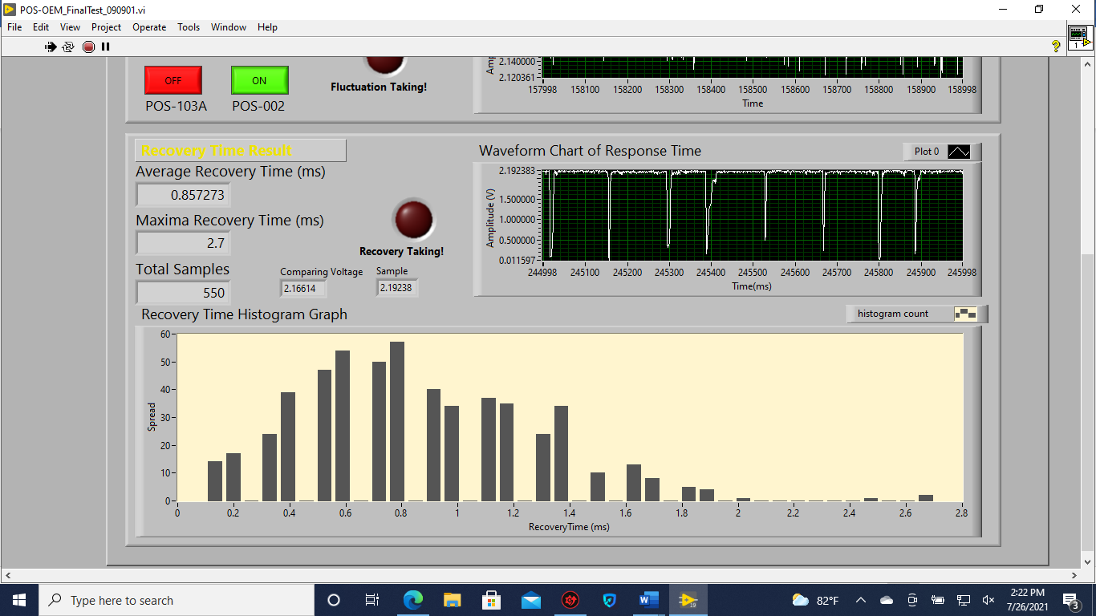

7) Tracking Speed Test for External Feed Back (fixed)
power value is 0.29 dBm
Tracking method: fixed
Step Sizes minimum:12;
Step Sizes maximum: 18;
Threshold: 0;
AD average: 2;
Feedback Delay: 5;
Fluctuation is 0.015169 dB (<0.1dB)

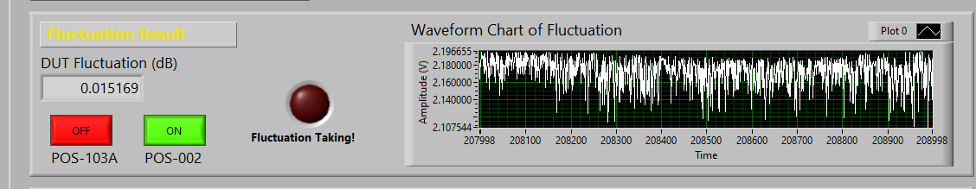

8) External Feed Back Recovery Time Test (fixed)
power value is 1.29 dBm
Tracking method: fixed
Step Sizes minimum: 12;
Step Sizes maximum: 18;
Threshold: 0;
AD average: 2;
Feedback Delay: 5;
Average Recovery Time is 0.820231 ms (<1.5ms)
Maximum Recovery Time is 3.2 ms (<5ms)

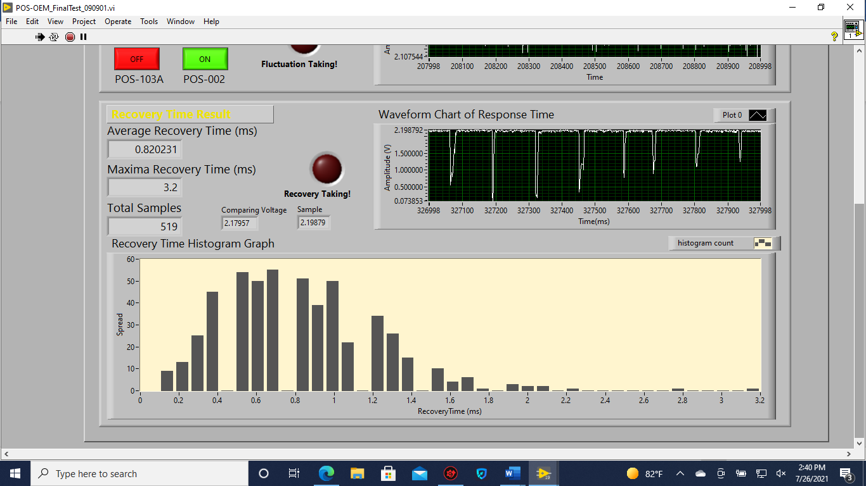

9) Minimum Search Test

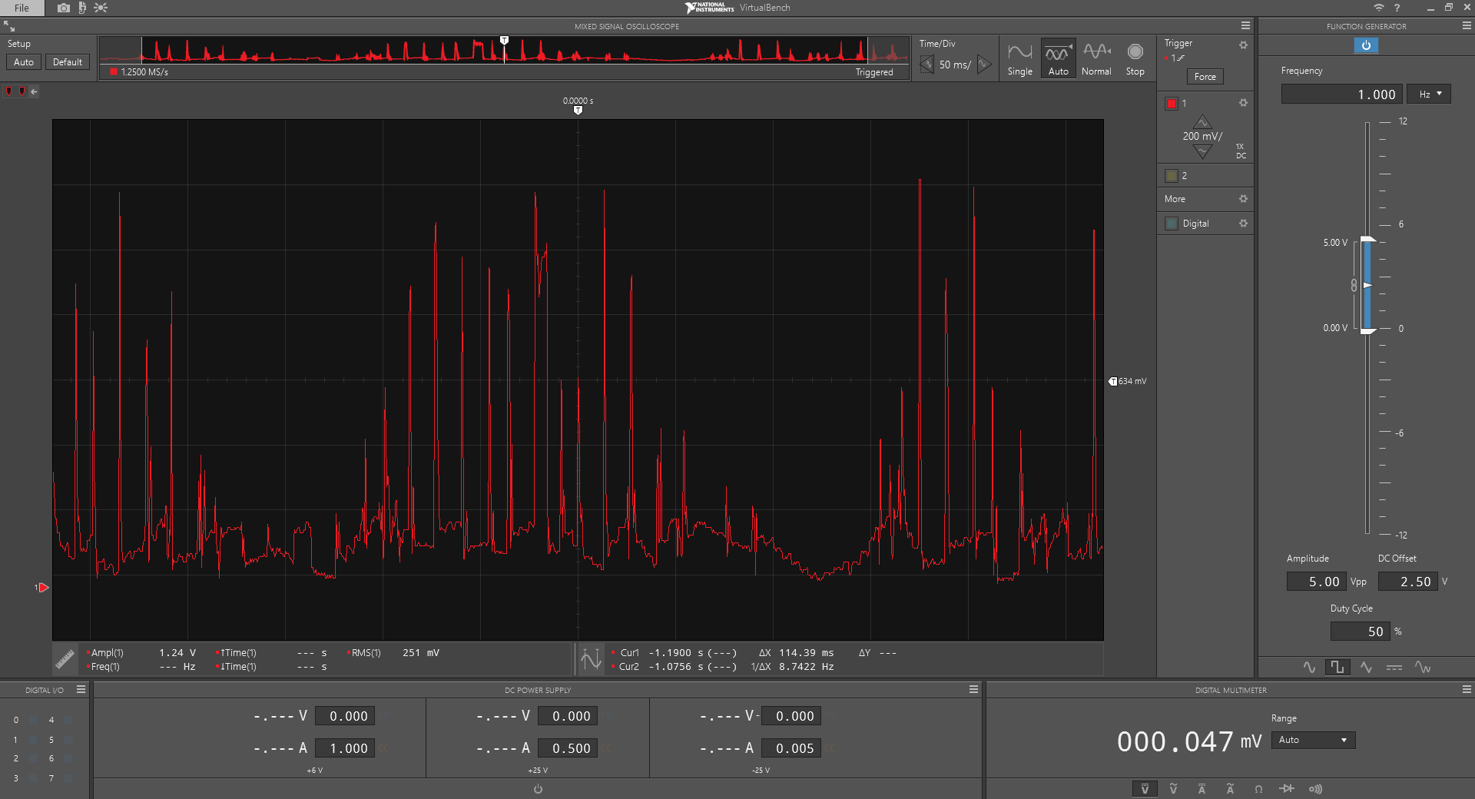

10) Trigger In Test
a) Trigger signal control tracking (level to enable: high) b) Trigger signal control tracking ((level to enable: low)
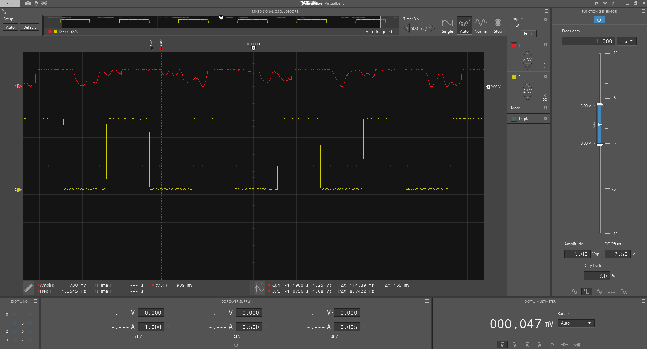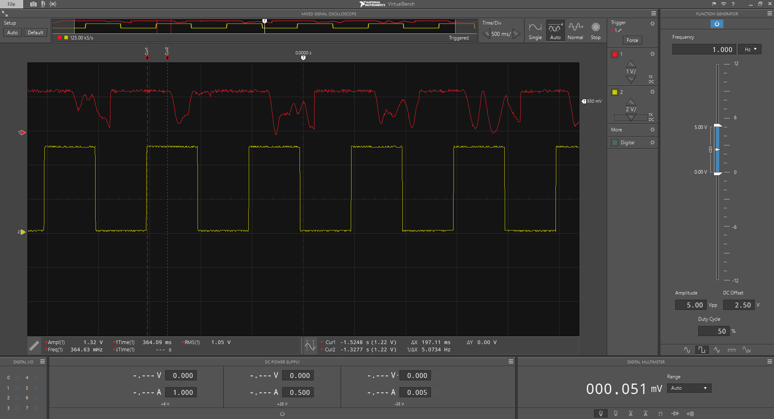

11) Trigger Out Test
a) Trigger in and out signal (level to enable: high) b) Trigger in and out signal (level to enable: low)
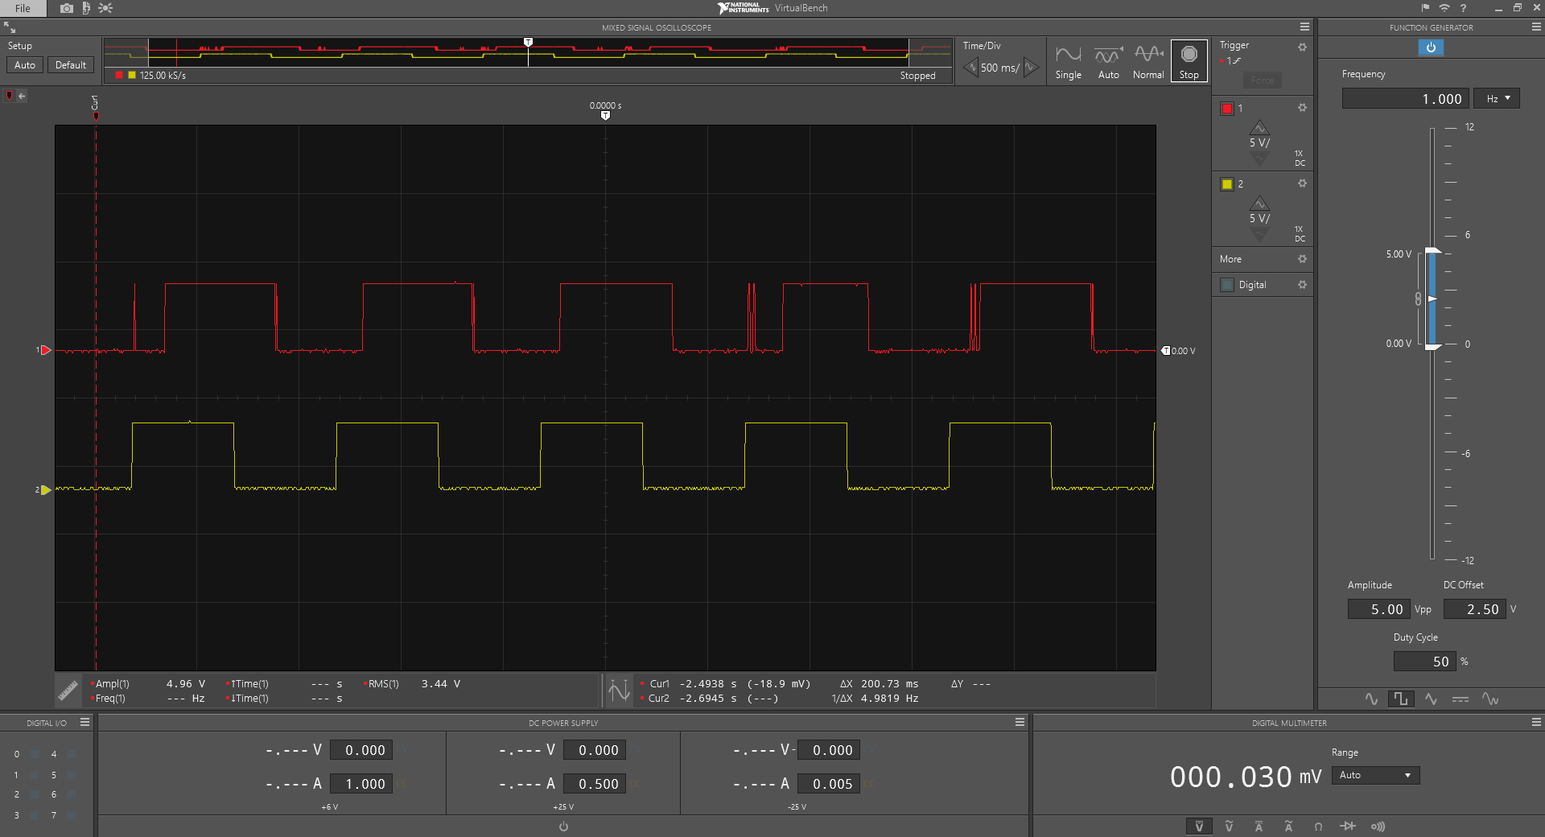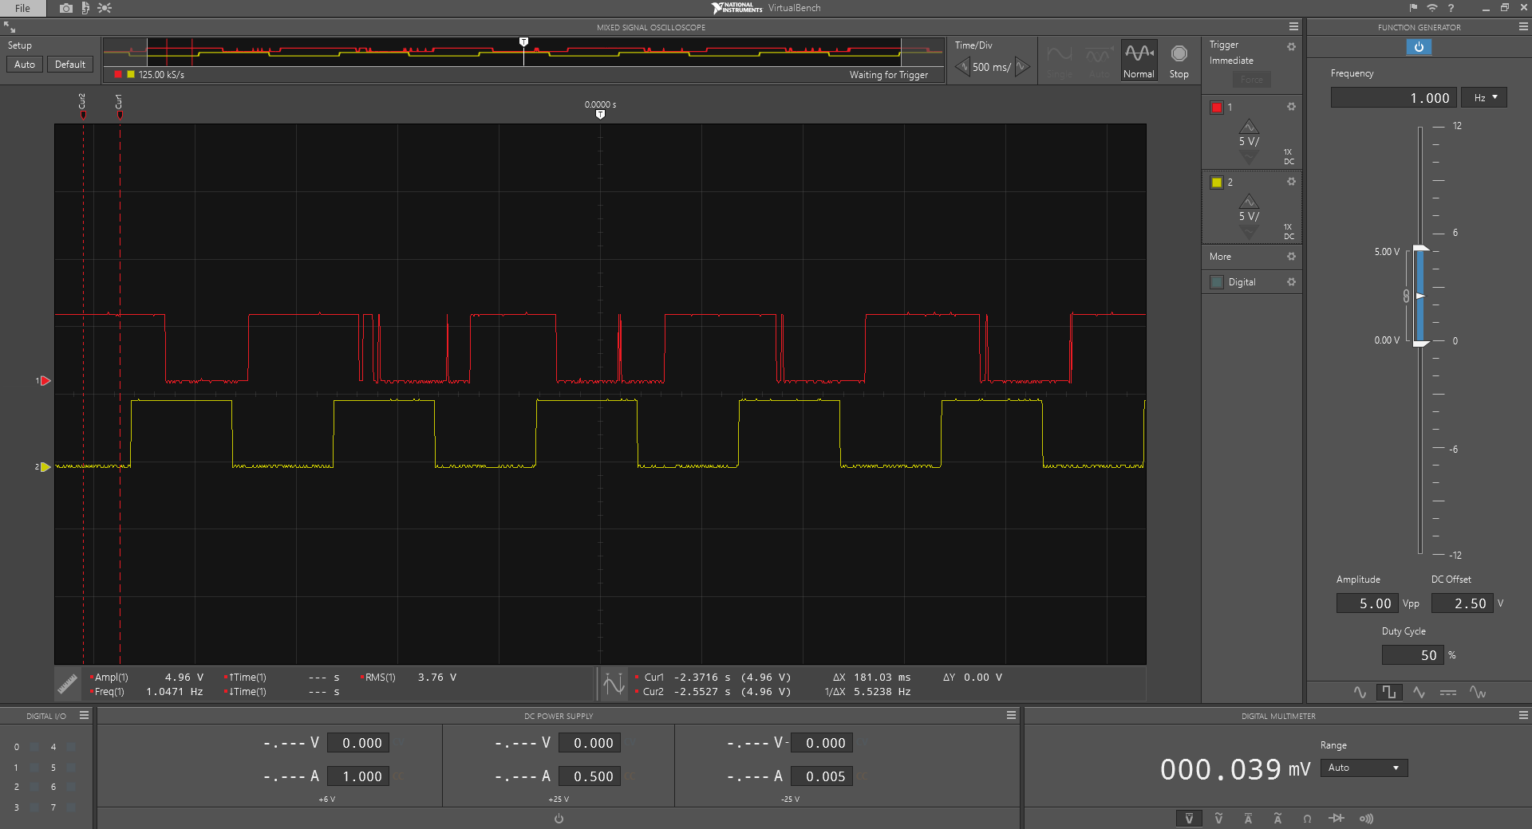

c) Trigger in and out signal Δt (165ms) (level enable: high) d) Trigger in and out signal Δt(614ms) (level enable: low)
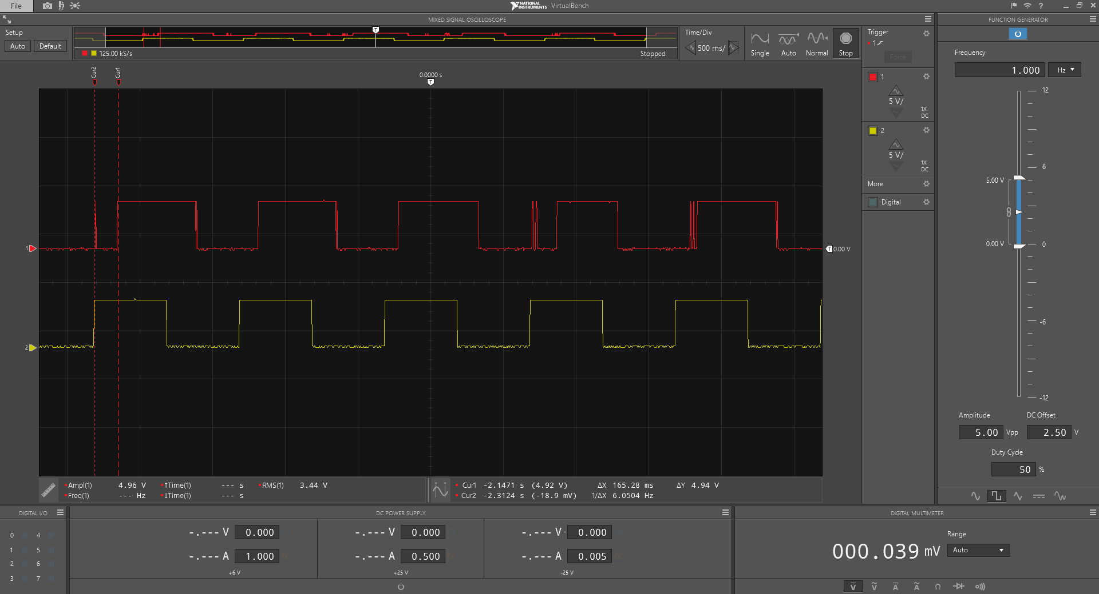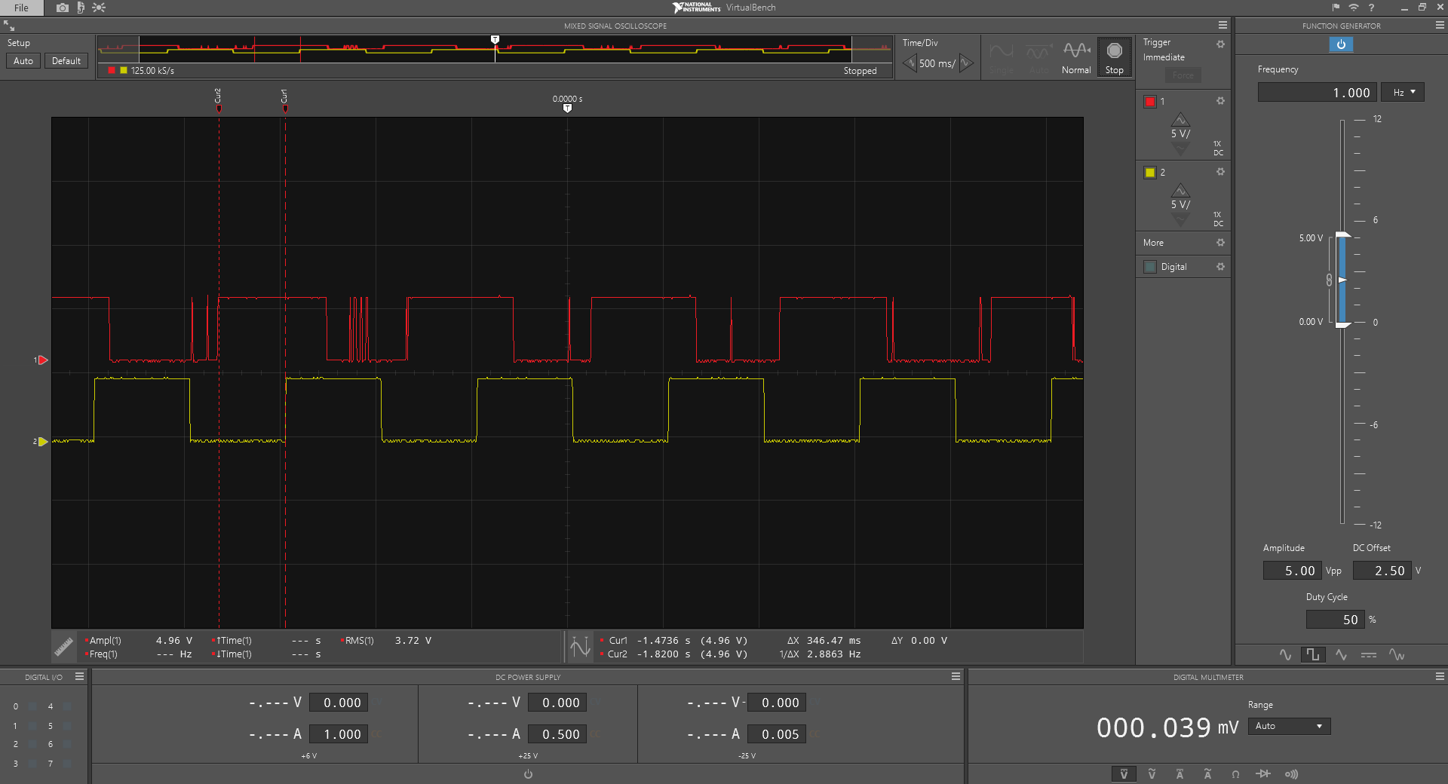

12) Power Accuracy

Wavelength(nm) | Power @Power meter(dBm) | Power @POS203 (dBm) | Power difference(dB)
1550 | 0.15 | 0.11 | 0.04dB
1550 | -3.27 | -3.21 | 0.06dB

