1、导入数据遇到安全模式问题
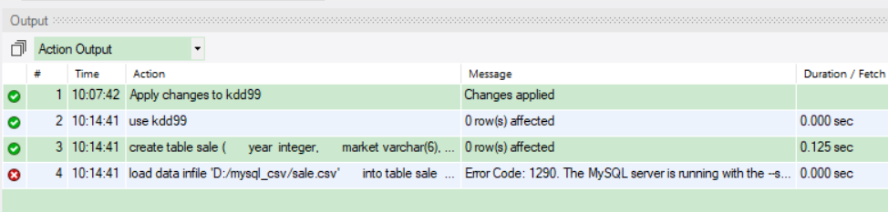

show variables like '%secure%';-- 查看安全路径
拷了文件夹。只要在安全路径下加了文件所在的文件夹就可以
把路径里面的D:直接替换成C:/ProgramData/MySQL/MySQL Server 8.0/Uploads/mysql_csv
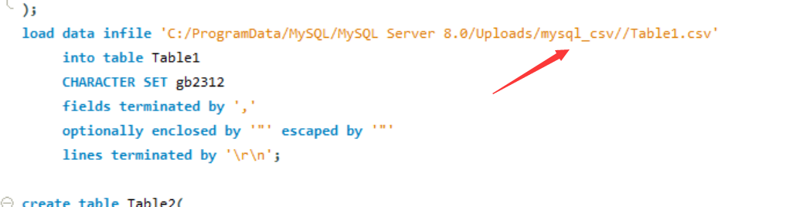

2、导入数据运行时间过长问题

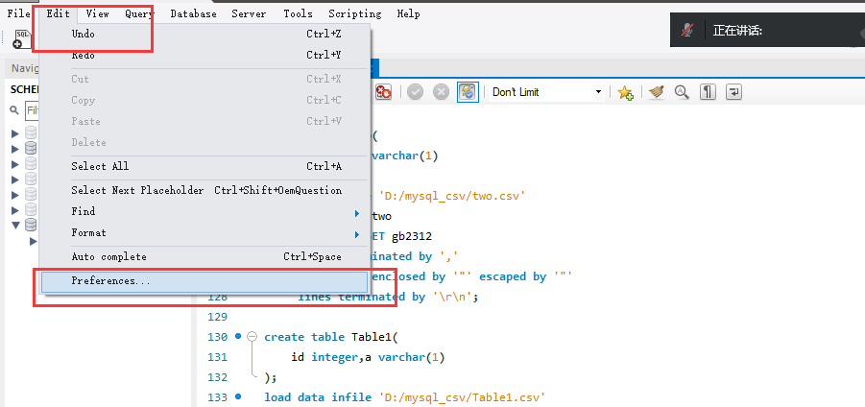
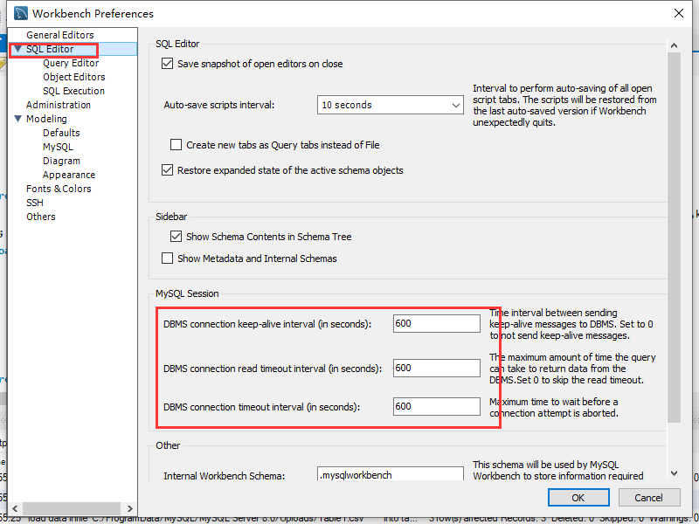

3、导出数据截断问题
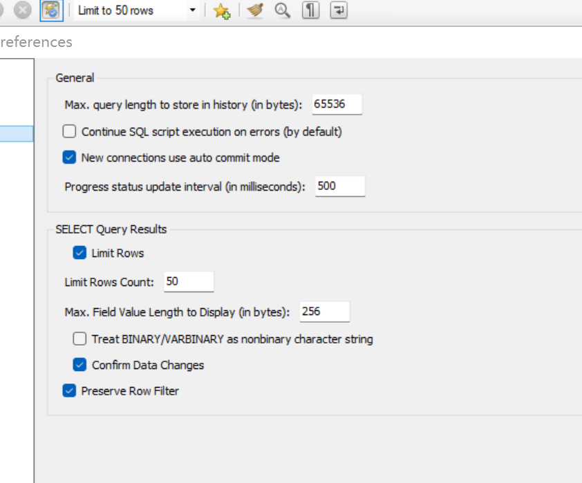

4、Group by相关报错
SELECT a.*,a.type,a.sex,a.age,avg(b.balance) as avg_balance,
sum(case when b.type="贷" then b.amount end) as sum_income,
sum(case when b.type="借" then b.amount end) as sum_expenditure,
sum(case when b.type="贷" then b.amount end)/sum(case when b.type="借" then b.amount end) as in_out_ratio
FROM kdd99.card_ana a
left join kdd99.kdd99_trans b on a.account_id =b.account_id
and timestampdiff(day,a.issued,b.date)<0 and timestampdiff(day,a.issued,b.date)>-180
group by a.account_id,a.type,a.sex,a.age
order by a.account_id ;

出现报错提示：“ not functionally dependent on columns in GROUP BY clause; this is incompatible with sql_mode=only_full_group_by”的，可能是因为系统安装的MySQL默认严格模式。可以在MySQL新建新的SQL tab，粘贴并运行如下代码，并关闭mysql再重新打开：
select version();
select @@sql_mode;
set @@global.sql_mode
='strict_trans_tables,no_zero_in_date,no_zero_date,error_for_division_by_zero,no_engine_substitution';

宽松模式设置参考网址：
https://blog.csdn.net/weixin_38004638/article/details/108433557#%E8%A7%A3%E5%86%B3%E6%AD%A5%E9%AA%A4

或者：都写出来
use kdd99;
select a.account_id,a.district_id,a.frequency,avg(b.balance) as avg_balance,std(b.balance) as std_balance,std(b.balance)/avg(b.balance) as cv_balance,
sum(case when b.type="贷" then b.amount end) as sum_income,
sum(case when b.type="借" then b.amount end) as sum_expenditure,
sum(case when b.type="贷" then b.amount end)/sum(case when b.type="借" then b.amount end) as in_out_ratio
from test2 as a
left join kdd99_trans as b on a.account_id =b.account_id and timestampdiff(day,"1998-01-01",b.date)<0 and timestampdiff(day,"1998-01-01",b.date)>-180 and y<>2
group by a.account_id,a.account_id,a.district_id,a.frequency;

