Fiber Impregnation Homework: Example Result Figures
Qualitative examples of the plots students should generate from the 2D fiber-scale impregnation package.
Example output | Main comparison | Manufacturing idea
fiber_patterns.png | square / hexagonal / random | packing controls resin pathways
spacing_vs_Vf.png | Vf = 0.40, 0.50, 0.60 | higher Vf narrows channels
viscosity_vs_temperature.png | 25 C to 150 C | temperature changes initial mobility
viscosity_vs_time.png | thermal viscosity plus cure | gelation can remove mobility
impregnation_vs_time_Vf_zoom.png | early-time Vf response | dense beds can stall early
impregnation_vs_time_pattern_temperature.png | pattern and temperature | geometry and process window compete
degree_of_cure_vs_time_pattern_temperature.png | DoC histories | cure is interpreted as a supplied constraint
Use these as example result formats, not as a substitute for the students' own generated plots and interpretation.

Selected Result Examples
The figures below illustrate the expected types of outputs from the instructor solution. Students should discuss physical trends, process tradeoffs, and how microstructure affects impregnation.

Figure 1. Fiber Architecture Examples
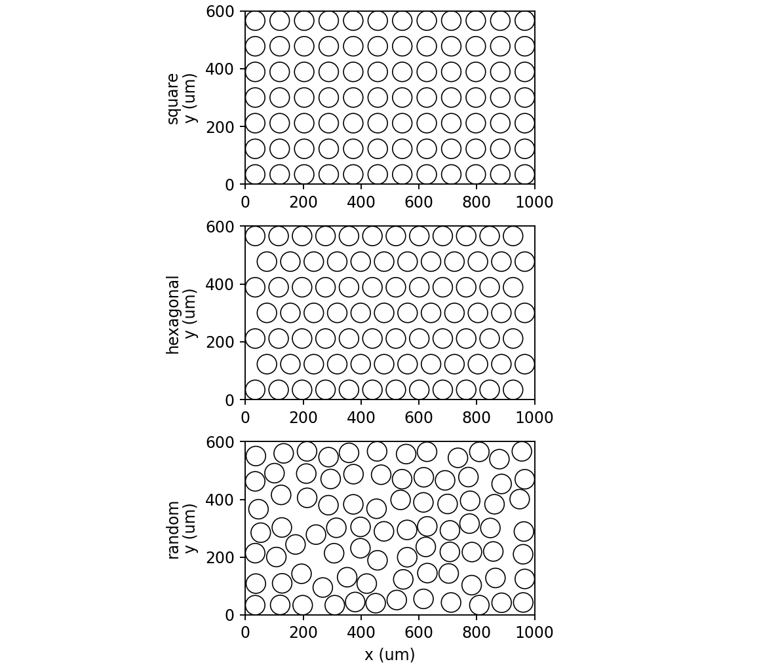
Square, hexagonal, and random 2D fiber arrangements at $V_{f}$ = 0.50.
What to notice: Students should compare the connected resin channels rather than only the nominal Vf.

Figure 2. Effect of $V_{f}$ on Fiber Spacing
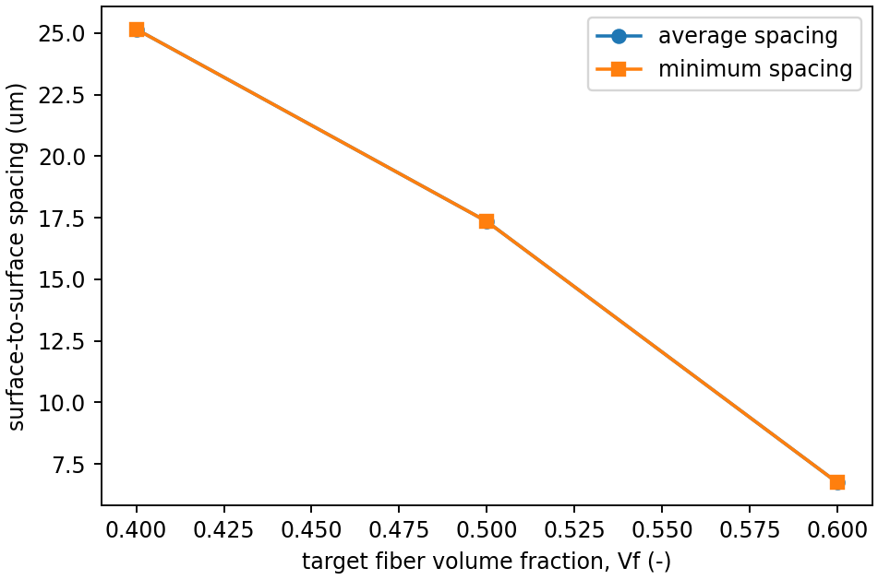
Average and minimum spacing decrease as fiber volume fraction increases.
What to notice: This figure links microstructure to manufacturing difficulty: narrow channels increase flow resistance.

Figure 3. Temperature-Only Viscosity
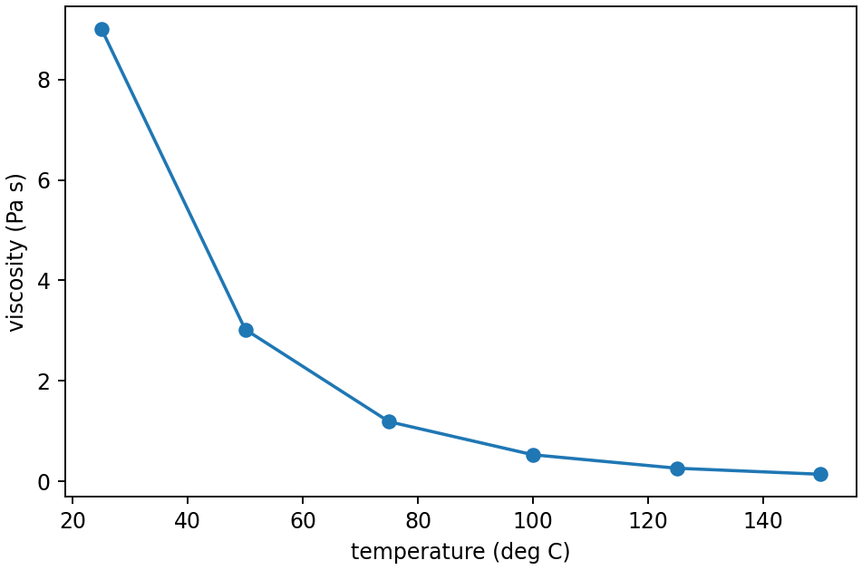
The Arrhenius temperature relation gives lower uncured viscosity at higher temperature.
What to notice: This is the processing-rheology input students implement before cure is coupled in.

Figure 4. Viscosity Evolution During Cure
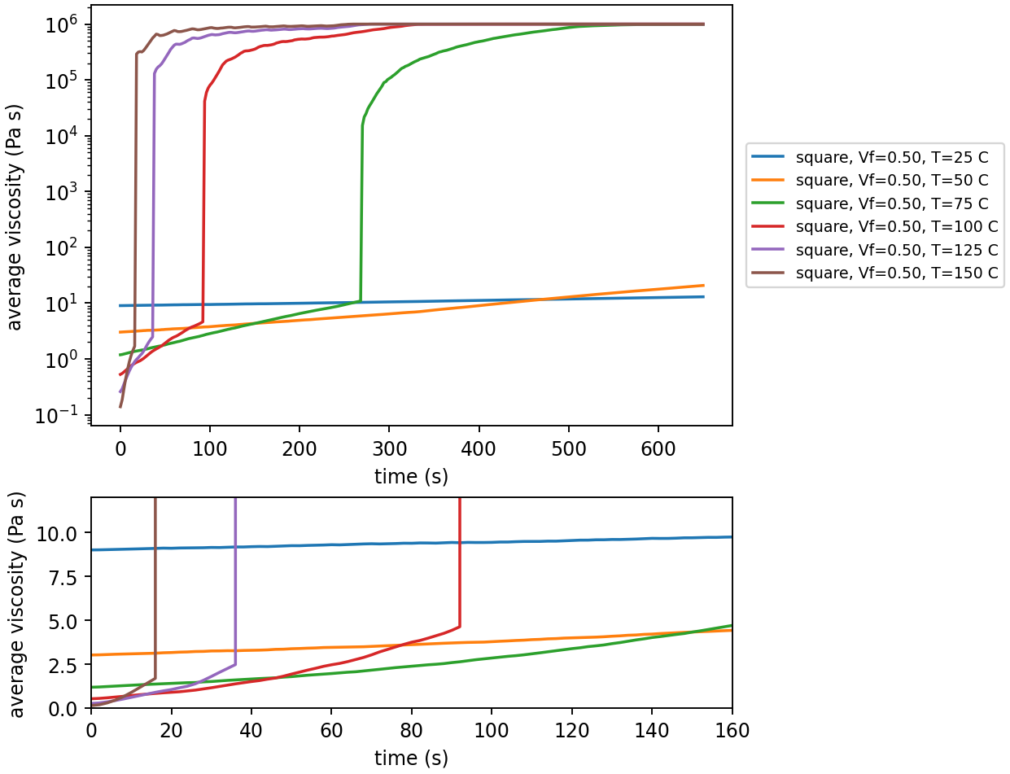
Average viscosity changes over time as temperature and cure compete.
What to notice: High temperature can lower initial viscosity but also accelerate cure and gelation.

Figure 5. Impregnation Sensitivity to $V_{f}$
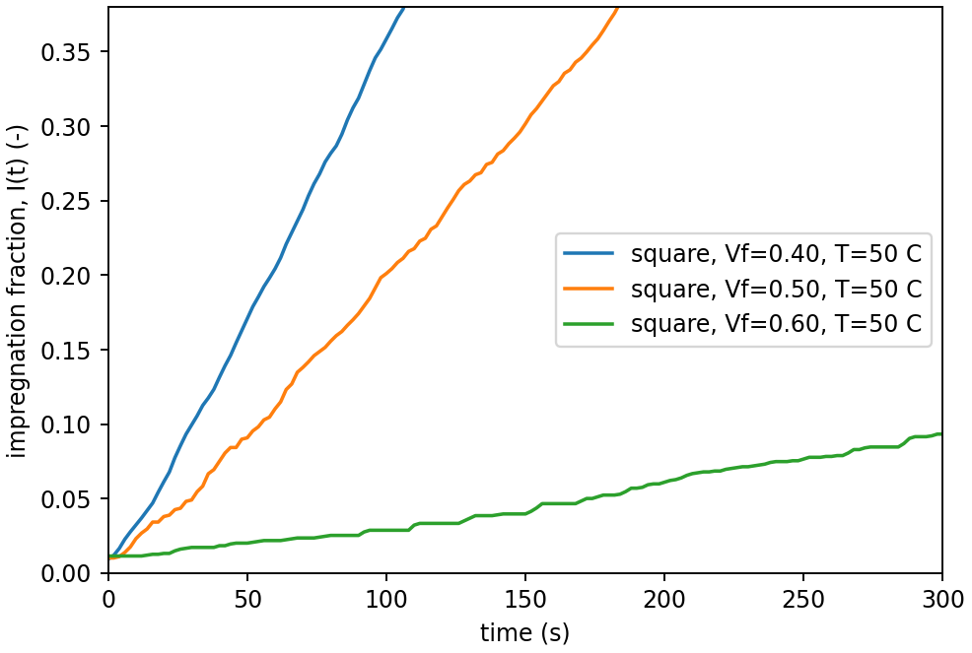
Zoomed early-time impregnation curves for square packing at different $V_{f}$.
What to notice: Higher $V_{f}$ can make impregnation stall early because the available channels are smaller.

Figure 6. Degree of Cure Time History
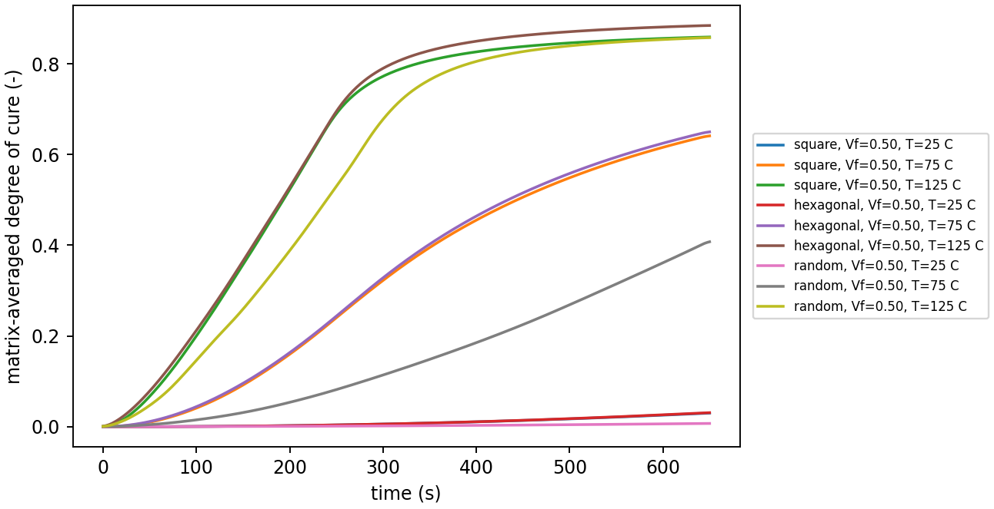
Matrix-averaged DoC for pattern-temperature cases.
What to notice: DoC is provided as a supplied model output; students use it to interpret when mobility is lost.

Video. Resin injection through different fiber patterns
Hexagonal pattern 25 °C


Quadratic pattern 25 °C

Random pattern 25 °C


