RESUME

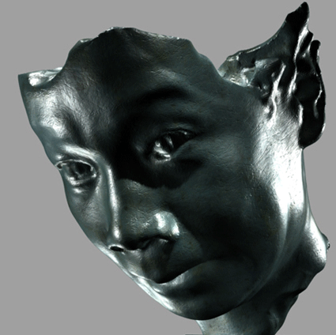
Chien-hsiung (Morris) Wang

e-mail: wangmorris@gmail.com

Website: www.morriswang.com

Education

1994-1995 -Master degree, New York Institute of Technology, major in computer arts.

1992-1993 -School of Visual Art, New York.

1986-89 -Graduated from National Taiwan Academy of Arts, major in sculpture.

Experiences

2009- 2010 Director of Multimedia Creative Center -Next Media Animation Limited.
2008 - 2009 -Overseas Supervisor, Lego Bionicle 3 @ CGCG Animation Studio, Taipei.
2007-present -Associate Professor, Chang Gung Institute of Technology, Taiwan.
1997-2007 -Technical Director/ Modeling Lead, Rhythm and Hues Studio, Los Angeles.
Responsible for characters designs, sculpting and texture mapping, and all functions of facial expressions.
Innovate new solutions to modeling technology and lecture to a team environment.
Participate in recruitment interview and portfolio selection.

Credits include:
Films: Lego Bionicle 3-the Legend Reborn(2009) ,Golden Compass(2007), Evan Almighty(2007), Garfield2(2006), Superman Returns(2006). The lion, The Witch, and The wardrobe(2005), Garfield(2003), Scooby Doo 2(2003), Around the World in 80 Days(2003), X Men 2, The Cat in the Hat, Dare Devil,
Scooby Doo, Harry Potter, Cats & Dogs, Babe 2-Pig in the City, Stuart Little, Six Days, Flint Stone, Dr. Dolittle 2 etc…
Commercials: Coca Cola1999, 2000 & 2001, Animal Kingdom in Disney (1998), Xerox-Copier’s story (1997).

Please check my IMDB online film credits: http://www.imdb.com/name/nm0910863/

2006 -Digital Sculpture Exhibition, Main Gallery at Fullerton University, Los Angeles.
-Torso series exhibited at Dynasty Gallery in Taipei, and one artwork is collected by National Taiwan Museum of Arts.

2005 -Product develpment consultant, Gaylord Design Studio.

2004 - Lecture in Taiwan, invited by Digital Content Institute(topic: from sculpture to computer
animation).

1992-2002 -Sculptor & designer, freelance. Clients include: Bradford Exchange, Hamilton Collection, Danbury Mint, Cast Art Industry, Avon, Sears, Sansco, Herco.

- -Teaching assistant, courses of Silicon graphic in graduate classes,
New York Institute of Technology, New York.

1990-92 -Sculpture studio established in Taiwan, created series of figurines for the gift market: Enesco, Franklin Mint, Roman Inc…

Awards

1989 -First prize, The 16th Exhibition of Taipei City Modern Art Museum.
-Group exhibition, the Art Exhibition at National Taiwan Education center.
-firrst prize, The 20th College Teachers and Students’ Exhibition

1987 -Group exhibition, the Art Exhibition at Tainen Cultural Center.

1986 -Group exhibition, the Art Exhibition at Tainen Cultural Center.

1983 -First prize, Illustration competition in National Military Bunch.

