**Time: Oct 01, 3:15-3:30 pm     Location: KEC 4th floor kitchen and dining room**

1. Discuss the project idea and determine the project content.

2. Discuss who is the product owner and who is the scrum master.

3. Create a new folder in google drive and everybody upload the user story.

4. Discuss the user stories and delete some useless functions.

**Time: Oct 02, 3:30-3:45 pm    Location: library 5165**

1. Separate to 2 subgroup to do front-end development and back-end development.

* Zhiyuan He, Zhengxian Lin, and Wendy are back-end subgroup members.
* Yujie Jiang, Kun Chen, and Muqi Wang are front-end subgroup members.

2. Everyone talk about what is the plan for next few days:

* Back-end development subgroup needs to learn php.
* Front-end development subgroup needs to learn how to use angular framework.
* Weijie Mo(Product Owner) needs to finish backlog, and need to find an Android IDE.

**Time: Oct 03, 6:40-6:55 pm   Location: JOHN 102**

1. Front-end group:

They found a website that can help them to learn php.

2. Back-end group:

They have read some instructions about angular.

**Time: Oct 04 3:30-3:45 pm   Location: library 1812**

1. Front-end group:

Install Typescript and Angular in every members computer, and learned some Typescript.

2. Back-end group:

* Zhengxian Lin wrote a document about some php instructions to help other members to learn php.
* They decided which IDE to use.

3. Weijie Mo installed Android Studio.

**Time: Oct 05 8:30-8:45 pm   Location: KEC 3114**

1. Front-end group:

* Learned how to use Angular and plan finish before Monday.

2. Back-end group:

* Learned php and plan finish before Wednesday.
* Learned how to use phpstorm IDE.

3. Weijie Mo still work on backlog and Android development.

**Time: Oct 08 6:35-6:50 pm   Location: JOHN 102**

1. Front-end group:

* Learned how to use Angular.
* Start to design the log-in page.

2. Back-end group:

* Learned php and learn database.
* Learned how to build apache.

3. Weijie Mo almost finish backlog and worked on the android development.

**Time: Oct 09 5:40-5:55 pm   Location: Austin 2nd floor**

1. Front-end group:

Working on the log-in page, and plan to finish it before Friday.

2. Back-end group:

Already build apache and they discuss about database.

3. Weijie Mo will finish backlog before Friday.

**Time: Oct 10 6:45-7:00 pm   Location: JOHN 102**

1. Front-end group:

* Finished the log-in page.
* Start to design the profile page of users.

2. Back-end group:

Still working on database.

3. Weijie Mo finished the backlog.

**Time: Oct 11 8:25-8:40 pm   Location: KEC 3114**

1. Front-end group:

Start to code for the account profile page.

2. Back-end group:

* Working on how to connect home page with the OSU log-in page.
* Working on how to get the customers’ information after they logged in.

3. Weijie Mo join to the back-end group.

**Time: Oct 12 9:05-9:20 pm   Location: KEC 4121**

1. Front-end group:

Designed the home page, which will show after the customers logged in.

2. Back-end group:

* Finished with the connection home page with the OSU log-in page.
* Still working on fix bugs of getting customers’ information.

**Time: Oct 15 After class   Location: JOHN 102**

1. Front-end group:

* Finish design the home page.
* Finish the code of profile page.

2. Back-end group:

Learn how to get customers’ information via CAS. (<http://onid.oregonstate.edu/docs/technical/cas.shtml>)

**Time: Oct 16 3:30-3:45 pm Location: Library 1812**

1. Front-end group:

* Perfect the log-in page.
* Start coding on the home page.

2. Back-end group:

Created the database of customers’ information via CAS.

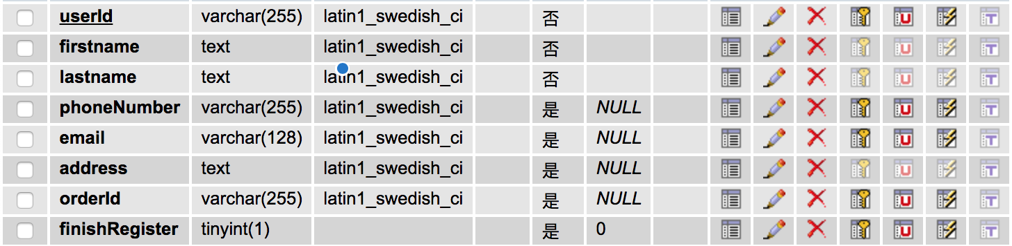

**Time: Oct 17 After class Location: JOHN 102**

1. Front-end group:

Still working on coding the home page.

2. Back-end group:

Use RESTful API to finish that how to search and add users’ information.

**Time: Oct 18 3:30-3:45 pm Location: Library 5160**

1. There were some bugs of the profile page, we fixed the bugs and perfect the profile page.

2. Finish how to delete and change users’ information.

3. We will finish the user test before Sunday night.

**Time: Oct 19 8:00-8:15 pm Location: KEC 1005**

1. The Back-end group finish that how to update users’ information.

2. Prepare for the sprint review.