Professor

Graduate Students

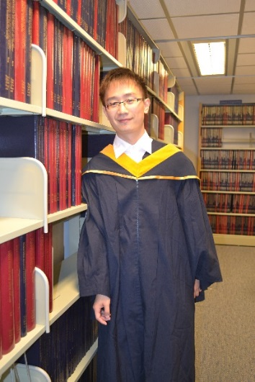

Jianbiao LU (吕建标)

PhD, 2015 expected;

MSc, HKUST, 2011;

BSc, SCUT (South China University of Technology)

Research topic: Nanoengineering SiGe with in-situ grown nanodots for efficient direct thermo-electric inter-conversion.



SU Yu

PhD candidate,

Department of Mechanical and Aerospace Engineering

The Hong Kong University of Science and Technology, 2017 expected

BSc, WU HAN University, China, 2013   
Research Interests: Thermoelectric cooling



Daniel Villaroman

PhD, The Hong Kong University of Science and Technology, 2016 expected

BEng, The Hong Kong University of Science and Technology, 2012

Research Interests: Nanoscale Heat Transport, Thermoelectrics, 1-D and 2-D materials, Graphene