QT笔记
一、kits 构建套件
QT version:
安装获取
编译器：
G++
GCC 系统提供
Android gcc :安卓
GCC
设备（安卓）：
jdk 1.8
sdk 25.2.5
ndk 17.2
二、pro文件项目配置文件
QT+=network //使用网络
QT-=gui //不使用gui
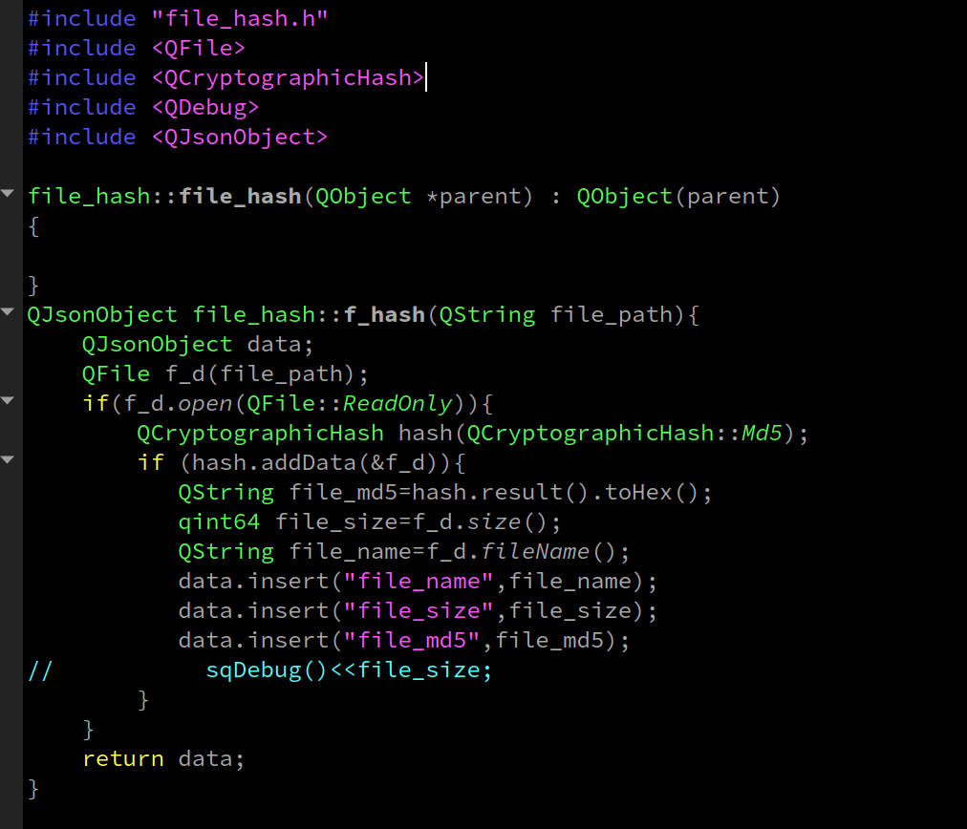

QT+=sql //使用
sql模块
三、QCryptographicHash
四、json
Qjsonarray //json列表
QJsonObject //json对象
例：QJsonObject json;
json.insert(“key”,”value”);
json.value(“key”).toString
json.keys();
QJsonDocment // 格式转换
json转换bindata; QJsonDocument(tmp_object).toBinaryData()
bindata转jsonObject QjsonDocument::fromBinaryData(data).object();

五、 文件夹不存在则创建
QDir meidi_dir(meidi_path);
if (!meidi_dir.exists()){
meidi_dir.mkpath("./");
}
QSQLdatabase;
QSqlDatabase db;
if (db.contains("connect")){
db.removeDatabase("connect");
}
db=QSqlDatabase::addDatabase("QMYSQL","connect");
db.setHostName(db_ip);
db.setDatabaseName(db_base);
db.setUserName(db_user);
db.setPassword(db_passwd);
QSqlQuery query(db);
query.prepare("insert into device(name,width,height) values(:name,:width,:heigth)");
query.bindValue(":name",device_name);
query.bindValue(":width",device_width);
query.bindValue(":heigth",device_heigth);
query.exec();
query.finish();
db.close();

}

六、QTcpServer
头文件
class sql_file_service:public QTcpServer
{
Q_OBJECT
public:
sql_file_service(); //构造函数
~sql_file_service();
protected:
void incomingConnection(qintptr soketDescriptor); //有连接时调用
};
///////////////////////////TCPSOCKET/////////////////////////////////
class tcp_socket :public QTcpSocket
{
Q_OBJECT
public:
tcp_socket(int socketdesc,QTcpSocket *parent=NULL);
private slots:
void Read_data();
void error_status(QAbstractSocket::SocketError socketError);
private:
};
cpp文件
sql_file_service::sql_file_service() {sql_file_service::setMaxPendingConnections(50); //最大连接数}
void sql_file_service::incomingConnection(qintptr soketDescriptor)
{
tcp_socket *socket=new tcp_socket(soketDescriptor);
//连接读取信号到新建立的Qtcpsocke的读取信号
connect(socket,SIGNAL(readyRead()),socket,SLOT(Read_data()));
//创建线程
QThread *task=new Qthread();
//关闭连接是退出线程
connect(socket,SIGNAL(disconnected()),task,SLOT(quit()));
//移动socket到新创建的线程
socket->moveToThread(task);
task->start();//启动线程
}
sql_file_service::~sql_file_service(){
this->close();
}
//////Qtcpsocket
//继承QTcpSocket 传入QTcpSocke 的参数，和初始值；
tcp_socket::tcp_socket(int socketdesc,QTcpSocket *parent):QTcpSocket (parent) {
this->setSocketDescriptor(socketdesc);
connect(this,SIGNAL(error(QAbstractSocket::SocketError)),this,SLOT(error_status(QAbstractSocket::SocketError)));
}
void tcp_socket::error_status(QAbstractSocket::SocketError socketError){
// qDebug()<<socketError;
}

void tcp_socket::Read_data(){ //有数据传入时执行
QByteArray data= this->readAll();
this.write() //写入
}
//监听
sql_file_service test;
if(!test.listen(QHostAddress::Any,1138)){
qDebug()<<"端口占用";
}

//QTcpSocket
QTcpSocket::connectToHost(server_host,server_port,QTcpSocket::ReadWrite)
server_connect.waitForReadyRead(); //阻塞直到有数据返回。
七、Qml 交互
类继承自QOBject
Q_INVOKABLE void get_list(int id);//方法定义
属性定义：
Q_PROPERTY(QString author READ author WRITE setAuthor NOTIFY authorChanged)
author ,setAuthor(QString),authorChaned() 方法
类 api;
//接口注册
engine.rootContext()->setContextProperty("api",&api);

八 QMl_布局
anchors.centerIn: parent //剧中
九、ListModel,支持json insert
var com=Qt.createComponent("../play/Test_play.qml")
var object=com.createObject("", {"width":edit_window.width,"height":edit_window.height,"device_id":device_id});
object.show();
object.destroy()

MouseArea{
cursorShape:Qt.SizeHorCursor
drag.target:height_edit //开启拖拽的组件ID
drag.axis: Drag.XAxis //拖拽方向约束
}

QquickPaintedItem:
//QPent 画笔https://doc.qt.io/qt-5/qpen.html
QPen pen(Qt::green, 3, Qt::DashDotLine, Qt::RoundCap, Qt::RoundJoin);
相当于：
pen.setStyle(Qt::DashDotLine) //画笔的样式
pen.setWidth(3) //画笔的宽度
pen.setBrush(Qt::green);画笔的颜色
pen.setCapStyle(); 端点风格 Qt::SquareCap//Qt::FlatCap//Qt::RoundCap
pen.setJoinStyle(); 连接样式 Qt::BevelJoin//Qt::MiterJoin//Qt::RoundJoin
pen.setDashPattern(); 虚线图案Qt::SolidLine//Qt::DashLine
#include <QQuickPaintedItem>
#include <QPainter>
class Paint_lien :public QQuickPaintedItem
{
Q_OBJECT
public:
Paint_lien();
void paint(QPainter *painter);
void line();
private:
QPainter *m_painter;
};
////////
#include <QPainter>
#include <QPainterPath>
#include <QDebug>
Paint_lien::Paint_lien()
{
}
void Paint_lien::line(){
m_painter->drawLine(10.0, 80.0, 90.0, 20.0); //直线
QPainterPath path; //路径
path.moveTo(20, 80); //移动点
path.lineTo(20, 30);//直线
path.cubicTo(80, 0, 50, 50, 80, 80); //贝塞尔曲线
m_painter->drawPath(path);
}
void Paint_lien::paint(QPainter *painter){
m_painter=painter;
line();
qDebug()<<"paint";
}
//注册
qmlRegisterType<Bus_Line>("Bus_line",1,0,"Bus_line");

//qml动画：
NumberAnimation on animationTime { // animationTime修改的属性
id: animationTimeAnimation
from: 0
to: 360
duration: 1000*360 //动画持续时间
loops: Animation.Infinite
}
//qml 屏幕像素：
width: Screen.desktopAvailableWidth
height: Screen.desktopAvailableHeight
//timer 定时器
Timer{
interval: 1000; //1秒
running: true; //自动运行
repeat: true; //循环
onTriggered: api.get_image(dom); //触发执行什么
}

//注册API
#include <QQmlContext>

sf_client api;
engine.rootContext()->setContextProperty("api",&api);

//转PDF
void Api::test(QString filename){
QPrinter printer;
// printer.setPageSize(QPrinter::A4);
printer.setPaperSize(QSizeF(100,100),QPrinter::Point);

printer.setOutputFormat(QPrinter::PdfFormat);
printer.setOutputFileName("nonwritable.pdf");
QPainter painter;
// if (! painter.begin(&printer)) { // failed to open file
// qWarning("failed to open file, is it writable?");
// }
painter.begin(&printer); //开始绘图
QImage i("something.png");
QRect target(100.0, 20.0, 80.0, 60.0);
QRect source(0.0, 0.0, 70.0, 40.0);
painter.drawImage(target,i,source);
// if (! printer.newPage()) {
// qWarning("failed in flushing page to disk, disk full?");
// }
printer.newPage(); //新建下一页
painter.drawText(10, 30, "Test 2到沙发");
painter.end();
}
//qml
Rectangle{
id:r
width: 90
height: 30
color: Qt.rgba(1,0,0,1)
MouseArea{
anchors.fill: parent
onPressed: {
r.grabToImage(function(result) {
result.saveToFile("something.png");
});
Api.test("something.png");
}
}
}

