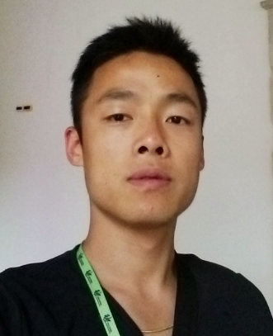**Ran Wang**

Address: Krusågade 9, 4th, 1719 København V

Mobile: 50555618

E-mail: [wangrandk@gmail.com](mailto:wangrandk@gmail.com)

Citizenship: Chinese holding Danish permanent resident permit

# I am very interested in this position, because I love data analysis, and my degree courses have prepared me for this position.

# I have a bachelor degree in Business Administration, and my master program is in Mathematical modelling and computation, where I focus on machine learning, financial engineering and constrained optimization. With me as your QA analyst, you have an analytical mindset team player with:

# Hands-on experience in data collection, validation, extraction, analysis, visualization and reporting.

# Hands-on experience from projects that involve but not limited to NLP, Data/Text mining, Recommendation Algorithm(CF/CBF), Time Series Analysis, Credit Score prediction for defaulting, Sentimental Analysis, Regression, Clustering, Classification and Spark.

# Hands-on experience in design and test of UX and system troubleshooting.

# Comprehensive knowledge of optimal portfolio of stock/bond, efficient frontier, sharp ratio, duration and convexity of bond, CAPM, VaR, Black-Scholes, and the skills to implement and modify the relevant models.

# I believe that my competences in business, machine learning and database will be a good starting point to kick-start a career with SimCorp. Most importantly, I am a quick learner with proactive lifelong learning mindset, which ensures that I can contribute a lot in a long run.

# Yours sincerely

# Ran Wang